通过社交媒体上的头像分析用户的幸福感

**Abstract：**

Profile images, as stable profile content, are posted by users on their own social media, which is driven by their own characteristics, including gender, age and personality. In this paper, we have investigated individual differences in profile picture choice between well-being traits. We concluded that each well-being trait has a specific type of profile images posting. For example, users high in positive relationship prefer to use pictures with bokeh and depth of filed style as their profile image. users high in engagement do not like to use pictures with surface texture, object details and quality of material as their profile image.

**Introduction：**

In recent years, researchers have tried to make use of profile images to study users’ online behaviors and offline psychological states. On the one hand, researchers try to figure out factors driving users to choose their profile images. On the other hand, they attempted to obtain the characteristics of users from their profile images. Several studies have examined the differences of users' profile images are related to age, gender and personality. For example, study[2] shows that users high in openness prefer more aesthetic photos, which tend to have higher contrast, sharpness, saturation and less blur. What attracts researchers is that users can choose profile images to enhance their physical attractiveness without being judged deceptive, this means profile images can reflect users' actual psychological states.

With the rise of social media, the way people express their feelings and opinions gradually shifts from offline to online. And the opinions and feelings expressed by users in social media can be spread and communicated quickly. Online platform allow users to create their own profiles with text, images, videos, etc. There profiles may be different from the user's actual profile, but it can reflect Personal psychological characteristics [1]. Users' feeling and opinions is beneficial to the development of personalized search engines, recommendation systems and online markets. For the government, effective control of the focus of public opinion and emotional orientation is good to improve the decision-making mechanism and timely response to emergencies.

study [2] conclude that users with different personalities have differences in color, content and other characteristics when selecting profile image on personal social media, which also prompts us to shift our research goals to happiness and image style. Importantly, literature [2] did not consider the abstract content contained in images, such as atmosphere and tone, it focused on colors, facial expressions, image composition and other certain content. study [21] reveals that texture information is also important for human perception of image style. Convolution neural network was used to extract style features and content information to identify image style, this method makes better use of the poor explanatory and abstract characteristics of CNNs to obtain abstract style of image. In this paper, we used the CNNs model proposed by study[3] to extract image style(（**Detailed, Pastel, Melancholy, etc**), then we uncover their relationships with well-being traits from the PERMA.

Well-being is not just about simply positive emotions or mood. Psychologists, organizations, and governments measuring well-being are now using multi-dimensional measures that include a range of factors .PERMA[14] decomposes the well-being construct into five domains: Positive emotion, Engagement, Relationships, Meaning, and Accomplishment (PERMA). With these five elements of PERMA, people can have their own happiness and enjoy a vigorous life。In our study, we found high correlation between well-being traits and users‘ profile image style. we use existing state-of-the-art text prediction methods to estimated users’ well-being.

**Related work:**

study [5] analyzes and models the user's personal features, including sexual

orientation, ethnicity, religious, by using the content of user ‘Likes’ and other basic data of user's account. At present, the prediction tasks of age, gender, personality and happiness all use the classical natural language method. study[19] demonstrated that Gender plays a role in determining the choice of profile picture. study[20] conclude that personality can predict some image choices and behaviors that might be useful for future work on authentication and identification. And other predictor variables are potentially also important when considering the types of individual characteristics which might predict on- line behavior on SNSs. There is a certain relationship between the style of users' profile image style and users' personality study[2] . For example, users with high openness prefer to use images with higher contrast, clarity and saturation.文献[4]建立了一个年龄、性别语料库（词典），并且使用一些带标记的数据集测试了其有效性。对于性别和年龄词典的训练，文章使用岭回归训练年龄模型，使用支持向量机训练性别模型，得到对应词汇的权重。study [7] proposed a unified approach to construct a profile of subjective well-being based on social media language in Facebook status updates. they apply sentiment analysis to generate users’ affect scores, and train a random forest model to predict SWL using affect scores and other language features of the status updates.文献[8] perform an additional evaluation at the user-level, finding that a multi-level cascaded model, using both message-level predictions and user- level features, performs best and outperforms popular lexicon-based happiness models.文献[12]验证了图像风格与图像内容之间存在依赖关系，比如Macro风格的图像与图像中存在动物有着很强的相关性，而Long Exposure和Sunny风格的图像则很多包含着汽车。

**Data**

twitter用户数据获取：

文献[11] focus on learning gender differences in the use of subjective language in English, Spanish and Russian Twitter data, and explore cross-cultural differences in emoticon and hashtag use for male and female users. 我们抽取其中的英文用户 We've used Scrapy to crawl 1721 English twitter users' tweets from January 1, 2010 to December 31, 2018. The number of users including tweets more than 100 were filtered out, and a total of 1523 users were screened and their images were obtained. DLATK[21] is used to process data, including filtering out English tweets and removing links, @data and repeated data in tweets。

**图像风格提取**

Different image styles bring different feelings to people. For different image styles, people can feel subtle differences, but it is quite difficult to describe them. One reason is that the style information of an image may be encoded in any component of the image including local and global, shape and color features. Another reason is that the definition of a style is often subjective, especially for photography works, which may vary from person to person. study [12] use low-level statistics, color choices, composition, and content to construct the style prediction model, which has a good explanation of what is the image style. In addition, through comparative experiments, the literature found that the performance of their classifier was quite accurate compared with that of trained artificial markers. study[13] propose a CNN-based model that integrates both content (or object) information and texture information for image style recognition. And their work using the CNN-based model improves over the state-of-the-art results. In their study, three style recognition datasets are experimented: WikiPainting, Flickr Style, and AVA Style. The Flickr Style was also introduced by Karayev et al. [12]. It contains 80,000 images with 20 style labels. The labels were grouped into several categories and each category contains two to five labels. For example, the Atmosphere category has two labels, Hazy and Sunny. We used Flickr dataset established to train the style recognition model.

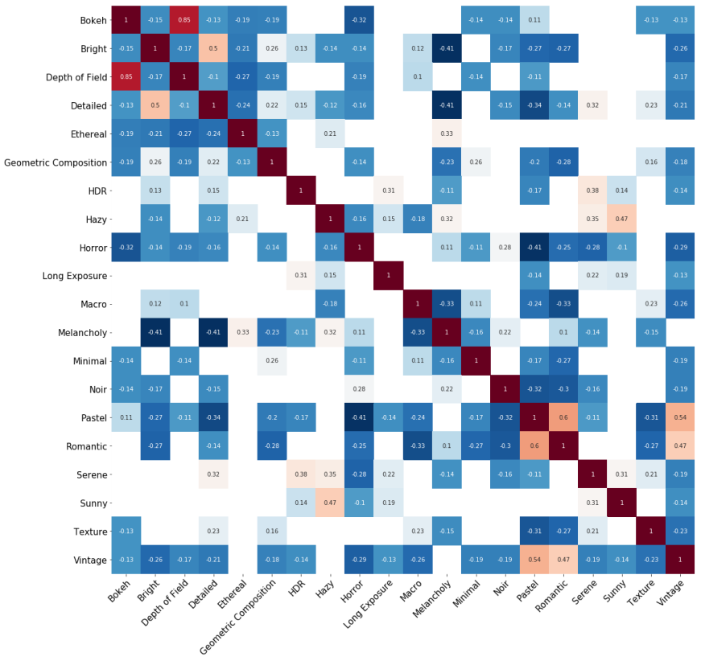

头像风格之间的相关性

In this work, We calculated the p value corresponding to the Pearson correlation between each feature and the target trait.

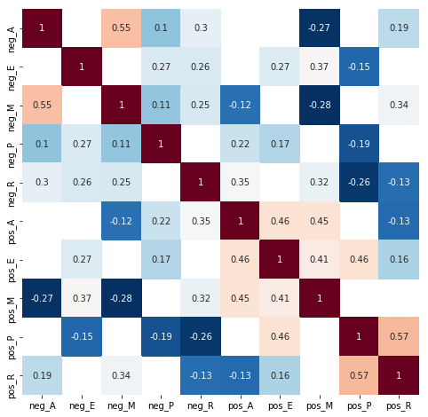**well-being提取**

**well-being之间的相关性**

PERMA categories contain different but related information. Consistent with the psychological literature[22], the highest correlations were between positive relationships (pos_R) and positive emotion (pos_P).

**Text analysis**

**well-being：**

Text-based prediction methods have been successfully used to predict a wide range of traits including age (Rao et al. 2010), gender (Burger et al. 2011), political orientation (Pennacchiotti and Popescu 2011), location (Cheng, Caverlee, and Lee 2010), impact (Lampos et al. 2014), income (Preot¸iuc-Pietro et al. 2015), occupation (Preot¸iucPietro, Lampos, and Aletras 2015), mental illnesses (De Choudhury, Counts, and Horvitz 2013) and personality (Schwartz et al. 2013). We use the method developed by (Schwartz 2016[8]) to assign each user scores for well-being，According to study [9], this model divides happiness into five categories, including Positive emotion, Engagement, Relationships, Meaning, and Accomplishment, and each category has two polarities. for example, The Engagement category contains two categories: Engagement and lack of accomplishment.

**age&gender：**

我们基于tweets文本分析的模型预测用户的年龄和性别，研究了在不同性别、年龄段的用户的幸福度的区别。结果显示随着年龄的增长，正向的PERMA均表现出增长的趋势，而反向的幸福感却随着年龄的增长而呈现下降的趋势。尤其对Relationship来说，女性和年龄越大的用户越容易表现出对他人的信任和肯定。其次，年龄越大的用户的Accomplishment越强。女性较于男性更容易表现出Engagement。

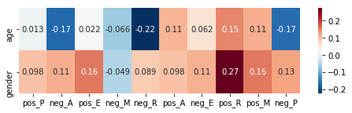

性别、年龄与well-being的相关性

（gender的值大于0时标识女性，age的值为连续的正值，标识用户的预测年龄）

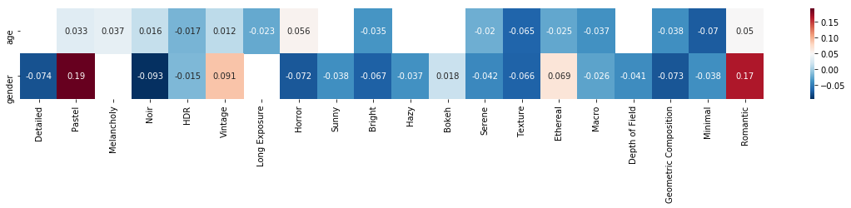

性别、年龄与风格的相关性

图像风格之间的相关性，由于往往一张图片属于多个风格分类，也就是不同风格之间具有相同的特征，所以风格之间的相关性也存在较大的差异。比如Bokeh与Depth of Filed表现出极强的相关性，原因在于前者由镜头产生的图像离焦部分的模糊的美学效果，后者在图像中为凸显最近物体而模糊背景物体，两者均存在模糊的图像内容。

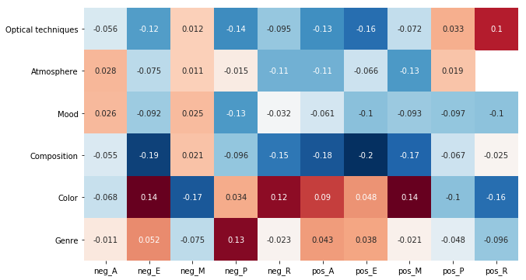**分析**

**头像风格与幸福感PERMA之间的相关性**

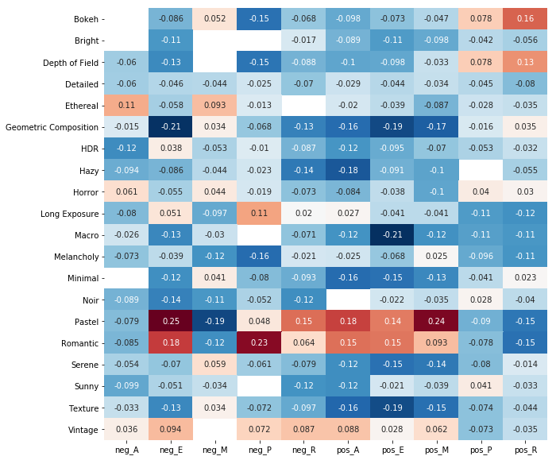

**头像风格与幸福感PERMA之间的相关性**

从上图可以看到Positive **Engagement**, Positive **Accomplishment** and Positive Meaning 与图像风格表现出相似的相关性，一方面风格Romantic 与 风格 Pastel 具有较强的相关性(p=0.6), 并且Pastel 与 Vintage 也就有强相关性(p=0.54)。另一方面，Positive **Engagement**, Positive **Accomplishment** and Positive Meaning 之间也具有较强的正相关性。These three styles of images are easier for ordinary people to distinguish as the names of the styles often come from the feeling the photos convey。

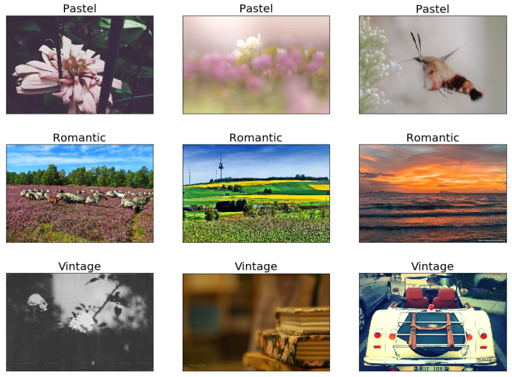

三种图片风格

**Positive Emotion：**

**Positive Emotion** Is one of the most studied aspects of well-being，positive emotion [14]includes positively valenced emotions such as joy, contentment, and excitement。

Most importantly, users high in Positive Emotion are correlated with Long Exposure, HDR, Pastel, and Ethereal styles. The classification of Long Exposure often feature refers to the state of moving objects expressed at a certain moment. Images where there is visible motion or there was a significantly long exposure required of a still scene. it needs to show something is visibly moving in the exposure. According to study [12], it is found that automobile content often appears in images of Long Exposure style, while Macro style has a strong correlation with animals appearing in images. The images of Pastel and Ethereal styles reflect soft, delicate and light colors or tones. (This kind of image is characterized by blur, ethereal and ethereal) That means that users who displayed positive emotions were more likely to use softer, more detailed images as their profile pictures. Positive Emotion is anti-correlated with Macro, Macro style lenses are often optimized for sharp focus on small areas close to the size of a film frame, The images in the style category are images taken with a macro lens that are much larger than normal objects, such as bees five times their normal size. Positive Emotion is also negatively correlated with Horror, which classifies images as horrible, bloody and weird.

Positive Emotion users tend to prefer pictures that are soft, delicate, clear and contain sports content. Reject horrible, bloody and abnormal images.

For users with negative emotions, the style of their avatar pictures has been correlated with Bright, Geometric Composition and Sunny. Bright style images display Bright, intense, psychedelic colors，Geometric Composition has been used to describe symmetrical objects such as circles, triangles and rectangles, as well as local repeating patterns.。值得注意的是，对于表现消极情绪的用户，他们往往还喜欢使用包含太阳的图片作为头像(Sunny风格的图像中包含的内容大多数有太阳)。

**Engagement：**

**Engagement**是包括行为、认知和情感的多维结构。它可以指对参与活动表现出的热情和兴趣、对工作的投入感和奉献、以及对手头任务的专注度等[15]。

Users of Engagement do not like to use pictures with textures and surface details as profile pictures(well-being与Macro, Texture and Geometric呈现负相关,并且三者均体现照片内容多包含物体的细节。). On the contrary, 对于缺乏Engagement的用户来说，他们要比正向Engagement得分高的用户更喜欢使用Pastel和Romantic风格的图像。相同的是两类人群都排斥Composition大类的图片。

**Relationship：**

**Relationship** includes trusting others, perceiving others as being there if needed, receiving social support, and giving to others[16]. Plenty of evidence indicates the importance of positive Relationship to health, longevity, and other important qualities of life. Users who lack relationship prefer images in styles like Pastel. 此类用户的头像一般不会涉及Hazy风格。对于Relationship得分较高的用户，他们更喜欢涉及optical techniques的images作为profile image。与缺乏Relationship的用户相比，他们不倾向于色彩较为丰富的profile image。

**Meaning:**

**Meaning** explains the purpose and importance of life, as well as the understanding of life [18]。Meaning得分较高的用户喜欢pastel风格。该类用户除了不喜欢使用Composition类别的图像，还不喜欢使用Atmosphere类别的图像作为profile image。

对于negative Meaning 的用户来说，他们的profile images通长会更偏向于使用构图细致、透明或者是半透明、空灵的Ethereal风格。，而少见色彩内容较为丰富的Romantic和Pastel风格。

**Accomplishment：**

**Accomplishment**通常根据奖励、荣誉和其他客观成就标志来定义。就个人成就感而言，它包括掌控力、感知能力和目标达成感。Accomplishment与Romantic和Pastel风格表现出较强的正相关性，与Hazy风格的负相关性最为强烈。也就是说，对于accomplishment越强的用户就越不喜欢使用包含细节、纹理清晰、物体的结构和质地等内容，他们更偏向于具有较高质量、异常美丽的图像。

缺乏成就感的人则偏好Sunny和Bright风格的头像，这一点与我们普通的认知有些相悖，在Sunny和Bright这两个风格中的图片包含大量强烈、大胆、几近疯狂的色彩，就如同阳光一样。与之对应的，该群体不喜欢Pastel和Melancholy这种颜色轻柔、细腻、色调柔和的风格的头像。

**总结：**

我们使用卷积神经网络提取用户图像的风格，用Pearson相关度量图像风格和用户幸福度之间的关系。该研究揭示了用户的幸福度在一定程度上影响着用户图像的选择。能够对相关心理学研究提供线索和依据。

该研究是首次分析了图像风格与用户well-being之间的相关性，发现不同well-being的用户所选用的头像存在一定的差异，positive emotion的用户更喜欢使用柔和、细腻风格的头像。engagement的用户则不喜欢图像中包含纹理、细节，而是偏向于场景较大的头像。Relationship 则与PE表现出相似的趋向，negative emotion和缺乏relationship的用户反而喜欢使用色彩更加鲜艳、明亮，包含几何内容的头像。meaning的用户更喜欢具有层次感的头像。Accomplishment的用户则偏好Romantic风格的图像。

**References**

[1] Profile pictures on social media: Gender and regional differences.

[2] Analyzing personality through social media profile picture choice

[3] Convolution neural network with two pathways for image style recognition

[4] Developing Age and Gender Predictive Lexica over Social Media

[5] Private traits and attributes are predictable from digital records of human behavior

[6] <https://www.faceplusplus.com>

[7] Building a profile of subjective well-being for social media users

[8] Predicting individual well-being through the language of social media

[9] M. J. C. Forgeard, E. Jayawickreme, M. Kern and M. E. P. Seligman, International Journal ofWell-being 1, 49 (2011).

[10] A Visionary New Understand of Happiness and Well-being

[11] Exploring Demographic Language Variations to Improve Multilingual Sentiment Analysis in Social Media

[12] Recognizing Image Style

[13] Convolution Neural Networks With Two Pathways for Image Style Recognition

[14] Doing the right thing : Measuring well-being for public policy

[15] M. Csikszentmihalyi, Creativity: Flow and the psychology of discovery and invention (Harper Perennial, 1997)

[16] The Oxford Handbook of Health Psychology

[17] Applied Psychology: Health and Well-being (2012)

[18] Man’s search for ultimate meaning

[19]Profile pictures on social media: Gender and regional differences

[20] A picture tells a thousand words: What Facebook and Twitter images convey about our personality

[21] DLATK: Differential Language Analysis ToolKit

[22]Diener, E., & Seligman, M. E. P. (2002). Very Happy People. Psychological Science, 13(1), 81–84. https://doi.org/10.1111/1467-9280.00415