实验编号： 7 **四川师大《IOS》实验报告 2018** 年 **10** 月 **24** 日

### **计算机科学学院** 2016 级 4 班 实验名称： Game单MVC _

姓名：_谭靖薇_ 学号：_2016110437 指导老师：__李贵洋__ 实验成绩:_____

**实验 七 ______** Game单MVC **________**

1. 实验目的及要求
2. 实现一款功能完整的game（Concentration）；
3. 掌握单MVC的主要思想；
4. 认真填写实验报告，要求附加部分运行界面和主要代码；
5. 对设计好的程序，检查输出是否符合预期，如有错请分析错误原因并解决；
6. 实验内容
7. 参照Stanford视频1和2完成一个game（Concentration）的制作；
8. 在(1)的基础上进一步完成Stanford Assignment 1的完整要求；
9. 采用autolayout布局解决横竖屏自适应如下所示；

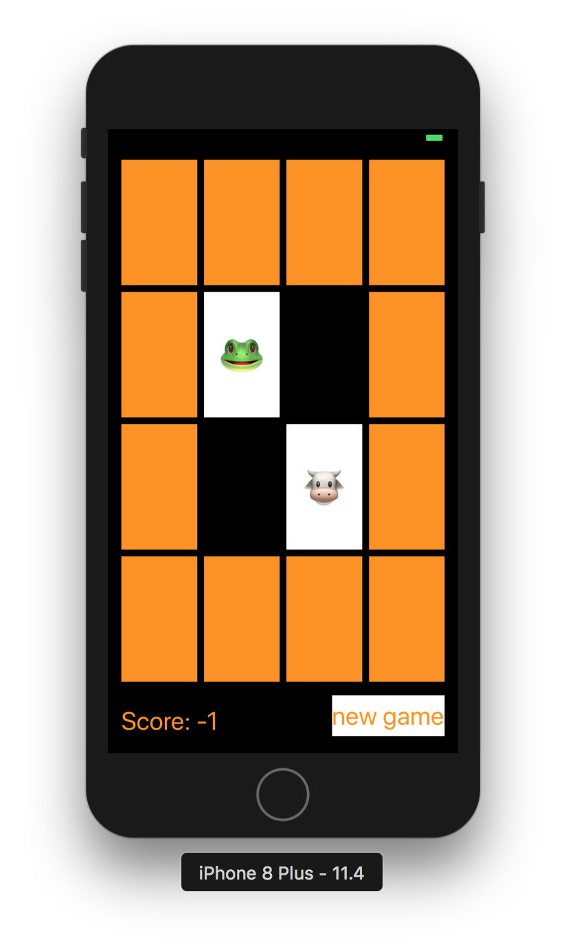

1. 实验主要流程、基本操作或核心代码、算法片段（该部分如不够填写，请另加附页）
2. 参照Stanford视频1和2完成一个game（Concentration）的制作；
3. 在(1)的基础上进一步完成Stanford Assignment 1的完整要求；
4. 采用autolayout布局解决横竖屏自适应如下所示；



* 程序代码：

*//*

*// ViewController.swift*

*// Concentration*

*//*

*// Created by liguiyang on 2018/10/22.*

*// Copyright © 2018年 liguiyang. All rights reserved.*

*//*

**import** UIKit

**class** ViewController: UIViewController {

**lazy** **var** game = Concentration(numberOfPairsOfCards: (cardButtons.count + 1) / 2)

**@IBOutlet** **weak** **var** scoreLabel: UILabel!

**@IBOutlet** **var** cardButtons: [UIButton]!

**@IBAction** **func** touchCard(**_** sender: UIButton) {

**if** **let** cardNumber = cardButtons.index(of: sender) {

game.chooseCard(at: cardNumber)

updateViewFromModel()

} **else** {

print("choose card was not in cardButtons")

}

}

**func** updateViewFromModel() {

**for** index **in** cardButtons.indices {

**let** button = cardButtons[index]

**let** card = game.cards[index]

**if** card.isFaceUp {

button.setTitle(emoji(for: card), for: UIControlState.normal)

button.backgroundColor = colorLiteral(red: 0.9999960065, green: 1, blue: 1, alpha: 1)

} **else** {

button.setTitle("", for: UIControlState.normal)

button.backgroundColor = card.isMatched ? colorLiteral(red: 1, green: 1, blue: 1, alpha: 0) : colorLiteral(red: 1, green: 0.5763723254, blue: 0, alpha: 1)

}

}

scoreLabel.text = "Score: \(game.score)"

}

**var** themes = [0:["🎃","👻","🐶","🐷","😊","😢","😄","😂","👩‍❤️‍👩","🐒","❤️"],

1:["💇","🤵","💇‍♂️","👊","🍵","🐛","🍉","🍇","🍑","🍒","🍓"],

2:["⚽️","🏀","🏈","⚾️","🎱","🏉","👕","🐸","🏓","🏸","🏒"],

3:["🚗","🚕","🚙","🚌","🚑","🚓","🏎","🚎","🚒","🚚","🛵"],

4:["⌚️","📱","💻","🖨","🖥","⌨️","💽","🗜","🕹","💾","☎️"],

5:["🇦🇱","🇩🇿","🇦🇫","🏳️‍🌈","🇦🇷","🇦🇪","🇦🇼","🇴🇲","🇮🇪","🇪🇹","🇪🇬"]]

**lazy** **var** emojiChoices = themes[0]!

**var** emoji = [Int: String]()

**func** emoji(for card: Card) -> String {

**if** emoji[card.identifier] == **nil**, emojiChoices.count > 0 {

**let** randomIndex = Int(arc4random_uniform(UInt32(emojiChoices.count)))

emoji[card.identifier] = emojiChoices.remove(at: randomIndex)

}

**return** emoji[card.identifier] ?? "?"

}

**@IBAction** **func** newGame(**_** sender: UIButton) {

game = Concentration(numberOfPairsOfCards: (cardButtons.count + 1) / 2)

**let** them = Int(arc4random_uniform(UInt32(themes.keys.count)))

emojiChoices = themes[them]!

updateViewFromModel()

}

}

* 运行截图：

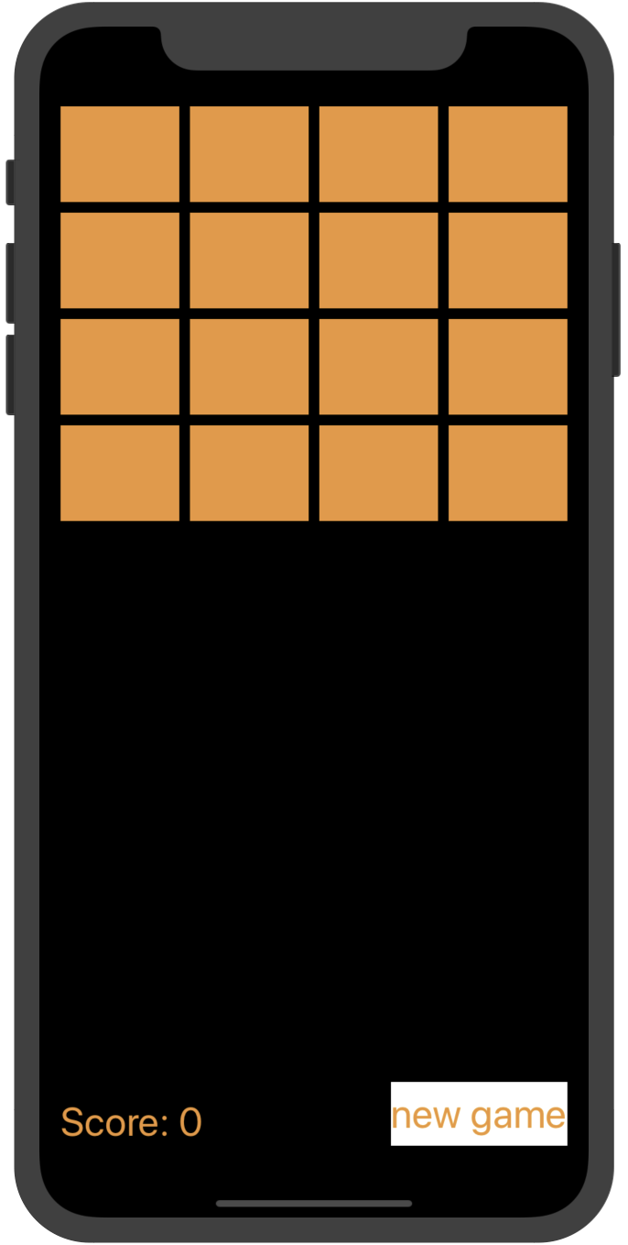

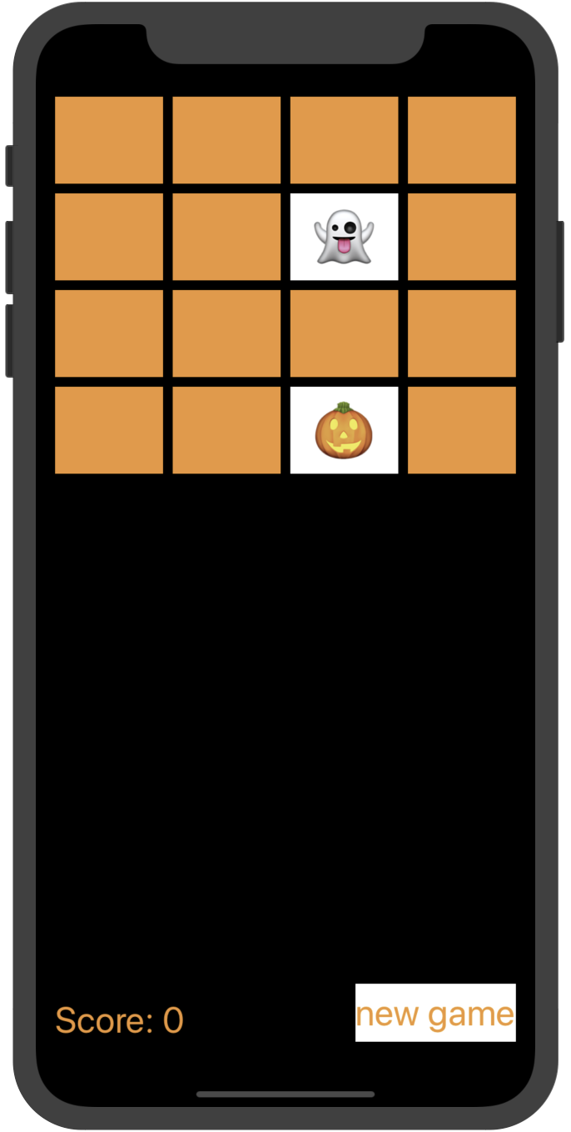

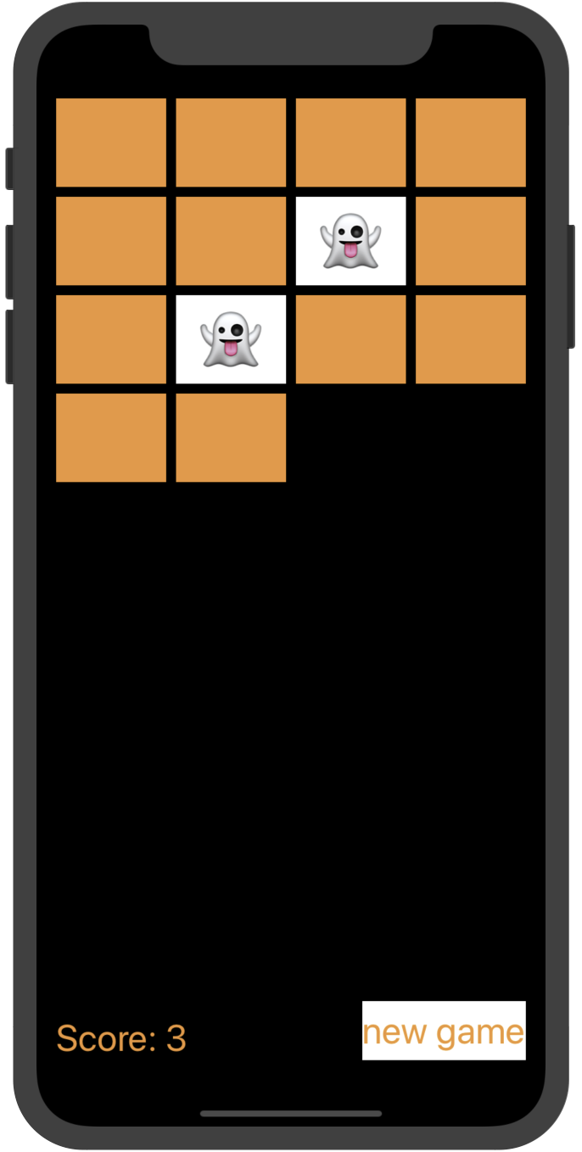

1. 实验结果的分析与评价（该部分如不够填写，请另加附页）

Github地址：https://github.com/xiongmaobeibei/ios_homework/tree/master/tjw/第7次上机作业

注：实验成绩等级分为（90－100分）优，（80－89分）良，(70-79分)中，（60－69分）及格，（59分）不及格。