实验编号： 11 **四川师大《IOS》实验报告 2018** 年 **11** 月 **21** 日

### **计算机科学学院** 2016 级 4 班 实验名称： 多MVC _

姓名：_谭靖薇_ 学号：_2016110437 指导老师：__李贵洋__ 实验成绩:_____

**实验 十一 ____**多MVC **_______**

1. 实验目的及要求
2. 掌握多MVC的设计以及实现；
3. 完成苹果官网的FoodTracker全部内容；
4. 实验要求
5. 认真填写实验报告，要求附加部分运行界面和主要代码；
6. 对设计好的程序，检查输出是否符合预期，如有错请分析错误原因并解决；
7. 实验内容
8. 实现一个简单的多mvc程序
   1. 控制器之间正向传参
   2. 控制器之间反向传参
9. 完成苹果官网的FoodTracker Demo（多MVC）
   1. TableView（自定制Cell）；
   2. NavigationController；
   3. Modal Controller;
   4. ImagePickerController;

说明：苹果官网Demo网址如下

<https://developer.apple.com/library/content/referencelibrary/GettingStarted/DevelopiOSAppsSwift/index.html>

1. 实验主要流程、基本操作或核心代码、算法片段（该部分如不够填写，请另加附页）
2. 实现一个简单的多mvc程序
   1. 控制器之间正向传参
   2. 控制器之间反向传参

* 程序代码：

Viewcontroller

*//*

*// ViewController.swift*

*// mutimvc*

*//*

*// Created by student on 2018/12/5.*

*// Copyright © 2018年 2016110437. All rights reserved.*

*//*

**import** UIKit

**protocol** StudentProtocol {

**func** change(name:String,no:String)

}

**class** ViewController: UIViewController,StudentProtocol {

**func** change(name:String,no:String) {

**self**.No = no

**self**.name = name

}

**var** name = ""

**var** No = ""

**@IBOutlet** **weak** **var** tfNo: UITextField!

**@IBOutlet** **weak** **var** tfName: UITextField!

**override** **func** viewDidLoad() {

**super**.viewDidLoad()

*// Do any additional setup after loading the view, typically from a nib.*

}

**override** **func** viewWillAppear(**_** animated: Bool) {

tfNo.text = No

tfName.text = name

}

**@IBAction** **func** showSecondVC(**_** sender: **Any**) {

No = tfNo.text!

name = tfName.text!

**let** secVC = UIStoryboard(name: "Main",bundle:**nil**).instantiateViewController(withIdentifier: "SecondVC") **as**! SecondViewController

secVC.No = No

secVC.name = name

secVC.delegate = **self**

**self**.navigationController?.pushViewController(secVC, animated: **true**)

}

**@IBAction** **func** shiwThirdVC(**_** sender: **Any**) {

**let** tirVC = UIStoryboard(name: "Main",bundle:**nil**).instantiateViewController(withIdentifier: "ThirdVC")

present(tirVC,animated: **true**,completion: **nil**)

}

}

SecondViewcontroller

*//*

*// SecondViewController.swift*

*// mutimvc*

*//*

*// Created by student on 2018/12/5.*

*// Copyright © 2018年 2016110437. All rights reserved.*

*//*

**import** UIKit

**class** SecondViewController: UIViewController {

**var** name = ""

**var** No = ""

**var** delegate: StudentProtocol?

**@IBOutlet** **weak** **var** tfNo: UITextField!

**@IBOutlet** **weak** **var** tfName: UITextField!

**override** **func** viewDidLoad() {

**super**.viewDidLoad()

tfNo.text = No

tfName.text = name

*// Do any additional setup after loading the view.*

}

**@IBAction** **func** back(**_** sender: **Any**) {

No = tfNo.text!

name = tfName.text!

delegate?.change(name: name, no: No)

navigationController?.popViewController(animated: **true**)

}

*/\**

*// MARK: - Navigation*

*// In a storyboard-based application, you will often want to do a little preparation before navigation*

*override func prepare(for segue: UIStoryboardSegue, sender: Any?) {*

*// Get the new view controller using segue.destination.*

*// Pass the selected object to the new view controller.*

*}*

*\*/*

}

thirdViewcontroller

*//*

*// ThirdViewController.swift*

*// mutimvc*

*//*

*// Created by student on 2018/12/5.*

*// Copyright © 2018年 2016110437. All rights reserved.*

*//*

**import** UIKit

**class** ThirdViewController: UIViewController {

**override** **func** viewDidLoad() {

**super**.viewDidLoad()

*// Do any additional setup after loading the view.*

}

**@IBAction** **func** close(**_** sender: **Any**) {

dismiss(animated: **true**, completion: **nil**)

}

*/\**

*// MARK: - Navigation*

*// In a storyboard-based application, you will often want to do a little preparation before navigation*

*override func prepare(for segue: UIStoryboardSegue, sender: Any?) {*

*// Get the new view controller using segue.destination.*

*// Pass the selected object to the new view controller.*

*}*

*\*/*

}

* 运行结果：

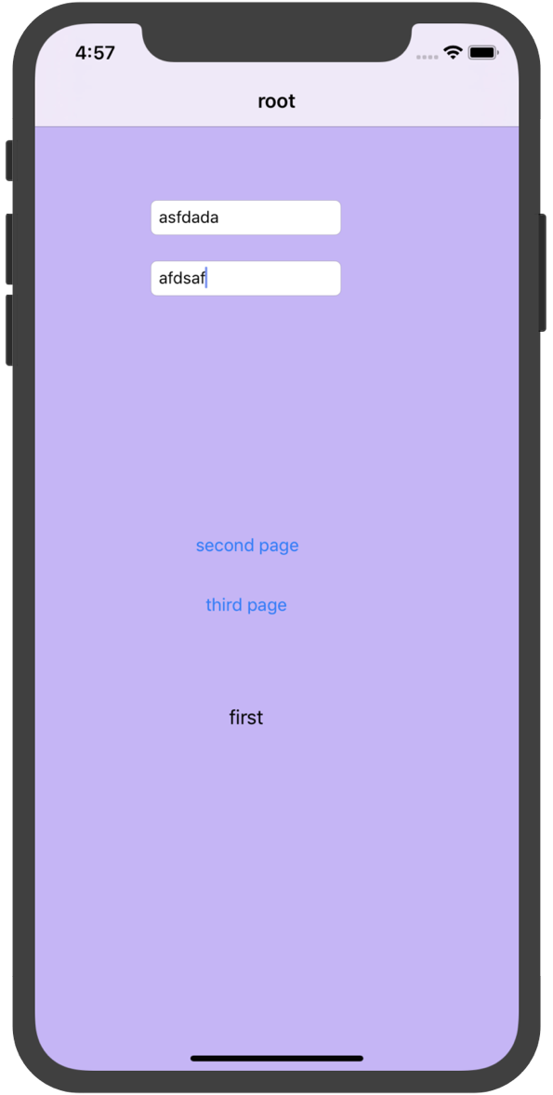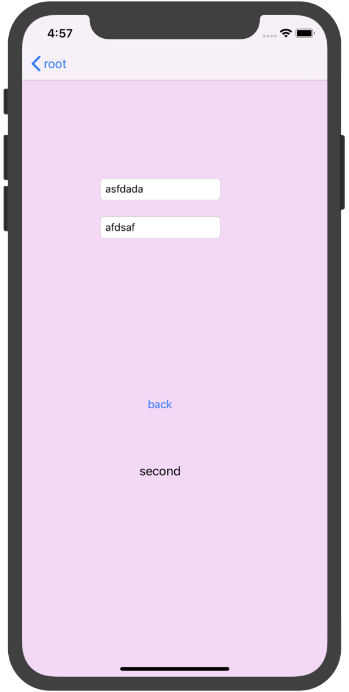

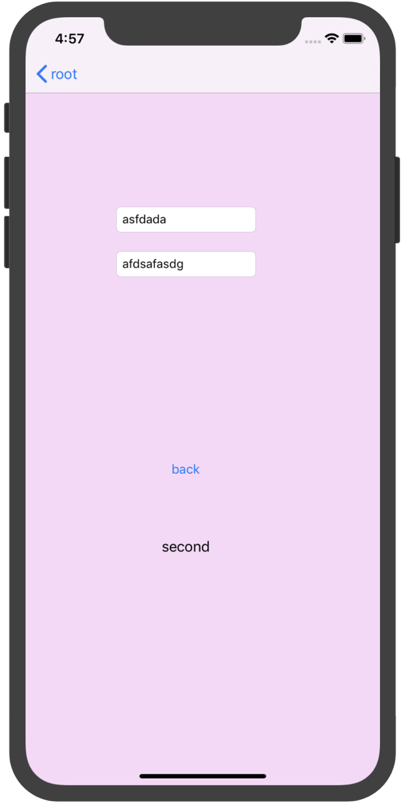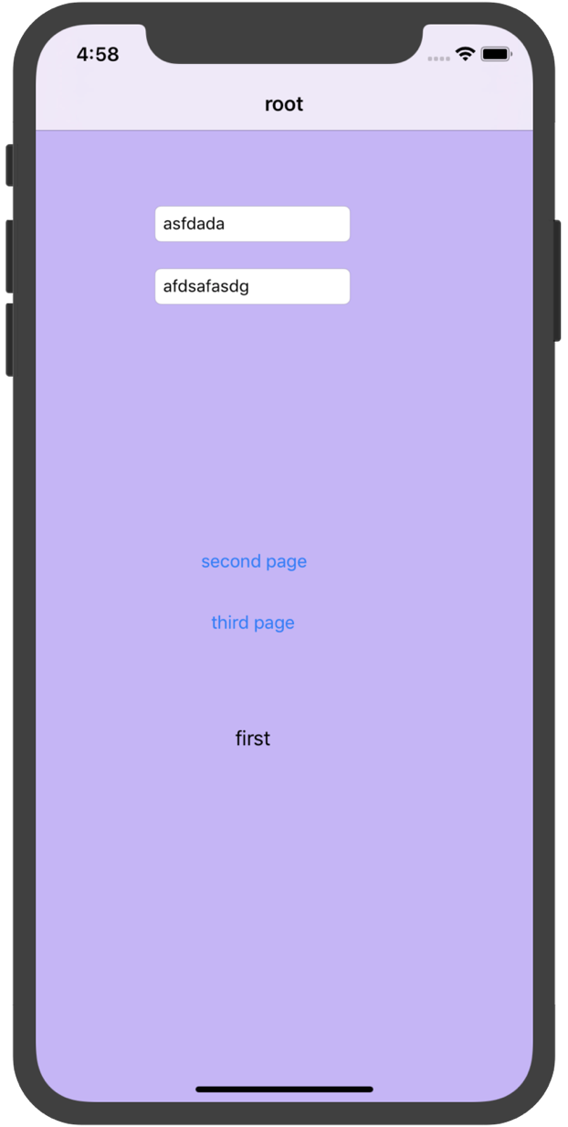

1. 完成苹果官网的FoodTracker Demo（多MVC）
   1. TableView（自定制Cell）；
   2. NavigationController；
   3. Modal Controller;
   4. ImagePickerController;

说明：苹果官网Demo网址如下

<https://developer.apple.com/library/content/referencelibrary/GettingStarted/DevelopiOSAppsSwift/index.html>

* 程序代码：

**import** UIKit

**import** os.log

**class** MealViewController: UIViewController, UITextFieldDelegate, UIImagePickerControllerDelegate, UINavigationControllerDelegate {

*//MARK: Properties*

**@IBOutlet** **weak** **var** nameTextField: UITextField!

**@IBOutlet** **weak** **var** photoImageView: UIImageView!

**@IBOutlet** **weak** **var** ratingControl: RatingControl!

**@IBOutlet** **weak** **var** saveButton: UIBarButtonItem!

*/\**

*This value is either passed by `MealTableViewController` in `prepare(for:sender:)`*

*or constructed as part of adding a new meal.*

*\*/*

**var** meal: Meal?

**override** **func** viewDidLoad() {

**super**.viewDidLoad()

*// Handle the text field’s user input through delegate callbacks.*

nameTextField.delegate = **self**

*// Set up views if editing an existing Meal.*

**if** **let** meal = meal {

navigationItem.title = meal.name

nameTextField.text = meal.name

photoImageView.image = meal.photo

ratingControl.rating = meal.rating

}

*// Enable the Save button only if the text field has a valid Meal name.*

updateSaveButtonState()

}

*//MARK: UITextFieldDelegate*

**func** textFieldDidBeginEditing(**_** textField: UITextField) {

*// Disable the Save button while editing.*

saveButton.isEnabled = **false**

}

**func** textFieldShouldReturn(**_** textField: UITextField) -> Bool {

*// Hide the keyboard.*

textField.resignFirstResponder()

**return** **true**

}

**func** textFieldDidEndEditing(**_** textField: UITextField) {

updateSaveButtonState()

navigationItem.title = textField.text

}

*//MARK: UIImagePickerControllerDelegate*

**func** imagePickerControllerDidCancel(**_** picker: UIImagePickerController) {

*// Dismiss the picker if the user canceled.*

dismiss(animated: **true**, completion: **nil**)

}

**func** imagePickerController(**_** picker: UIImagePickerController, didFinishPickingMediaWithInfo info: [String : **Any**]) {

*// The info dictionary may contain multiple representations of the image. You want to use the original.*

**guard** **let** selectedImage = info[UIImagePickerControllerOriginalImage] **as**? UIImage **else** {

fatalError("Expected a dictionary containing an image, but was provided the following: \(info)")

}

*// Set photoImageView to display the selected image.*

photoImageView.image = selectedImage

*// Dismiss the picker.*

dismiss(animated: **true**, completion: **nil**)

}

*//MARK: Navigation*

**@IBAction** **func** cancel(**_** sender: UIBarButtonItem) {

*// Depending on style of presentation (modal or push presentation), this view controller needs to be dismissed in two different ways.*

**let** isPresentingInAddMealMode = presentingViewController **is** UINavigationController

**if** isPresentingInAddMealMode {

dismiss(animated: **true**, completion: **nil**)

}

**else** **if** **let** owningNavigationController = navigationController{

owningNavigationController.popViewController(animated: **true**)

}

**else** {

fatalError("The MealViewController is not inside a navigation controller.")

}

}

*// This method lets you configure a view controller before it's presented.*

**override** **func** prepare(for segue: UIStoryboardSegue, sender: **Any**?) {

**super**.prepare(for: segue, sender: sender)

*// Configure the destination view controller only when the save button is pressed.*

**guard** **let** button = sender **as**? UIBarButtonItem, button === saveButton **else** {

os_log("The save button was not pressed, cancelling", log: OSLog.default, type: .debug)

**return**

}

**let** name = nameTextField.text ?? ""

**let** photo = photoImageView.image

**let** rating = ratingControl.rating

*// Set the meal to be passed to MealTableViewController after the unwind segue.*

meal = Meal(name: name, photo: photo, rating: rating)

}

*//MARK: Actions*

**@IBAction** **func** selectImageFromPhotoLibrary(**_** sender: UITapGestureRecognizer) {

*// Hide the keyboard.*

nameTextField.resignFirstResponder()

*// UIImagePickerController is a view controller that lets a user pick media from their photo library.*

**let** imagePickerController = UIImagePickerController()

*// Only allow photos to be picked, not taken.*

imagePickerController.sourceType = .photoLibrary

*// Make sure ViewController is notified when the user picks an image.*

imagePickerController.delegate = **self**

present(imagePickerController, animated: **true**, completion: **nil**)

}

*//MARK: Private Methods*

**private** **func** updateSaveButtonState() {

*// Disable the Save button if the text field is empty.*

**let** text = nameTextField.text ?? ""

saveButton.isEnabled = !text.isEmpty

}

}

* 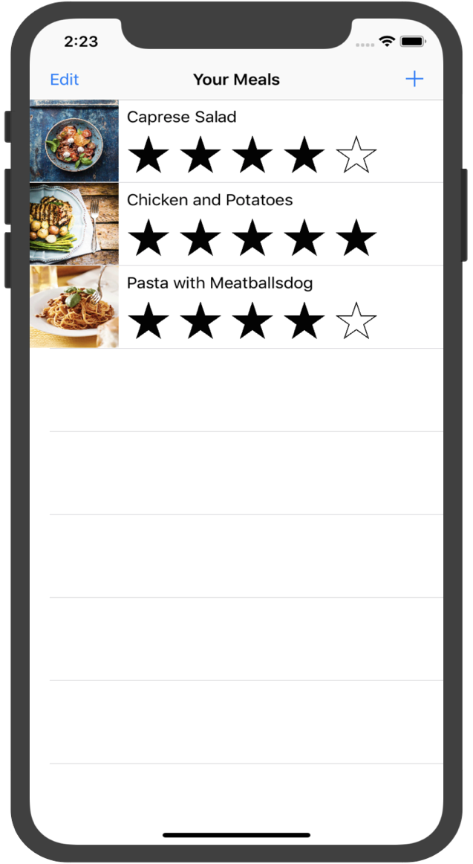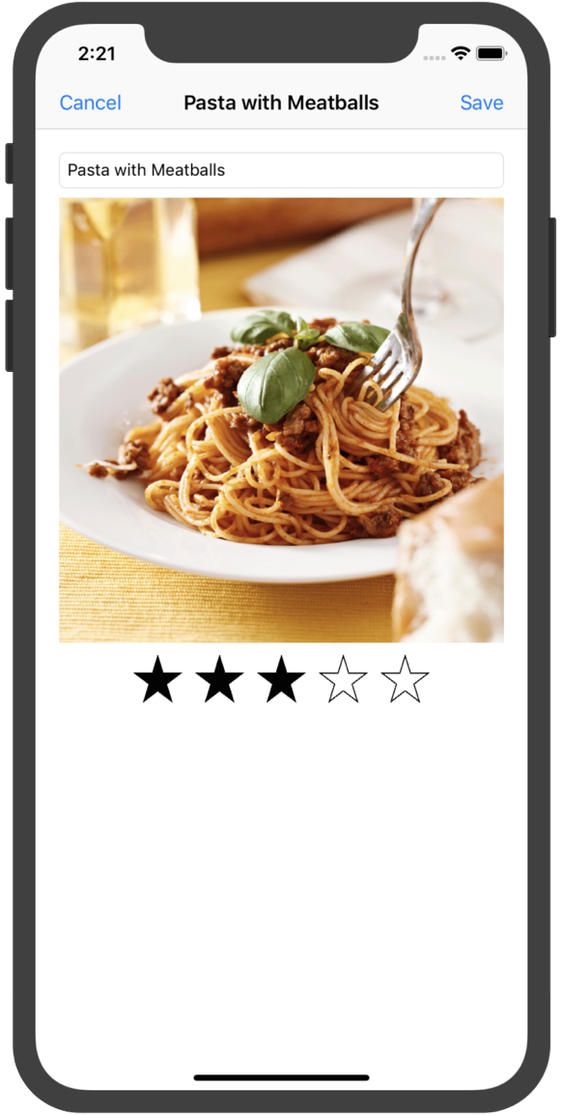运行结果：

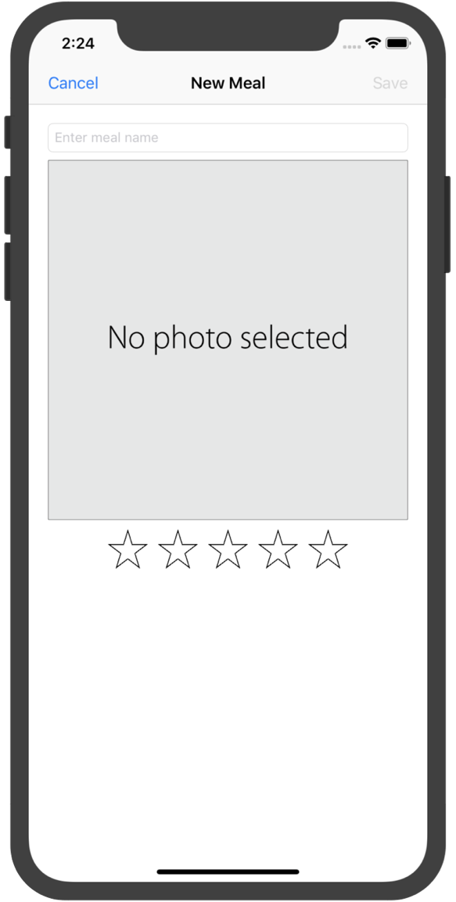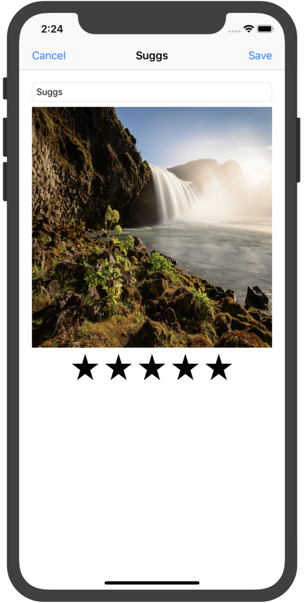

1. 实验结果的分析与评价（该部分如不够填写，请另加附页）

Github地址：

注：实验成绩等级分为（90－100分）优，（80－89分）良，(70-79分)中，（60－69分）及格，（59分）不及格。