实验编号： 7 **四川师大《IOS》实验报告 2018** 年 **10** 月 **24** 日

### **计算机科学学院** 2016 级 4 班 实验名称： Game单MVC _

姓名：_谭靖薇_ 学号：_2016110437 指导老师：__李贵洋__ 实验成绩:_____

**实验 七 ______** Game单MVC **________**

1. 实验目的及要求
2. 实现一款功能完整的game（Concentration）；
3. 掌握单MVC的主要思想；
4. 实验要求
5. 认真填写实验报告，要求附加部分运行界面和主要代码；
6. 对设计好的程序，检查输出是否符合预期，如有错请分析错误原因并解决；
7. 实验内容
8. 参照Stanford视频1和2完成一个game（Concentration）的制作；
9. 在(1)的基础上进一步完成Stanford Assignment 1的完整要求；
10. 采用autolayout布局解决横竖屏自适应如下所示；

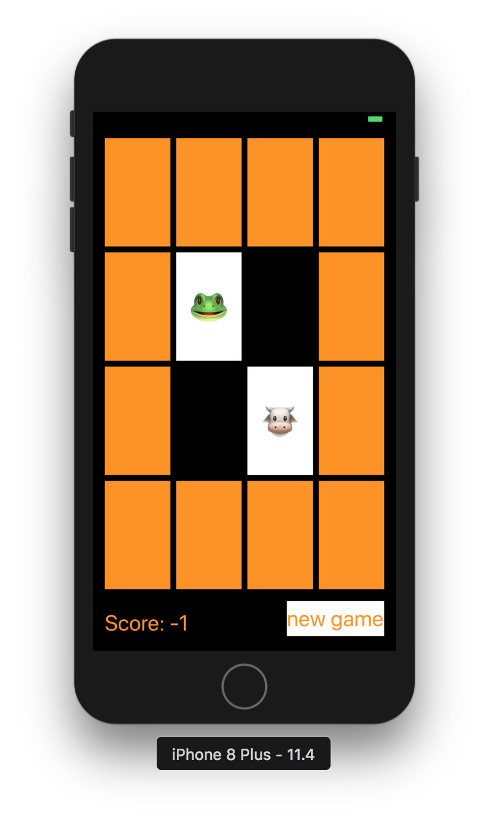

1. 实验主要流程、基本操作或核心代码、算法片段（该部分如不够填写，请另加附页）
2. 参照Stanford视频1和2完成一个game（Concentration）的制作；
3. 在(1)的基础上进一步完成Stanford Assignment 1的完整要求；
4. 采用autolayout布局解决横竖屏自适应如下所示；



* 程序代码：

*//*

*// ViewController.swift*

*// Concentration*

*//*

*// Created by liguiyang on 2018/10/22.*

*// Copyright © 2018年 liguiyang. All rights reserved.*

*//*

**import** UIKit

**class** ViewController: UIViewController {

**lazy** **var** game = Concentration(numberOfPairsOfCards: (cardButtons.count + 1) / 2)

**@IBOutlet** **weak** **var** scoreLabel: UILabel!

**@IBOutlet** **var** cardButtons: [UIButton]!

**@IBAction** **func** touchCard(**_** sender: UIButton) {

**if** **let** cardNumber = cardButtons.index(of: sender) {

game.chooseCard(at: cardNumber)

updateViewFromModel()

} **else** {

print("choose card was not in cardButtons")

}

}

**func** updateViewFromModel() {

**for** index **in** cardButtons.indices {

**let** button = cardButtons[index]

**let** card = game.cards[index]

**if** card.isFaceUp {

button.setTitle(emoji(for: card), for: UIControlState.normal)

button.backgroundColor = colorLiteral(red: 0.9999960065, green: 1, blue: 1, alpha: 1)

} **else** {

button.setTitle("", for: UIControlState.normal)

button.backgroundColor = card.isMatched ? colorLiteral(red: 1, green: 1, blue: 1, alpha: 0) : colorLiteral(red: 1, green: 0.5763723254, blue: 0, alpha: 1)

}

}

scoreLabel.text = "Score: \(game.score)"

}

**var** themes = [0:["🎃","👻","🐶","🐷","😊","😢","😄","😂","👩‍❤️‍👩","🐒","❤️"],

1:["💇","🤵","💇‍♂️","👊","🍵","🐛","🍉","🍇","🍑","🍒","🍓"],

2:["⚽️","🏀","🏈","⚾️","🎱","🏉","👕","🐸","🏓","🏸","🏒"],

3:["🚗","🚕","🚙","🚌","🚑","🚓","🏎","🚎","🚒","🚚","🛵"],

4:["⌚️","📱","💻","🖨","🖥","⌨️","💽","🗜","🕹","💾","☎️"],

5:["🇦🇱","🇩🇿","🇦🇫","🏳️‍🌈","🇦🇷","🇦🇪","🇦🇼","🇴🇲","🇮🇪","🇪🇹","🇪🇬"]]

**lazy** **var** emojiChoices = themes[0]!

**var** emoji = [Int: String]()

**func** emoji(for card: Card) -> String {

**if** emoji[card.identifier] == **nil**, emojiChoices.count > 0 {

**let** randomIndex = Int(arc4random_uniform(UInt32(emojiChoices.count)))

emoji[card.identifier] = emojiChoices.remove(at: randomIndex)

}

**return** emoji[card.identifier] ?? "?"

}

**@IBAction** **func** newGame(**_** sender: UIButton) {

game = Concentration(numberOfPairsOfCards: (cardButtons.count + 1) / 2)

**let** them = Int(arc4random_uniform(UInt32(themes.keys.count)))

emojiChoices = themes[them]!

updateViewFromModel()

}

}

* 运行截图：

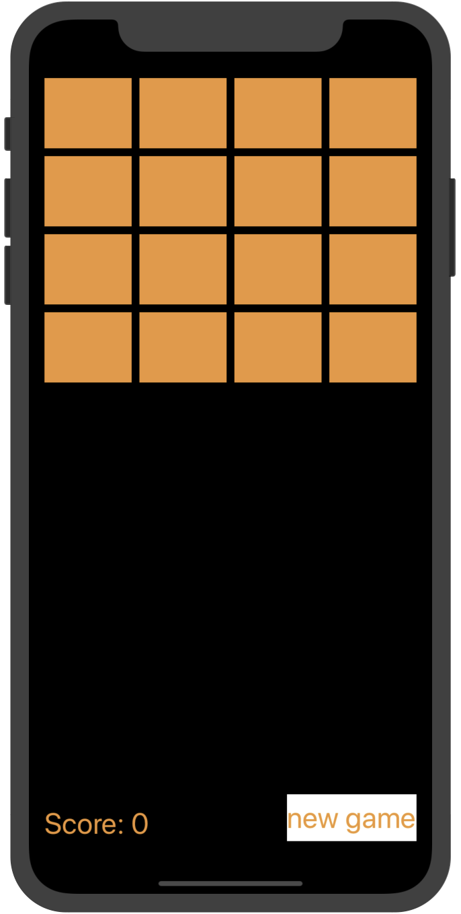

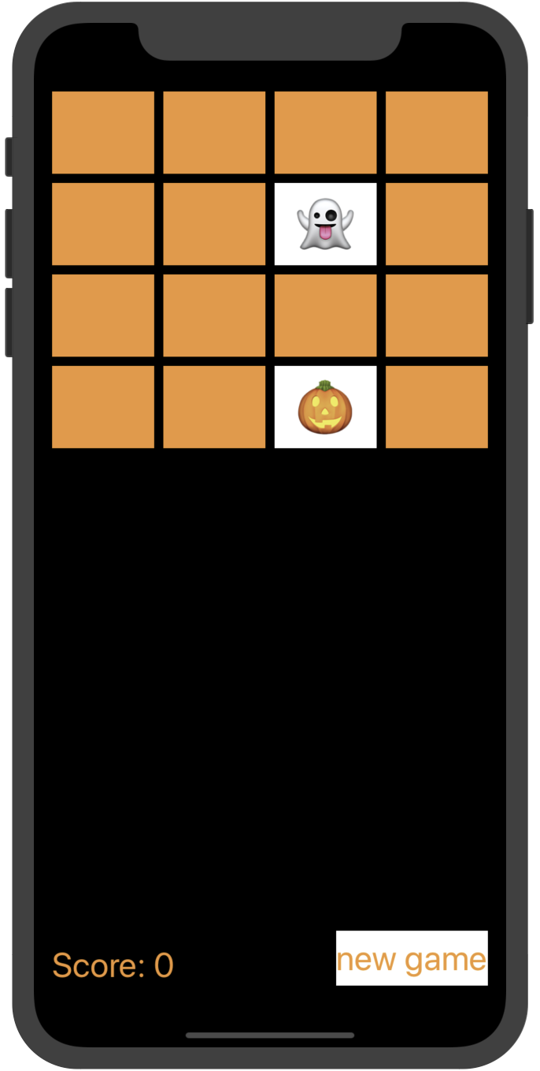

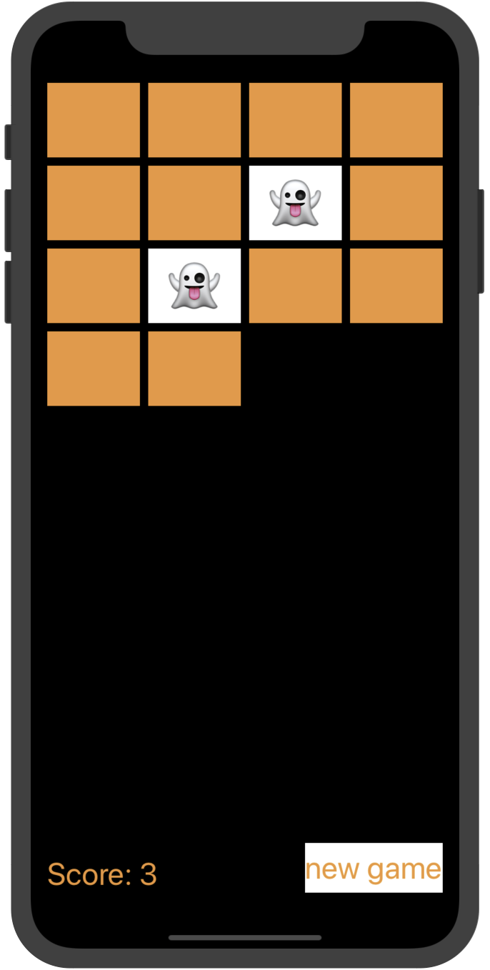

1. 实验结果的分析与评价（该部分如不够填写，请另加附页）

Github地址：

注：实验成绩等级分为（90－100分）优，（80－89分）良，(70-79分)中，（60－69分）及格，（59分）不及格。