We have uploaded the results and deep models to

BaiduYun (<https://pan.baidu.com/s/1I42WVCLz2SwPjJD7nydJvg> )

and

OneDrive (<https://1drv.ms/u/s!An-BNLJWOClliGSEa6QY9TVedqJH?e=8vSWld> ).

Please download these zipped files and unzip them into the folders ‘results/lai/’. The folder tree is as follows.

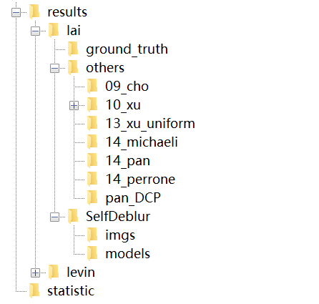

A color image is converted to YCbCr, and our SelfDeblur is performed on Y channel. Thus, the results in ‘SelfDeblur/imgs/’ have blur kernels by G_k, Y channel results by G_x, and the color results by converting YCbCr to RGB.

Then you can run ‘statistic/statistic_lai.m’ to compute the metrics reported in the paper.