Paul Xiong

Winter 2017

PROG2070 => Section#1

My Git log for Assignment#1

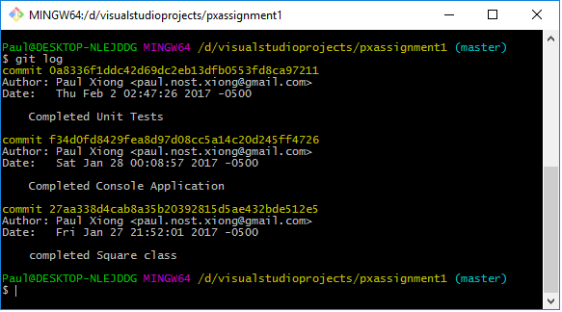

My Unit test results for Assignment#1

