在开发过程中遇到的一些问题
- 启动报错：引用日志jar导致报错
报错内容：
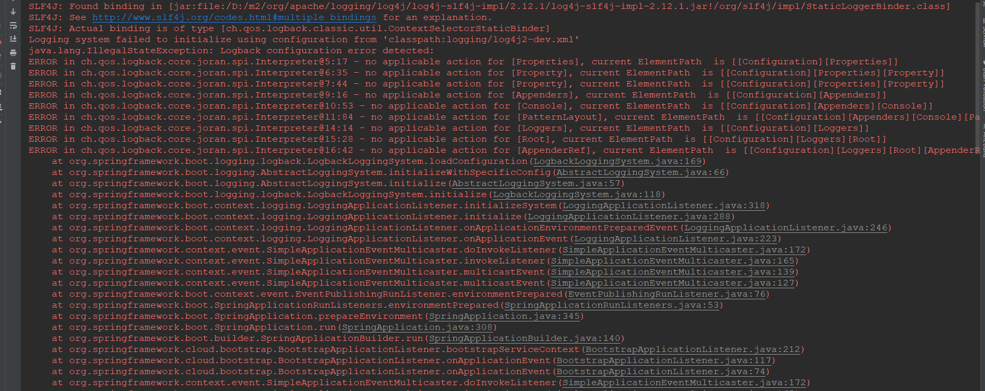
ERROR in ch.qos.logback.core.joran.spi.Interpreter@5:17 - no applicable action for [Properties], current ElementPath is [[Configuration][Properties]]
ERROR in ch.qos.logback.core.joran.spi.Interpreter@6:35 - no applicable action for [Property], current ElementPath is [[Configuration][Properties][Property]]
ERROR in ch.qos.logback.core.joran.spi.Interpreter@7:44 - no applicable action for [Property], current ElementPath is [[Configuration][Properties][Property]]
ERROR in ch.qos.logback.core.joran.spi.Interpreter@9:16 - no applicable action for [Appenders], current ElementPath is [[Configuration][Appenders]]
ERROR in ch.qos.logback.core.joran.spi.Interpreter@10:53 - no applicable action for [Console], current ElementPath is [[Configuration][Appenders][Console]]
ERROR in ch.qos.logback.core.joran.spi.Interpreter@11:84 - no applicable action for [PatternLayout], current ElementPath is [[Configuration][Appenders][Console][PatternLayout]]
ERROR in ch.qos.logback.core.joran.spi.Interpreter@14:14 - no applicable action for [Loggers], current ElementPath is [[Configuration][Loggers]]
ERROR in ch.qos.logback.core.joran.spi.Interpreter@15:28 - no applicable action for [Root], current ElementPath is [[Configuration][Loggers][Root]]
ERROR in ch.qos.logback.core.joran.spi.Interpreter@16:42 - no applicable action for [AppenderRef], current ElementPath is [[Configuration][Loggers][Root][AppenderRef]]
at org.springframework.boot.logging.logback.LogbackLoggingSystem.loadConfiguration(LogbackLoggingSystem.java:169)
at org.springframework.boot.logging.AbstractLoggingSystem.initializeWithSpecificConfig(AbstractLoggingSystem.java:66)
at org.springframework.boot.logging.AbstractLoggingSystem.initialize(AbstractLoggingSystem.java:57)
at org.springframework.boot.logging.logback.LogbackLoggingSystem.initialize(LogbackLoggingSystem.java:118)
at org.springframework.boot.context.logging.LoggingApplicationListener.initializeSystem(LoggingApplicationListener.java:318)
at org.springframework.boot.context.logging.LoggingApplicationListener.initialize(LoggingApplicationListener.java:288)
at org.springframework.boot.context.logging.LoggingApplicationListener.onApplicationEnvironmentPreparedEvent(LoggingApplicationListener.java:246)
at org.springframework.boot.context.logging.LoggingApplicationListener.onApplicationEvent(LoggingApplicationListener.java:223)
at org.springframework.context.event.SimpleApplicationEventMulticaster.doInvokeListener(SimpleApplicationEventMulticaster.java:172)
at org.springframework.context.event.SimpleApplicationEventMulticaster.invokeListener(SimpleApplicationEventMulticaster.java:165)
at org.springframework.context.event.SimpleApplicationEventMulticaster.multicastEvent(SimpleApplicationEventMulticaster.java:139)
at org.springframework.context.event.SimpleApplicationEventMulticaster.multicastEvent(SimpleApplicationEventMulticaster.java:127)
at org.springframework.boot.context.event.EventPublishingRunListener.environmentPrepared(EventPublishingRunListener.java:76)
at org.springframework.boot.SpringApplicationRunListeners.environmentPrepared(SpringApplicationRunListeners.java:53)
at org.springframework.boot.SpringApplication.prepareEnvironment(SpringApplication.java:345)
at org.springframework.boot.SpringApplication.run(SpringApplication.java:308)
at org.springframework.boot.builder.SpringApplicationBuilder.run(SpringApplicationBuilder.java:140)
at org.springframework.cloud.bootstrap.BootstrapApplicationListener.bootstrapServiceContext(BootstrapApplicationListener.java:212)
at org.springframework.cloud.bootstrap.BootstrapApplicationListener.onApplicationEvent(BootstrapApplicationListener.java:117)
at org.springframework.cloud.bootstrap.BootstrapApplicationListener.onApplicationEvent(BootstrapApplicationListener.java:74)
at org.springframework.context.event.SimpleApplicationEventMulticaster.doInvokeListener(SimpleApplicationEventMulticaster.java:172)
at org.springframework.context.event.SimpleApplicationEventMulticaster.invokeListener(SimpleApplicationEventMulticaster.java:165)
at org.springframework.context.event.SimpleApplicationEventMulticaster.multicastEvent(SimpleApplicationEventMulticaster.java:139)
at org.springframework.context.event.SimpleApplicationEventMulticaster.multicastEvent(SimpleApplicationEventMulticaster.java:127)
at org.springframework.boot.context.event.EventPublishingRunListener.environmentPrepared(EventPublishingRunListener.java:76)
at org.springframework.boot.SpringApplicationRunListeners.environmentPrepared(SpringApplicationRunListeners.java:53)
at org.springframework.boot.SpringApplication.prepareEnvironment(SpringApplication.java:345)
at org.springframework.boot.SpringApplication.run(SpringApplication.java:308)
at org.springframework.boot.SpringApplication.run(SpringApplication.java:1226)
at org.springframework.boot.SpringApplication.run(SpringApplication.java:1215)
at com.ubtech.mdm.gateway.GatewayApp.main(GatewayApp.java:12)
Exception in thread "main" java.lang.IllegalStateException: java.lang.IllegalStateException: Logback configuration error detected:
ERROR in ch.qos.logback.core.joran.spi.Interpreter@5:17 - no applicable action for [Properties], current ElementPath is [[Configuration][Properties]]
ERROR in ch.qos.logback.core.joran.spi.Interpreter@6:35 - no applicable action for [Property], current ElementPath is [[Configuration][Properties][Property]]
ERROR in ch.qos.logback.core.joran.spi.Interpreter@7:44 - no applicable action for [Property], current ElementPath is [[Configuration][Properties][Property]]
ERROR in ch.qos.logback.core.joran.spi.Interpreter@9:16 - no applicable action for [Appenders], current ElementPath is [[Configuration][Appenders]]
ERROR in ch.qos.logback.core.joran.spi.Interpreter@10:53 - no applicable action for [Console], current ElementPath is [[Configuration][Appenders][Console]]
ERROR in ch.qos.logback.core.joran.spi.Interpreter@11:84 - no applicable action for [PatternLayout], current ElementPath is [[Configuration][Appenders][Console][PatternLayout]]
ERROR in ch.qos.logback.core.joran.spi.Interpreter@14:14 - no applicable action for [Loggers], current ElementPath is [[Configuration][Loggers]]
ERROR in ch.qos.logback.core.joran.spi.Interpreter@15:28 - no applicable action for [Root], current ElementPath is [[Configuration][Loggers][Root]]
ERROR in ch.qos.logback.core.joran.spi.Interpreter@16:42 - no applicable action for [AppenderRef], current ElementPath is [[Configuration][Loggers][Root][AppenderRef]]
at org.springframework.boot.context.logging.LoggingApplicationListener.initializeSystem(LoggingApplicationListener.java:324)
at org.springframework.boot.context.logging.LoggingApplicationListener.initialize(LoggingApplicationListener.java:288)
at org.springframework.boot.context.logging.LoggingApplicationListener.onApplicationEnvironmentPreparedEvent(LoggingApplicationListener.java:246)
at org.springframework.boot.context.logging.LoggingApplicationListener.onApplicationEvent(LoggingApplicationListener.java:223)
at org.springframework.context.event.SimpleApplicationEventMulticaster.doInvokeListener(SimpleApplicationEventMulticaster.java:172)
at org.springframework.context.event.SimpleApplicationEventMulticaster.invokeListener(SimpleApplicationEventMulticaster.java:165)
at org.springframework.context.event.SimpleApplicationEventMulticaster.multicastEvent(SimpleApplicationEventMulticaster.java:139)
at org.springframework.context.event.SimpleApplicationEventMulticaster.multicastEvent(SimpleApplicationEventMulticaster.java:127)
at org.springframework.boot.context.event.EventPublishingRunListener.environmentPrepared(EventPublishingRunListener.java:76)
at org.springframework.boot.SpringApplicationRunListeners.environmentPrepared(SpringApplicationRunListeners.java:53)
at org.springframework.boot.SpringApplication.prepareEnvironment(SpringApplication.java:345)
at org.springframework.boot.SpringApplication.run(SpringApplication.java:308)
at org.springframework.boot.builder.SpringApplicationBuilder.run(SpringApplicationBuilder.java:140)
at org.springframework.cloud.bootstrap.BootstrapApplicationListener.bootstrapServiceContext(BootstrapApplicationListener.java:212)
at org.springframework.cloud.bootstrap.BootstrapApplicationListener.onApplicationEvent(BootstrapApplicationListener.java:117)
at org.springframework.cloud.bootstrap.BootstrapApplicationListener.onApplicationEvent(BootstrapApplicationListener.java:74)
at org.springframework.context.event.SimpleApplicationEventMulticaster.doInvokeListener(SimpleApplicationEventMulticaster.java:172)
at org.springframework.context.event.SimpleApplicationEventMulticaster.invokeListener(SimpleApplicationEventMulticaster.java:165)
at org.springframework.context.event.SimpleApplicationEventMulticaster.multicastEvent(SimpleApplicationEventMulticaster.java:139)
at org.springframework.context.event.SimpleApplicationEventMulticaster.multicastEvent(SimpleApplicationEventMulticaster.java:127)
at org.springframework.boot.context.event.EventPublishingRunListener.environmentPrepared(EventPublishingRunListener.java:76)
at org.springframework.boot.SpringApplicationRunListeners.environmentPrepared(SpringApplicationRunListeners.java:53)
at org.springframework.boot.SpringApplication.prepareEnvironment(SpringApplication.java:345)
at org.springframework.boot.SpringApplication.run(SpringApplication.java:308)
at org.springframework.boot.SpringApplication.run(SpringApplication.java:1226)
at org.springframework.boot.SpringApplication.run(SpringApplication.java:1215)
at com.ubtech.mdm.gateway.GatewayApp.main(GatewayApp.java:12)
Caused by: java.lang.IllegalStateException: Logback configuration error detected:
ERROR in ch.qos.logback.core.joran.spi.Interpreter@5:17 - no applicable action for [Properties], current ElementPath is [[Configuration][Properties]]
ERROR in ch.qos.logback.core.joran.spi.Interpreter@6:35 - no applicable action for [Property], current ElementPath is [[Configuration][Properties][Property]]
ERROR in ch.qos.logback.core.joran.spi.Interpreter@7:44 - no applicable action for [Property], current ElementPath is [[Configuration][Properties][Property]]
ERROR in ch.qos.logback.core.joran.spi.Interpreter@9:16 - no applicable action for [Appenders], current ElementPath is [[Configuration][Appenders]]
ERROR in ch.qos.logback.core.joran.spi.Interpreter@10:53 - no applicable action for [Console], current ElementPath is [[Configuration][Appenders][Console]]
ERROR in ch.qos.logback.core.joran.spi.Interpreter@11:84 - no applicable action for [PatternLayout], current ElementPath is [[Configuration][Appenders][Console][PatternLayout]]
ERROR in ch.qos.logback.core.joran.spi.Interpreter@14:14 - no applicable action for [Loggers], current ElementPath is [[Configuration][Loggers]]
ERROR in ch.qos.logback.core.joran.spi.Interpreter@15:28 - no applicable action for [Root], current ElementPath is [[Configuration][Loggers][Root]]
ERROR in ch.qos.logback.core.joran.spi.Interpreter@16:42 - no applicable action for [AppenderRef], current ElementPath is [[Configuration][Loggers][Root][AppenderRef]]
at org.springframework.boot.logging.logback.LogbackLoggingSystem.loadConfiguration(LogbackLoggingSystem.java:169)
at org.springframework.boot.logging.AbstractLoggingSystem.initializeWithSpecificConfig(AbstractLoggingSystem.java:66)
at org.springframework.boot.logging.AbstractLoggingSystem.initialize(AbstractLoggingSystem.java:57)
at org.springframework.boot.logging.logback.LogbackLoggingSystem.initialize(LogbackLoggingSystem.java:118)
at org.springframework.boot.context.logging.LoggingApplicationListener.initializeSystem(LoggingApplicationListener.java:318)

报错原因：
在项目中引入了spring-boot-starter-log4j2.jar，其他jar中也包含了logg的jar，导致jar包冲突。pom.xml如下：
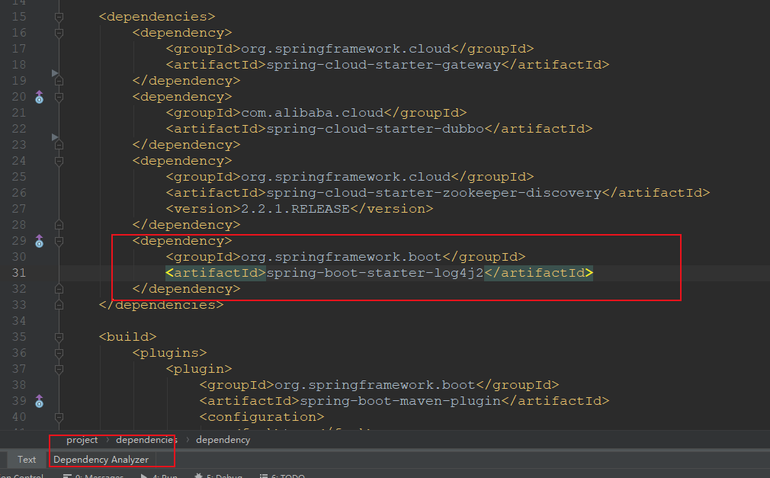
如何解决问题：
在pom.xml点击Dependency Analyzer，然后搜索log,查看每个搜索出来的结果，如下图：
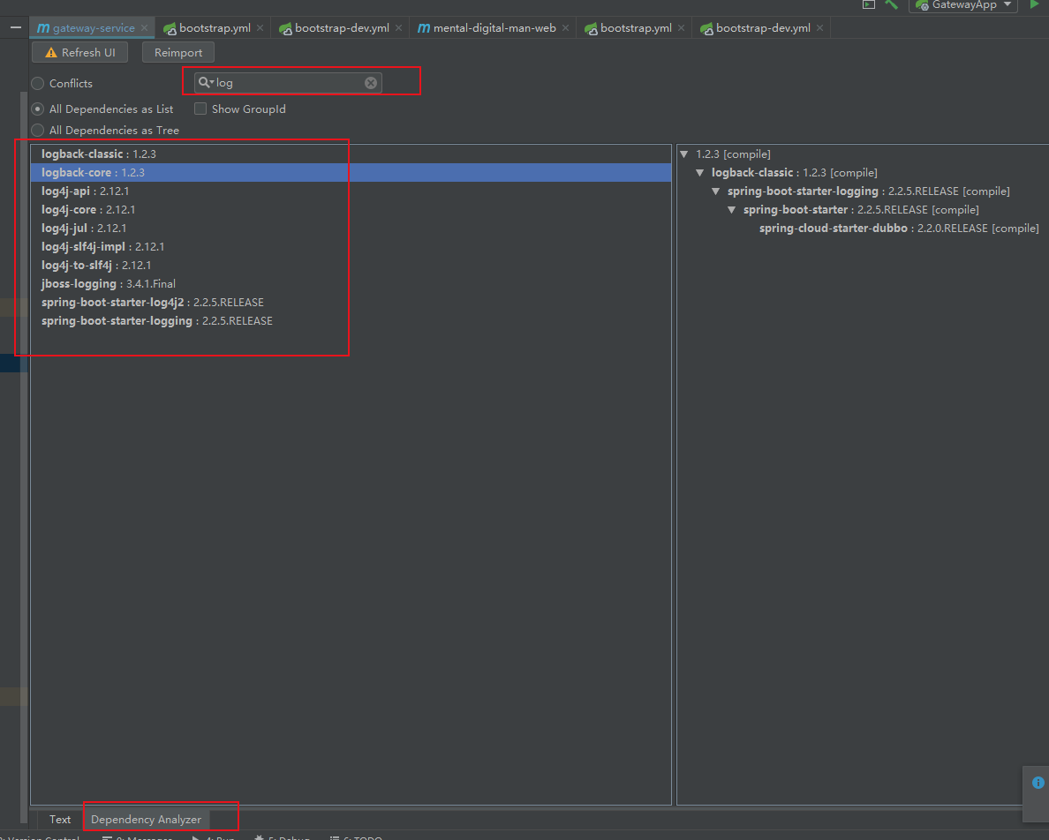
然后在pom.xml使用<exclusions>过滤掉对应jar包含的log.jar，如下图：
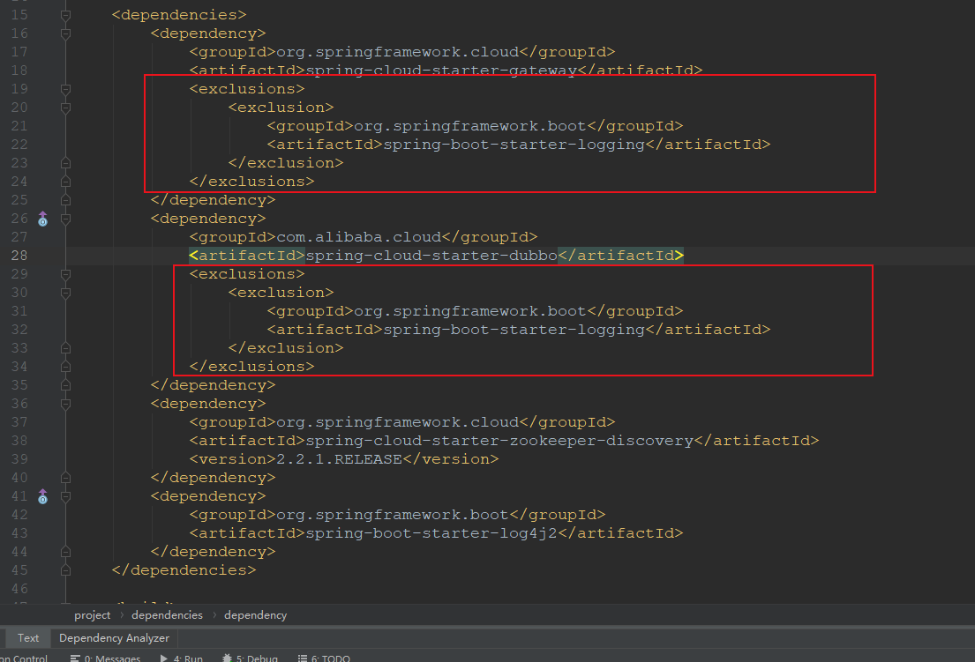
重新启动项目就ok了。
- 在linux服务器中启动jar提示：运行jar包报 “XXX中没有主清单属性”
报错原因：
打包后的jar文件中的MANIFEST.MF缺少项目启动项，即没有Main-Class

如何解决问题：
在pom.xml文件中加入以下代码：
<plugin>
<groupId>org.springframework.boot</groupId>
<artifactId>spring-boot-maven-plugin</artifactId>
</plugin>
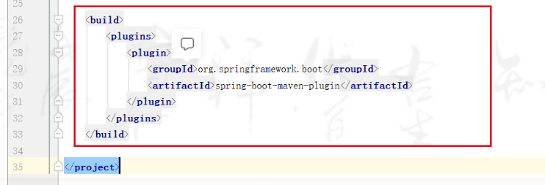

3、在linux服务器中启动jar提示：
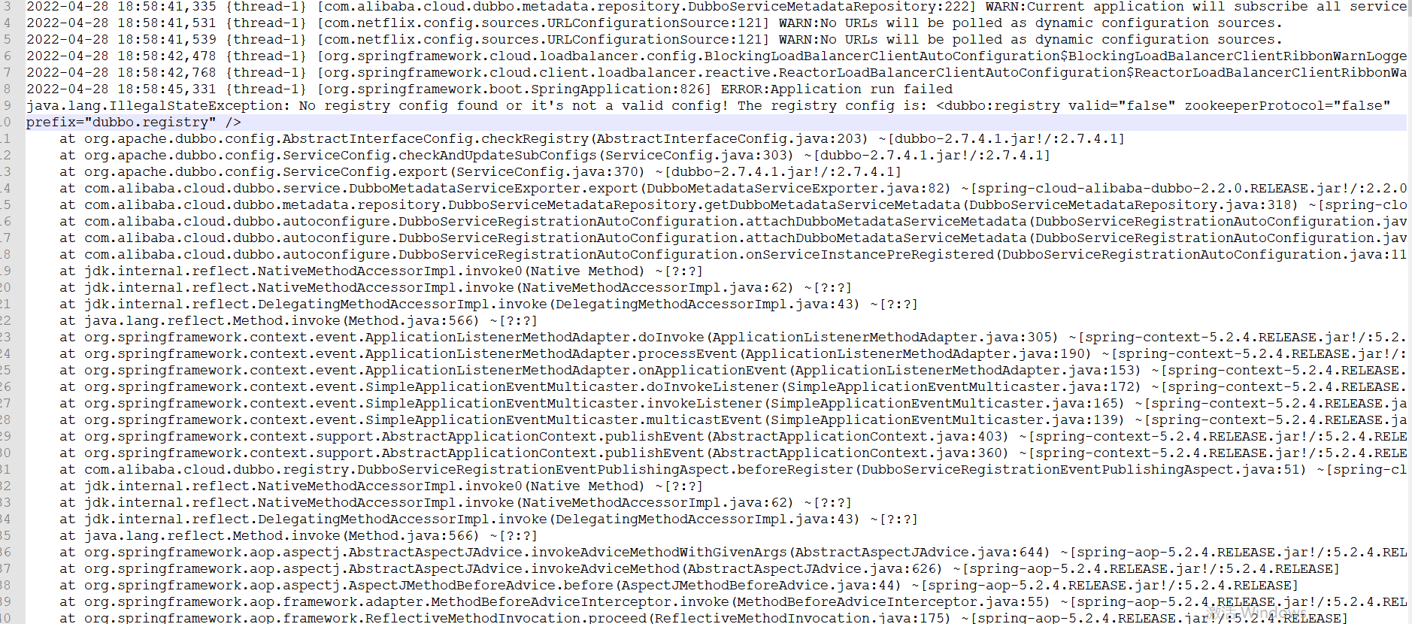

报错原因：
缺少dubbo服务注册的配置

如何解决问题：
找到dubbo配置，然后加入
dubbo:
registry:
address: zookeeper://127.0.0.1:2181
metadata-report:
address: zookeeper://127.0.0.1:2181

