一、下载破解补丁：
安装完idea2018.3.1之后，下载破解补丁：JetbrainsIdesCrack-3.4-release-enc.jar
在百度网盘中下载

将下载后的jar包放到安装IntelliJ IDEA路径的bin目录下
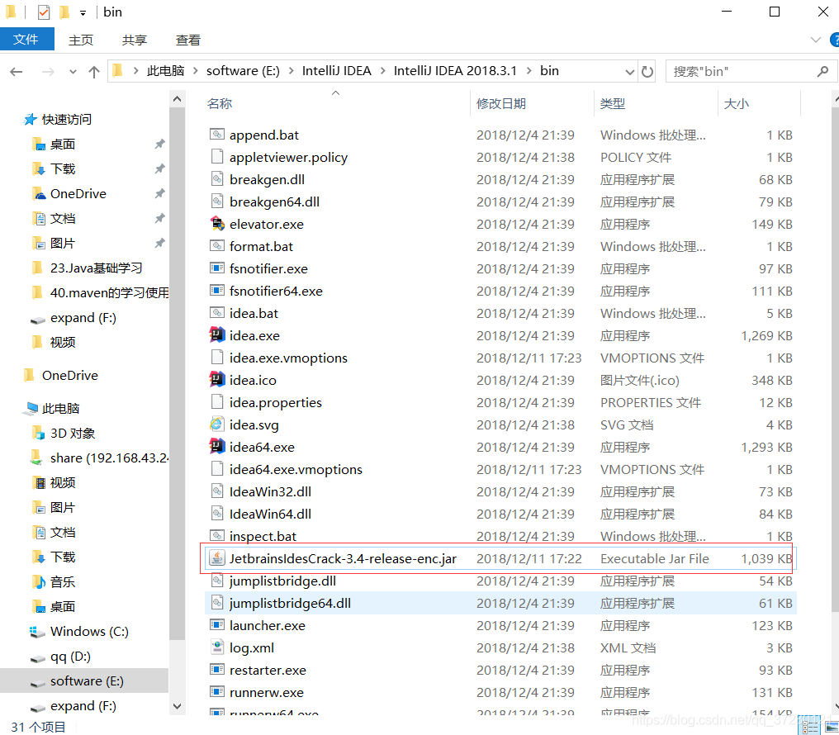

三、 在安装IntelliJ IDEA路径的bin目录下找到idea.exe.vmoptions和idea64.exe.vmoptions文件
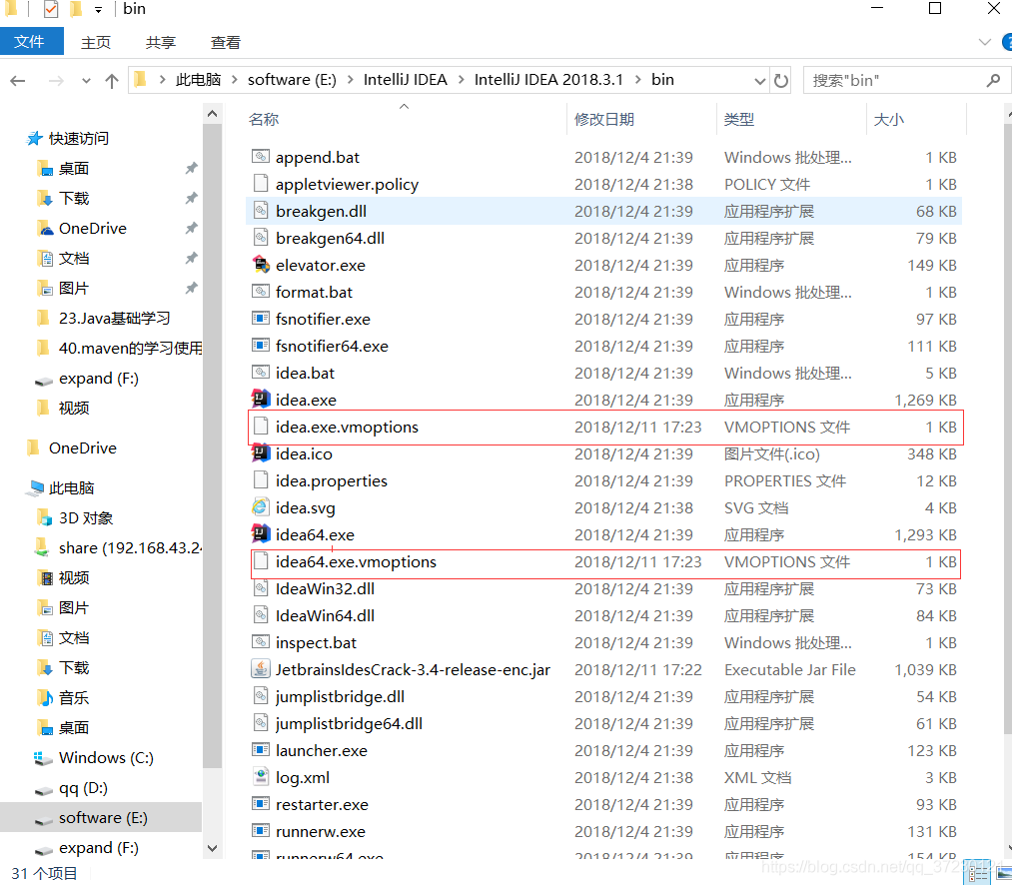

四、使用notepad++或者记事本打开idea.exe.vmoptions和idea64.exe.vmoptions文件进行编辑，在每个文件的最后一行添加如下内容：
-javaagent:E:\IntelliJ IDEA\IntelliJ IDEA 2018.3.1\bin\JetbrainsIdesCrack-3.4-release-enc.jar
注意：需要根据自己路径进行配置，千万别直接复制粘贴！
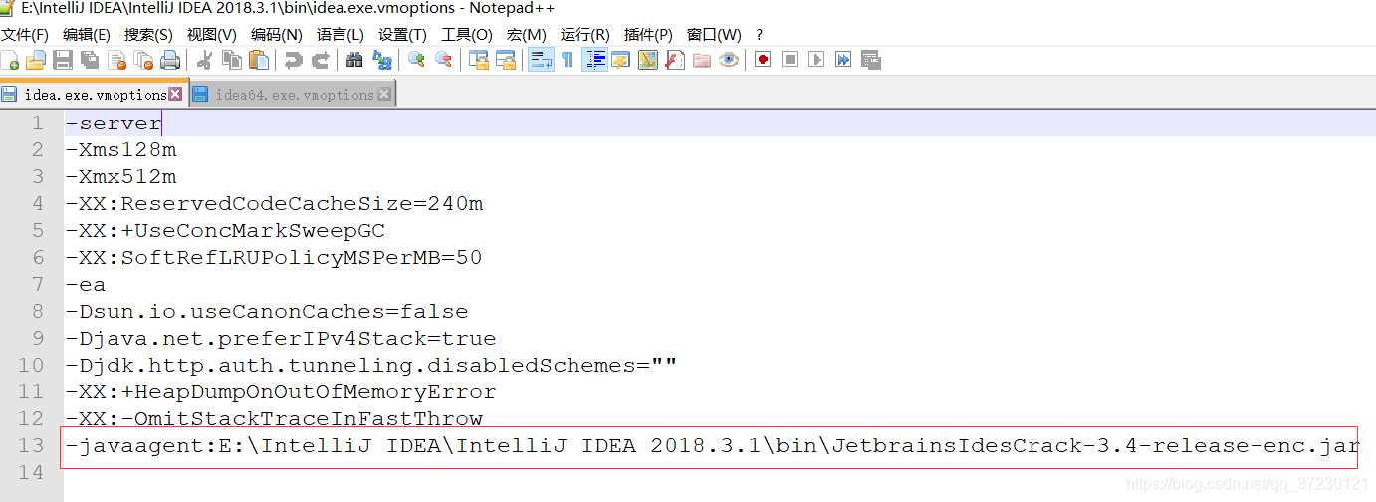

五、重新启动IntelliJ IDEA，或者启动后点击help->Register，然后进入激活界面：
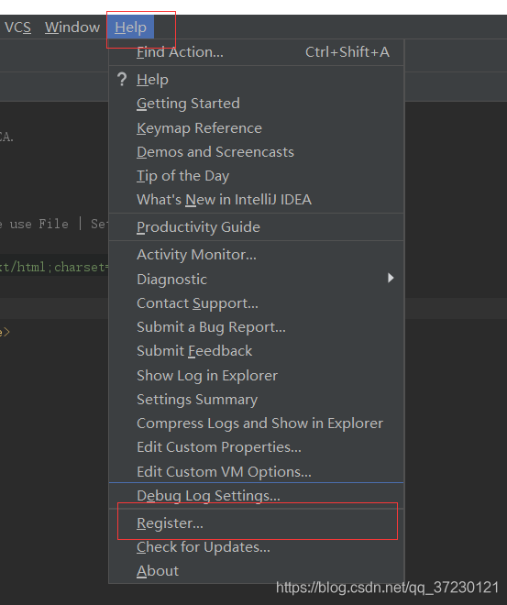
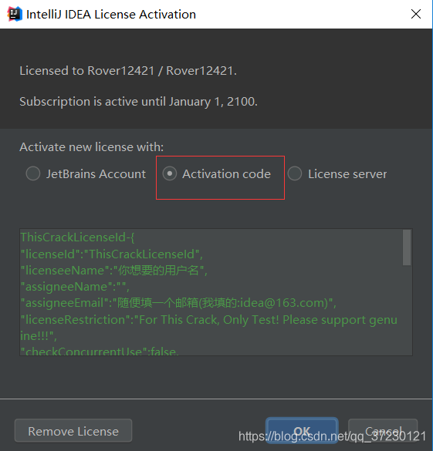

六、在Activation Code中输入：
ThisCrackLicenseId-{
"licenseId":"ThisCrackLicenseId",
"licenseeName":"你想要的用户名",
"assigneeName":"",
"assigneeEmail":"随便填一个邮箱(我填的:idea@163.com)",
"licenseRestriction":"For This Crack, Only Test! Please support genuine!!!",
"checkConcurrentUse":false,
"products":[
{"code":"II","paidUpTo":"2099-12-31"},
{"code":"DM","paidUpTo":"2099-12-31"},
{"code":"AC","paidUpTo":"2099-12-31"},
{"code":"RS0","paidUpTo":"2099-12-31"},
{"code":"WS","paidUpTo":"2099-12-31"},
{"code":"DPN","paidUpTo":"2099-12-31"},
{"code":"RC","paidUpTo":"2099-12-31"},
{"code":"PS","paidUpTo":"2099-12-31"},
{"code":"DC","paidUpTo":"2099-12-31"},
{"code":"RM","paidUpTo":"2099-12-31"},
{"code":"CL","paidUpTo":"2099-12-31"},
{"code":"PC","paidUpTo":"2099-12-31"}
],
"hash":"2911276/0",
"gracePeriodDays":7,
"autoProlongated":false}
七、输入完之后点击ok即可。

