现有一个需求：从数据库中查询某个表的记录，需要分页，按时间倒序排序，并且在页面展示需要展示序号，第一页从1开始，如果每页展示10条，第二页序号需要从11开始。如下图：

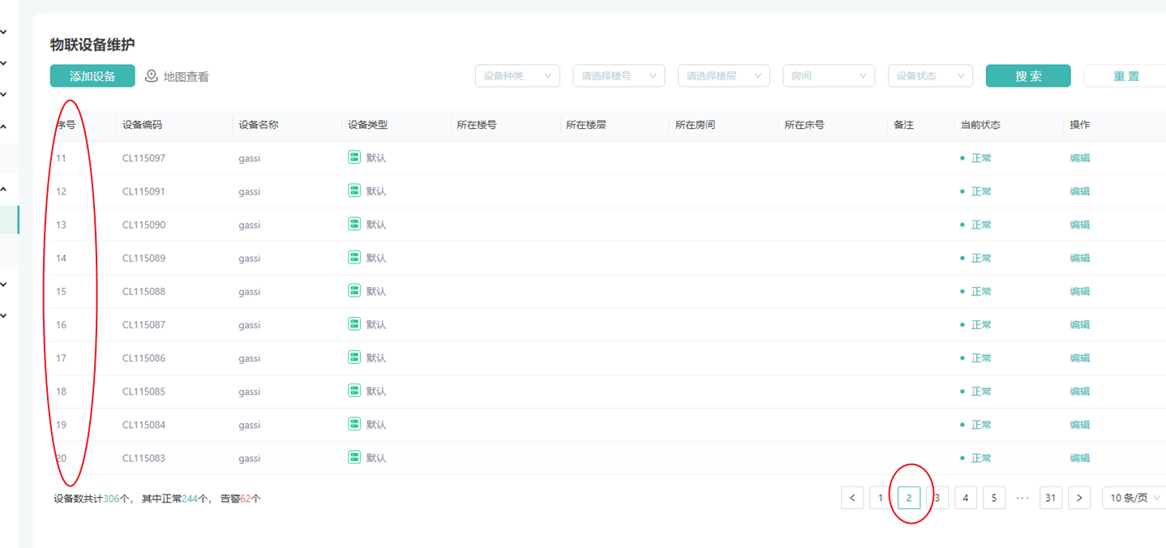

Sql如下：

select  
 @rownum := @rownum + 1 AS num,  
 case deal_type when 'DEAL' then '处理类' when 'NOTIFY' then '提醒类' else '其他' end as dealTypeName,  
 case when alarm_status=2 then '处理类' else case when deal_type = 'DEAL' then '未响应' else '已提醒' end end as alarmStatusStr,  
 case when deal_time is null then '-' else TIMESTAMPDIFF(MINUTE, create_time, deal_time) end AS dealGap,

iam.*  
 from iot_alarm_message iam, (SELECT @rownum := #{start}) AS rownum

ORDER BY iam.`create_time` DESC  
 limit #{start}, #{limit}

上面的sql中num就是需要的序号。