产品手册自动化生成前端填充内容

1 产品规格页

界面内容
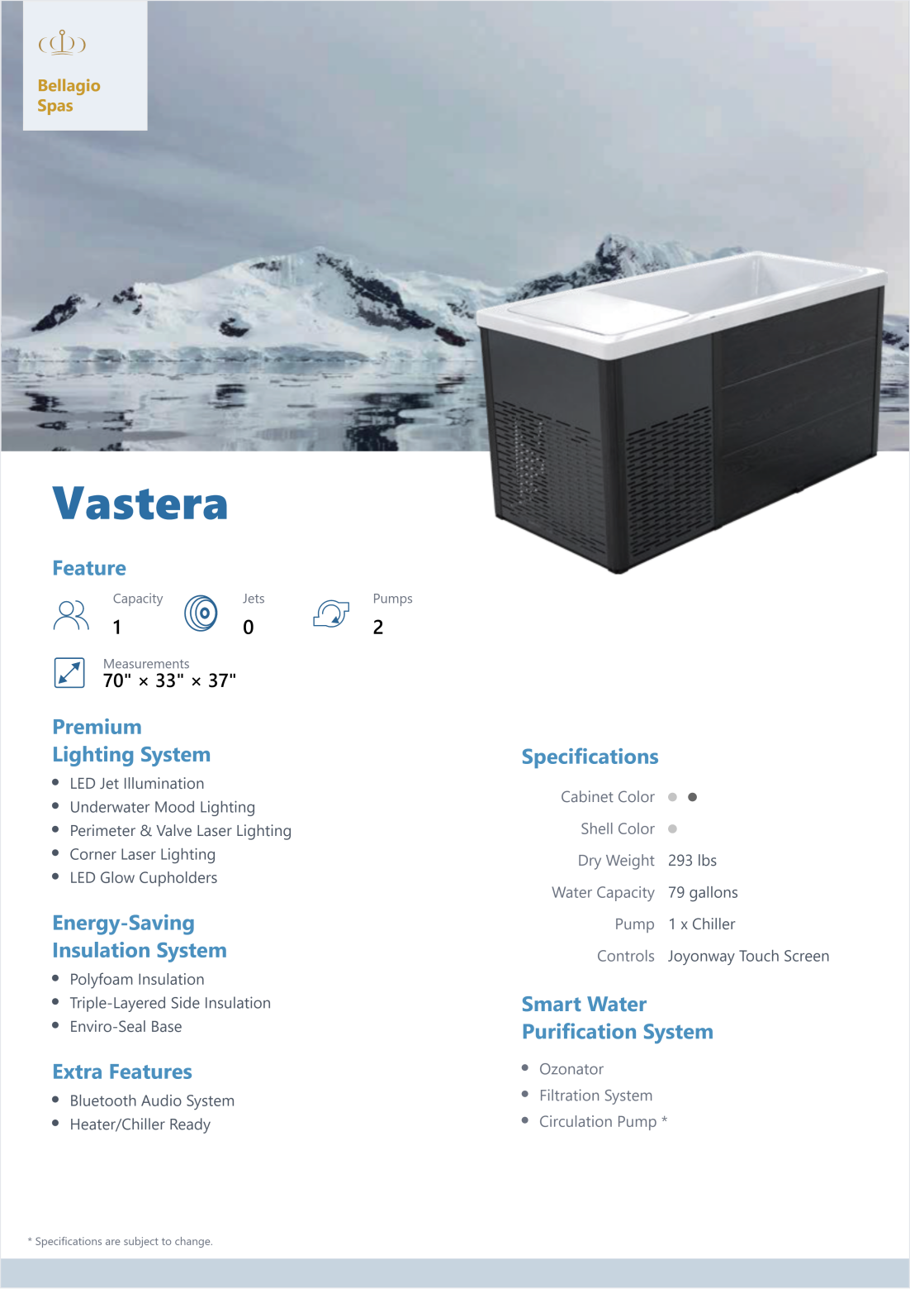

对应json格式数据
JSON
{
productTitle: 'Vastera',
features: { capacity: '1', jets: '0', pumps: '2' },
measurements: '70" × 33" × 37"',
premiumFeatures: ['LED Jet Illumination', 'Underwater Mood Lighting', 'Perimeter & Valve Laser Lighting', 'Corner Laser Lighting', 'LED Glow Cupholders'],
insulationFeatures: ['Polyfoam Insulation', 'Triple-Layered Side Insulation', 'Enviro-Seal Base'],
extraFeatures: ['Bluetooth Audio System', 'Heater/Chiller Ready'],
specs: [
['#c4c4c4', '#666666'],
'#c4c4c4',
'293 lbs',
'79 gallons',
'1 x Chiller',
'Joyonway Touch Screen',
],
smartWater: ['Ozonator', 'Filtration System', 'Circulation Pump *'],
images: { product: '/back/product.png', background: '/back/back.png' },
}

json格式数据说明
// - productTitle: string
// - features: { capacity: string, jets: string, pumps: string }
// - measurements: string
// - premiumFeatures: string[] // Premium Lighting System 列表
// - insulationFeatures: string[] // Energy-Saving Insulation System 列表
// - extraFeatures: string[] // Extra Features 列表
// - specs: [CabinetColor, ShellColor, DryWeight, WaterCapacity, Pump, Controls]
// · CabinetColor: 颜色值，支持 string 或 string[]；
// 支持分隔符：空格 / 逗号 / 分号，例如 "#c4c4c4 #666666" 或 ["#c4c4c4", "#666666"]
// · ShellColor: 同上，颜色值 string 或 string[]
// · 其余（DryWeight/WaterCapacity/Pump/Controls）为普通字符串
// - smartWater: string[]
// - images: { product: string, background: string }

2 产品海报页

界面内容
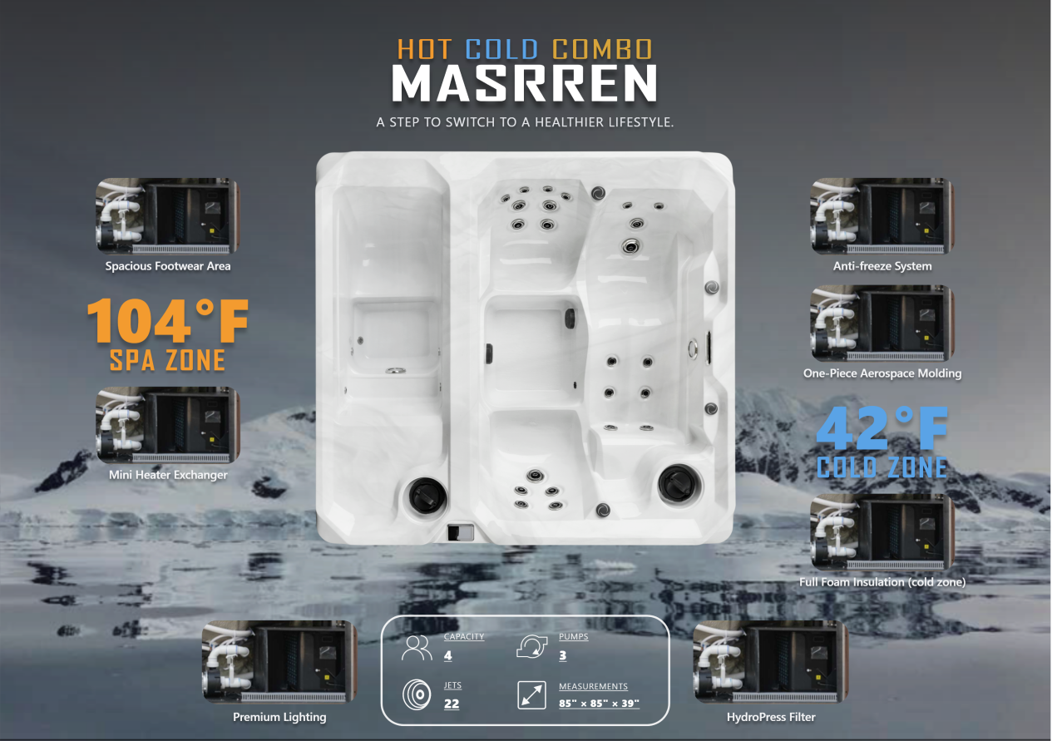

对应json格式数据
JSON
{
"background": "/poster/back.png",
"product": "/poster/product.png",
"leftTop": { "img": "/poster/image.png", "cap": "Spacious Footwear Area" },
"leftBottom": { "img": "/poster/image.png", "cap": "Mini Heater Exchanger" },
"rightTop": { "img": "/poster/image.png", "cap": "Anti-freeze System" },
"rightMid": { "img": "/poster/image.png", "cap": "One-Piece Aerospace Molding" },
"rightBottom": { "img": "/poster/image.png", "cap": "Full Foam Insulation (cold zone)" },
"bottomLeft": { "img": "/poster/image.png", "cap": "Premium Lighting" },
"bottomRight": { "img": "/poster/image.png", "cap": "HydroPress Filter" },
"hotNum": { "value": "104°F", "zone": "SPA ZONE" },
"coldNum": { "value": "42°F", "zone": "COLD ZONE" },
"specs": { "capacity": "4", "pumps": "3", "jets": "22", "measurements": '85" × 85" × 39"' }
}

json格式数据说明
// - background: string 海报背景图 URL
// - product: string 海报产品主图 URL
// - leftTop / leftBottom / rightTop / rightMid / rightBottom / bottomLeft / bottomRight: { img: string, cap: string }
// · img: 该卡片的图片 URL（留空则不显示）
// · cap: 该卡片的文字说明
// - hotNum: { value: string, zone: string } 热区大数字与分区文案
// - coldNum: { value: string, zone: string } 冷区大数字与分区文案
// - specs: { capacity: string, pumps: string, jets: string, measurements: string }

3 产品说明书

3.1 界面内容（Cover）
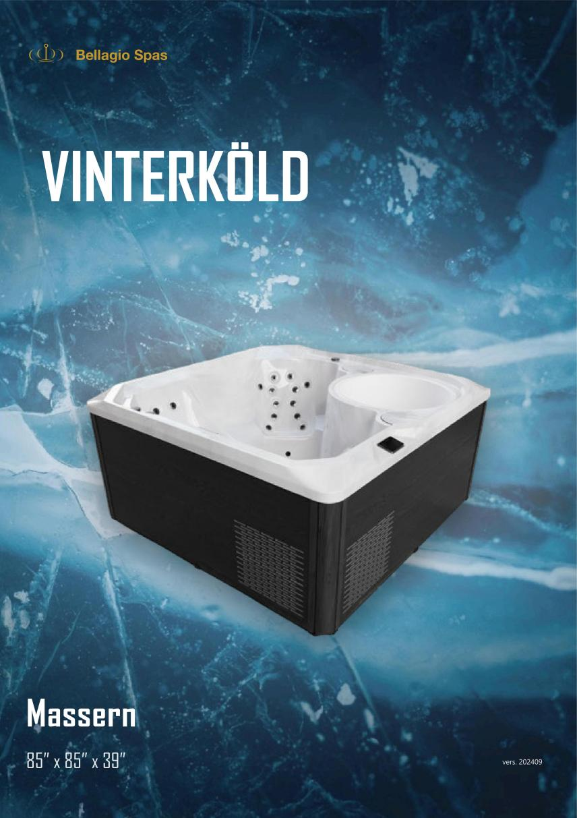

对应json格式数据
JSON
{
header: 'Cover',
blocks: [
{ type: 'cover', title: 'VINTERKÖLD', sizeText: '85” x 85” x 39”', backSrc: '/instruction_book/back.jpg', productSrc: '/instruction_book/product.png' }
]
},

json格式数据说明
// - header: 页面标题
// - blocks: 页面内容块数组
// · type: 内容块类型
// - cover: 封面块
// · title: 主标题/机型名
// · sizeText: 尺寸说明
// · backSrc: 背景图 URL（整页背景）
// · productSrc: 产品主图 URL

3.2 界面内容（Embrace the Revitalizing Chill）
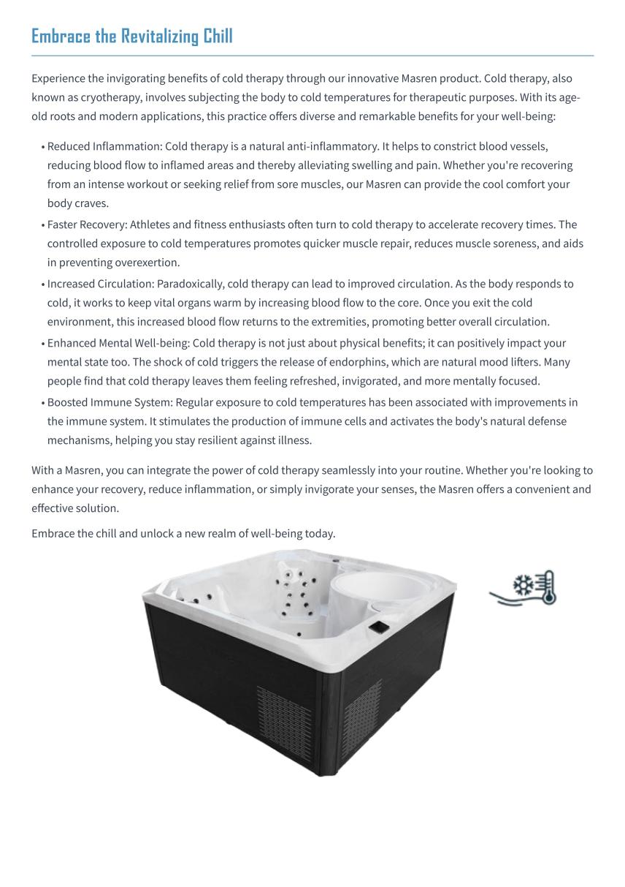

对应json格式数据
JSON
{
header: 'Embrace the Revitalizing Chill',
blocks: [
{ type: 'heading', text: 'Embrace the Revitalizing Chill' },
{ type: 'paragraph', text: 'Experience the invigorating benefits of cold therapy through our innovative Masren product. Cold therapy, also known as cryotherapy, involves subjecting the body to cold temperatures for therapeutic purposes. With its age-old roots and modern applications, this practice offers diverse and remarkable benefits for your well-being:' },
{ type: 'list', items: [
'Reduced Inflammation:Cold therapy is a natural anti-inflammatory. It helps to constrict blood vessels, reducing blood flow to inflamed areas and thereby alleviating swelling and pain. Whether you\'re recovering from an intense workout or seeking relief from sore muscles, our Masren can provide the cool comfort your body craves.',
'Faster Recovery: Athletes and fitness enthusiasts often turn to cold therapy to accelerate recovery times. The controlled exposure to cold temperatures promotes quicker muscle repair, reduces muscle soreness, and aids in preventing overexertion.',
'Increased Circulation: Paradoxically, cold therapy can lead to improved circulation. As the body responds to cold, it works to keep vital organs warm by increasing blood flow to the core. Once you exit the cold environment, this increased blood flow returns to the extremities, promoting better overall circulation.',
'Enhanced Mental Well-being: Cold therapy is not just about physical benefits; it can positively impact your mental state too. The shock of cold triggers the release of endorphins, which are natural mood lifters. Many people find that cold therapy leaves them feeling refreshed, invigorated, and more mentally focused.',
'Boosted Immune System: Regular exposure to cold temperatures has been associated with improvements in the immune system. It stimulates the production of immune cells and activates the body\'s natural defense mechanisms, helping you stay resilient against illness.'
] },
{ type: 'paragraph', text: 'With a Masren, you can integrate the power of cold therapy seamlessly into your routine. Whether you\'re looking to enhance your recovery, reduce inflammation, or simply invigorate your senses, the Masren offers a convenient and effective solution.' },
{ type: 'paragraph', text: 'Embrace the chill and unlock a new realm of well-being today.' },
{ type: 'imageFloat-bottom-left', src: '/instruction_book/product.png' },
{ type: 'imageFloat-bottom-right', src: '/instruction_book/cold.png' }
]
},

json格式数据说明
// - header: 页面标题
// - blocks: 页面内容块数组
// · type: 内容块类型
// - heading: 一级标题
// · text: 标题文本
// - paragraph: 段落
// · text: 段落文本
// - list: 列表
// · items: 列表项数组（可含基础 HTML）
// - imageFloat-<pos>: 浮动图
// · src: 图片 URL
// · pos: 位置（bottom-left|bottom-right|top-left|top-right）

3.3 界面内容（Premium Materials）
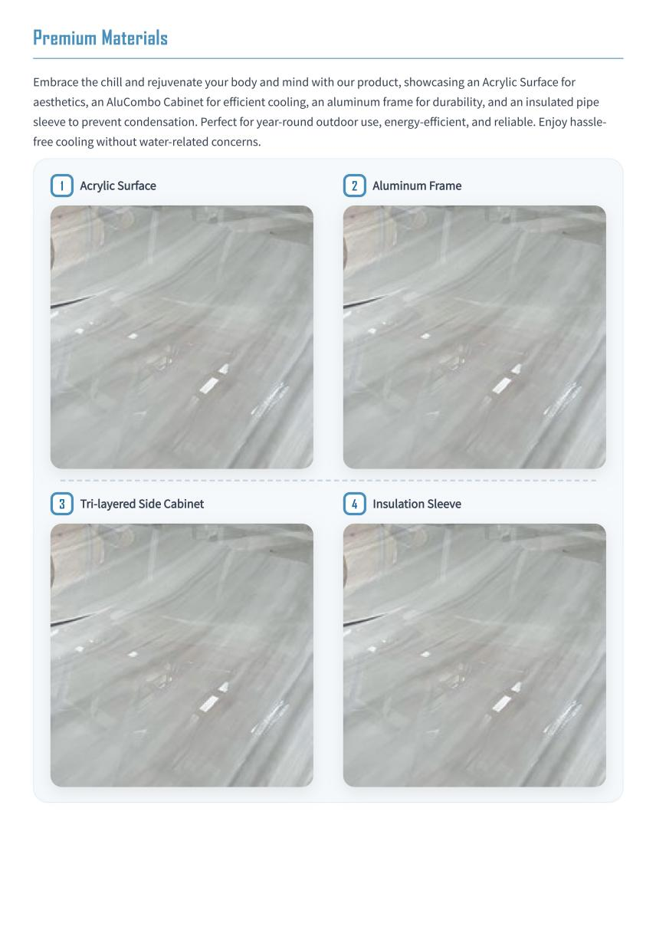

对应json格式数据
SQL
{
header: 'Premium Materials',
blocks: [
{ type: 'heading', text: 'Premium Materials' },
{ type: 'paragraph', text: 'Embrace the chill and rejuvenate your body and mind with our product, showcasing an Acrylic Surface for aesthetics, an AluCombo Cabinet for efficient cooling, an aluminum frame for durability, and an insulated pipe sleeve to prevent condensation. Perfect for year-round outdoor use, energy-efficient, and reliable. Enjoy hassle-free cooling without water-related concerns.' },
{ type: 'grid4', items: [
{ index: 1, title: 'Acrylic Surface', imgSrc: '/instruction_book/Acrylic_Surface.png' },
{ index: 2, title: 'Aluminum Frame', imgSrc: '/instruction_book/Acrylic_Surface.png' },
{ index: 3, title: 'Tri-layered Side Cabinet', imgSrc: '/instruction_book/Acrylic_Surface.png' },
{ index: 4, title: 'Insulation Sleeve', imgSrc: '/instruction_book/Acrylic_Surface.png' }
] }
]
},

json格式数据说明
// - header: string 页面标题
// - blocks:
// · { type: 'heading', text } 标题
// · { type: 'paragraph', text } 简述
// · { type: 'grid4', items } 四宫格
// items: [{ index: number 序号, title: string 标题, imgSrc: string 图片 }]

3.4 界面内容（Installation & User Manual）
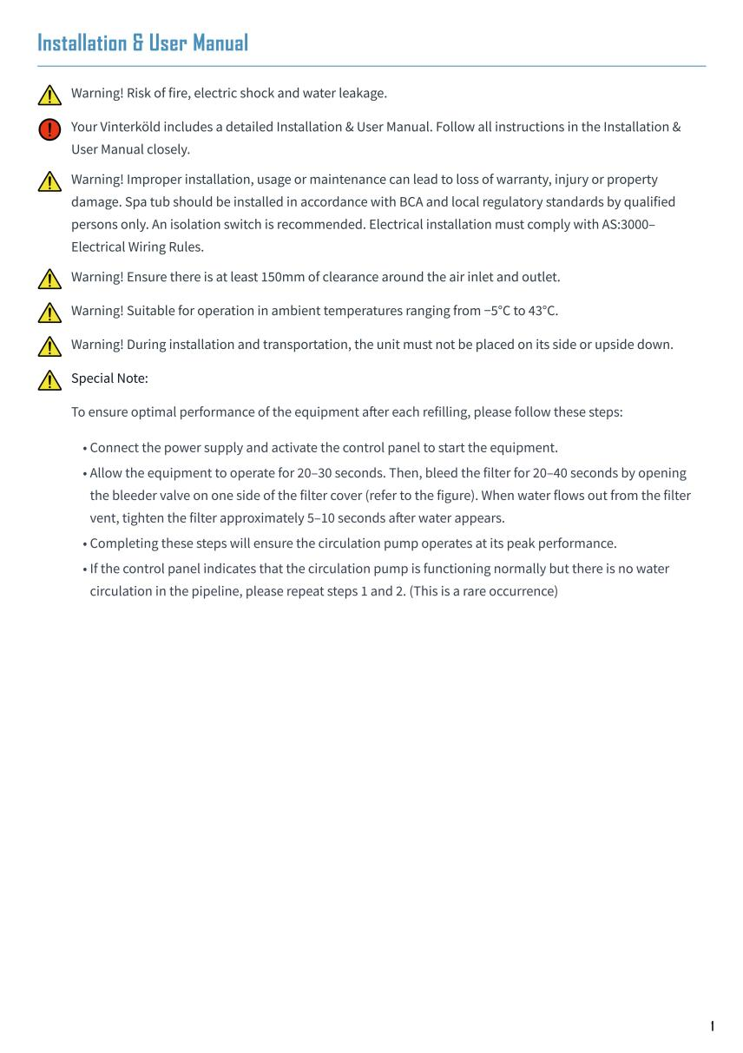

对应json格式数据
JSON
{
header: 'Installation & User Manual',
blocks: [
{ type: 'heading', text: 'Installation & User Manual' },
{ type: 'callout-warning', text: 'Warning! Risk of fire, electric shock and water leakage.' },
{ type: 'callout-error', text: 'Your Vinterköld includes a detailed Installation & User Manual. Follow all instructions in the Installation & User Manual closely.' },
{ type: 'callout-warning', text: 'Warning! Improper installation, usage or maintenance can lead to loss of warranty, injury or property damage. Spa tub should be installed in accordance with BCA and local regulatory standards by qualified persons only. An isolation switch is recommended. Electrical installation must comply with AS:3000–Electrical Wiring Rules.' },
{ type: 'callout-warning', text: 'Warning! Ensure there is at least 150mm of clearance around the air inlet and outlet.' },
{ type: 'callout-warning', text: 'Warning! Suitable for operation in ambient temperatures ranging from −5°C to 43°C.' },
{ type: 'callout-warning', text: 'Warning! During installation and transportation, the unit must not be placed on its side or upside down.' },
{ type: 'callout-warning', className: 'special-note', text: 'Special Note:' },
{ type: 'paragraph', className: 'callout-align', text: 'To ensure optimal performance of the equipment after each refilling, please follow these steps:' },
{ type: 'list', className: 'callout-align', items: [
'Connect the power supply and activate the control panel to start the equipment.',
'Allow the equipment to operate for 20–30 seconds. Then, bleed the filter for 20–40 seconds by opening the bleeder valve on one side of the filter cover (refer to the figure). When water flows out from the filter vent, tighten the filter approximately 5–10 seconds after water appears.',
'Completing these steps will ensure the circulation pump operates at its peak performance.',
'If the control panel indicates that the circulation pump is functioning normally but there is no water circulation in the pipeline, please repeat steps 1 and 2. (This is a rare occurrence)'
] }
]
},

json格式数据说明
// - header: string 页面标题
// - blocks:
// · { type: 'heading', text } 标题
// · { type: 'callout-warning' | 'callout-error', text, className? } 警示（text 支持 HTML）
// · { type: 'paragraph', text, className? } 说明
// · { type: 'list', items: string[], className? } 步骤/要点

3.5 界面内容（How To Set Up）
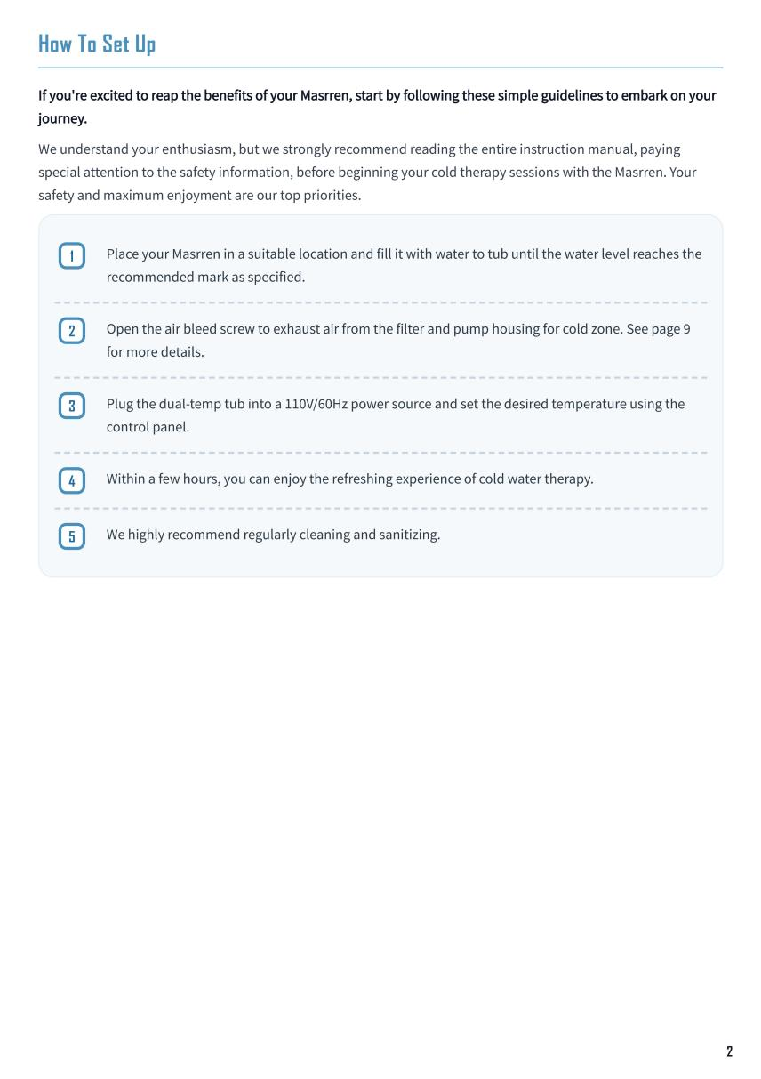

对应json格式数据
JSON
{
header: 'How To Set Up',
blocks: [
{ type: 'heading', text: 'How To Set Up' },
{ type: 'paragraph', className: 'lead', text: "If you're excited to reap the benefits of your Masrren, start by following these simple guidelines to embark on your journey." },
{ type: 'paragraph', text: 'We understand your enthusiasm, but we strongly recommend reading the entire instruction manual, paying special attention to the safety information, before beginning your cold therapy sessions with the Masrren. Your safety and maximum enjoyment are our top priorities.' },
{ type: 'steps', items: [
'Place your Masrren in a suitable location and fill it with water to tub until the water level reaches the recommended mark as specified.',
'Open the air bleed screw to exhaust air from the filter and pump housing for cold zone. See page 9 for more details.',
'Plug the dual-temp tub into a 110V/60Hz power source and set the desired temperature using the control panel.',
'Within a few hours, you can enjoy the refreshing experience of cold water therapy.',
'We highly recommend regularly cleaning and sanitizing.'
] }
]
},

json格式数据说明
// - header: string 页面标题
// - blocks:
// · { type: 'heading', text } 标题
// · { type: 'paragraph', text, className? } 引导说明
// · { type: 'steps', items: string[] } 步骤（自动编号）

3.6 界面内容（Important Safety Instructions）

界面1
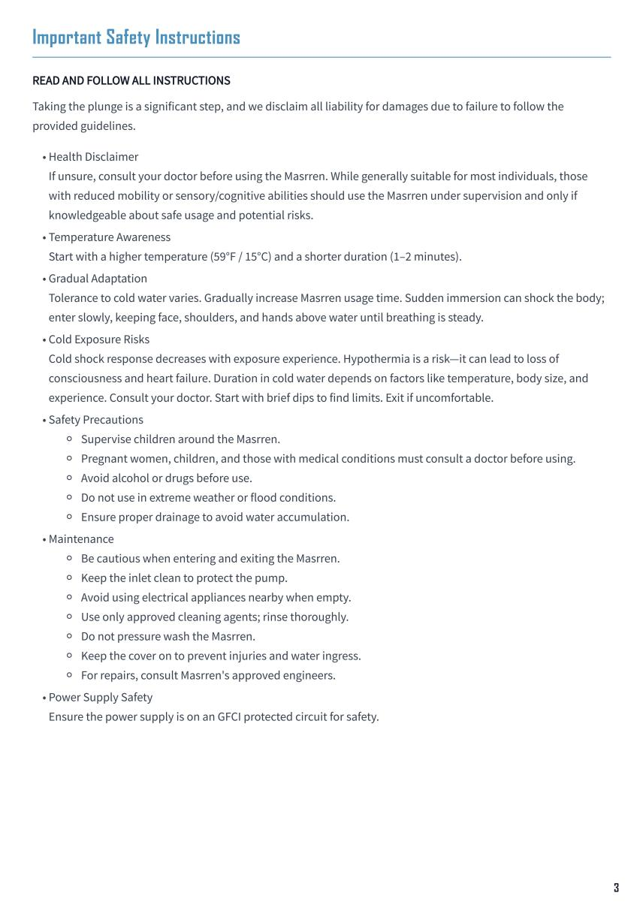

对应json格式数据（界面1）
XML
{
header: 'Important Safety Instructions',
blocks: [
{ type: 'heading', text: 'Important Safety Instructions' },
{ type: 'paragraph', className: 'lead', text: 'READ AND FOLLOW ALL INSTRUCTIONS' },
{ type: 'paragraph', text: 'Taking the plunge is a significant step, and we disclaim all liability for damages due to failure to follow the provided guidelines.' },
{ type: 'list', items: [
'Health Disclaimer<br/>If unsure, consult your doctor before using the Masrren. While generally suitable for most individuals, those with reduced mobility or sensory/cognitive abilities should use the Masrren under supervision and only if knowledgeable about safe usage and potential risks.',
'Temperature Awareness<br/>Start with a higher temperature (59°F / 15°C) and a shorter duration (1–2 minutes).',
'Gradual Adaptation<br/>Tolerance to cold water varies. Gradually increase Masrren usage time. Sudden immersion can shock the body; enter slowly, keeping face, shoulders, and hands above water until breathing is steady.',
'Cold Exposure Risks<br/>Cold shock response decreases with exposure experience. Hypothermia is a risk—it can lead to loss of consciousness and heart failure. Duration in cold water depends on factors like temperature, body size, and experience. Consult your doctor. Start with brief dips to find limits. Exit if uncomfortable.',
'Safety Precautions<ul><li>Supervise children around the Masrren.</li><li>Pregnant women, children, and those with medical conditions must consult a doctor before using.</li><li>Avoid alcohol or drugs before use.</li><li>Do not use in extreme weather or flood conditions.</li><li>Ensure proper drainage to avoid water accumulation.</li></ul>',
'Maintenance<ul><li>Be cautious when entering and exiting the Masrren.</li><li>Keep the inlet clean to protect the pump.</li><li>Avoid using electrical appliances nearby when empty.</li><li>Use only approved cleaning agents; rinse thoroughly.</li><li>Do not pressure wash the Masrren.</li><li>Keep the cover on to prevent injuries and water ingress.</li><li>For repairs, consult Masrren\'s approved engineers.</li></ul>',
'Power Supply Safety<br/>Ensure the power supply is on an GFCI protected circuit for safety.'
] }
]
},

json格式数据说明（界面1）
// - header: string 页面标题
// - blocks:
// · { type: 'heading', text } 标题
// · { type: 'paragraph', text, className? } 提示
// · { type: 'list', items: string[] } 安全要点（items 可含 HTML，如 <br/>、<ul>）

界面2
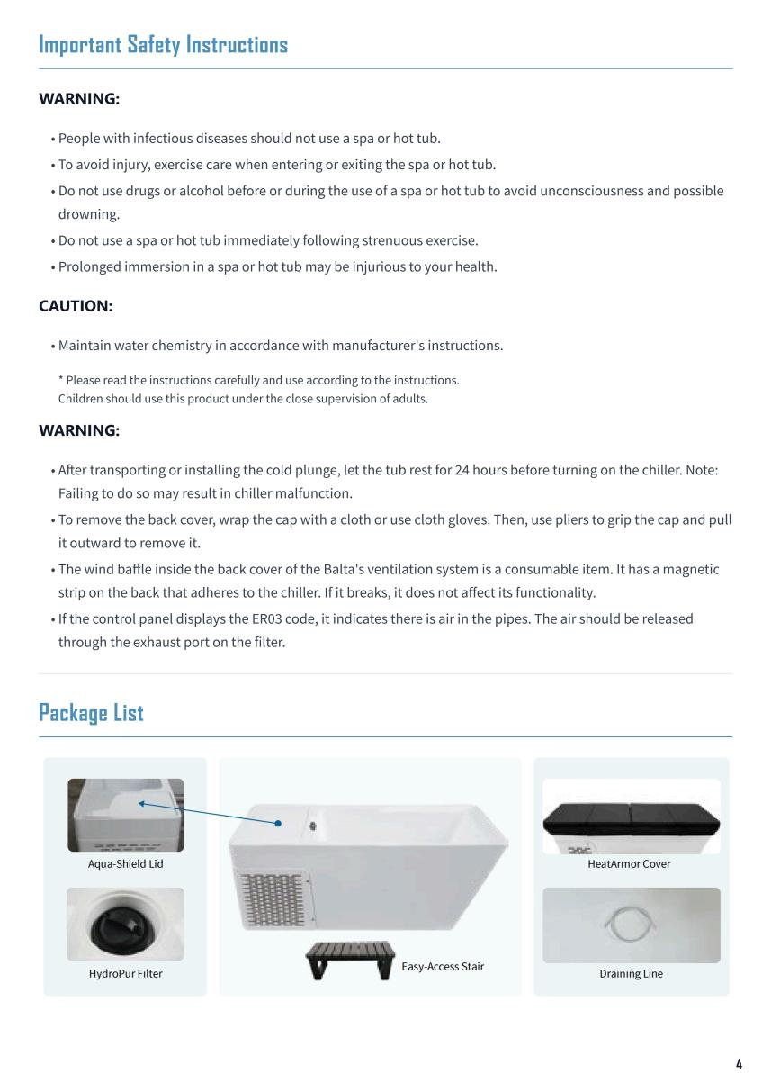

对应json格式数据（界面2）
Go
{
header: 'Important Safety Instructions',
blocks: [
{ type: 'heading', text: 'Important Safety Instructions' },
{ type: 'heading', level: 2, text: 'WARNING:' },
{ type: 'list', items: [
'People with infectious diseases should not use a spa or hot tub.',
'To avoid injury, exercise care when entering or exiting the spa or hot tub.',
'Do not use drugs or alcohol before or during the use of a spa or hot tub to avoid unconsciousness and possible drowning.',
'Do not use a spa or hot tub immediately following strenuous exercise.',
'Prolonged immersion in a spa or hot tub may be injurious to your health.'
] },
{ type: 'heading', level: 2, text: 'CAUTION:' },
{ type: 'list', items: [
"Maintain water chemistry in accordance with manufacturer's instructions."
] },
{ type: 'paragraph', className: 'warning-text', text: '* Please read the instructions carefully and use according to the instructions.\nChildren should use this product under the close supervision of adults.' },
{ type: 'heading', text: 'WARNING:' },
{ type: 'list', items: [
'After transporting or installing the cold plunge, let the tub rest for 24 hours before turning on the chiller. Note: Failing to do so may result in chiller malfunction.',
'To remove the back cover, wrap the cap with a cloth or use cloth gloves. Then, use pliers to grip the cap and pull it outward to remove it.',
"The wind baffle inside the back cover of the Balta's ventilation system is a consumable item. It has a magnetic strip on the back that adheres to the chiller. If it breaks, it does not affect its functionality.",
'If the control panel displays the ER03 code, it indicates there is air in the pipes. The air should be released through the exhaust port on the filter.'
] },
{ type: 'divider' },
{ type: 'heading', text: 'Package List' },
{ type: 'image', src: '/instruction_book/package_list.png', fullWidth: true }
]
},

json格式数据说明（界面2）
// - header: string 页面标题
// - blocks:
// · { type: 'heading', text } 标题
// · { type: 'heading', level: 2, text } 分组标题（WARNING/CAUTION）
// · { type: 'list', items: string[] } 分组要点
// · { type: 'paragraph', text, className? } 警示说明
// · { type: 'divider' } 分割线
// · { type: 'image', src, fullWidth?, rotate?, marginTop? } 插图

3.7 界面内容（Specification）
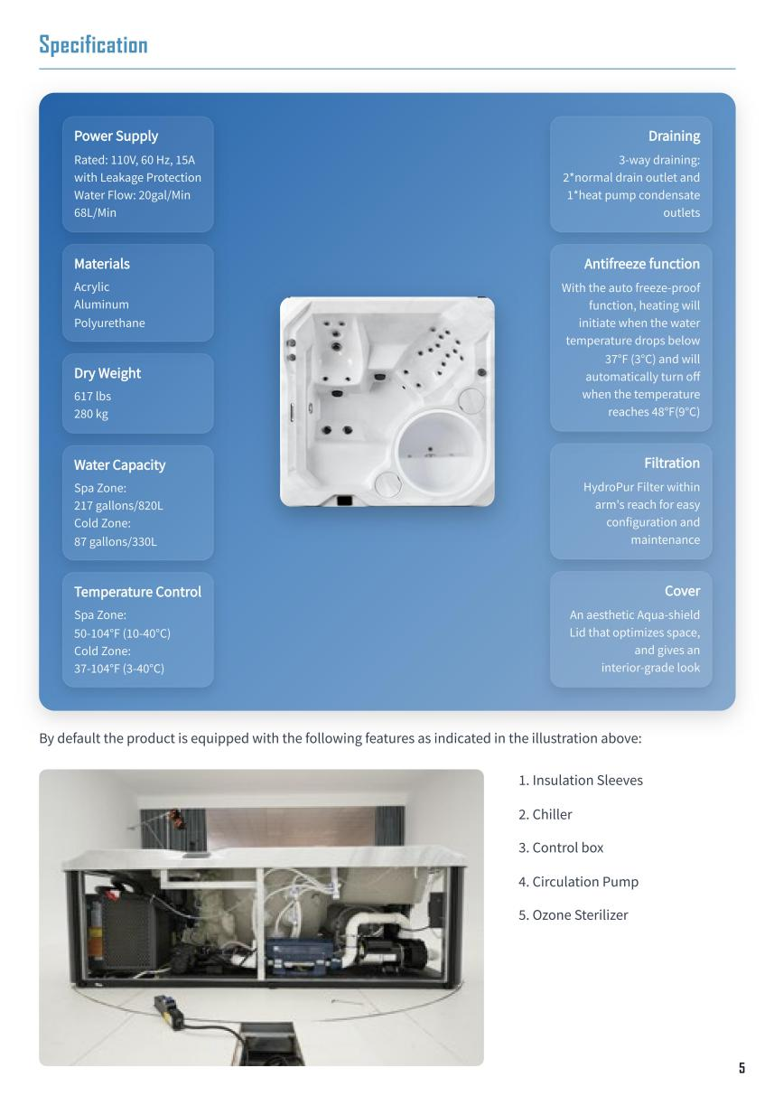

对应json格式数据
Go
{
header: 'Specification',
blocks: [
{ type: 'heading', text: 'Specification' },
{ type: 'spec-box',
imageSrc: '/instruction_book/Specification_1.png',
specs: {
topLeft: { title: 'Power Supply', items: ['Rated: 110V, 60 Hz, 15A', 'with Leakage Protection', 'Water Flow: 20gal/Min', '68L/Min'] },
topRight: { title: 'Draining', items: ['3-way draining:', '2*normal drain outlet and', '1*heat pump condensate', 'outlets'] },
leftTop: { title: 'Materials', items: ['Acrylic', 'Aluminum', 'Polyurethane'] },
leftMiddle1: { title: 'Dry Weight', items: ['617 lbs', '280 kg'] },
leftMiddle2: { title: 'Water Capacity', items: ['Spa Zone:', '217 gallons/820L', 'Cold Zone:', '87 gallons/330L'] },
leftBottom: { title: 'Temperature Control', items: ['Spa Zone:', '50-104°F (10-40°C)', 'Cold Zone:', '37-104°F (3-40°C)'] },
rightTop: { title: 'Antifreeze function', items: ['With the auto freeze-proof', 'function, heating will', 'initiate when the water', 'temperature drops below', '37°F (3°C) and will', 'automatically turn off', 'when the temperature', 'reaches 48°F(9°C)'] },
rightMiddle: { title: 'Filtration', items: ['HydroPur Filter within', 'arm\'s reach for easy', 'configuration and', 'maintenance'] },
rightBottom: { title: 'Cover', items: ['An aesthetic Aqua-shield', 'Lid that optimizes space,', 'and gives an', 'interior-grade look'] }
}
},
{ type: 'paragraph', text: 'By default the product is equipped with the following features as indicated in the illustration above:' },
{ type: 'grid2', items: [
{ type: 'image', src: '/instruction_book/Specification_2.png' },
{ type: 'list', ordered: true, items: [
'Insulation Sleeves',
'Chiller',
'Control box',
'Circulation Pump',
'Ozone Sterilizer'
] }
] }
]
},

json格式数据说明
// - header: string 页面标题
// - blocks:
// · { type: 'heading', text } 标题
// · { type: 'spec-box', imageSrc, specs } 规格盒
// specs: 分区 { topLeft/topRight/leftTop/leftMiddle1/leftMiddle2/leftBottom/rightTop/rightMiddle/rightBottom }
// 每区 { title: string, items: string[] }
// · { type: 'paragraph', text } 说明
// · { type: 'grid2', items } 左右图文
// items: [{ type: 'image', src } | { type: 'list', ordered?, items }]

3.8 界面内容（Touchscreen Control Panel）
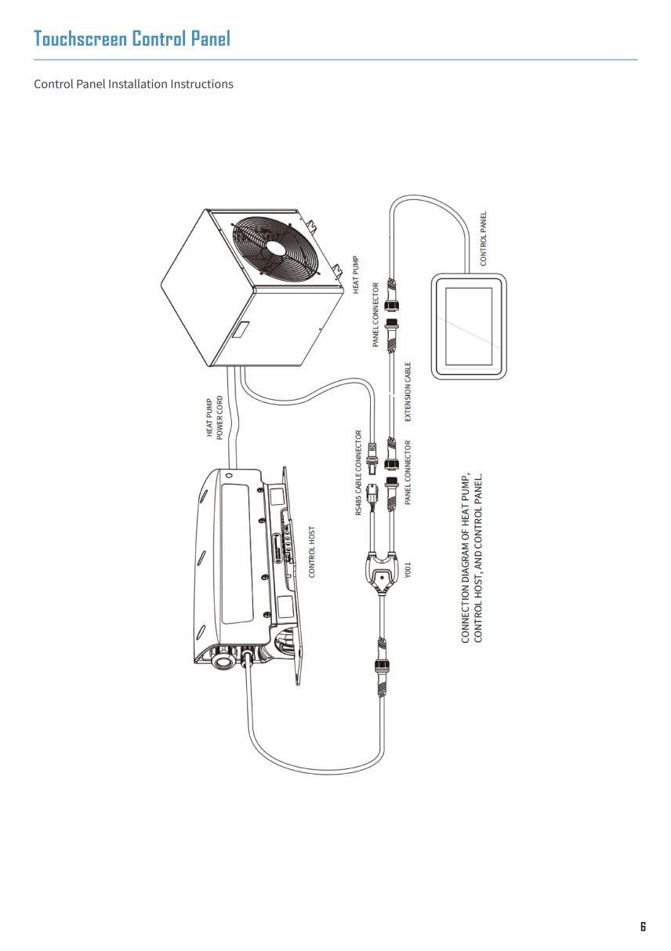

对应json格式数据
YAML
{
header: 'Touchscreen Control Panel',
blocks: [
{ type: 'heading', text: 'Touchscreen Control Panel' },
{ type: 'paragraph', text: 'Control Panel Installation Instructions' },
{ type: 'image', src: '/instruction_book/Touchscreen_Control_Panel.png', fullWidth: true, rotate: -90, marginTop: 240 }
]
},

json格式数据说明
// - header: string 页面标题
// - blocks:
// · { type: 'heading', text } 标题
// · { type: 'paragraph', text } 简述
// · { type: 'image', src, fullWidth?, rotate?, marginTop? } 插图

3.9 界面内容（Troubleshooting）

界面1
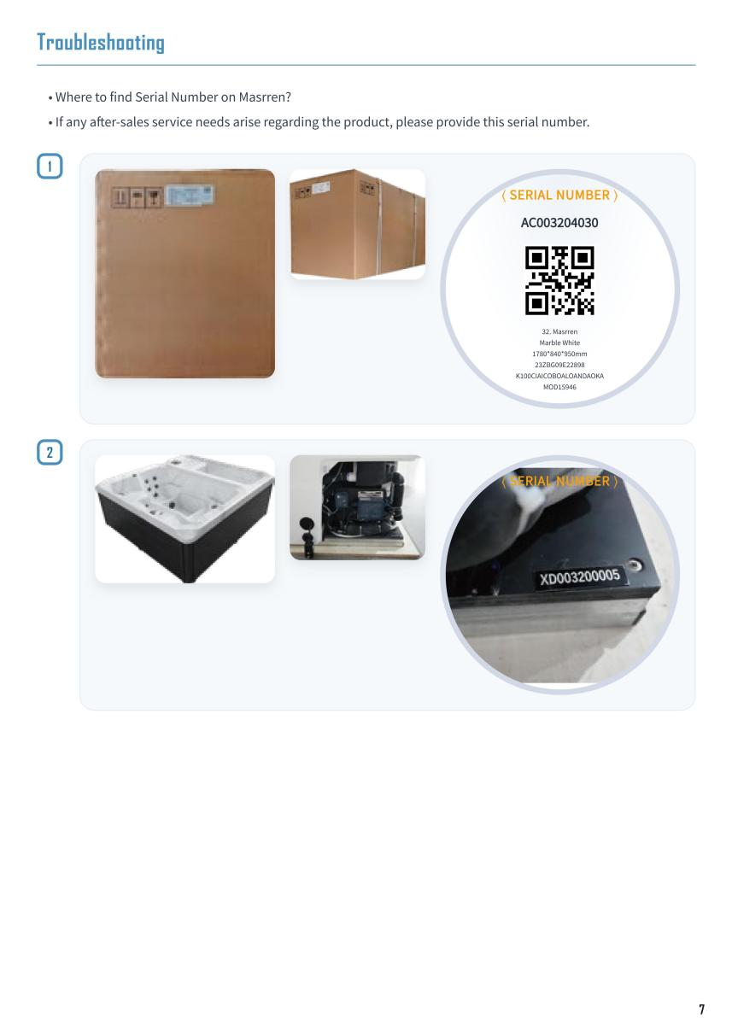

对应json格式数据（界面1）
Bash
{
header: 'Troubleshooting',
blocks: [
{ type: 'heading', text: 'Troubleshooting' },
{ type: 'list', items: [
'Where to find Serial Number on Masrren?',
'If any after-sales service needs arise regarding the product, please provide this serial number.'
] },
{ type: 'ts-section', index: 1, images: [
'/instruction_book/Troubleshooting1_1.png',
'/instruction_book/Troubleshooting1_2.png',
'/instruction_book/Troubleshooting1_3.png'
], magnifier: {
serial: 'AC003204030',
qrSrc: '/instruction_book/Troubleshooting1_3.png',
qrVisible: true,
qrSize: 78,
qrMargin: '6px auto 8px',
bgSrc: '',
lines: [
'32. Masrren',
'Marble White',
'1780*840*950mm',
'23ZBG09E22898',
'K100CIAICOBOALOANDAOKA',
'MOD15946'
]
} },
{ type: 'ts-section', index: 2, images: [
'/instruction_book/Troubleshooting2_1.png',
'/instruction_book/Troubleshooting2_2.png',
'/instruction_book/Troubleshooting2_3.png'
], magnifier: { bgSrc: '/instruction_book/Troubleshooting2_3.png', qrSrc: '' } }
]
},

json格式数据说明（界面1）
// - header: string 页面标题
// - blocks:
// · { type: 'heading', text } 标题
// · { type: 'list', items } 引导问题
// · { type: 'ts-section', index, images, magnifier } 故障定位图
// images: [string, string, string]
// magnifier?: {
// serial?: string 序列号
// qrSrc?: string 二维码图片
// qrVisible?: boolean 是否显示二维码
// qrSize?: number 二维码大小
// qrMargin?: string 二维码外边距
// bgSrc?: string 放大镜背景图
// lines?: string[] 放大镜下说明文字

界面2
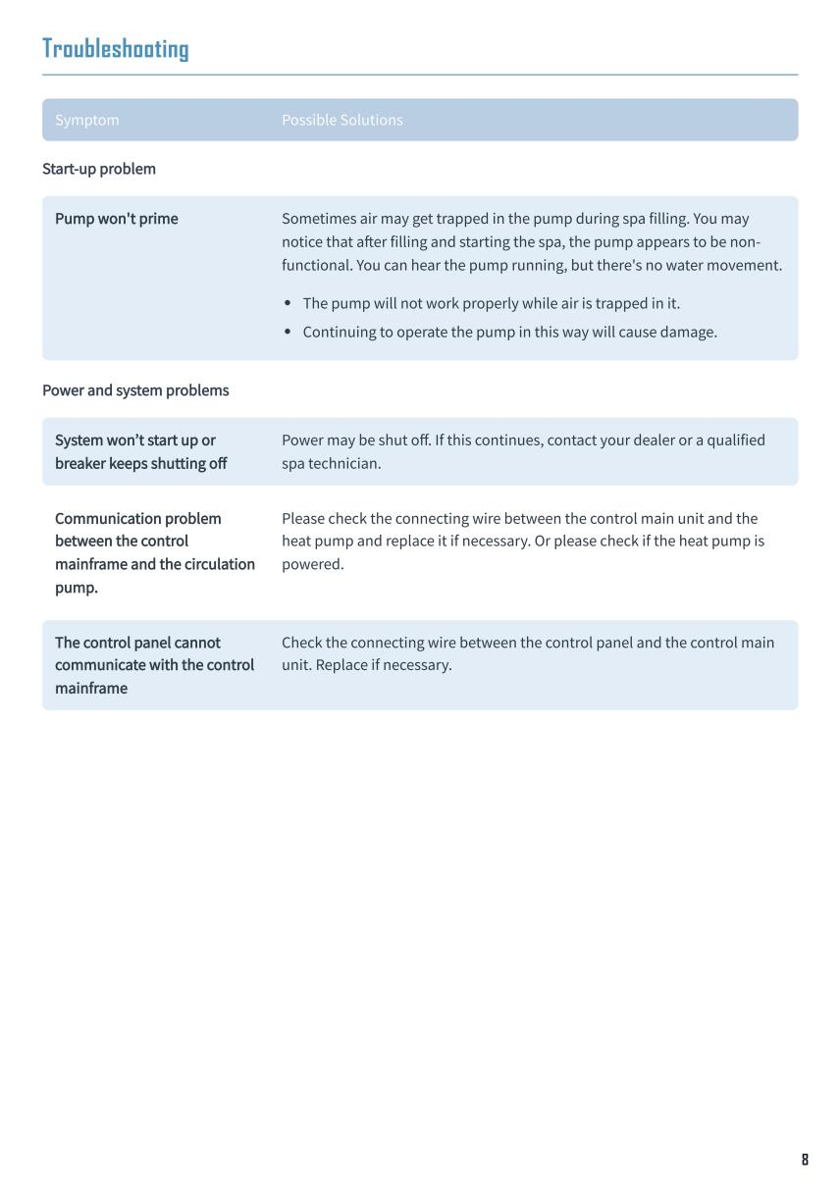

对应json格式数据（界面2）
SQL
{
header: 'Troubleshooting',
blocks: [
{ type: 'heading', text: 'Troubleshooting' },
{ type: 'troubleTable', headers: ['Symptom','Possible Solutions'], groups: [
{ title: 'Start-up problem', items: [
{ symptom: "Pump won't prime", description: 'Sometimes air may get trapped in the pump during spa filling. You may notice that after filling and starting the spa, the pump appears to be non-functional. You can hear the pump running, but there\'s no water movement.', solutions: [
'The pump will not work properly while air is trapped in it.',
'Continuing to operate the pump in this way will cause damage.'
] }
]},
{ title: 'Power and system problems', items: [
{ symptom: "System won’t start up or breaker keeps shutting off", solutions: 'Power may be shut off. If this continues, contact your dealer or a qualified spa technician.' },
{ symptom: 'Communication problem between the control mainframe and the circulation pump.', solutions: 'Please check the connecting wire between the control main unit and the heat pump and replace it if necessary. Or please check if the heat pump is powered.' },
{ symptom: 'The control panel cannot communicate with the control mainframe', solutions: 'Check the connecting wire between the control panel and the control main unit. Replace if necessary.' }
]}
] }
]
},

json格式数据说明（界面2）
// - header: string 页面标题
// - blocks:
// · { type: 'heading', text } 标题
// · { type: 'troubleTable', headers, groups } 故障表
// headers: [string, string] 表头（症状/可能解决方案）
// groups: [{ title: string, items }]
// · items: 数组 { symptom: string, description?: string, solutions: string | string[] }

界面3
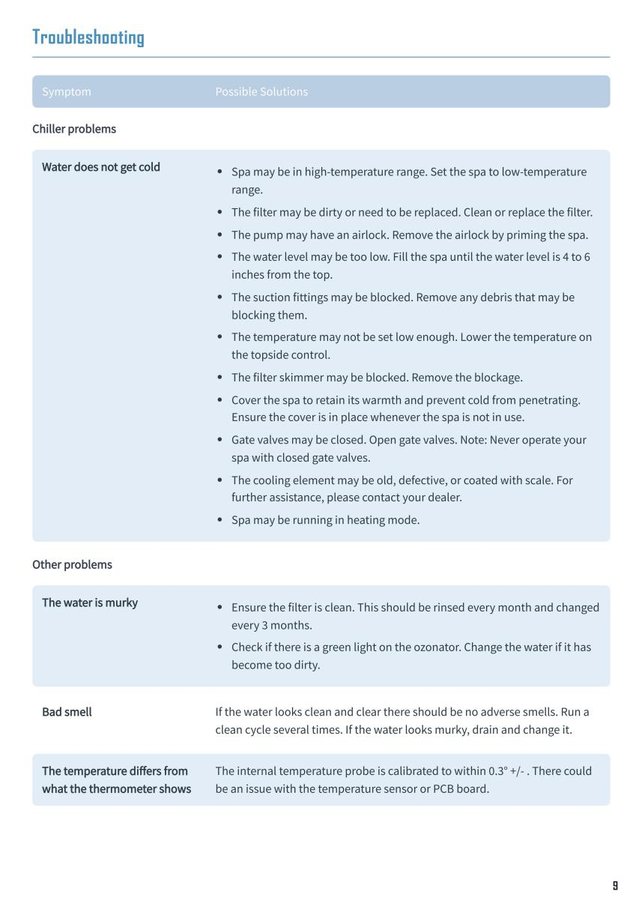

对应json格式数据（界面3）
SQL
{
header: 'Troubleshooting',
blocks: [
{ type: 'heading', text: 'Troubleshooting' },
{ type: 'troubleTable', headers: ['Symptom','Possible Solutions'], groups: [
{ title: 'Chiller problems', items: [
{ symptom: 'Water does not get cold', solutions: [
'Spa may be in high-temperature range. Set the spa to low-temperature range.',
'The filter may be dirty or need to be replaced. Clean or replace the filter.',
'The pump may have an airlock. Remove the airlock by priming the spa.',
'The water level may be too low. Fill the spa until the water level is 4 to 6 inches from the top.',
'The suction fittings may be blocked. Remove any debris that may be blocking them.',
'The temperature may not be set low enough. Lower the temperature on the topside control.',
'The filter skimmer may be blocked. Remove the blockage.',
'Cover the spa to retain its warmth and prevent cold from penetrating. Ensure the cover is in place whenever the spa is not in use.',
'Gate valves may be closed. Open gate valves. Note: Never operate your spa with closed gate valves.',
'The cooling element may be old, defective, or coated with scale. For further assistance, please contact your dealer.',
'Spa may be running in heating mode.'
] }
]},
{ title: 'Other problems', items: [
{ symptom: 'The water is murky', solutions: [
'Ensure the filter is clean. This should be rinsed every month and changed every 3 months.',
'Check if there is a green light on the ozonator. Change the water if it has become too dirty.'
] },
{ symptom: 'Bad smell', solutions: 'If the water looks clean and clear there should be no adverse smells. Run a clean cycle several times. If the water looks murky, drain and change it.' },
{ symptom: 'The temperature differs from what the thermometer shows', solutions: 'The internal temperature probe is calibrated to within 0.3° +/- . There could be an issue with the temperature sensor or PCB board.' }
]}
] }
]
},

json格式数据说明（界面3）
// - header: string 页面标题
// - blocks:
// · { type: 'heading', text } 标题
// · { type: 'troubleTable', headers, groups }（同上）

