独立tomcat部署需要准备事项
- 独立tomcat，启动端口不为8080
- 修改/home/mas/eie/cmd/mas
- .bashrc
- Run脚本
------------------------------------------
1.准备tomcat，并修改其端口号。

2.修改/eie/cmd/mas 脚本
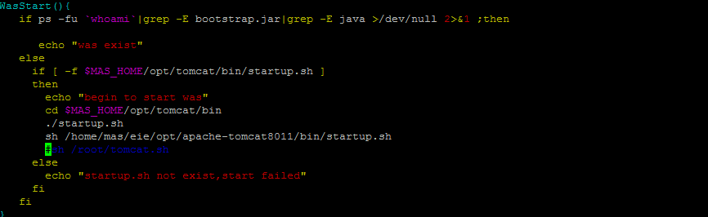

WasStart(){
if ps -fu `whoami`|grep -E bootstrap.jar|grep -E java >/dev/null 2>&1 ;then
echo "was exist"
else
if [ -f $MAS_HOME/opt/tomcat/bin/startup.sh ]
then
echo "begin to start was"
cd $MAS_HOME/opt/tomcat/bin
./startup.sh
sh /home/mas/eie/opt/apache-tomcat8011/bin/startup.sh
#sh /root/tomcat.sh
else
echo "startup.sh not exist,start failed"
fi
fi
}

以上有个问题当独立tomcat状态为启动mas状态为停止时
Mas status 显示结果为
***********************************************************************
mtm [OFF]
masagent [OFF]
was [ON]
sms [OFF]
eup [OFF]
mms [OFF]
sps [OFF]
***********************************************************************

所以最好先mas stop was
在启动mas start was

3Mas权限下修改.bashrc文件
linux-o31w:~ # su - mas
mas@linux-o31w:~> vi .bashrc
test -s ~/.alias && . ~/.alias || true
export PATH=$MAS_HOME/cmd:$PATH:/opt/ibm/db2/V9.7/bin:
...
alias tom='/home/mas/eie/opt/apache-tomcat8011/bin/run'

修改完成后，例如：
mas@linux-o31w:~> cat .bashrc
test -s ~/.alias && . ~/.alias || true
export MAS_HOME=/home/mas/eie
export PATH=$MAS_HOME/cmd:$PATH:/opt/ibm/db2/V9.7/bin:
#/home/mas/eie/opt/apache-tomcat8011/bin:
alias dtom='cd /home/mas/eie/opt/apache-tomcat8011/'
alias cdbin='cd /home/mas/eie/opt/apache-tomcat8011/bin/'
alias tom='/home/mas/eie/opt/apache-tomcat8011/bin/run'

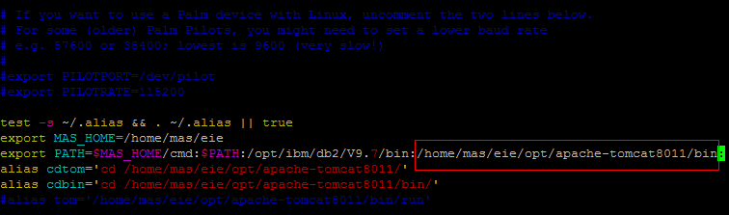

修改完成后需要source .bashrc 文件

4.Tomcat/bin目录下新增脚本run

mas@linux-o31w:~>cat /home/mas/eie/opt/apache-tomcat8011/bin/run
#!/bin/sh
tmp=run
CATALINA_HOME=`echo $0 |sed "s/\(.*\)$tmp/\1/g"`
#echo $CATALINA_HOME
count="ps -fu `whoami` |grep bootstrap.jar | grep $CATALINA_HOME | grep -v grep | wc -l"
t=`eval $count`
#echo $t

tomcat_help(){
echo "================================================"
echo "=tom status 显示tomcat状态 ="
echo "=tom start 启动tomcat ="
echo "=tom stop 停止tomcat ="
echo "=tom logs 查看tomcat日志 ="
echo "=tom restart 重启tomcat ="
echo "================================================"
}

check_tomcat()
{
echo "--------------------------"
echo "--> check tomcat info <--"
echo "--------------------------"
ps -fu `whoami` | grep bootstrap.jar | grep $CATALINA_HOME | grep -v grep
if [ $t -ne 0 ] ;then
echo "-->Tomcat exist $t"
echo "--------------------------"
else
echo "-->Tomcat is not exist $t"
echo "--------------------------"
fi
}

start_tomcat()
{

if [ $t -ne 0 ];then # if ps -fu `whoami` | grep -E java >/dev/null 2>$1 ; then
echo "--------------------------"
echo "-->Tomcat exist $t"
echo "--------------------------"
else
echo "--------------------------"
echo "-->Start tomcat pls wait"
echo "--------------------------"
sh $CATALINA_HOME/startup.sh
fi

}

kill_tomcat()
{

if [ $t -ne 0 ] ;then
echo "--------------------------"
echo "-->Tomcat exist $t Stop tomcat now"
echo "--------------------------"
ps -fu `whoami` |grep bootstrap.jar | grep $CATALINA_HOME | grep -v grep | awk '{ print $2 }'| xargs kill -9 #2 >/dev/null
sleep 3
else
echo "--------------------------"
echo "-->Tomcat is stop $t"
echo "--------------------------"
fi

}

tail_logs()
{

echo "--------------------------"
echo "-->tail tomcat:$CATALINA_HOME../logs/catalina.out"
echo "--------------------------"
tail -f $CATALINA_HOME/../logs/catalina.out

}

run_tomcat()
{

case $1 in
status)
check_tomcat
;;
start)
start_tomcat
;;
stop)
kill_tomcat
;;
logs)
tail_logs
;;
restart)
echo "restart tomcat now"
kill_tomcat
echo "pls wait 6s"
sleep 6
sh $CATALINA_HOME/startup.sh | tee $CATALINA_HOME/autostart.log
check_tomcat
echo "tomcat is running..."
;;
*)
tomcat_help
;;
esac

}
run_tomcat $1

新增完成请给tomcat/bin目录新增权限 chmod 755 /home/mas/eie/opt/apache-tomcat8011/bin/*

5.完成后使用情况
mas@linux-o31w:~> tom
================================================
=tom status 显示tomcat状态 =
=tom start 启动tomcat =
=tom stop 停止tomcat =
=tom logs 查看tomcat日志 =
=tom restart 重启tomcat =
================================================
mas@linux-o31w:~> tom status
--------------------------
--> check tomcat info <--
--------------------------
mas 8132 1 2 16:06 pts/0 00:00:23 /usr/java/jdk1.5.0_06/jre/bin/java -Djava.util.logging.manager=org.apache.juli.ClassLoaderLogManager -Djava.util.logging.config.file=/home/mas/eie/opt/apache-tomcat8011/conf/logging.properties -Djava.endorsed.dirs=/home/mas/eie/opt/apache-tomcat8011/endorsed -classpath :/home/mas/eie/opt/apache-tomcat8011/bin/bootstrap.jar -Dcatalina.base=/home/mas/eie/opt/apache-tomcat8011 -Dcatalina.home=/home/mas/eie/opt/apache-tomcat8011 -Djava.io.tmpdir=/home/mas/eie/opt/apache-tomcat8011/temp org.apache.catalina.startup.Bootstrap start
-->Tomcat exist 1
--------------------------
mas@linux-o31w:~> tom start
--------------------------
-->Tomcat exist 1
--------------------------
mas@linux-o31w:~> tom stop
--------------------------
-->Tomcat exist 1 Stop tomcat now
--------------------------
mas@linux-o31w:~> tom logs
--------------------------
-->tail tomcat:/home/mas/eie/opt/apache-tomcat8011/bin/../logs/catalina.out
--------------------------
2012-04-10 16:07:44,233 INFO [com.fs.util.fsInterceptor.RightInterceptor] - <initializing role intercepter...>
2012-04-10 16:07:44,248 INFO [com.fs.util.fsInterceptor.LogInterceptor] - <initializing log intercepter...>
Apr 10, 2012 4:07:44 PM org.apache.coyote.http11.Http11Protocol start
INFO: Starting Coyote HTTP/1.1 on http-8011
Apr 10, 2012 4:07:44 PM org.apache.jk.common.ChannelSocket init
INFO: JK: ajp13 listening on /0.0.0.0:8002
Apr 10, 2012 4:07:44 PM org.apache.jk.server.JkMain start
INFO: Jk running ID=0 time=0/20 config=null
Apr 10, 2012 4:07:44 PM org.apache.catalina.startup.Catalina start
INFO: Server startup in 52387 ms
^C
mas@linux-o31w:~> tom restart
restart tomcat now
--------------------------
-->Tomcat is stop 0
--------------------------
pls wait 6s
Using CATALINA_BASE: /home/mas/eie/opt/apache-tomcat8011
Using CATALINA_HOME: /home/mas/eie/opt/apache-tomcat8011
Using CATALINA_TMPDIR: /home/mas/eie/opt/apache-tomcat8011/temp
Using JRE_HOME: /usr/java/jdk1.5.0_06/jre
--------------------------
--> check tomcat info <--
--------------------------
mas 9108 1 33 16:25 pts/0 00:00:00 /usr/java/jdk1.5.0_06/jre/bin/java -Djava.util.logging.manager=org.apache.juli.ClassLoaderLogManager -Djava.util.logging.config.file=/home/mas/eie/opt/apache-tomcat8011/conf/logging.properties -Djava.endorsed.dirs=/home/mas/eie/opt/apache-tomcat8011/endorsed -classpath :/home/mas/eie/opt/apache-tomcat8011/bin/bootstrap.jar -Dcatalina.base=/home/mas/eie/opt/apache-tomcat8011 -Dcatalina.home=/home/mas/eie/opt/apache-tomcat8011 -Djava.io.tmpdir=/home/mas/eie/opt/apache-tomcat8011/temp org.apache.catalina.startup.Bootstrap start
-->Tomcat is not exist 0
--------------------------
tomcat is running...

