A ROBUST AND EFFICIENT CONVEX POLYGONAL APPROXIMATION ALGORITHM FOR CLOSED DIGITAL CURVES
(题目中实词首字母大写,二号黑体)
Lin Lin, Xiao-Long Xie, Fang-Yu Chen
（名前姓后，两个名字之间用连字符连接, 五号斜体）

(School of Mechatronics Engineering, Harbin Institute of Technology, Harbin 150001, China)
（单位采用小单位前，大单位后，若有多个单位需要编号，作者姓名右上角加上相应的编号,六号正体）

Abstract： In order to improve the accuracy and efficiency of 3D model retrieval, the method based on affinity propagation clustering algorithm is proposed. Firstly, projection ray-based method is proposed to improve the feature extraction efficiency of 3D models. Based on the relationship between model and its projection, the intersection in 3D space is transformed into intersection in 2D space, which reduces the number of intersection and improves the efficiency of the extraction algorithm. In feature extraction, multi-layer spheres method is analyzed. The two-layer spheres method makes the feature vector more accurate and improves retrieval precision. Secondly, Semi-supervised Affinity Propagation (S-AP) clustering is utilized because it can be applied to different cluster structures. The S-AP algorithm is adopted to find the center models and then the center model collection is built. During retrieval process, the collection is utilized to classify the query model into corresponding model base and then the most similar model is retrieved in the model base. Finally, 75 sample models from Princeton library are selected to do the experiment and then 36 models are used for retrieval test. The results validate that the proposed method outperforms the original method and the retrieval precision and recall ratios are improved effectively.
（摘要四要素：目的、过程和方法、结果、结论，小五号）

Keywords: feature extraction; project ray-based method; affinity propagation clustering; 3D model retrieval
（关键词3～8个，小五号）
CLC Number: TP391.7（中图分类号必须有，小五号）
正文为单栏排版，行间距为单倍行距，五号

- Introduction（一级标题从引言部分开始编号，以下以此类推，四号黑体）
With the development and wide application of CAD/CAM technology, the number of 3D models grows greatly. How to retrieve the desired 3D model from the mass model base efficiently and to use them for re-design becomes an urgent demand. When designing 3D model for a new product, the designers often need to retrieve similar models and revise them and this will improve the design efficiency. If the number of 3D model is small, it is easy to find the suitable 3D model, but if the number of 3D models is large, it is difficult to find the desired model only by the designer’s memory in a short time. So the computer is required to speed up the design process. In addition, in other areas which need to process a large number of 3D geometry information, 3D retrieval technology also has the wide application.
参考文献采用顺序编码制,该用上角标的用上角标
Feature extraction of 3D model is the most important part of retrieval technology. Feature extraction is extracting the characteristic descriptors from the 3D model and forming a feature vector, which can be utilized to distinguish 3D models. The similarity between two models can be calculated based on the feature vectors, and then the most similar 3D model is retrieved from the model bases. The algorithms of 3D model feature extraction can be divided into the following categories^{[1-3]}: the algorithms based on the geometric information, the algorithms based on the sum moment of the spatial and frequency domain and the algorithms based on topological relationships. The ray-based method^{[4]} belonging to the geometry information method has been widely used and many feature extraction algorithms are derived from it. However, due to the low efficiency of the algorithm and its application limitations on the some issues, it should be improved in practice. In order to improve the efficiency of ray-based method, the projection ray-based method is proposed in this paper, which reduces the intersection calculation of triangular facets and rays.
收稿日期,基金项目,通信作者在首页页脚处
The process of 3D model retrieval is calculating and comparing the similarity between the feature vectors of 3D models. Supposing there are a feature vector space 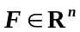 and two feature vectors 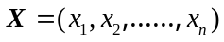 and 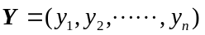, the similarity can be calculated by using the following methods:
全文的矢量、向量、矩阵量符号用黑斜体，变量用白斜体
正文中提到的公式编号，未提到的不编号
1）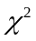 statistical distance:
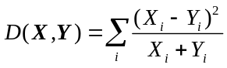 (1)
- Minkowski-form distance (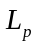):
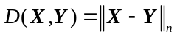 (2)
If 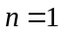, the absolute distance is:
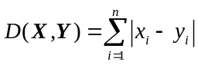 (3)
If 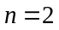, the Euclidean distance is:
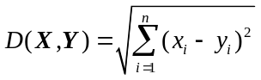 (4)
According to the above expressions, the large-scale model base and high dimension of feature vector will lead to a high computational complexity of 3D retrieval. In order to limit the retrieval scope and improve the efficiency, the cluster algorithm is applied in the paper to find the representative models from the model base and they are used to classify the query model into the correct cluster. Then the retrieval is executed only in cluster, so it can improve the efficiency.
K-means clustering ^{[5-6]} is the most widely applied method, and it can deal with large-scale data with fast iteration speed. But K-means algorithm is sensitive to initial cluster centers and easy to fall into the local minimum. Therefore it is required to run many times with the different initialization to find the best clustering results. However, this strategy is effective only with a small number of clusters and the better initialization.
Support vector machine technology^{[7]} (SVM) has wide application in the field of data classification and it overcomes the problems of high dimension and local minimum. However, SVM is a supervised learning algorithm and a large-scale quadratic programming. As to a multi-classification problem, although various solutions are proposed, the large computation is not solved.
The recent proposed affinity propagation clustering (AP) algorithm^{[8-11]} and K-means algorithm both belong to the K centers clustering method. However, it overcomes the shortcomings of K-means and it does not need to select the initial cluster centers. AP continually searches for the right cluster center during the iterative process, and finally makes the fitness function (objective function) of clustering maximizes. It avoids the problems of selecting initial values and it has fast run speed on large-scale data. Therefore, it is very suitable for high dimensional and large-scale classification issue.
In this paper, AP is adopted to obtain the representative models from each model base, and then the query model is determined which the most possible model base it belongs to by comparing with the representative models. Then, the above similarity Eqs. (1)-(4) are used for the most similar model retrieval from the model base. It limits the retrieval scope and improves retrieval speed and accuracy.
- Principle and Steps of Ray-Based Method（一级标题实词的首字母大写，四号黑体）
The basic idea of the ray-based method is that: the sampling rays are emitted to some directions from the center of 3D model. If the rays intersect the triangular facets which compose the model surface, the maximum distance from the intersections to the center is used as a feature of 3D model (as shown in Fig. 1.)
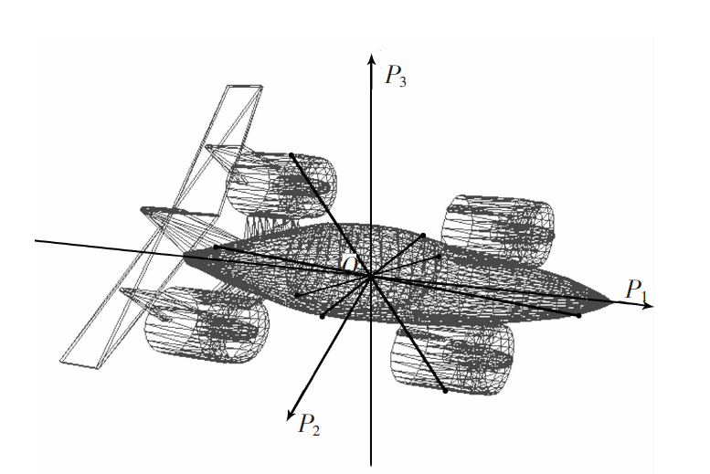
Fig. 1 Principle of ray-based method
（图和表格标题第一个单词首字母大写，小五粗体）
The feature extraction process includes the following steps:
1) The pretreatment of the 3D model: the model’s center is moved to the origin, and then the model is scaled to the unit size, and all the models are put in the same direction;
2) Supposing the model is surrounded by the unit ball whose center is the origin, the rays are emitted around uniformly, and then the coordinates of the intersection point are calculated.
A series of sampling rays through the origin in spherical coordinates can be expressed as:
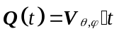
坐标轴和点、角符号用斜体，矢量符号用黑斜体，6号字
where is the direction of ray; is the length of ray, and 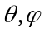 are shown in Fig. 2.
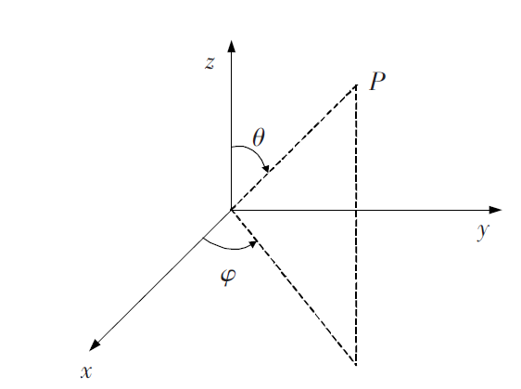
Fig. 2 Diagram of spherical coordinates
The coordinates of a point on a triangular facet can be expressed as:
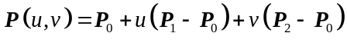
where 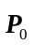, 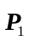 and 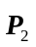 are the vertices of the triangular.
If 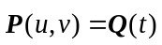, the parameters u, v and t can be calculated by:
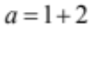
If 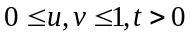, the corresponding parameters and t are saved.
3) Taking the maximum distance from the intersections to the origin as a feature of the model, and then extracting the all feature vectors from 3D model.
- Project Ray-Based Method

3.1 Project Relationship Analysis of Ball-Section and Triangular Facets（二级标题实词首字母大写，四号黑体；若还有三级标题，第一个单词首字母大写，其他小写，五号斜体）
The rays with a fixed and various compose a ball cross-section, and then the ball cross-section is projected to the section through the origin and perpendicular to the ball cross-section. The projection is a line whose equation is:
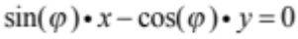
The locations of the ball cross-section and triangular facets are shown in Fig. 3.
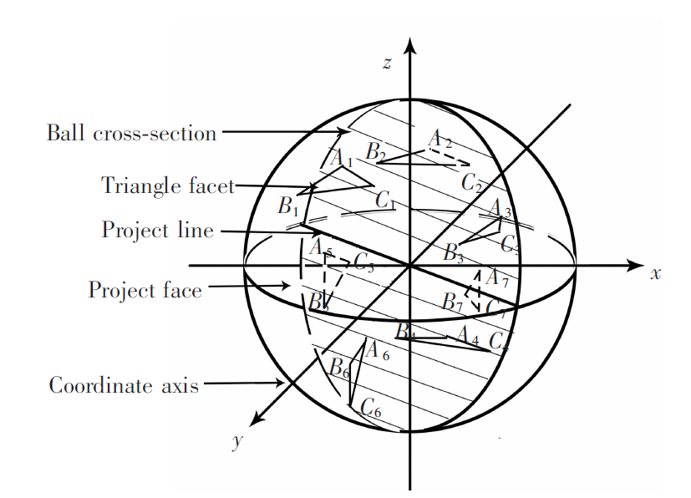
Fig. 3 Relations of cross-section and triangular facets
Because the model is limited in the unit ball, the intersection of the ball cross-section and the triangular facets can be judged according to whether the project line of ball cross-section intersects the projections of the triangular facets. The relationship is shown in Fig. 4.
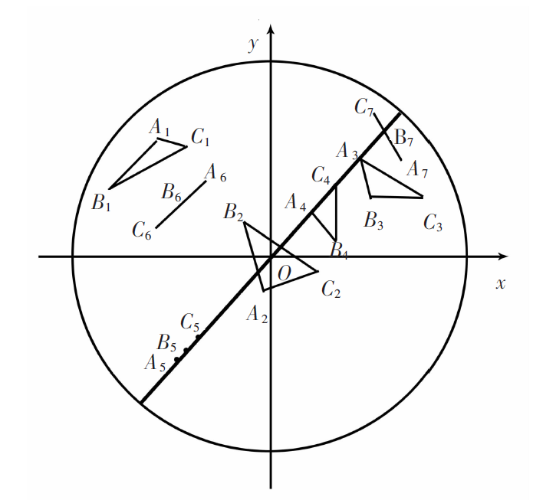
Fig. 4 Projection relationship of ball cross-section and triangular facets
Figs. 3 and 4 describe the location relationship between the ball cross-section and the spatial triangle facets and the corresponding projection relationship. According to the above analysis, the location relationship between the line and the triangle in the same plane can be used to determine whether the triangle intersects the ball section. Then two judgment methods are:
1) The method based on distance. If at least one vertex of triangle is on the line or on the other side of the line, the triangle intersects the line. The distance equation from a point P(x,y) to a line through the origin is 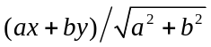, where the sign of ax+by can be used to determine the location relationship between the points and lines. Then by using the relationships between all the points of triangle and the line, whether the ball cross-section and intersect the triangular facet can be determined. For example, P₁ and P₂ are endpoints of a side L₁ of triangle; D₁ and D₂ are the distances from P₁ and P₂ to L₂. If 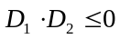, L₁ intersects L₂; otherwise, they do not intersect. The location relationship is shown in Fig. 5.
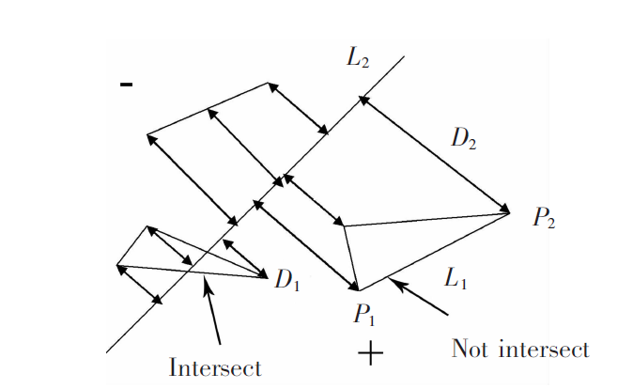
Fig. 5 Location relation between two lines
2) Method based on intersection angle.As to a triangle 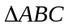, if one of the following Eq. (5) holds, it means that the line is through any side of the triangle, then the line and triangle intersect. The process is shown in Fig. 6.
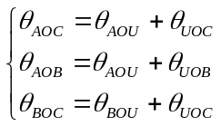 (5)
where 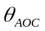 is the angle between the vectors OA and OC, which can be got by the cosine formula.
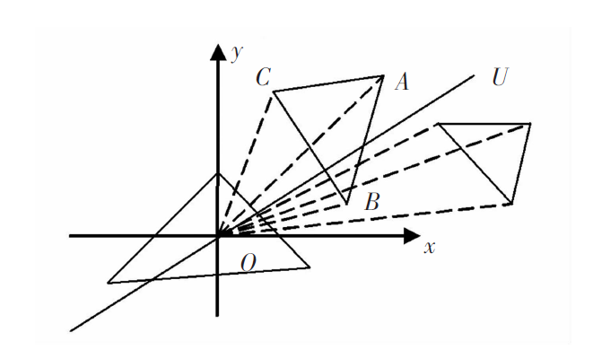
Fig. 6 Diagram of angle relationship

3.2 Steps of Project Ray-Based Algorithm
An important way to improve the efficiency of ray-based method is to reduce the number of unnecessary intersection. The idea is that: 1) getting N planes with a fixed , different in the ball; 2) using the method in Section 3.1 to record the triangular facets intersecting the planes. Because a plane (a ball cross-section) includes a series of rays, if triangular facets do not intersect the ball cross-section, it definitely does not intersect the rays in the ball cross-section. 3) removing the rays which do not intersect the triangular facets. The steps of project ray-based method are as follows:
- The graticule variables l and w are initialized as 0.
- If 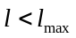, the corresponding is calculated, and the ball cross-section with angle is determinate whether it intersects triangular facets. The intersected triangles facets are put into the collection s. 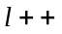. if 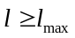, the algorithm is end.
- If 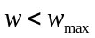, the corresponding is calculated. . if 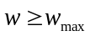, it goes to step 2;
- If the index number 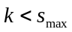(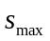 is the maximum number of triangular facets), the corresponding variables u, v and t are calculated by using the method proposed in Section 2. 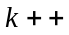. if 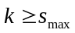, 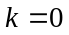 and the algorithm returns to step 3.
- If the variables u, v and t do not meet the intersection conditions, 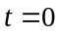. Then 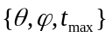 is a feature vector of 3D model.
The algorithm flow is shown in Fig. 7. The variables l, w and k represent the index numbers of graticule and triangular facets while 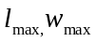and 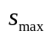 represent the maximum numbers of graticule and triangular facets. The variable t is the distance from the intersection to origin while 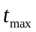 is the maximum distance.
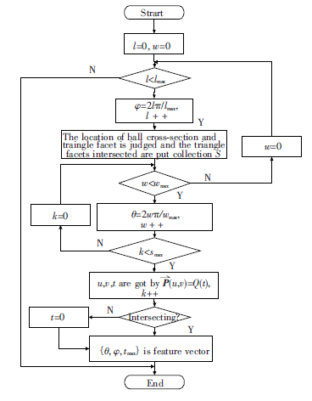
流程图中的yes和no分别用“Y”和“N”
Fig. 7 Flow of projection ray-based algorithm
Supposing the number of rays is 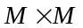, the number of the triangular facets that compose the surface of a 3D model is 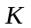; the vertices number of triangles facets is and the final number of the triangular facets needed to be calculated for the intersection is 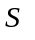.
Because the computation of removing the no-intersection triangular is much smaller than intersection calculation between the rays and triangle facets, it can be ignored. The iteration times in ray-based method is 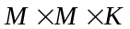; the iteration times in the improved project ray-based method is 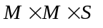. Thus, the ratio of computing work is 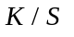. The larger 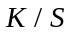 means that the method is more effective. The number of removed no-intersection triangular facets is 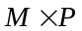 by method based on distance and 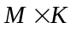by method based on intersection angle. The computation of method based on distance is 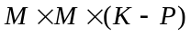, which is less than that of method based on intersection angle. From Eq. (5), it can be concluded that intersection judgment by method based on intersection angle is more complexity than that by method based on distance. Therefore, the method based on distance is better.
The above approach uses single-layer sphere to extract features. However, this approach ignores the inner information of the model, so it is only suitable for convex model. In order to use the inner information of models when the approach is utilized in dealing with models with other topological structures, multi-layer spheres approach is proposed. The steps are: (i) limiting the model in a ball; (ii) dividing the ball into N layers averagely; (iii) emitting the rays from center to sampling points on each sphere, and calculating the intersection points of rays and the model. If there is no sampling point between the (n-1)-th sphere and nth sphere, then this sampling point is eliminated as the features of nth layer, where 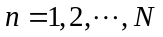.
Now the examples are presented to validate the effectiveness of the proposed approach. The single-layer sphere is utilized firstly, and the project ray-based algorithm is utilized to extract features. Then the Euclidean distance is utilized to compare the similarity between models, and the results are used to draw the Precision-Recall diagram to evaluate the precision of the retrieval.
The Precision and Recall represent the precision ratio and recall ratio respectively, and they can be utilized to evaluate the retrieval results. Precision ratio is the ratio of correct models in all retrieved models, and it is utilized to evaluate the precision of retrieved results. Precision ratio is calculated as the number of correct models divided by the number of retrieved models. Recall ratio is the ratio of correct retrieved models in all models, and it is utilized to evaluate the ability to retrieve the correct models. Recall ratio is calculated as the number of correct retrieved models divided by the number of all models. So in the Precision-Recall diagram, the curve, which is closer to upper-right, mean the retrieved results are better.
The models of bottle and box are utilized as test data, and the number of rays is 1,024. In the experiments, the results of different models are different, as shown in Fig. 8. According to the results in Fig. 8, the precise of box models is lower than that of bottle models, and the reason is that the topological structure of box models is more complicated than that of bottle models. There is plenty inner information in box models, so the single-layer sphere cannot describe these models accurately.
曲线图不要背景网格，不同曲线尽量用区别较大的线型区分（如此图可以在线上加不同的符号），或用指示线的形式，不要单纯用颜色区分（黑白印刷分不出来），横纵坐标一定要有量符号或量说明和单位（无量纲的只需说明）
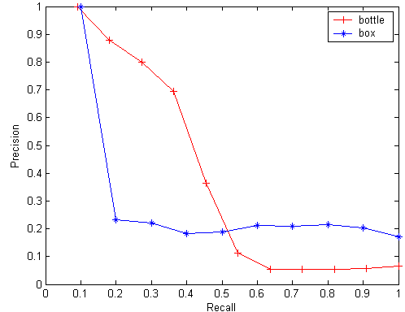
Fig. 8 Results of bottle and box models
The results of box models are not very good when using single-layer sphere, so two-layer spheres are used, and the precision is improved. The results are shown in Fig. 9.
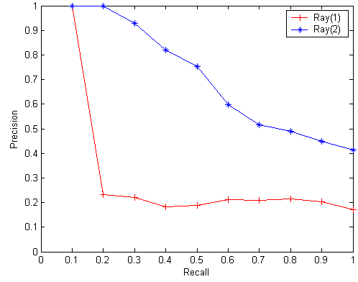
Fig. 9 Results of box models
According to the experiments, the multi-layer spheres project ray-based approach can extract the features of models with the complicated topological structure effectively.
The Gear models, Lflange models and Sflange models are also taken as testing models. In the experiments, the ray numbers are set as 1024, and then the numbers of spheres are increased from 1 to 3. The results show that retrieved precision of two-layer spheres method is much better than one-layer sphere method, while the retrieved precision of three-layer spheres method is only little better than one-layer sphere method. Thus, the number of spheres should be set a reasonable value. The experiment also evaluates the number of rays. The ray numbers are set as 64, 256 and 1024, and the results show that the precision increases as the increase of ray numbers, while the improvement is not very obvious. Thus, generally, the ray number is set as 1024, and the two-layer sphere method is utilized. In this way, the feature vector of 3D models contains more information. It uses fine-grained features to describe 3D models, so it is more accurate and it can improve the retrieval precision.
- Affinity Propagation Clustering Method
Affinity propagation clustering (AP) is a new clustering algorithm and its run speed is fast even for multi-classification problem. Before the iteration process of AP, the similarity matrix : 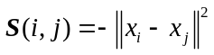 consisting of the similarity between data points is fed as input. The algorithm first takes all the data points as the potential cluster centers and supposes that there are messages energy 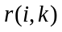and 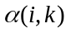 between any two data points i and k. The is value message sent from point to the candidate cluster center point , which is used to evaluate whether the point is of suitability as the cluster center for the point ; is the value message sent from candidate cluster centers to point , which is used to evaluate whether the point is ready to select the point as the cluster centers. The stronger the information energy and are, the more possible the point is as the clustering center, while the point is more possible to belong to the class with the center point. The expressions of and are shown in the following equations.
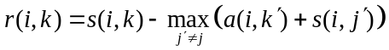 (6)
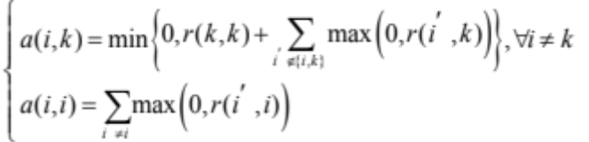 (7)
In order to avoid vibrations during the iteration process, the damping factor is introduced in the algorithm, and the message energy in the iteration is:
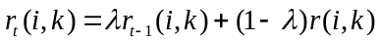 (8)
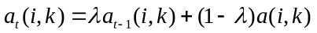 (9)
The diagonal values 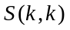 in S matrix are used ​​as the evaluation criteria for a point being a cluster center, which is called the bias parameter 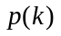. Generally, the median of all non-diagonal elements is adopted as the value of . The parameter is used in Eq. (10).
不要用英文单词或多个英文字母作为变量，可用一个英文字符带上、下角标的形式
(10)
A larger leads to larger 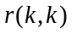 and 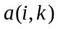, which means the point is more possible to be the final cluster center. When is larger, more points tend to be the final cluster centers. Therefore, enlarging or not can increase or decrease cluster numbers produced by AP.
The steps of AP algorithm are as follows:
(1) Initializing the elements of similarity matrix S, attraction matrix R and the attribution matrix A as 0, and the damping factor 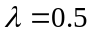, the number of iterations 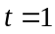, the maintain number of cluster information C_{count}=0. Assigning the maximum iteration number t_{max} and the maximum information maintain number C_{count max} and the medians of all S-diagonal elements to p(k);
(2) The new attraction 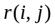 and new attributions 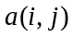, 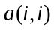 in iteration are calculated by Eqs. (6) to (7);
(3) The final attraction and final attributions , in iteration t are calculated by Eqs. (8) to (9);
(4) Finding the representative points by the equation 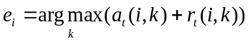;
(5) Repeating steps (2)-(4) until the representative points keep consistent during many times iteration or 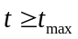.
According to AP algorithm, it assumes that all the clusters in feature space are compact. In AP, the energy function is the sum of similarities between samples and cluster centers, which is 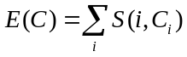. Supposing that the number of clusters is J, and AP minimizes 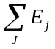. Thus, if the cluster structure is compact, it is easy to guarantee that each 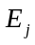 is small, and then is small, so AP can achieve good results in this condition. But if the cluster structure is loose, that is to say, the clusters are not very clear, AP algorithm tends to produce more clusters to make every and minimize , so AP would produce too many clusters, and the results are not accurate.
In order to improve the accuracy of AP algorithm and make the algorithm effective when the scale of model set changes or the complex degree of models changes, the semi-supervised AP clustering algorithm (S-AP) in Ref.[12] is utilized to cluster 3D models.
In S-AP algorithm, the clustering centers are also determined according to smaller , but the objective function is not minimizing , while it uses validity index to supervise the clustering. The Silhouette index ^{[13]} is used as the validity index.
Supposing that 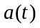 is the average dissimilarity or distance between sample t in cluster 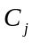 and all the other samples in this cluster, while 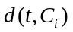 is the average dissimilarity or distance between sample t and samples in another cluster 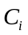, and 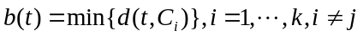. Then the Silhouette index of sample t is .
The average of 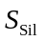 values of all the samples in data set can represent the quality of the clustering results. The larger average Silhouette index is, the better the quality of clustering is, so the cluster results of the maximum index is the best result of clustering. In AP, the number of clusters increases and decreases with the increase and decrease of the value of p. In S-AP, the initial value of p is the median of attraction degree 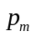, and its value decreases dynamically to obtain smaller number of clusters. Then the maximum 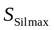 and its clustering results are obtained. The increment of p is 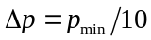, where 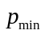 is the minimum of attraction degree. The flow of S-AP algorithm is shown in Fig. 10.
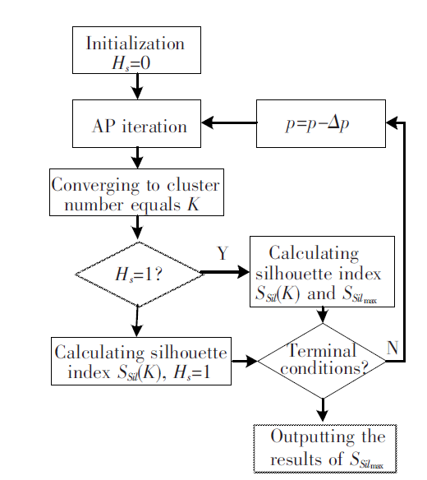
Fig. 10 Flow of S-AP
AP algorithm is an unsupervised method, but searching representative models as cluster centers in 3D models is a classification problem which is a supervised problem. In order to enhance the effectiveness of AP algorithm, the similarity matrix S which is input into the algorithm is modified.
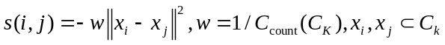
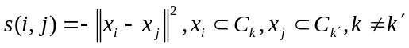
In this study, the similarity between two samples in one cluster multiplies a weight to increase the information energy between samples in one cluster and decrease the information energy between samples in different clusters. This modification can make the cluster center model more representative because a sample model which is on the edge of two clusters is not likely to be a cluster center. Supposing that the set of cluster centers is 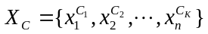, and the number of models in kth cluster is 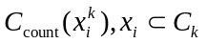. The computational complexity is 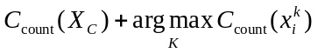, while the computational complexity of original approach is 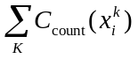.
- Simulation and Result Analysis
In order to verify the effectiveness of the proposed method proposed, 6 types of 3D models are selected from the Princeton library^{[14]}. The projection ray-based method is used to get the 256 feature vectors 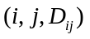by emitting 1616 rays, where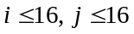 are the index number of graticule and 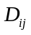is the maximum distance from the intersections to origin. The 3D models include bottle, flange, gear, gun, helicopter and human body model. The parts of the sample models are shown in Fig.11.
若是照片或抓图，一定要保证图的清晰

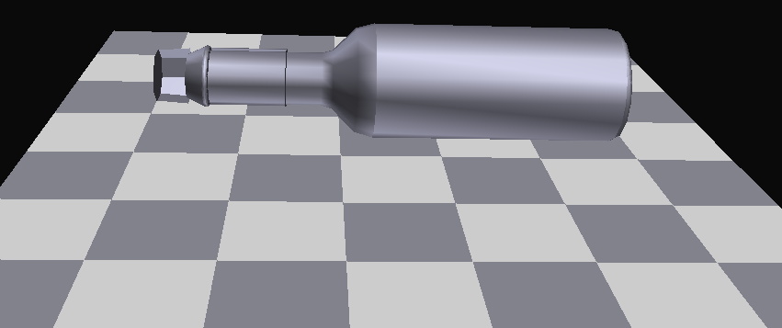 | 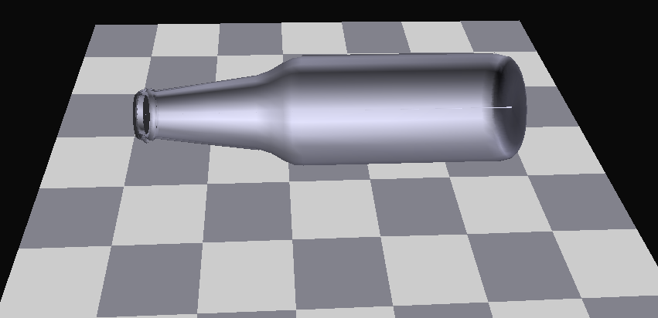 | 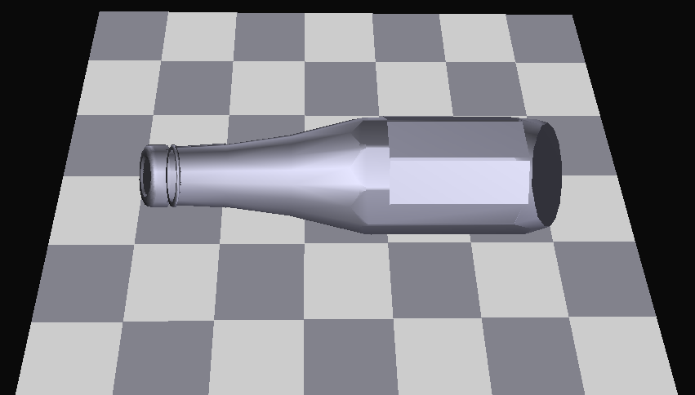 | 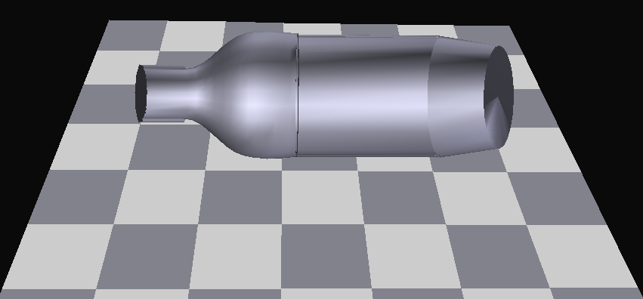
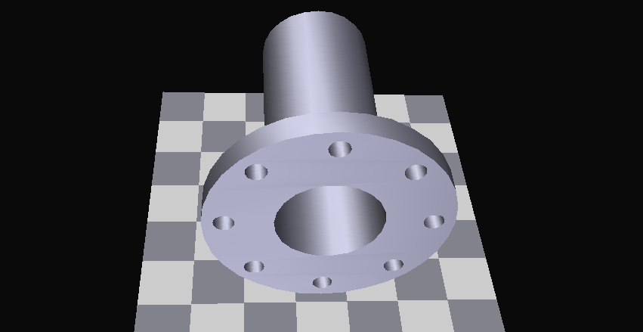 | 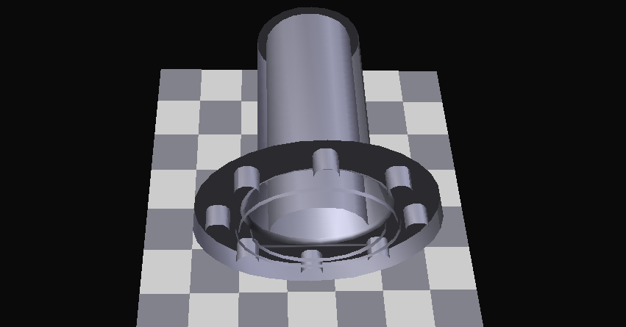 | 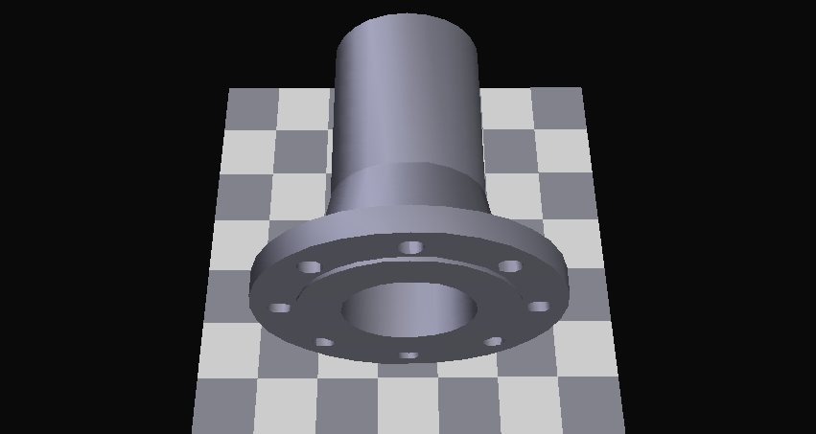 | 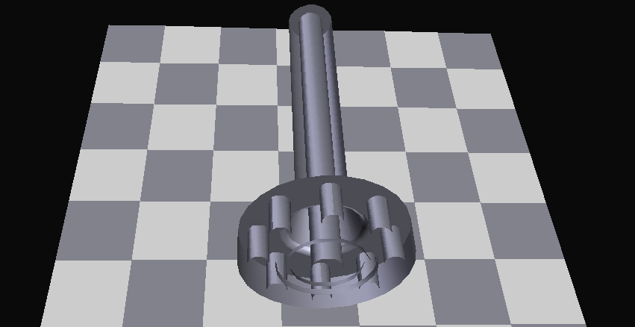
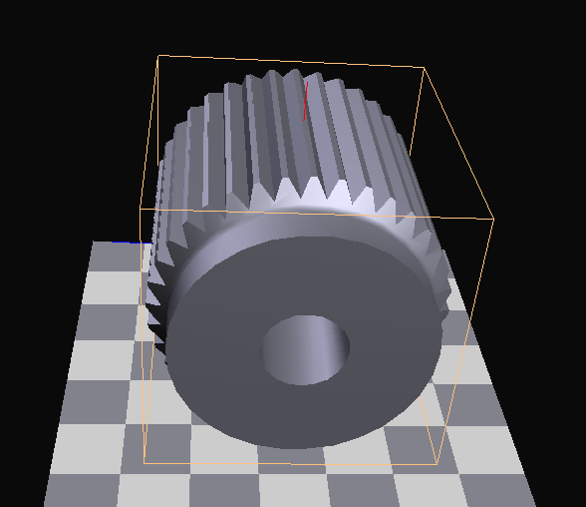 | 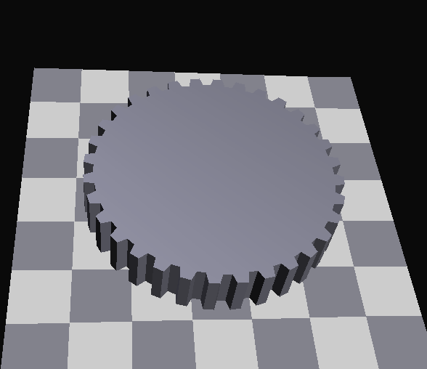 | 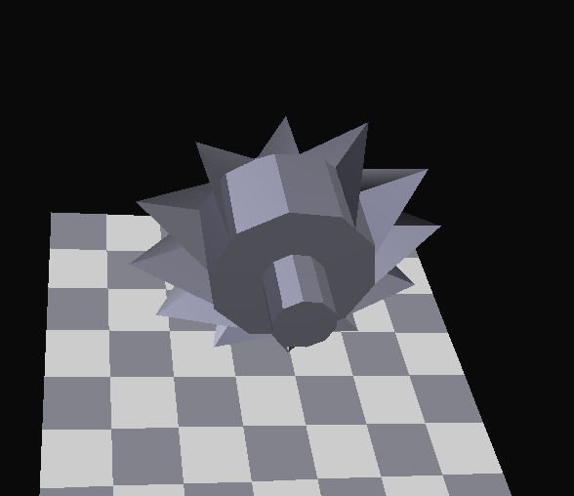 | 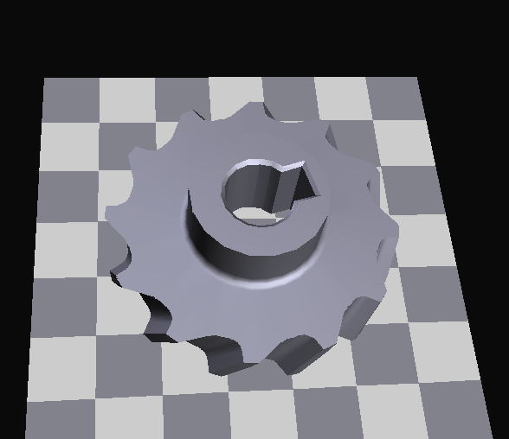
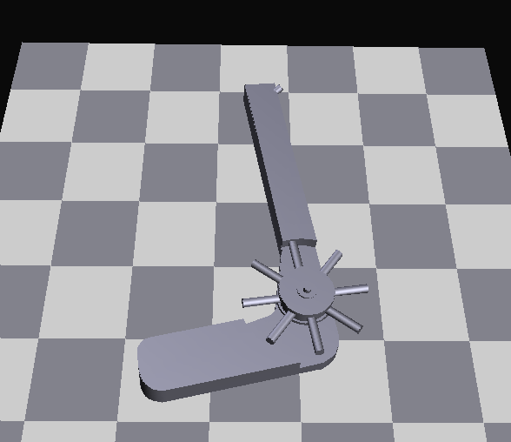 | 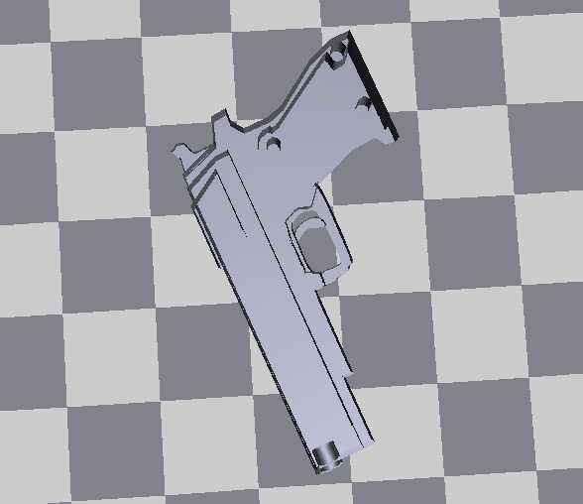 | 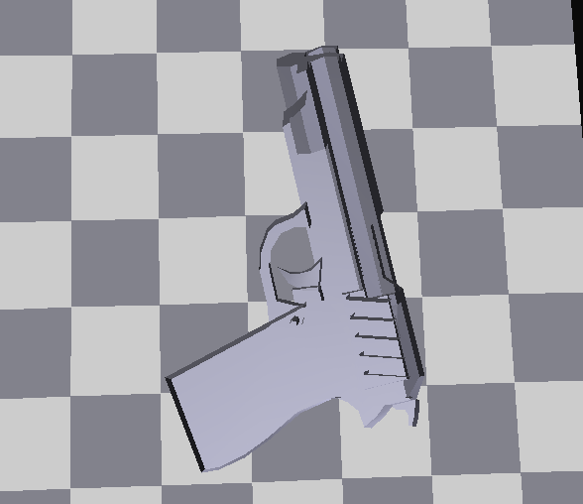 | 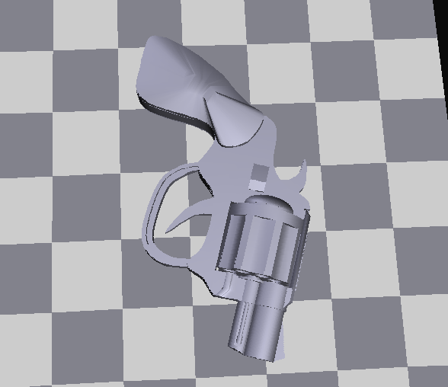
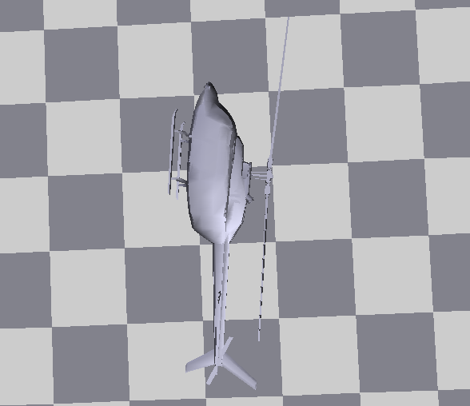 | 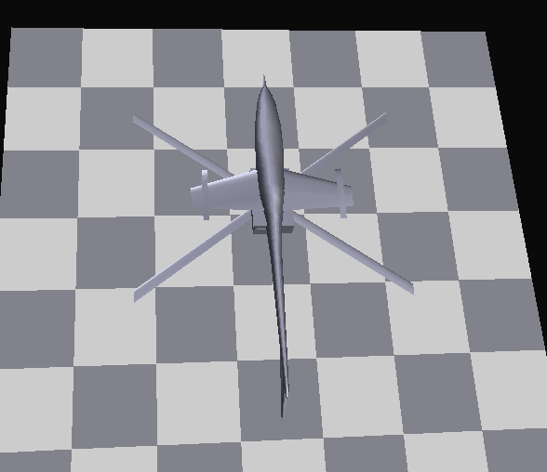 | 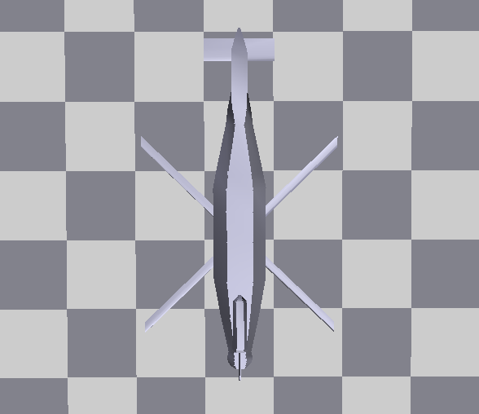 | 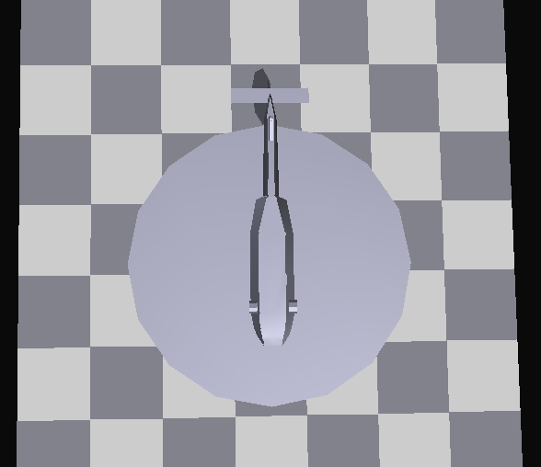
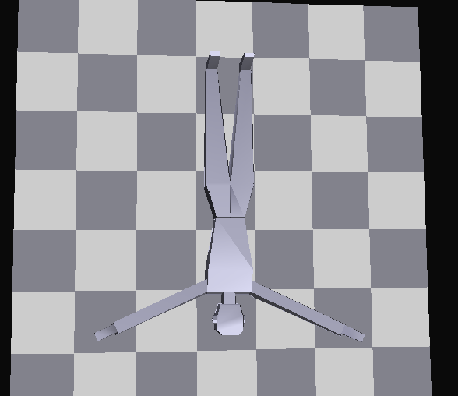 | 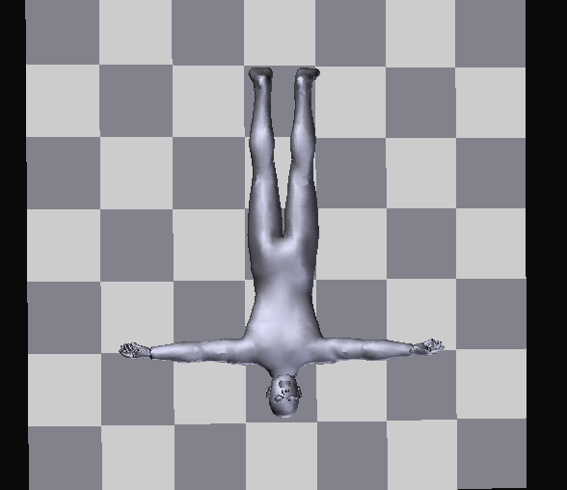 | 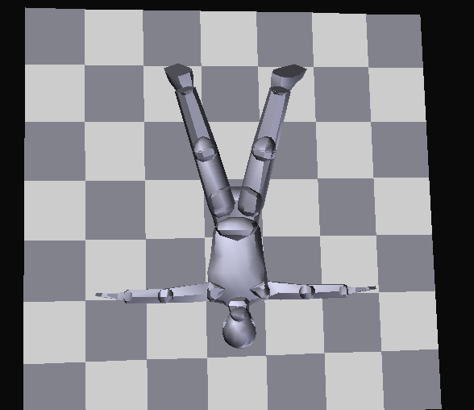 | 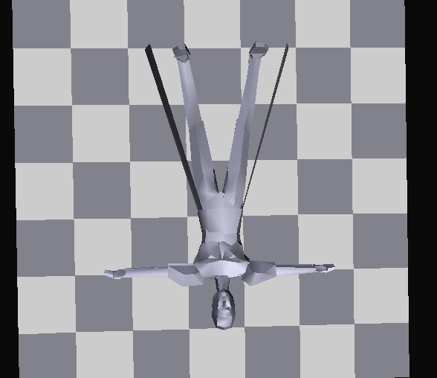

Fig.11 Parts of the sample models
First, AP algorithm is adopted to classify the 78 models in 6 model bases in order to find the center models of each base which are representative and distinctive. The test environment is Windows XP. MATLAB7.1 Software is used for simulation. The clustering error is calculated as follows:
表格采用三线表的形式，若只有一列数据，且数据较多，可通栏横排，若有多列数据采用下文表3的形式，表中文字6号字
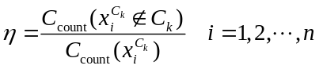 (11)
where 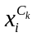 is the center models of class K (there are several center models); 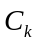 is the cluster K.
The clustering results are shown in Table 2.
Table 2 Clustering results
Model | Bottle | Flange | Gear | Gun | Helicopter | Human body
Error(%) | 0 | 0 | 22.0 | 37.5 | 38.9 | 5.0
The clustering errors of gun and helicopter models are larger. The reason is that the gun and helicopter models have a lot of detailed characteristic. As mentioned above, a ray may intersect several facets, but only the maximum distance from the intersections to origin is adopted as the feature vector. So the features extracted from gun and helicopter models cannot describe the models exactly. However, for the convex models, such as the human body, flange and bottle models, the clustering results are better. Therefore the ray-based methods are not suitable for the 3D models with more detail characteristics. The extraction method with higher precision can be used in this situation: such as wavelet moments^{[15]}, 3D Zernik moments ^{[16]}, Fourier analysis^{[17]}, and spherical harmonic analysis method ^{[18-20]} and other 3D model feature extraction methods.
(1) The analysis of computation complexity. First, the Euclidean distance between the retrieved model and the center models is utilized to judge which model base it may belong to.
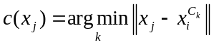 ,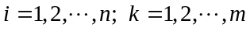
Then, the retrieval algorithm searches in the corresponding model base for the most similar 3D model. The total computational complexity is:

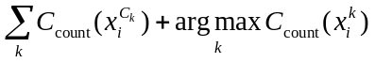
where 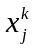 is the models in cluster K,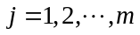.
However, if retrieval from all of the model bases by the original method, the calculation is . Due to 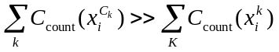, therefore, the calculation of the method is much smaller than that of original method.
(2) The analysis of precision. 39 bottle, body and flange models are selected from 75 samples for testing. After clustering by Eq. (11), the clustering error is 0. This means that the all 39 models are classified to the correct model base. The most similar model and the entire similar models will be retrieved from the correct model base. Therefore the recall and precision rates are 100%. On the other hand, the 3D retrieval system developed by the paper is used to retrieve the similar model from all the model bases. With the 256 feature vectors extracted by the project ray-based method, the retrieval process of the 3 bottle, 3 human body and 3 flange models are done (as shown in Figs. 11-13). The retrieval results are listed in descending order of the similarity, and the first 10 retrieved models are taken to calculate the precision rate which is shown in Table 3.
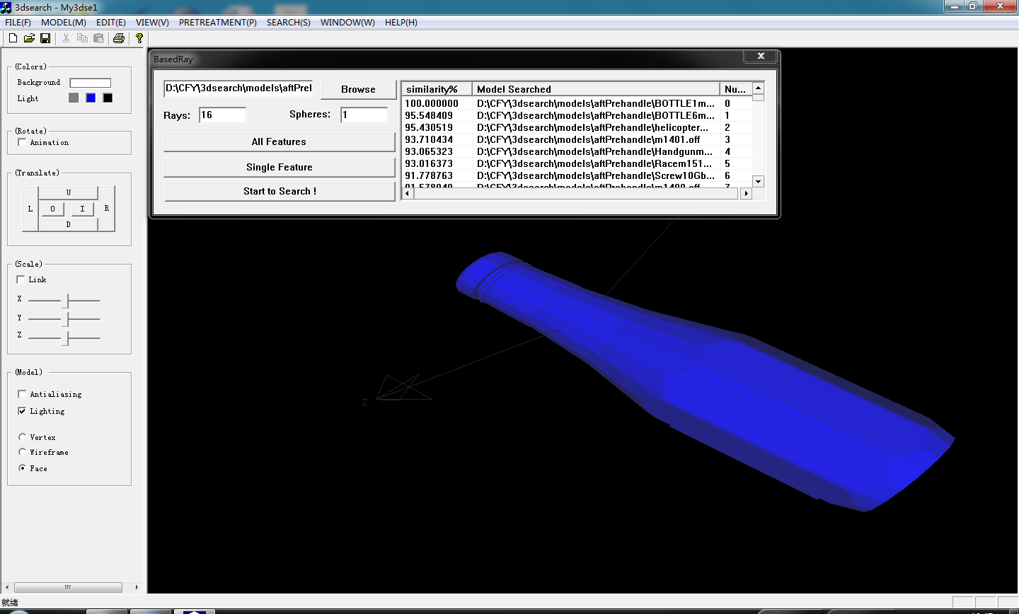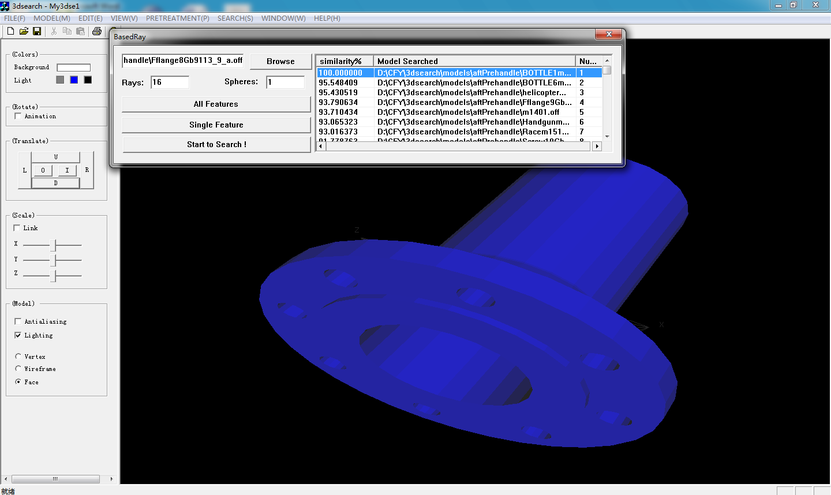
Fig. 12 Interface of bottle retrieval Fig. 13 Interface of flange retrieval
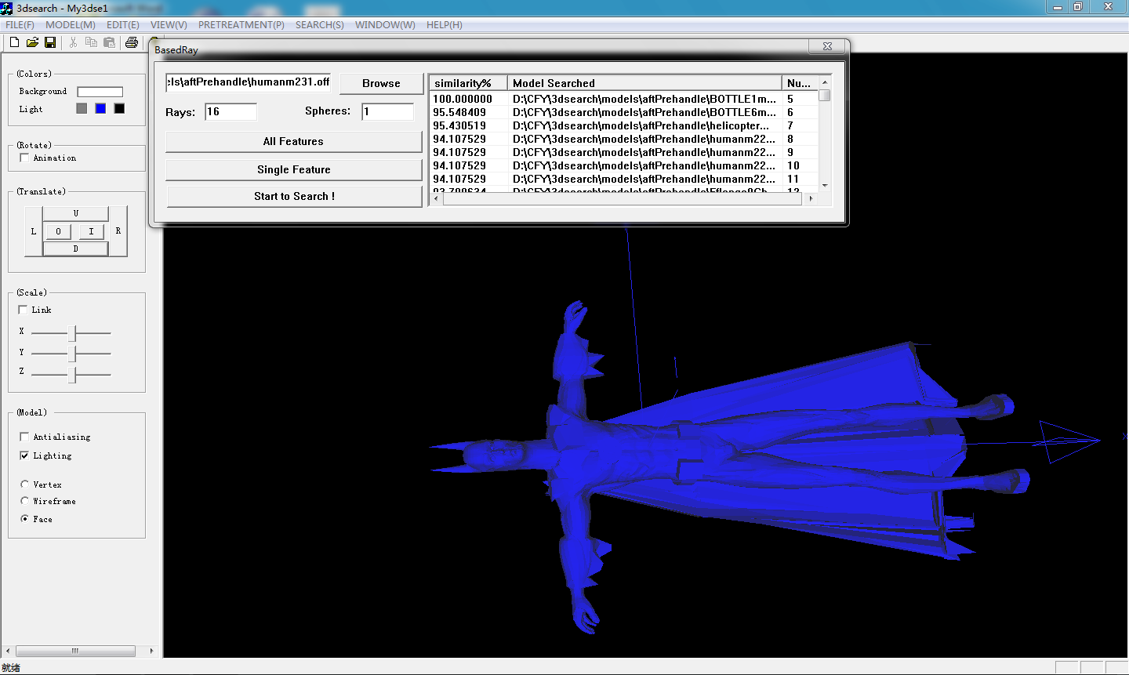
三线表中带单位的量符号或量说明集中放在第一行，下边为数据
Fig. 14 Interface of human body retrieval

Table 3 Results of model retrieval
Model | Bottle |  | Flange |  | Human body
Model | Name | Precision(%) | Name | Precision(%) | Name | Precision(%)
Model 1 | M482 | 30 | Gb9113_1 | 20 | Humanm219 | 60
Model 2 | M483 | 30 | Gb9113_2 | 100 | Humanm221 | 60
Model 3 | M484 | 60 | Gb9113_3 | 90 | Humanm237 | 60

From Table 3, the retrieval precisions of 3 types of models are low. The reasons are that less feature vectors are extracted, and moreover, the limitation of ray-based method itself. It is inaccurate that only the maximum distance is extracted as the feature vector for 3D model. However, even in the case of fewer features, the method proposed by the paper can achieve the higher retrieval precision, which shows that the method is of the practicability and effectiveness.
- Conclusions
The project ray-based method which reduces the computational complexity and improves the extraction efficiency is proposed for feature extraction of 3D models in this paper. In feature extraction, multi-layer spheres method is proposed and the choice of ray number and sphere number are discussed. The two-layer spheres method is utilized and it can make the feature vector more accurate and improve retrieval precision. Semi-supervised Affinity Propagation (S-AP) Clustering is utilized because it can be applied to different cluster structures. S-AP algorithm is adopted to cluster and find the center models which can represent the model library. The query model is firstly classified to corresponding model base, and then, the most similar model is retrieved in the model base. The S-AP clustering algorithm is efficient and its clustering results are more accurate. In feature extraction, the multi-layer spheres method can extract accurate features even for complicated 3D models, and in model retrieval, the application of S-AP improves the retrieval efficiency.

References（格式要求见文档最后）
[1] Cui Chenyang, Shi Jiaoying. Analysis of feature extraction in 3D model retrieval. Journal of Computer-aided Design & Computer Graphics, 2004,16(7):882-889 (in Chinese)
[2] Yang Yubin,Lin Hui,Zhu Qing. Content-based 3D model retrieval: a survey.Chinese Journal of Computers, 2004,27(10):1297-1310 .(in Chinese)
[3] Zheng Bochuan, Peng Wei. A survey on 3D model retrieval techniques.Journal of Computer-aided Design & Computer Graphics,2004,16(7):873-881. (in Chinese)
[4] Vranic D V, Saupe D. 3D model retrieval. Proceedings of Spring Conference on Computer Graphics. Budmerice, Slovakia , 2000.89-93.
[5] Chang Chihtang, Lai Jim Z C, Jeng Muder. A fuzzy K-means clustering lgorithm using cluster center displacement . Journal of Information Science and Engineering, 2011,27(3): 995-1009.
[6] Ahmad Amir, Dey Lipika. A k-means type clustering algorithm for subspace clustering of mixed numeric and categorical datasets. Pattern Recognition,2011,32(7): 1062-1069.
[7] Cortes C , Vapnik V. Support-vector networks. Machine Learning, 1995, 20(3):273-297.
[8] Frey B J, Dueek D. Clustering by passing messages between data points. Science, 2007, 315(5814):972-976.
[9] Guan Renchu, Shi Xiaohu, Marchese Maurizio. Text clustering with seeds affinity propagation. IEEE Transactions on Knowledge and Data Engineering, 2011, 23(4): 627-637.
[10] Guo Kun, Zhang Qishan. Affinity propagation clustering based on grey relational analysis, Journal of Grey System, 2010,22(2): 147-156.
[11] Kelly K. Affinity program slashes computing times. http://www.news.utoronto.ca/bin6/070215-2952.asp, 2007-10-25.
[12] Wang Kaijun, Li Jian, Zhang Junying, et al. Semi-supervised affinity propagation clustering. Computer Engineering. 2007,33(23):197-201.(in Chinese)
[13] Dudoit S, Fridlyand J. A prediction-based resampling method for estimating the number of clusters in a dataset. Genome Biology,2002,3(7):0036.1-0036.21
[14] Dobkin D. Princeton shape retrieval and analysis group.http://shape.cs.princeton.edu/search.html.2001-11.
[15] Cui Li. The theories of N-D generalized quasi-real wavelets & wavelet moments and their applications . Jilin University Doctor Thesis, 2004.33-86.
[16] Novitni M, Klein R. 3D Zernik descriptors for content based shaped retrieval. Proceedings Of ACM Symposium on Solid Modeling and Applications. Washington, DC. 2003.216-225.
[17] Osada R, Funkhouser T, Chazelle B, et al. Shape distributions. ACM Transaction on Graphics, 2002, 21(4):807-823.
[18] Vranic D V, Saupe D. 3D model retrieval with spherical harmonics and moments. Proceedings of the DAGM 2001. Munich. 2001.392-397.
[19] Vranic D V, Saupe D, Richter J. Tools for 3D-object retrieval: Karhuner-Loeve transform and spherical harmonics. Proceedings of IEEE Workshop on Multimedia Signal Processing. Cannes. 2001.293-296.
[20] Vranic D V, Saupe D. An improvement of rotation invariant 3D-shape descriptor. Proceedings of the IEEE Internat ional Conference on Image Processing. Barcelona. 2003.757-760.

参考文献不少于15篇，格式要求如下：
- 专著：[序号]作者姓名．书名．出版地：出版者，出版年．起页码－止页码．
- 期刊：[序号]作者姓名．论文题目.期刊名，出版年，卷（期）：起页码－止页码．
- 会议论文集：[序号]作者姓名．论文题目.论文集名.出版地：出版者，出版年.起页码－止页码．
- 硕士及博士学位论文：[序号]作者姓名．论文题目.出版地：出版者，出版年.
- 电子文献：[序号]主要责任者.电子文献题名。电子文献的出处或可获得地址，发表或更新日期/引用日期（任选）。
- 专利：[序号]专利所有者.专利题名.专利国别：专利号，出版日期.
报告的著录格式和专著的著录格式一致。另外，出版者为出版商名称，出版地为出版商所在城市名。

