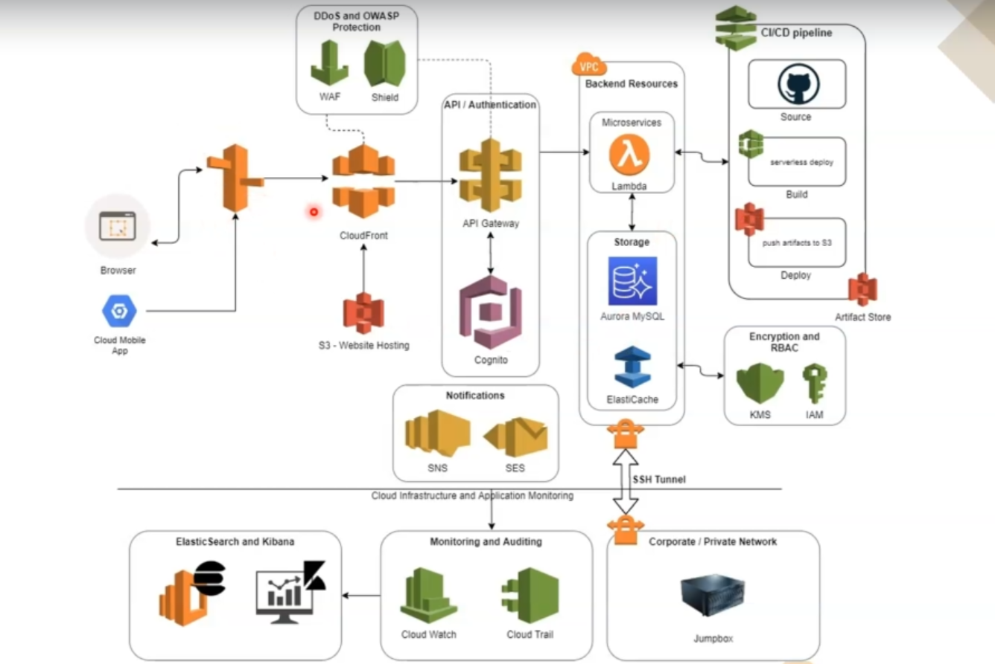

Add ALB (EC2/ECS/ECS fargate as path based routing )