prerequisite

1 create following

cat <<EOF > ./mycreds.json

{"username" : " rdsadmin1 "}

EOF

aws secretsmanager create-secret --name RDS-postgres-username \

--description "CarSales RDS postgres username" \

--secret-string <file://mycreds.json>

Terraform will output ALB URL (Since we will create RDS DB, it will took about 20 minutes to finish, just be patient)

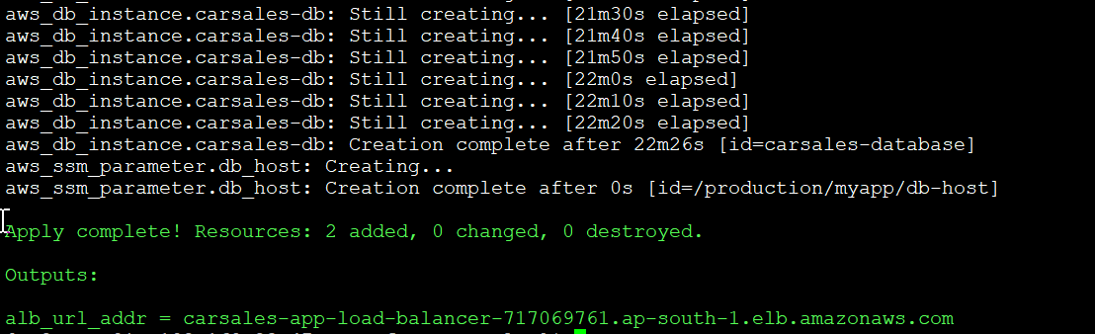

http to https redirect when you input <http://carsales-app-load-balancer-717069761.ap-south-1.elb.amazonaws.com> it will automatically redirect to <https://carsales-app-load-balancer-717069761.ap-south-1.elb.amazonaws.com>

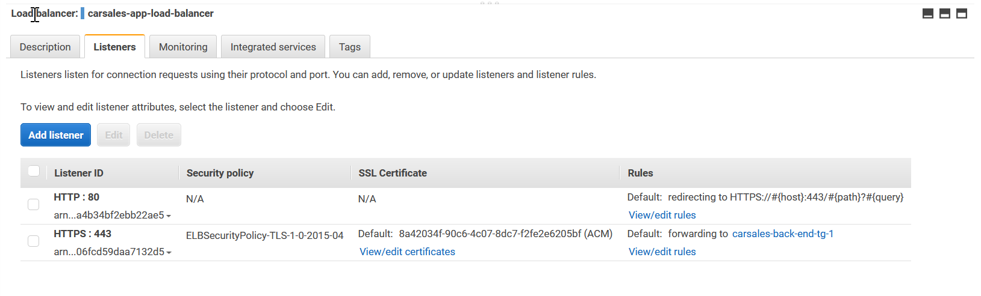

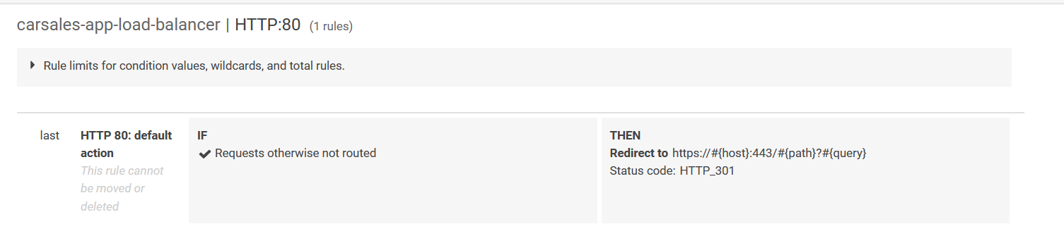

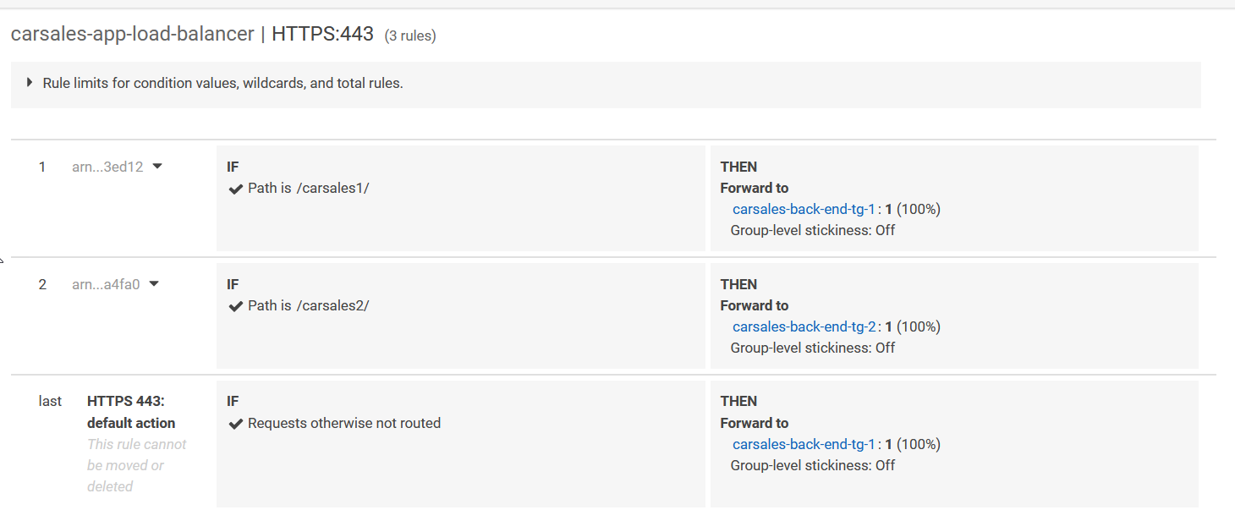

Register ALB use Route53. Create carsales.aconex.design A record to ALB



Use Certificate get from AWS Certificate Manager

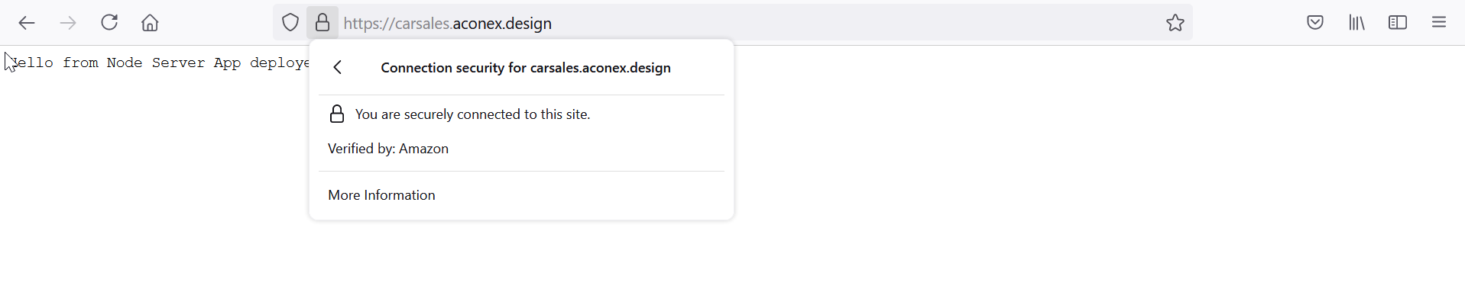

ALB path based routing, different path related to different target group/ECS service

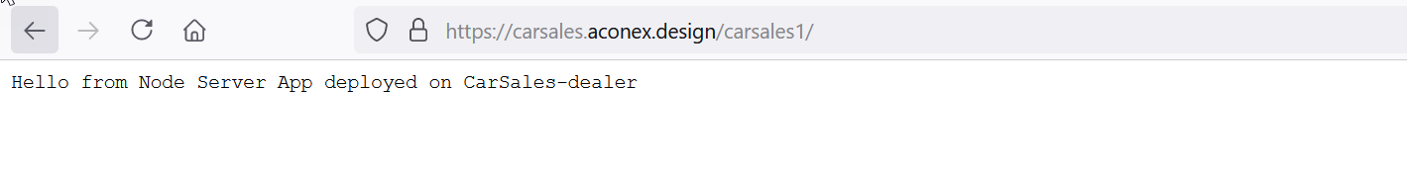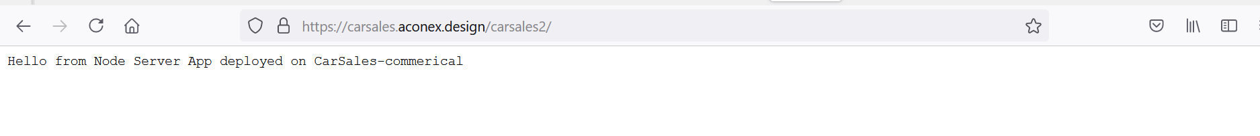

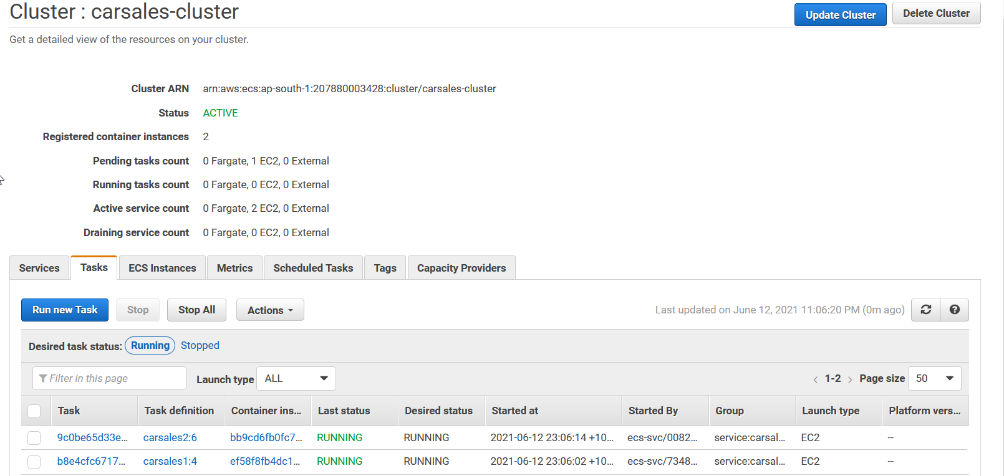

Access ECS EC2 instance from bastion host. Login to container and check command env output (you can find RDS db_url and RDS database password which can be used to access database) and df -hT (EFS mount)

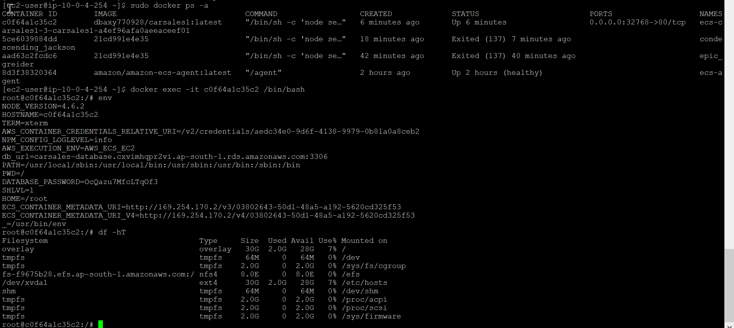

ECS service autoscale based on load

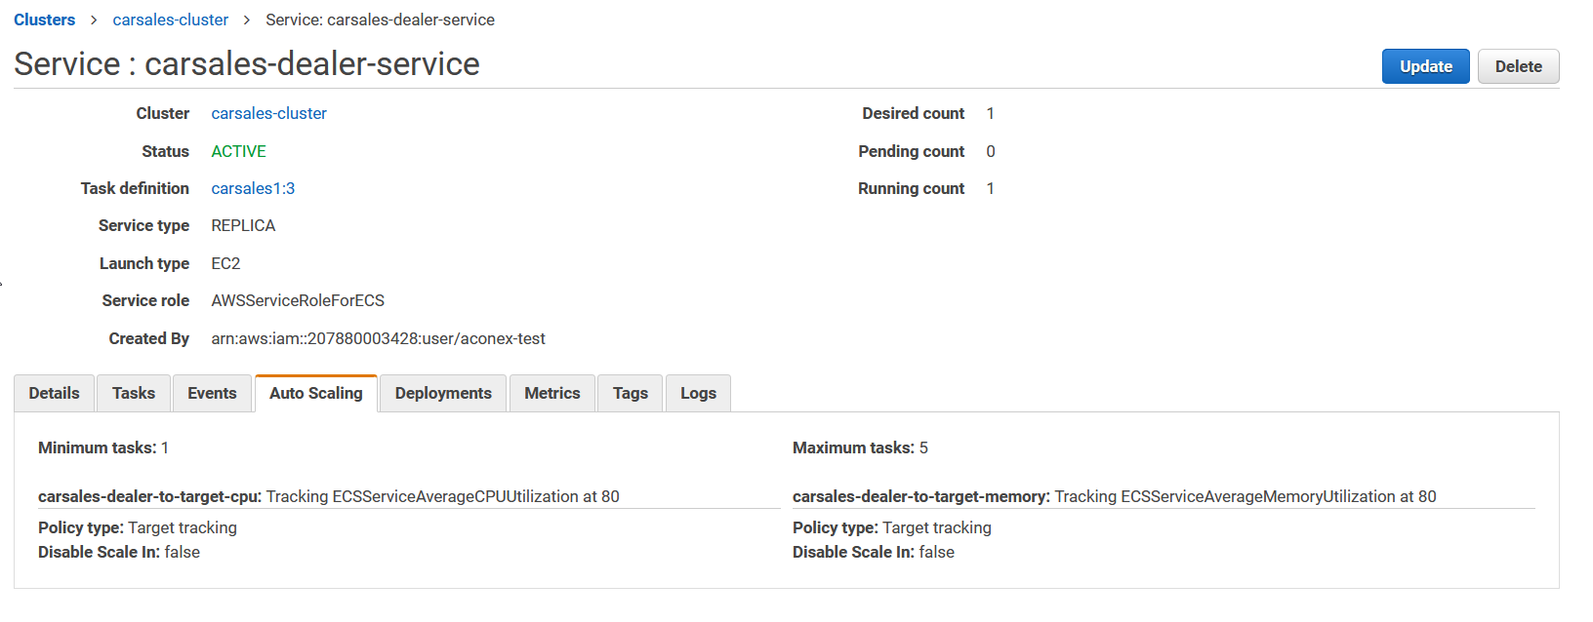

EC2 instances which compose ECS clusters auto scale based on workload

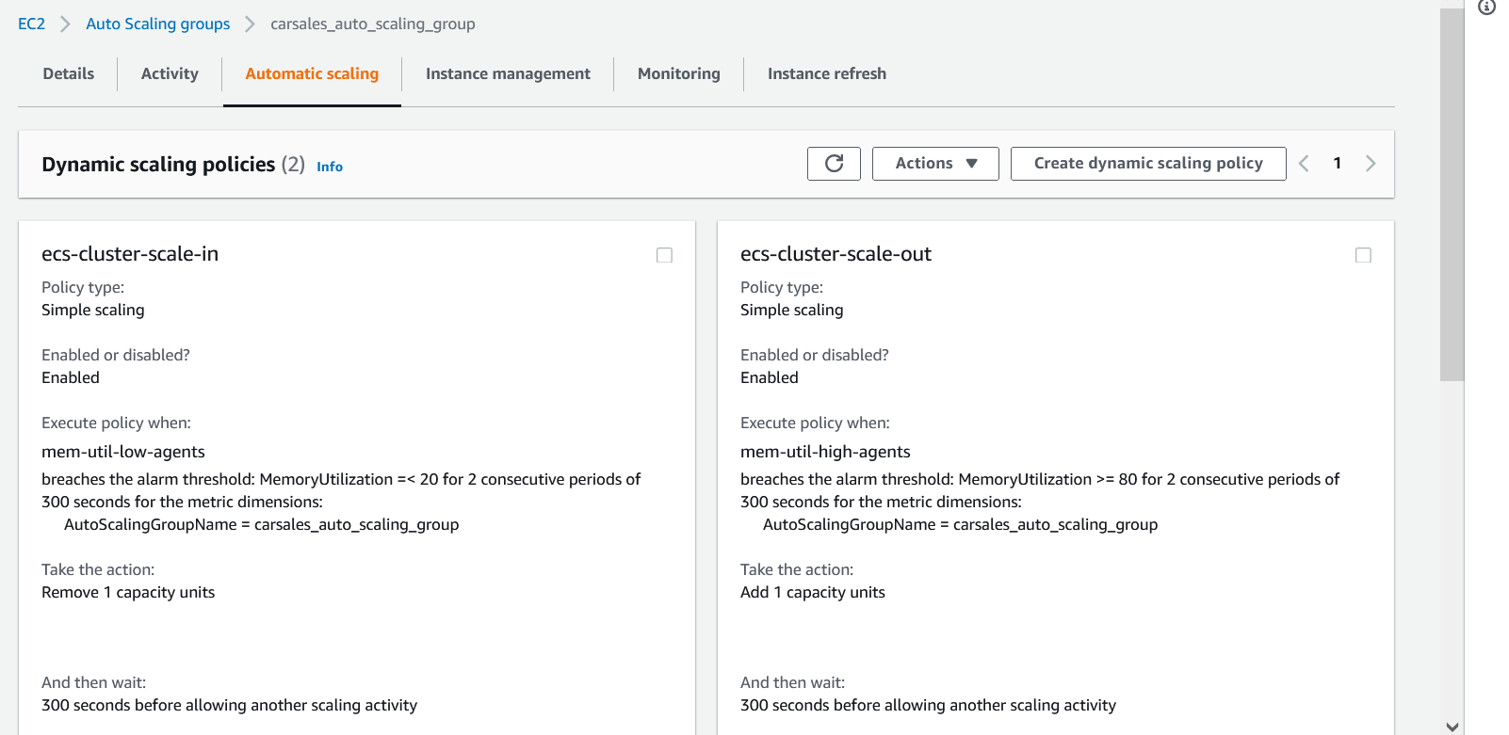

RDS db URL and password save to SSM parameter store. Password is generated by random string.

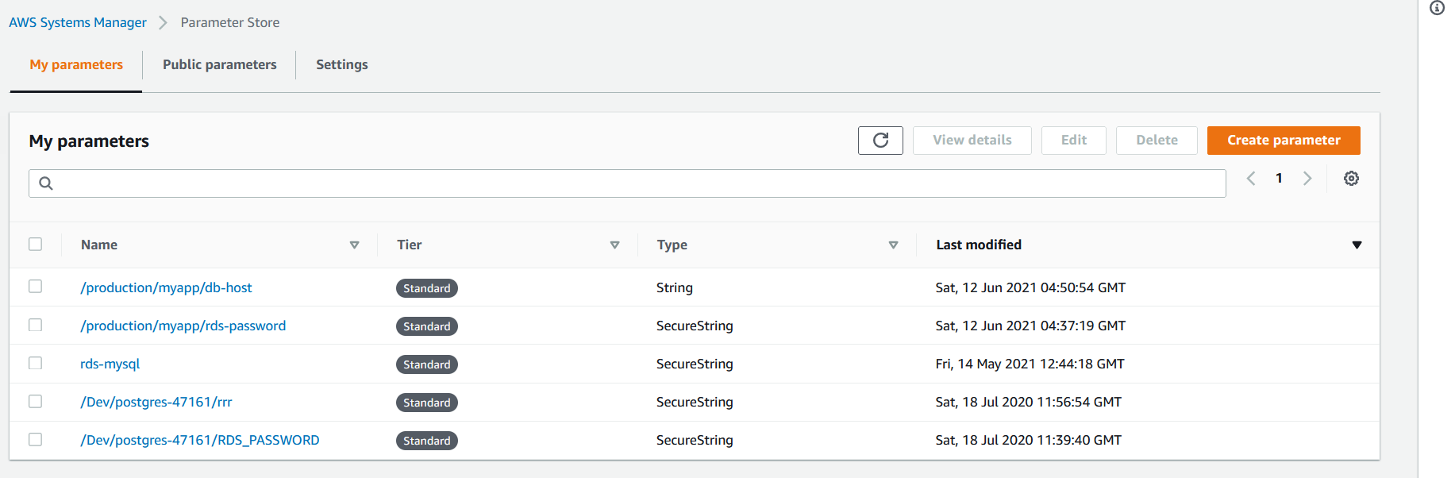

RDS can only be accessed by EC2 ECS instances

