电 子 科 技 大 学
毕 业 设 计 论 文

学生姓名 熊英飞
学生学号 2008009013
所在学院 计算机科学与工程学院
所学专业 计算机科学与技术
指导教师 吴跃
指导单位 计算机科学与工程学院

2004年5月30日
电 子 科 技 大 学
毕业设计（论文）任务书

拟题单位 电子科技大学 审题人 吴跃

题目全称 语言独立的面向方面扩展的设计与实现

主要任务：
- 分析目前基于.Net的面向方面实现。
- 研究现有语言的问题和改进的途径。
- 设计一个语言独立的面向方面扩展语法。
- 实现一个语言独立的面向方面编织器。

起止时间： 2004年2月20日至2004年6月15日
学生姓名 熊英飞专业计算机科学与技术班次20080090
指导单位 计算机科学与工程学院
指导教师 吴跃
设计地点 计算机科学与工程学院
成果形式 代码、可执行程序、论文

2004年6月15日

Abstract 1
Chapter 1 Introduction 2
1.1 Background 2
1.2 Objectives 2
Chapter 2 The State of Art 4
2.1 Java AOP Approaches 4
2.1.1 AspectJ 4
2.1.2 Hyper/J 4
2.2 .Net AOP Approaches 5
2.2.1 Loom.net 5
2.2.2 Eos 5
2.2.3 AopDotNetAddIn 5
2.2.4 AspectC# 6
2.2.5 Weave.Net 6
2.2.6 SetPoint! 6
2.2.7 AOP.Net 6
2.2.8 Summary 6
Chapter 3 The Design of CCC Language 7
3.1 Basic Conceptions 7
3.1.1 Join Point 7
3.1.2 Pointcut 7
3.1.3 Advice 8
3.1.4 Aspect 8
3.2 Our Design Principals 8
3.2.1 The role of CCC 8
3.2.2 Use XML to Specify Aspect 9
3.2.3 Static Join Point Model 9
3.2.4 Pointcuts are as primitive as possible 12
3.2.5 Context Binding Specified by Advice 12
3.3 The Syntax and Semantics of CCC 13
3.3.1 Pointcuts 13
3.3.2 Named Pointcuts 18
3.3.3 Advices 19
3.3.4 Aspects 21
Chapter 4 The Design and Implementation of System 22
4.1 The Overall Architecture 22
4.2 The Design of Code Graph 23
4.2.1 Core classes 23
4.2.2 Helper classes 24
4.2.3 The aspect-oriented part of code graph 26
4.3 The Design of Weaver 28
4.3.1 The Interpreter Pattern 28
4.3.2 The Use of Interpreter Pattern in Pointcut Evaluation 29
4.3.3 The Execution Flow of Weaver 31
4.4 Current Implementation Limits 32
Chapter 5 Conclusion 33
5.1 Summary of Objectives 33
5.2 Benefits 34
5.3 Future Work 34
5.3.1 Aspect Reuse 34
5.3.2 Language-specific Aspect-Orient Tool 34
Reference 35
Acknowledgement 37
Appendix 38
The complete schema for CCC language 38

语言独立的面向方面扩展的设计与实现
学生姓名：熊英飞 班 级：2008009013
指导老师：吴跃 教授
指导单位： 计算机科学与工程学院
摘要
自从面向方面编程最早在ECOOP`97上被提出以后，面向方面编程的工具与方法学在Java领域得到了飞速发展。然而，尽管.Net和Java非常相近，目前在.Net平台上的面向方面工具都还停留在实验阶段。复杂的底层结构与多语言支持的功能使得将面向方面编程应用到.Net平台非常困难。
本论文的目标是在.Net平台上设计与实现一个语言独立的方面编织工具。该工具名叫CCC，全称是Cross-language Cross Cutter。CCC通过XML来描述方面信息，直接对编译后的assembly中的IL语言进行操作。所以CCC能够应用到所有的.Net语言上。

Abstract
Since AOP was first announced in ECOOP`97, the AOSD tools and methodologies have developed in a rapid speed in Java area. However, no matter how homologous .Net and Java are, AOP tools on .Net platform are still in experimental stage. The complex infrastructure and multi-language support make it hard to establish aspect-oriented programming on .Net.
The objectives of this dissertation include design and implementation of a language-independent aspect weaving tool for Microsoft .Net platform, CCC, which stands for Cross-language Cross Cutter. CCC relies on XML to specify aspect binding and targets at IL in compiled assembly, thus it can be applied to any .Net language.
关 键 词
CCC | .Net
AOP | 面向方面编程
Weave | 编织
language-independence | 语言独立

Introduction

Background
In the evolution of programming language, there is an obvious approach: putting code which is logically related together. OOSD (Object-Oriented Software Development) encapsulates data member and its related functions into a class, and this approach achieves comprehensibility and modifiability. But there is still a lot of code, which are logically related, scattered throughout the system. These pieces of code are called “cross-cuts”, for they crosscut the class boundaries. To maintain this “cross-cutting” code is very costly and error-prone, because each modification requires navigating through all the classes and modifying each duplicate. To solve this problem, AOSD (Aspect-Oriented Software Development) emerged.
AOSD tries to decompose the crosscutting code into “Aspect”, a modularized unit which can contain crosscutting code together. After AOP was first announced by Gregor Kiczales in ECOOP`97, the AOSD tools and methodologies developed in a rapid speed, especially in Java area. So far, several major AOP tools in Java language, such as AspectJ, JBoss, Hyper/J, have gained wide commitment and have been used, although in a limited way, in some industrial projects.
Although.Net and Java are homologous, AOP tools on .Net platform are still in their experimental stage. For one thing, the .Net infrastructure is much more complex than Java, which makes the .Net languages, such as C#, have more language constructs than Java. Hence the mature AOP tools on Java platform can not port to .Net without redesign. For another, the .Net is language-independent in its nature. So the AOP tool on .Net platform is better to also be language-independent, which brings many new problems.

Objectives
Our project is to design and implement of a language-independent aspect weaving tool for Microsoft .Net platform, CCC, which stands for Cross-language Cross Cutter. The objectives of the project include the following:
- Analysis of existing AOP tools
- Analyzing the problems in existing language and trying to avoid them in CCC language design
- Designing AOP extensions to all .Net language
- Development of a weaver tool which targets at IL in compiled assemblies

The State of Art

Java AOP Approaches

AspectJ
AspectJ is one of the earliest and most widely used AOP tools, developed by Xerox PARC. It introduces an aspect-oriented extension to Java language. AspectJ supports two types of crosscutting implementation: The first type enables the developer to define additional implementation to run at certain well-defined points of execution in the program; this is called “dynamic crosscutting”. The second type enables the developer to define new operations on existing types; this is called “static crosscutting”.

Hyper/J
Hyper/J is also one of the earliest tools. It adopts a different approach than most other aspect-oriented tools but reaches the same goal. The developers of Hyper/J think modern languages suffer from a problem called “tyranny of dominant decomposition”: these languages permit the separation and encapsulation of only one kind of concern at a time. So the parts of software addressing other concerns, known as “cross-cutting concerns” in other AOP tools, will cause problem. It defines a unit to encapsulate concerns, called hyperslice. This concept is somewhat similar to "aspect” in other aspect-oriented languages. By defining the relationships between a set of hyperslices, the user can integrate them into a hypermodule. And the whole system is composed of hypermodules.

.Net AOP Approaches

Loom.net
Loom.net project consists of two independent sub projects: the dynamic weaver RAPIER LOOM.NET and the static weaver. The dynamic weaver is CLS-compatible library which weaves aspect at runtime. To achieve this, every object being woven must be explicitly created by the weaver object, so the crosscutting concern is not completely separated. And the dynamic weaving is also very slow.
The static weaver is preprocessor that operates on binary .NET assemblies, so it is applicable to all .Net Language. The static weaver uses both xml file and an extension to c# language to specify crosscutting. But unfortunately, static weaver doesn’t modify existing assemblies but creates new ones. And the clients still have to modify their code to reference to the new assembly.

Eos
Eos is an AO extension to C#. It introduces new keyword to C# and preprocesses the source file before compile. Also as an experimental model in University of Virginia, it introduces a new language construct “instance aspect”, which confines the cross-cutting not only on classes but on instances. The current release of Eos is stablest among all the AOP tools on .Net we have ever seen, but its functionality is so limited that it does not support some basic pointcut like call().

AopDotNetAddIn
This newly emerged project, although without a former name, is perhaps the best AspectJ-like tool available. It uses xml to specify crosscutting behavior. It is a preprocessor operating on source files, but with the help of well-designed .Net CodeDom, it can be applied on C#, VB and J#, almost all popular .Net languages. Also as an add-in, it is well integrated with Visual Studio.Net, so its user interface is the best one among all tools. Unfortunately, this project is only at version 0.11 and not stable enough to use yet.

AspectC#
AspectC# is one of the earliest projects trying to bring AOP into .Net world. It adds an extension to C# and preprocesses file before compiling. Unfortunately, this project seems have not progressed since a year ago and the previous version is very unstable.

Weave.Net
Weave.net will be a tool weaving code at IL level, same as Loom.net. It uses XML file to specify crosscutting and independent of all .Net languages. But it is still under development and nothing has released.

SetPoint!
SetPoint! is an project trying to solve the unclarity in current syntax-based based pointcut by introducing a new concept called semantic pointcuts. It is still under research and will be developed using Microsoft's .NET framework.

AOP.Net
AOP.NET is a project following the early attempt of AOP#. This project is still under development.

Summary
From the introductions above we could conclude that: the .Net AOP tools are in their elementary stage. Some tools have never released, and the released tools are either unstable or of limited functionality.

The Design of CCC Language

Basic Conceptions

Join Point
A join point is a well-defined point in the program flowError: Reference source not found. Join point model is very critical to aspect-oriented programming language design, for it provides the common frame of reference that makes it possible to define the dynamic structure of crosscutting concerns
In CCC, we define six types of join points. Method Reference, Method Declaration, Field Set Reference, Field Get Reference, Type Reference, Type Declaration.
Method reference represents the point on which a method is called, that is, a method is referred by the other parts of the system. The IL directives call and callvirt are examples of this join point.
Method declaration represents the point where a method is declared. It works like the execution() pointcut in AspectJ. All method declarations, no matter private or public, are considered method declaration join points.
Field set reference represents the point where a field is being set. The IL directives stfld and stsfld are examples of this join point.
Field get reference represents the point when the value of the field is being retrieved. The IL directives ldfld and ldsfld are examples of this join point.
Type reference represents the point where a type is referred. It also includes the dynamically created type such as array and managed pointer.
Type declaration represents the point where a type is declared.

Pointcut
A pointcut picks out certain join points in the program flowError: Reference source not found. In general, a pointcut is a set of conditions to filter out the join points which are not of interest.
In CCC, pointcut is represented by pointcut expressions, which will be defined latter. And a pointcut can also have a name, so that we can refer to existing pointcuts defined before.

Advice
A piece of advice is code that is executed when a join point is reachedError: Reference source not found. Advice is the place where the crosscutting code (also referred as behavior code) lies. When the program runs and reaches some join points, the code in advice are invoked, as if it was woven into the program structure.
In CCC, advice also takes the responsibility to expose data from the executing context of the reached join point, which is always done by pointcuts in other aspect-oriented languages. This is a design tradeoff, and will be explained in next section.

Aspect
Aspect is the unit of modularity for crosscutting concerns. In CCC, aspect works like a class, encapsulating pointcuts and advices into a whole unit.

Our Design Principals

The role of CCC
Although we demonstrate CCC as a language, we are not expecting CCC to be widely used like C# that every programmer knows about it. CCC is language-independent, which means the CCC language must be written in some media separated from other code of the system. We believe programmers will reject this idea, because the theory behind AOP is to put pieces of code which are logically related together, and this breaks it.
So the best role for CCC is to be used as a tool to support aspect-oriented language implementation. Any other aspect-oriented language could firstly be transformed to CCC and then compiled by CCC Compiler. The only thing that the language implementer needs to do is transform his language to CCC, which is not of much work. Like IL is the intermediate language of object-oriented programming on .Net platform, we hope CCC would become the intermediate language of aspect-oriented programming on .Net platform.
However, CCC is still a language. We would welcome the use of CCC in experiment or in small scale. We just don’t encourage large-scale use of CCC in industrial project.

Use XML to Specify Aspect
One important characteristic of CCC is language-independence. To achieve language-independence, the media used to specify aspect in CCC must be independent of any .Net language. Also, it must be flexible enough so that the complex elements in an aspect-oriented language could be explicitly and clearly specified.
We regard XML as suitable media for this situation. Derived from SGML, XML is language-independent in its nature. XML, as a “metalanguage”, also meets our second requirements. It is flexible enough to describe any language constructs.
At the mean time, with the help of XSD (eXtensible Structure Definition), we can easily write a schema to automatically validate the grammar and syntax of user-written xml file, which saves a lot of code and developing time.
Another problem related to this topic is where the behavior code lies. The language like AspectJ surrounded the behavior code with advice declaration, so that the code is stored together with the aspect. But this is not suitable for a language-independent weaver. If we put the behavior code within the advice declaration, we must create a special compiler to deal with the behavior code. Such special compiler is impossible to recognize all languages, so the behavior code is limited to several languages and thus not language-independent.
Our approach is to let user write the behavior code within a static method in the target assembly. This method is called behavior method. And when declaring the advice, the user uses the method name to refer to the behavior method. The reason of the method being static is that a static method can be called at anytime without object creation.

Static Join Point Model
We classify the join point model into two categories: dynamic join point model and static join point model.
The join point model used in AspectJ and many other AspectJ-like languages is dynamic join point model. That is, the properties of the join point can only be determined at run-time. For example, if write the following code in AspectJ:
pointcut a() : args(String)
This pointcut a() selects not only the method whose first formal parameter type is String, but also the method which will be called with String argument at runtime (Note the difference between the two words: parameter and argument). That is to say, a method whose first formal parameter is object will be selected by the pointcut a() if it is called with an argument of String.
The dynamic join point model looks fine at first glance: pointcut a() does select all methods whose first argument is String. But it has significant effect towards system performance. Continuing the above example, in order to catch all the point when a method is called with String argument, the system has to type-check the argument value of all method whose first formal parameter type is object. This overhead is too significant to be ignored, because a lot of methods in Java library use object as its first parameter, such as the methods in Vector. To make matter worse, using any type in args() expression will also cause this overhead, for all types are derived from object.
When the programmer writes down the above statement, the things in his/her mind must be selecting some method whose first parameter is String. He/She will be unlikely to realize the significant effect towards the system.
So we choose static join point model as our join point model in CCC. The static join point model means all properties of the join point can be statically determined at compile time. Consider writing the following code in CCC:
<PointCut Name="a">
<And>
<ParameterTypeIs>
<ParameterIndex>1</ParameterIndex>
<Type>
<TypeNameMatches>System.String</TypeNameMatches>
</Type>
</ParameterTypeIs>
<ParameterCountIs>1</ParameterCountIs>
</And>
</PointCut>
This piece of code has almost the same meaning as the above AspectJ code except that: it only selects the method whose first formal parameter is String. Other methods, such as the methods whose first formal parameter is object, are not affected. So the programmers have more control over the system’s behavior.
One virtue of static join point model is: one can easily simulate the dynamic join point model by writing a little code. For example, if we are going to simulate the following AspectJ code:
pointcut a() : args(String)
before() : a()
{
//do something
}
We can write code in CCC like this:
<PointCut Name="a">
<And>
<ParameterTypeIs>
<ParameterIndex>1</ParameterIndex>
<Type><Inherits>
<TypeNameMatches>System.Object</TypeNameMatches>
</Inherits></Type>
</ParameterTypeIs>
<ParameterCountIs>1</ParameterCountIs>
</And>
</PointCut>
<Advice PointCut="a" Behaviour="Sample.Behaviour" Type="Before">
<Parameters>
<Parameter Name="StringArgument">
<Type><Direct>System.Object</Direct></Type>
<Binding Type="Argument" Index="0"/>
</Parameter>
</Parameters>
</Advice>
To select the join point where argument is of String type, we write a simple line in the behavior method:
public static void Behavior(object stringArgument)
{
if (stringArgument is String)
{
//do something
}
}

Pointcuts are as primitive as possible
In many aspect-oriented languages, pointcuts are not primitive. Take AspectJ as an example, the call() expression is not a primitive pointcut. It combines expressions of args() and within(), method name filtering and return type filtering. The nonprimitive pointcut is easy to write, but sometimes not flexible enough.
Because one important role of CCC is used as an intermediate language, so flexibility is most important. Every pointcut we defined in CCC is a primitive pointcut. The call() pointcuts in AspectJ is decomposed into six pointcuts: <Call>, <MethodNameMatches>, <DeclaringTypeIs>, <ParameterTypeIs>, <ParameterCountIs>, <ReturnTypeIs>

Context Binding Specified by Advice
In AspectJ and AspectJ-like languages, context binding is specified by pointcuts. We believe this approach has the following drawbacks:
- The binding declaration is separated from the parameter declaration
When we declare a parameter in advice, our intention is to bind this parameter to some data in the executing context. But unfortunately, the binding declaration is in pointcut, so we have to navigate to the pointcut to check if the parameter has been correctly bound. Sometimes the context binding behavior defined in the pointcut is not what we wanted, and we have to declare new pointcut. Since every parameter declared in advice is aimed to be bound on something, putting the two declarations together can greatly improve the readability and modifiability.
- Parameter binding must be explicitly checked
When parameter declaration and binding declaration is separated, there might be errors of parameter unbound or binding arguments not provided. Both situation should be explicitly checked, which adds burden to both user and compiler implementer.
- Ambiguous expression could be formed
When context binding is specified by pointcuts, we can write code like this:
pointcut a(int arg1) : call(* SomeMethod(..)) || args(arg1);
What if args(arg1) evaluated as false and call(* SomeMethod(..)) evaluated as true? What will be passed to arg1? This is an ambiguous expression. AspectJ considers such ambiguous expression as an error. But such semantic error is best to be avoided by carefully designing the syntax.
Because of these drawbacks, the binding behavior in CCC is specified by advice. In CCC, every parameter declaration in advice contains a binding declaration specifying which data in the executing context this parameter should be bound to. This have solved all the above problems: binding declaration and parameter declaration are put together, and never will be parameter unbound error, binding arguments not provided error or ambiguous expression error occur.

The Syntax and Semantics of CCC

Pointcuts
The syntax of pointcut is listed below in XSD schema:
<xs:complexType name="PointCut">
<xs:choice>
<xs:element name="And" type="BinaryOperatorPointCut" />
<xs:element name="Or" type="BinaryOperatorPointCut" />
<xs:element name="Not" type="UnaryOperatorPointCut" />
<xs:element name="Call" type="FilterPointCut" />
<xs:element name="Execution" type="FilterPointCut" />
<xs:element name="Set" type="FilterPointCut" />
<xs:element name="Get" type="FilterPointCut" />
<xs:element name="MemberAccessibiltyIs" type="MemberAccessibilityPointCut" />
<xs:element name="StaticMember" type="FilterPointCut" />
<xs:element name="InstanceMember" type="FilterPointCut" />
<xs:element name="TargetTypeIs" type="TypeOperandPointCut" />
<xs:element name="ReturnTypeIs" type="TypeOperandPointCut" />
<xs:element name="ParameterTypeIs" type="ParameterTypePointCut" />
<xs:element name="ParameterCountIs" type="xs:nonNegativeInteger"/>
<xs:element name="DeclaringTypeIs" type="TypeOperandPointCut" />
<xs:element name="WithInMethod" type="MethodOperandPointCut" />
<xs:element name="BaseOf" type="TypeOperandPointCut" />
<xs:element name="InterfaceOf" type="TypeOperandPointCut" />
<xs:element name="Inherits" type="TypeOperandPointCut" />
<xs:element name="Implements" type="TypeOperandPointCut" />
<xs:element name="ArrayOf" type="TypeOperandPointCut" />
<xs:element name="ManagedPointerOf" type="TypeOperandPointCut" />
<xs:element name="Overrides" type="MethodOperandPointCut" />
<xs:element name="FieldNameMatches" type="PatternPointCut" />
<xs:element name="MethodNameMatches" type="PatternPointCut" />
<xs:element name="TypeNameMatches" type="PatternPointCut" />
<xs:element name="PointCutReference" type="PointCutReferencePointCut" />
</xs:choice>
</xs:complexType>
We can see from the schema that the pointcut type consists of different types of concrete pointcut. The combination of these concrete pointcuts is called pointcut expression. We’ll explain these concrete pointcuts one by one.

Binary Operator Pointcuts
<xs:complexType name="BinaryOperatorPointCut">
<xs:choice maxOccurs="unbounded" minOccurs="2">
<xs:element name="And" type="BinaryOperatorPointCut" />
<xs:element name="Or" type="BinaryOperatorPointCut" />
<xs:element name="Not" type="UnaryOperatorPointCut" />
<xs:element name="Call" type="FilterPointCut" />
<xs:element name="Execution" type="FilterPointCut" />
<xs:element name="Set" type="FilterPointCut" />
<xs:element name="Get" type="FilterPointCut" />
<xs:element name="MemberAccessibiltyIs" type="MemberAccessibilityPointCut" />
<xs:element name="StaticMember" type="FilterPointCut" />
<xs:element name="InstanceMember" type="FilterPointCut" />
<xs:element name="TargetTypeIs" type="TypeOperandPointCut" />
<xs:element name="ReturnTypeIs" type="TypeOperandPointCut" />
<xs:element name="ParameterTypeIs" type="ParameterTypePointCut" />
<xs:element name="ParameterCountIs" type="xs:nonNegativeInteger"/>
<xs:element name="DeclaringTypeIs" type="TypeOperandPointCut" />
<xs:element name="WithInMethod" type="MethodOperandPointCut" />
<xs:element name="BaseOf" type="TypeOperandPointCut" />
<xs:element name="InterfaceOf" type="TypeOperandPointCut" />
<xs:element name="Inherits" type="TypeOperandPointCut" />
<xs:element name="Implements" type="TypeOperandPointCut" />
<xs:element name="ArrayOf" type="TypeOperandPointCut" />
<xs:element name="ManagedPointerOf" type="TypeOperandPointCut" />
<xs:element name="Overrides" type="MethodOperandPointCut" />
<xs:element name="FieldNameMatches" type="PatternPointCut" />
<xs:element name="MethodNameMatches" type="PatternPointCut" />
<xs:element name="TypeNameMatches" type="PatternPointCut" />
<xs:element name="PointCutReference" type="PointCutReferencePointCut" />
</xs:choice>
</xs:complexType>
Binary operator pointcuts are not really binary, because they can have more than 2 operands. But when there are n operands and n is larger than 2, these operands will be reformed into n – 1 binary expressions when compiling. So we still refer them as “binary”.
<And> pointcut matches the join point that all its operands match.
<Or> pointcut match the join point that any one of its operands matches.

Unary Operator Pointcuts
<xs:complexType name="UnaryOperatorPointCut">
<xs:complexContent>
<xs:extension base="PointCut" />
</xs:complexContent>
</xs:complexType>
<Not> matches all the join points which its operand doesn’t match.

Filter Pointcuts
<xs:complexType name="FilterPointCut">
<xs:complexContent>
<xs:extension base="PointCut" />
</xs:complexContent>
</xs:complexType>
All the filter pointcuts match some specific types of join points. They filter out the other types of join points from its inner pointcut, so they are called filter pointcuts
<Call> matches method reference. It filters out all the join points which are not method reference. Only the join points which are method reference and are matched by the inner pointcut of <Call> will be matched.
<Execution> matches method declaration. It filters out all the join points which are not method declaration.
<Set> and <Get> matches field set reference and field get reference respectively.
<StaticMember> matches method reference, method declaration, field set reference or field get reference when the referred type member in the join point is a static member. <InstanceMember> is similar to <StaticMember> except that it matches only instance members (that is, the members are not static).

Member Accessibility Pointcuts
<xs:complexType name="MemberAccessibilityPointCut">
<xs:attribute name="Accessibility" use="required">
<xs:simpleType>
<xs:restriction base="xs:string">
<xs:enumeration value="Public" />
<xs:enumeration value="Family" />
<xs:enumeration value="Assembly" />
<xs:enumeration value="FamOrAssem" />
<xs:enumeration value="FamANDAssem" />
<xs:enumeration value="Private" />
<xs:enumeration value="Any" />
</xs:restriction>
</xs:simpleType>
</xs:attribute>
</xs:complexType>
<MemberAccessibiltyIs> matches method reference, method declaration, field set reference or field get reference when the referred type member has the same accessibility as the accessibility specified by the attribute “Accessibility”.

Type Operand Pointcuts
<xs:complexType name="TypeOperandPointCut">
<xs:complexContent>
<xs:extension base="PointCut" />
</xs:complexContent>
</xs:complexType>
Type operand pointcut has one pointcut operand and it requires the operand pointcut matches type reference join point or the whole pointcut matches nothing.
<TargetTypeIs> matches method reference, field set reference or field get reference when the type of the target object is matched by the operand pointcut. Note that the join point model in CCC is static join point model, so <TargetTypeIs> will only match the join points whose target type is exactly matched by the operand pointcut, not the ones whose target types might be the types matched by the operand pointcut at runtime.
<DeclaringTypeIs> matches method reference, method declaration, field set reference or field get reference when the type of “this” pointer at the join point will be matched by its operand pointcut.
<ReturnTypeIs> matches method reference or method declaration when the return type of the method is matched by the operand pointcut.
<BaseOf> matches type reference or type declaration when the type in the join point is the base type of any one of the types matched by its operand reference.
<InterfaceOf> matches type reference or type declaration when the type in the join point is an interface and one of the types matched by its operand pointcut has implemented this interface.
<Inherites> matches type reference or type declaration when the type in the join point is derived from one of the types matched by the operand pointcut.
<Implements> matches type reference or type declaration when the type in the join point has implemented one of the interfaces matched by the operand pointcut.
<ArrayOf> matches type reference when the referenced type is an array and the element type of that array is matched by the operand pointcut.
<ManagedPointerOf> matches type reference when the referenced type is a managed pointer and the element type of that managed pointer is matched by the operand pointcut.

Parameter Pointcuts
<xs:complexType name="ParameterTypePointCut">
<xs:sequence>
<xs:element name="ParameterIndex" type="xs:nonNegativeInteger" />
<xs:element name="Type" type="PointCut" />
</xs:sequence>
</xs:complexType>
<ParameterTypeIs> matches method declaration or method reference when the type of the method parameter whose index is “ParameterIndex” is matched by the pointcut declared in “Type”.
<ParameterCountIs> matches method declaration or method reference when the method has the same number of parameter as the number specified in the pointcut.

Method Operand Pointcuts
<xs:complexType name="MethodOperandPointCut">
<xs:complexContent>
<xs:extension base="PointCut" />
</xs:complexContent>
</xs:complexType>
Type operand pointcuts have one pointcut operand and they require the operand pointcut matches method declaration join point or the whole pointcut matches nothing.
<WithInMethod> matches method reference, field set reference or field get reference when the statement representing the join point appears in one of the methods matched by the operand pointcut.
<Overrides> matches method reference or method declaration when the method in the join point has overridden one of the method matched by the operand pointcut.

Pattern Operand Pointcuts
<xs:complexType name="PatternPointCut">
<xs:simpleContent>
<xs:extension base="PatternString" />
</xs:simpleContent>
</xs:complexType>
<xs:simpleType name="PatternString">
<xs:restriction base="xs:string">
<xs:pattern value="((\p{L}|\p{Nl}|[_%?])(\p{L}|\p{Nl}|\p{Nd}|\p{Mn}|\p{Mc}|\p{Cf}|[%?])*)([.](\p{L}|\p{Nl}|[_%?])(\p{L}|\p{Nl}|\p{Nd}|\p{Mn}|\p{Mc}|\p{Cf}|%?])*)*"/>
</xs:restriction>
</xs:simpleType>
Pattern Operand Pointcuts have a string operand that contains wildcards, this operand is called pattern. There are two types of wildcards in CCC: “?” matches a single arbitrary character, “%” matches characters of arbitrary number.
<TypeNameMatches> matches type declaration or type reference when the full name of that type (that is, namespace name + “.” + type name) is matched by the pattern.
<FieldNameMatches> matches field get reference or field set reference. It has two forms. When the pattern contains no character “.”, it is in its first form. The pointcut matches the fields whose name is matched by the pattern in all types of the system. When the pattern contains character “.”, it is in its second form. If we split the pattern string into two parts with the last “.” appeared in the string, the pointcut is equivalent to the following pointcut:
<And>
<FieldNameMatches>first part</FieldNameMatches>
<DeclaringTypeIs>
<TypeNameMatches>second part</TypeNameMatches>
</DeclaringTypeIs>
</And>
<MethodNameMatches> is similar to <FieldNameMatches>. It matches method reference and method declaration. When there is no “.” in the pattern string, it matches the methods whose name is matched by the pattern. When there is “.” in the pattern, the pattern is split into two parts. The first part is used to match type name and the second part is used to match method name.

Pointcut Reference
<xs:complexType name="PointCutReferencePointCut">
<xs:attribute name="Name" type="TypeReferenceString"/>
</xs:complexType>
<xs:simpleType name="TypeReferenceString">
<xs:restriction base="xs:string">
<xs:pattern value="((\p{L}|\p{Nl}|[_])(\p{L}|\p{Nl}|\p{Nd}|\p{Mn}|\p{Mc}|\p{Cf})*)([.]((\p{L}|\p{Nl}|[_])(\p{L}|\p{Nl}|\p{Nd}|\p{Mn}|\p{Mc}|\p{Cf})*))*" />
</xs:restriction>
</xs:simpleType>
Pointcut reference is a means to refer to existing pointcut. Name attribute is the full name of an existing named pointcut (defined latter). If the named pointcut is in the same aspect, the aspect name could be omitted.
When the system evaluates a pointcut reference, it jumps to the referred pointcut and evaluates the referred pointcut instead.

Named Pointcuts
<xs:complexType name="NamedPointCut">
<xs:complexContent>
<xs:extension base="PointCut">
<xs:attribute name="Name" type="xs:string" use="required" />
<xs:attribute name="Accessibility" default="Private">
<xs:simpleType>
<xs:restriction base="xs:string">
<xs:enumeration value="Public" />
<xs:enumeration value="Private" />
</xs:restriction>
</xs:simpleType>
</xs:attribute>
</xs:extension>
</xs:complexContent>
</xs:complexType>
A pointcut can be given a name and will then be called named pointcut. Other parts of the system can refer to the pointcut using the name. A named pointcut also have an attribute “Accessibility”. When the accessibility is “Public”, this pointcut can be referred to from any parts of the system. When the accessibility is “Private”, this pointcut can only be referred to within the aspect in which it declared.

Advices
<xs:complexType name="Parameters">
<xs:sequence>
<xs:element name="Parameter" type="Parameter" minOccurs="1" maxOccurs="unbounded" />
</xs:sequence>
</xs:complexType>
<xs:complexType name="Parameter">
<xs:sequence>
<xs:element name="Type" type="TypeReference" />
<xs:element name="Binding" type="ParameterBinding" />
</xs:sequence>
<xs:attribute name="Name" type="xs:string" use="required" />
</xs:complexType>
<xs:complexType name="ParameterBinding">
<xs:attribute name="Type" use="required">
<xs:simpleType>
<xs:restriction base="xs:string">
<xs:enumeration value="This" />
<xs:enumeration value="Target" />
<xs:enumeration value="Argument" />
<xs:enumeration value="Field" />
</xs:restriction>
</xs:simpleType>
</xs:attribute>
<xs:attribute name="Index" type="xs:nonNegativeInteger" use="optional">
<xs:annotation><xs:documentation>
This attribute exists when and only when Type == Argument
It indicate the index of the argument to be bound. Zero based.
</xs:documentation></xs:annotation>
</xs:attribute>
</xs:complexType>
<xs:complexType name="Advice">
<xs:all>
<xs:element name="PointCut" type="PointCut" minOccurs="0" />
<xs:element name="Parameters" type="Parameters" minOccurs="0" />
</xs:all>
<xs:attribute name="PointCut" type="TypeReferenceString" />
<xs:attribute name="Behaviour" type="MemberReference" use="required" />
<xs:attribute name="Type" use="required">
<xs:simpleType>
<xs:restriction base="xs:string">
<xs:enumeration value="Before" />
<xs:enumeration value="After" />
</xs:restriction>
</xs:simpleType>
</xs:attribute>
</xs:complexType>
Advice defines what will be executed at specific pointcut in execution of the program. The code to be executed is called behavior.
The behavior code is defined in a public static method in CCC. Users can specify the full method name in “Behaviour” attribute to define which method will be used by the advice. The full method name means: namespace name + type name + method name, such as “SomeNamespace.SomeClass.SomeMethod”. If there are multiple methods with the same name, such as overloaded methods, the weaver will report an error.
The pointcut in the advice can be given in two ways: by named pointcut or by anonymous pointcut. By giving a name in the “PointCut” attribute, we can refer to some pointcut already declared. Or we can declare a new anonymous pointcut through the “PointCut” element. Either way is OK but not both of them.
The “Type” attribute defines how the behavior code is executed at the join points. The advice has two types in this release. The before advice means the behavior code runs just before the join point picked out by the pointcut. The after advice means the behavior code runs just after the join point picked out by the pointcut, even if it throws an exception.
Advices also expose data from the execution context at the join points. The exposed data can then be passed into the behavior method as parameters. This exposing behavior is defined in the “Parameters” element.
Each parameter has a “Name” attribute to specify the name of the parameter, a “Type” element to specify the type of the parameter and a “Binding” element to specify which data this parameter will be bound to. The types of parameters in the behavior method must exactly match the types of advice parameters, or the weaver will report an error.
There are 4 types of binding in this release. “This” applies to method reference, method declaration, field set reference and field get reference join points, binding the current executing object (that is, this object in C#) to the parameter.
“Target” applies to method reference, field set reference and field get reference. It binds the target object (the object on which a call or field operation is applied to) to the parameter.
“Field” applies to the field set reference and field get reference join points. When it is applied to field set reference, it binds the parameter with the value to be set to the field. When it is applied to field get reference, it binds the value of the field
“Argument” applies to the method set reference and method get reference join points. When binding type is argument, the “Index” attribute will be applicable. “Argument” binds the parameter with the argument passed to the method whose index is as same as the value specified by “Index” attribute.

Aspects
<xs:element name="Aspects">
<xs:complexType>
<xs:sequence>
<xs:element name="Aspect" type="Aspect" maxOccurs="unbounded" minOccurs="0" />
</xs:sequence>
</xs:complexType>
</xs:element>
<xs:complexType name="Aspect">
<xs:choice maxOccurs="unbounded" minOccurs="0">
<xs:element name="Advice" type="Advice" />
<xs:element name="PointCut" type="NamedPointCut" />
</xs:choice>
<xs:attribute name="Name" type="xs:string" use="required" />
</xs:complexType>
Aspect wraps named pointcuts and advices together to form a modular cross-cutting unit. An aspect also has a name so that it can be referred to latter. The only root element in CCC is “Aspects”; it contains zero or more aspects.

The Design and Implementation of System
To achieve the goal of a language-independent weaver, we decided to create a weaver operates at the IL directives in the compiled assembly directly. The system accepts the compiled assembly and the xml file specifying aspects as input and output the woven assembly.

The Overall Architecture
To make matters simple, we created a set of classes to represent the assembly structure in memory. This set of classes is called code graph. The system first parses the assembly into code graph, then performs weaving operations on code graph, and finally generates new assembly according to the woven code graph.
The System falls into five major parts: Assembly Parser, Weaver, Assembly Generator, Code Graph and Driver, their relationships are shown below:
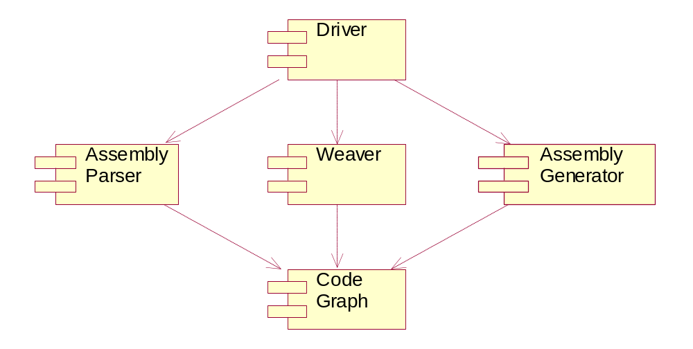
Figure 1 System Overview
Code graph is a set of classes to represent the type hierarchy in memory.
Assembly parser analyzes the structure of assembly and parses it into code graph.
Weaver reads the aspect specified in xml files and weaves them into code graph.
Assembly generator reads the code structure in code graph and writes them into the new assembly.
Driver controls the whole flow.

The Design of Code Graph

Core classes
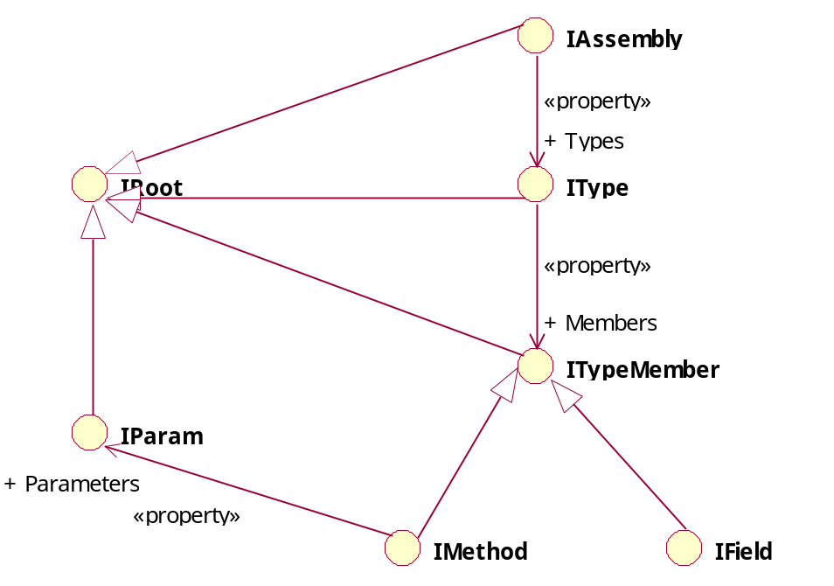
Figure 2 Static Model of Core Classes
The hierarchy of Code Graph is shown above. The IRoot is the root of all code graph objects. IAssembly represents an assembly. It contains all the types in this assembly. Each type is represented as an instance of IType. IType maintains an array of ITypeMember, from which IMethod and IField derive. The other types of type member, such as delegate and event, are not of interest in our system, so they are not included in the code graph. IMethod also associates with IParam, which represents one of the parameters in the method.
Note the types shown in the above diagram are all interfaces. To create a code graph, one must define some concrete classes to implement the interfaces. There are two reasons for this design:
- The implementation can be easily modified. If we draw the dependent relationship onto a diagram, it is something like this:
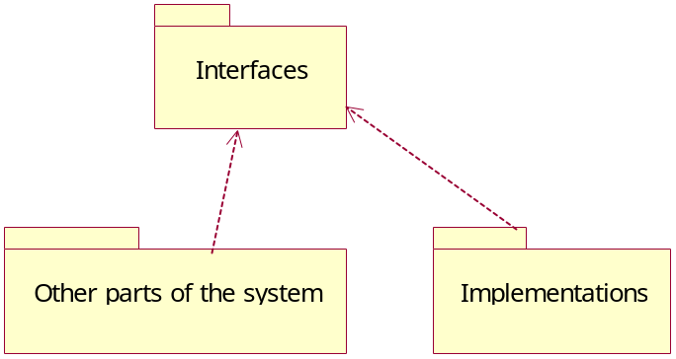
Figure 3 Package Diagram of Code Graph
The other parts of the system depend on interfaces and implementations depend on interfaces, but nothing depends on one implementations. So the implementations are independent of the other part of the system and can be modified freely with nothing affected.
- We can provide different kinds of implementations in different situations. In fact, we provided two kinds of implementations in this release. One only performs the simple task of data storage, and will be constructed by the assembly parser (The names of the classes in this implementation begin with “Code”). The other one dynamically reflects the code graph on querying with the help of System.Reflection classes. (The names of the classes in this implementation begin with “Reflection”).

Helper classes
With the core classes, we have built the basic framework of code graph. But the basic framework is not enough for satisfying the need of clients. Clients may want to quickly find a type by name, or get the sub types of a specific type. All these tasks need extra code. We can ask the clients to write this extra code themselves, but this might bring 2 problems:
- There will be a lot of code duplications. Every client who wants to finish the same task would keep a copy of the code. Code duplication is one of the major problems to maintenance.
- The system will be hard to optimize. To quickly find something by name, the best solution is to build an index for that name. But it is impossible for clients to build such an index, for no client owns code graph. Thus the clients have to do linear search, which is rather slow.
Another solution is to add methods to existing core classes. This might be the most common object-oriented solution, but we rejected this solution for the following reasons:
- This breaks the Single Responsibility Principle. The responsibility of core classes is to store data, adding these methods would add other responsibilities, such as search, to them.
- There would be multiple implementations of the interfaces, so the code would be duplicated in each implementation.
So our solution is to create another set of classes to delegate to the core classes. These classes are called helper classes. While the core classes take the responsibility of data storage, the helper classes take other responsibilities. And there would be no code duplications.
After adding the helper classes, the dependency diagram of the system becomes:
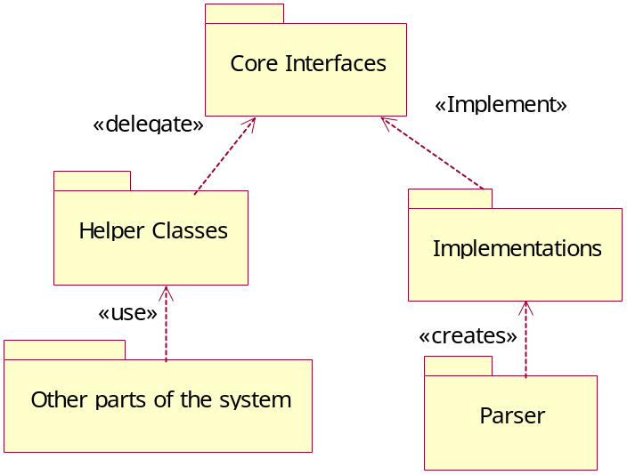
Figure 4 Package Diagram with Helper Classes
The other parts of the system no longer use core classes directly. They access the helper classes to delegate to the core classes.
The hierarchy of helper classes is shown below:
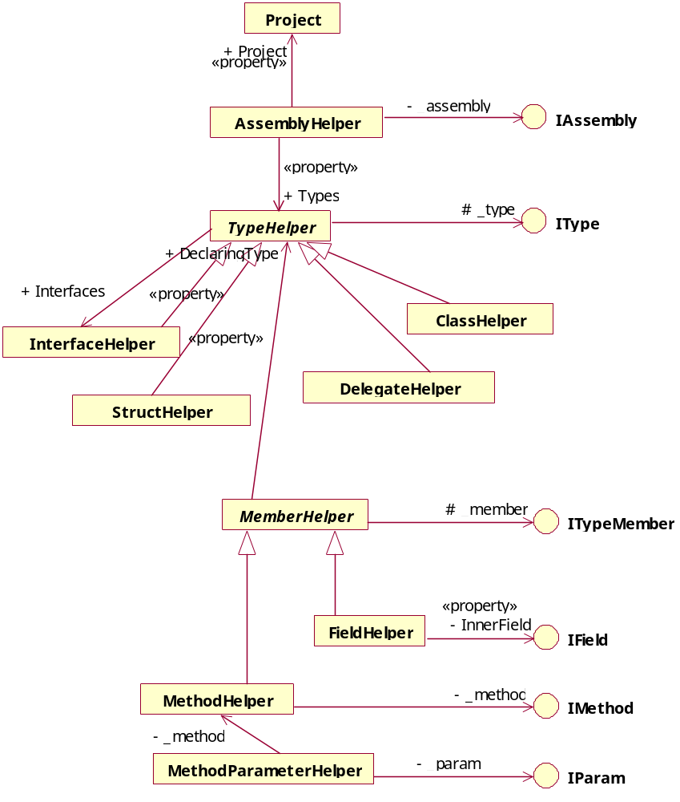
Figure 5 Static Model of Helper Classes

The aspect-oriented part of code graph
The last two sections have described the object-oriented part of code graph. The aspect-oriented code, defined in the xml file, will also be parsed into the code graph. The aspect-oriented part of code graph is shown below:
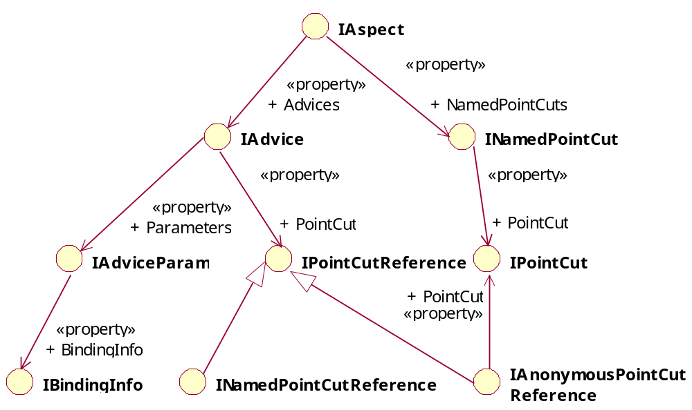
Figure 6 Aspect-Oriented Part of Code Graph
IAspect: the counterpart of <Aspect> element. It maintains two lists: the list of IAdvice and the list of INamedPointCut.
IAdvice: the counterpart of <Advice> element. It maintains a list of IAdviceParam and a IPointCutReference object to indicate which pointcut it uses.
INamedPointCut: the counterpart of <PointCut> element in <Aspect> element.
IPointCut: the base interface of all pointcuts. In code graph, each type of pointcut is represented by an interface derived from IPointcut. There are dozens of such interfaces so they are not shown on the diagram.
IPointCutReference: The base interface of pointcut references. There are two types of pointcut reference. INamedPointCutReference refers to a named pointcut by specifying its name. IAnonymousPointCutReference refers to a pointcut by declaring it within its body.
IAdviceParam: the counterpart of <Parameter> element in <Advice> element.
IBindingInfo: the counterpart of <Binding> element in <Parameter> element.

The Design of Weaver

The Interpreter Pattern
The intent of interpreter pattern is: Given a language, define a representation for its grammar along with an interpreter that uses the representation to interpret sentences in the language.
The structure of interpreter pattern is shown below:
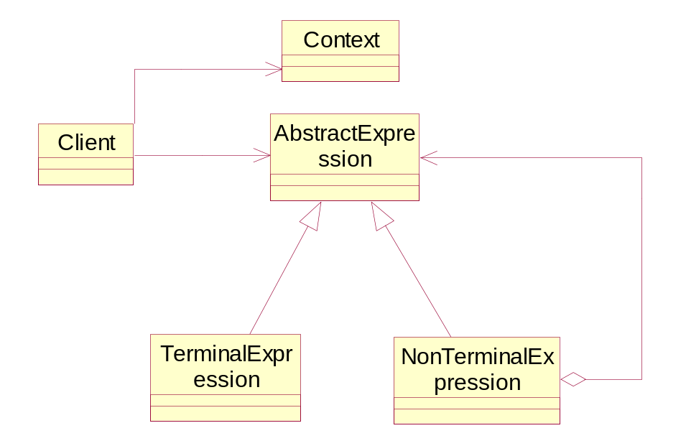
Figure 7 Static Model of Interpreter Pattern
AbstractExpression: Declares an abstract Interpret operation that is common to all nodes in the abstract syntax tree.
TerminalExpression: Implements an Interpret operation associated with terminal symbols in the grammar. An instance is required for every terminal symbol in a sentence.
NonterminalExpression: One such class is required for every rule R ::= R1 R2 ... Rn in the grammar. It maintains instance variables of type AbstractExpression for each of the symbols R1 through Rn. It implements an Interpret operation for nonterminal symbols in the grammar. Interpret typically calls itself recursively on the variables representing R1 through Rn.
Context: Contains information that's global to the interpreter.
Client: Builds (or is given) an abstract syntax tree representing a particular sentence in the language that the grammar defines. The abstract syntax tree is assembled from instances of the NonterminalExpression and TerminalExpression classes. Client also invokes the Interpret operation.
First the client builds (or is given) the sentence as an abstract syntax tree of NonterminalExpression and TerminalExpression instances. Then the client initializes the context and invokes the Interpret operation. Each NonterminalExpression node defines Interpret in terms of Interpret on each sub expression. The Interpret operation of each TerminalExpression defines the base case in the recursion. The Interpret operations at each node use the context to store and access the state of the interpreter.

The Use of Interpreter Pattern in Pointcut Evaluation
As we have stated above, pointcuts are expressed as recursive expressions in CCC. To judge whether an advice should be applied on a specific join point or not, we have to evaluate the pointcut expression.
If we consider join points as sentences in a language, then we can build an abstract syntax tree for pointcuts to interpret them. The pointcuts such as <And>, <Call> could be considered as NonterminalExpression and the pointcuts such as <MethodNameMatches>, <MemberAccessibilityIs> could be considered as TerminalExpression.
To express this idea, we can draw a diagram with some selected pointcuts:
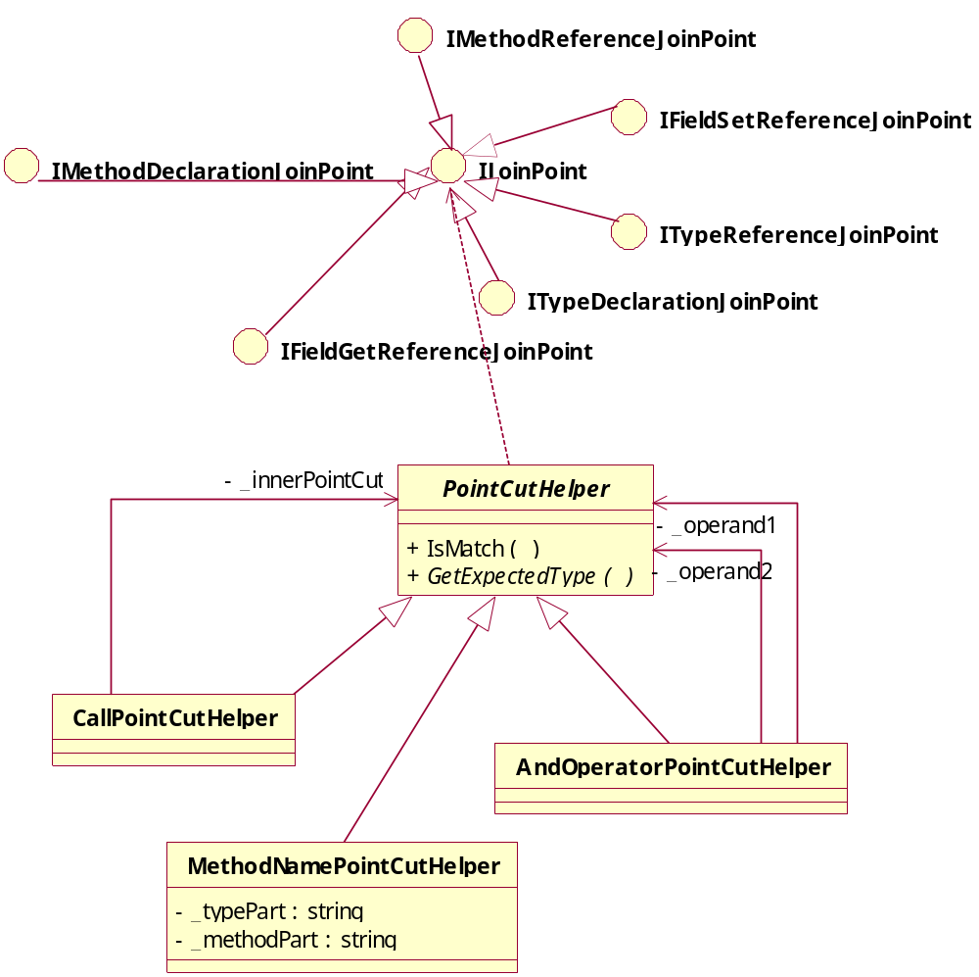
Figure 8 Static Model of Pointcut Evaluation
IJoinPoint represent a join point. It has 6 sub classes representing the 6 types of join points respectively.
PointCutHelper acts as AbstractExpression. The IsMatch() method accepts a IJoinPoint object as parameter and returns whether this join point should be matched by this pointcut or not. AndOperatorPointCutHelper and CallPointCutHelper are NonterminalExpressions, which are composite objects of AbstractExpressions. The MethodNamePointCutHelper is TerminalExpression.
To illustrate the interaction of these classes, consider the following pointcut:
<And>
<Call><MethodNameMatches>SwiftWing.CodeGraph.PointCutHelper.*</MethodNameMatches></Call>
<MemberAccessibilityIs>Public</MemberAccessibilityIs>
</And>
The sequence diagram of IsMatch() is shown below:
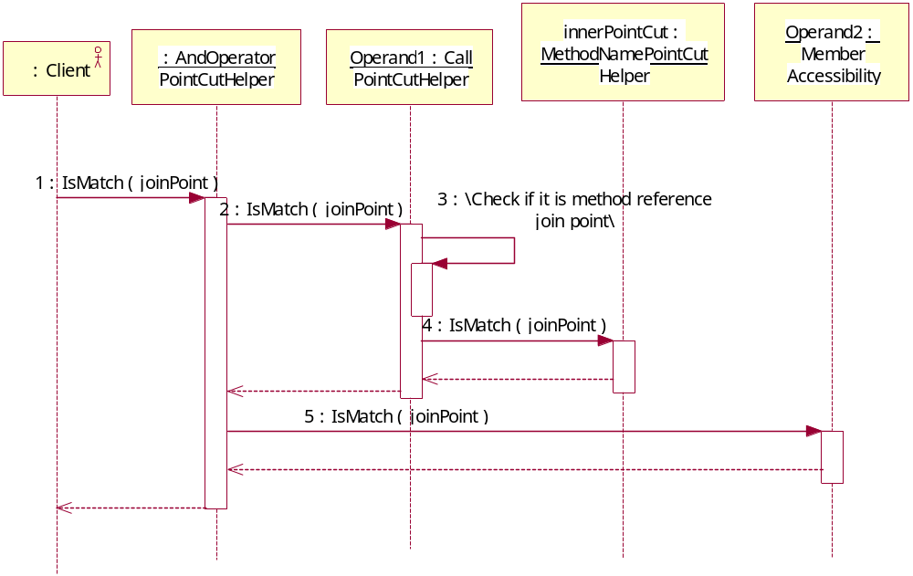
Figure 9 Dynamic Model of Pointcut Evaluation
Now we have the ability to judge whether a join point will be matched by a pointcut or not. But to find all the join points a specific pointcut will match, the client have to pass every join point to IsMatch() method, which is not very effective. To accelerate the matching process, we add another method: GetExpectedType() to PointCutHelper. This method returns a JoinPointType object, which indicates what kind of join points this pointcuts will match. Now the client can call GetExpectedType() first and passes to IsMatch() method only the types of join points the pointcut will match.
Like IsMatch() method, GetExpectedType() is also implemented in a composite way, where the nonterminal pointcuts call the method of terminal pointcuts.

The Execution Flow of Weaver
Now that we have the ability to find all the join points in the system, we can describe the execution flow of weaver by the following steps:
- Find all join points in the system.
- For each advice in the system, apply the following steps:
  - Find the join points the advice will affect
    - Call GetExpectedType() to get what types of join points the pointcut will match
    - Pass each join point belonging to these types to IsMatch() method to see if it will be matched by the pointcut or not.
  - Apply the advice to these join points

Current Implementation Limits
Although we strived to implement all features defined in CCC language, but there are certain features which are difficult to implement without making modification to the .Net framework. The features which are not implemented in current release or whose behaviors deviate from the semantics of CCC are listed below:
- Unmanaged code is not supported.
- The default value of field in IL language is not supported.
- <Overrides> matches only the method which overrides the method declared in its base class. It doesn’t match the method which overrides the method declared in the interface.
- The method reference join point does not include the execution points where a method is invoked indirectly by the “calli” IL directive.
- The field set reference join point does not include the execution points where a field is modified indirectly through its address.
- The field get reference join point does not include the execution points where the value of a field is retrieved indirectly through its address.

Conclusion

Summary of Objectives
In Section 1.2 we discussed the objectives of our project. We believe that we have met, if not exceeded every objective. We will now look at each objective in turn:
- Analysis of existing AOP tools
In Chapter 2 we investigated the state of the art of AOP tool support. Two typical tools on Java platform and all major tools on .Net platform are covered. We summarize the characteristics of each tool and analyzed the strong points and weak points of them.
- Analyzing the problems in existing language and trying to avoid them in CCC language design
In Section 3.2 we explained our design principals and among these principals two improvements to current language were suggested: 1) Change dynamic join point model to static join point model. 2) Context binding should be specified by advice. All these suggestions are applied to CCC language design.
- Designing AOP extensions to all .Net language
Chapter 3 covers the CCC language design. We believe we have designed a language which is intact and powerful enough to modularize the crosscutting concerns. The complete schema for language syntax is listed in Appendix.
- Development of a weaver tool which targets at IL in compiled assemblies
Chapter 4 is about the design and implementation of the system. We have found a way to evaluate pointcut expressions by using interpreter patterns. By proper optimization, this design achieves both elegance and efficiency. We also created an assembly parser and an assembly generator so that our system could deal with assembly directly and hence is language-independent.

Benefits
We believe we have created a tool that enables the modularization of crosscutting concerns on .Net platform. To our knowledge this is the first language-independent weaver available on .Net platform. (Loom.net requires aspects be written in C# so it is not completely language-independent and Weave.NET has not released yet) We hope this tool will accelerate the development of language-specific tool on .Net platform and will enable the .Net community to get more involved with aspect-oriented software development.

Future Work
The future work of CCC will involve researches in the following areas:

Aspect Reuse
Aspect is always good reusable unit in its nature. But unfortunately, most languages have not provided a mechanism to support aspect reuse. With attribute, the powerful extending mechanism provided by .Net, we can store the aspect code in the assembly and other assemblies could refer to it. So we plan to implement aspect reuse on binary level in CCC.
We are going to add a new feature to aspect: inheritance. An aspect could inherit from another existing aspect. In the parent aspect, a pointcut can be declared as virtual or abstract and these pointcuts could be overridden in the sub-aspects. Then the advices in the sub-aspects, either inherited or newly declared, will be woven according to the overriding pointcuts. Thus the existing aspects are reused to the new join points.

Language-specific Aspect-Orient Tool
As we have claimed in Section 3.2.1, the role of CCC is to be a tool to support aspect-orient language implementation. So development of aspect-oriented extension to existing language is our ultimate goal. We plan to develop an AspectJ-like extension to C# and implement it based on CCC.
Reference
- AOSD Steering Committee, aosd.net, http://www.aosd.net, 2004
- The AspectJ Team. The AspectJ Homepage. http://www.aspectj.org, 2004
- The AspectJ Team. The AspectJ Programming Guide. http://dev.eclipse.org/viewcvs/indextech.cgi/~checkout~/aspectj-home/doc/progguide/index.html, 2004
- Donal.Lafferty. AspectC# Homepage. http://www.dsg.cs.tcd.ie/index.php?category_id=169, 2003
- Howard Kim. AspectC#: An AOSD implementation for C#: [Master of Science. Thesis], Dublin: Trinity College, 2002
- The AspectC++ Development Team. AspectC++ Homepage. http://www.aspectc.org/, 2004
- Olaf Spinczyk, Andreas Gal, Wolfgang Schröder-Preikschat. AspectC++: An Aspect-Oriented Extension to C++. in Proceedings of the 40th International Conference on Technology of Object-Oriented Languages and Systems (TOOLS Pacific 2002), 2002
- Donal.Lafferty. Weave.Net Homepage. http://www.dsg.cs.tcd.ie/index.php?category_id=193, 2003
- Donal Lafferty and Vinny Cahill. Language Independent Aspect-Oriented Programming. in Proceedings of OOPSLA, 2003
- Serge Lidin. Inside Microsoft.NET IL Assembler(, 袁勤勇, 何欣, 卢冬梅). 北京：机械工业出版社, 2003. 1~234
- OSM Web crew. Loom.Net homepage. http://www.dcl.hpi.uni-potsdam.de/cms/research/loom/, 2004
- Wolfgang Schult and Andreas Polze. Aspect-Oriented Programming with C# and .NET. in Proceedings of International Symposium on Object-oriented Real-time distributed Computing (ISORC) 2002, 241-248
- Wolfgang Schult and Andreas Polze. RAPIER-LOOM.NET Online Documentation. http://www.dcl.hpi.uni-potsdam.de/RAPIER-LOOM/, 2004
- Hridesh Rajan and Kevin Sullivan. Eos Homepage. http://www.cs.virginia.edu/~eos/, 2004
- Peri Tarr and Harold Ossher. Hyper/J™ User and Installation Manual. http://www.research.ibm.com/hyperspace, 2000
- Mohamed Mesalem. AopDotNetAddIn Homepage. http://www.geocities.com/m_mesalem/aop.html, 2003
- SetPoint! team. SetPoint! Homepage. http://www.dc.uba.ar/people/proyinv/setpoint/, 2004
- Fabian Schmied. AOP.Net Homepage. http://wwwse.fhs-hagenberg.ac.at/se/berufspraktika/2002/se99047/contents/english_home.html
- Robert C. Martin, Agile Software Development: Principles, Patterns, and Practices. 北京：中国电力出版社，2003，95~99
- Erich Gamma, Richard Helm, Ralph Johnson, John Vlissides, Design Patterns: Elements of Reusable Object-Oriented Software. Addison Wesley Longman, 1995, 243~257
- Dan Wahlin. XML for ASP.NET Developers(, 王宝良). 北京：清华大学出版社，2002. 110~127
- 曹东刚，梅宏. 面向Aspect的程序设计—一种新的编程范型. 计算机科学, 2003, Vol.30, No.9, 5~10
Acknowledgement
I would first and foremost thank my mentor, Professor Wu Yue, for his selfless effort to provide us a perfect work environment and for his help, advice and guidance both inside and outside the office hours throughout the term. His devotional, humble and factualistic attribute towards work has greatly influenced me.
I would also like to thank: my co-worker Wan Feng for his diligent work inspiring me forward. The staff of SwiftWing Studio for their help throught out all my years at UESTC. The lecturers at UESTC for delivering edifying courses. My girl friend for taking care of my lives. All my friends for their support.
Finally, I would like to thank my family for all their love and support. Thank you!
Appendix

The complete schema for CCC language
<?xml version="1.0" encoding="utf-8" ?>
<xs:schema targetNamespace="http://SwiftWing.org/CCC" elementFormDefault="qualified" xmlns="http://SwiftWing.org/CCC"
xmlns:mstns="http://SwiftWing.org/CCC" xmlns:xs="http://www.w3.org/2001/XMLSchema" xmlns:msdata="urn:schemas-microsoft-com:xml-msdata">
<xs:element name="Aspects">
<xs:complexType>
<xs:sequence>
<xs:element name="Aspect" type="Aspect" maxOccurs="unbounded" minOccurs="0" />
</xs:sequence>
</xs:complexType>
</xs:element>
<xs:complexType name="Aspect">
<xs:choice maxOccurs="unbounded" minOccurs="0">
<xs:element name="Advice" type="Advice" />
<xs:element name="PointCut" type="NamedPointCut" />
</xs:choice>
<xs:attribute name="Name" type="xs:string" use="required" />
</xs:complexType>
<xs:complexType name="Parameters">
<xs:sequence>
<xs:element name="Parameter" type="Parameter" minOccurs="1" maxOccurs="unbounded" />
</xs:sequence>
</xs:complexType>
<xs:complexType name="Parameter">
<xs:sequence>
<xs:element name="Type" type="TypeReference" />
<xs:element name="Binding" type="ParameterBinding" />
</xs:sequence>
<xs:attribute name="Name" type="xs:string" use="required" />
</xs:complexType>
<xs:complexType name="ParameterBinding">
<xs:attribute name="Type" use="required">
<xs:simpleType>
<xs:restriction base="xs:string">
<xs:enumeration value="This" />
<xs:enumeration value="Target" />
<xs:enumeration value="Argument" />
<xs:enumeration value="Field" />
</xs:restriction>
</xs:simpleType>
</xs:attribute>
<xs:attribute name="Index" type="xs:nonNegativeInteger" use="optional">
<xs:annotation><xs:documentation>
This attribute exists when and only when Type == Argument
It indicate the index of the argument to be bound. Zero based.
</xs:documentation></xs:annotation>
</xs:attribute>
</xs:complexType>
<xs:complexType name="Advice">
<xs:all>
<xs:element name="PointCut" type="PointCut" minOccurs="0" />
<xs:element name="Parameters" type="Parameters" minOccurs="0" />
</xs:all>
<xs:attribute name="PointCut" type="TypeReferenceString" />
<xs:attribute name="Behaviour" type="MemberReference" use="required" />
<xs:attribute name="Type" use="required">
<xs:simpleType>
<xs:restriction base="xs:string">
<xs:enumeration value="Before" />
<xs:enumeration value="After" />
</xs:restriction>
</xs:simpleType>
</xs:attribute>
</xs:complexType>
<xs:complexType name="NamedPointCut">
<xs:complexContent>
<xs:extension base="PointCut">
<xs:attribute name="Name" type="xs:string" use="required" />
<xs:attribute name="Accessibility" default="Private">
<xs:simpleType>
<xs:restriction base="xs:string">
<xs:enumeration value="Public" />
<xs:enumeration value="Private" />
</xs:restriction>
</xs:simpleType>
</xs:attribute>
</xs:extension>
</xs:complexContent>
</xs:complexType>
<xs:simpleType name="MemberReference">
<xs:restriction base="xs:string">
<xs:pattern value="((\p{L}|\p{Nl}|[_])(\p{L}|\p{Nl}|\p{Nd}|\p{Mn}|\p{Mc}|\p{Cf})*)([.]((\p{L}|\p{Nl}|[_])(\p{L}|\p{Nl}|\p{Nd}|\p{Mn}|\p{Mc}|\p{Cf})*))*([.]((\p{L}|\p{Nl}|[_])(\p{L}|\p{Nl}|\p{Nd}|\p{Mn}|\p{Mc}|\p{Cf})*))" />
</xs:restriction>
</xs:simpleType>
<xs:simpleType name="TypeReferenceString">
<xs:restriction base="xs:string">
<xs:pattern value="((\p{L}|\p{Nl}|[_])(\p{L}|\p{Nl}|\p{Nd}|\p{Mn}|\p{Mc}|\p{Cf})*)([.]((\p{L}|\p{Nl}|[_])(\p{L}|\p{Nl}|\p{Nd}|\p{Mn}|\p{Mc}|\p{Cf})*))*" />
</xs:restriction>
</xs:simpleType>
<xs:simpleType name="PatternString">
<xs:restriction base="xs:string">
<xs:pattern value="((\p{L}|\p{Nl}|[_%?])(\p{L}|\p{Nl}|\p{Nd}|\p{Mn}|\p{Mc}|\p{Cf}|[%?])*)([.](\p{L}|\p{Nl}|[_%?])(\p{L}|\p{Nl}|\p{Nd}|\p{Mn}|\p{Mc}|\p{Cf}|_u37 ??])*)*"/>
</xs:restriction>
</xs:simpleType>
<xs:complexType name="ArrayTypeReference">
<xs:sequence>
<xs:element name="Rank" type="xs:int" />
<xs:element name="ElementType" type="TypeReference" />
</xs:sequence>
</xs:complexType>
<xs:complexType name="TypeReference">
<xs:annotation>
<xs:documentation>
Some types are not originally declared but created dynamically when necessary,
such as array or managed pointer. So to reference to a type, you must specify whether
you are referencing a original type, an array or a managed pointer.
</xs:documentation>
</xs:annotation>
<xs:choice>
<xs:element name="Direct" type="TypeReferenceString" />
<xs:element name="Array" type="ArrayTypeReference" />
<xs:element name="ManagedPointer" type="ManagedPointerTypeReference" />
</xs:choice>
</xs:complexType>
<xs:complexType name="ManagedPointerTypeReference">
<xs:sequence>
<xs:element name="ElementType" type="TypeReference" />
</xs:sequence>
</xs:complexType>
<xs:complexType name="PointCut">
<xs:choice>
<xs:element name="And" type="BinaryOperatorPointCut" />
<xs:element name="Or" type="BinaryOperatorPointCut" />
<xs:element name="Not" type="UnaryOperatorPointCut" />
<xs:element name="Call" type="FilterPointCut" />
<xs:element name="Execution" type="FilterPointCut" />
<xs:element name="Set" type="FilterPointCut" />
<xs:element name="Get" type="FilterPointCut" />
<xs:element name="MemberAccessibiltyIs" type="MemberAccessibilityPointCut" />
<xs:element name="StaticMember" type="FilterPointCut" />
<xs:element name="InstanceMember" type="FilterPointCut" />
<xs:element name="TargetTypeIs" type="TypeOperandPointCut" />
<xs:element name="ReturnTypeIs" type="TypeOperandPointCut" />
<xs:element name="ParameterTypeIs" type="ParameterTypePointCut" />
<xs:element name="ParameterCountIs" type="xs:nonNegativeInteger"/>
<xs:element name="DeclaringTypeIs" type="TypeOperandPointCut" />
<xs:element name="WithInMethod" type="MethodOperandPointCut" />
<xs:element name="BaseOf" type="TypeOperandPointCut" />
<xs:element name="InterfaceOf" type="TypeOperandPointCut" />
<xs:element name="Inherits" type="TypeOperandPointCut" />
<xs:element name="Implements" type="TypeOperandPointCut" />
<xs:element name="ArrayOf" type="TypeOperandPointCut" />
<xs:element name="ManagedPointerOf" type="TypeOperandPointCut" />
<xs:element name="Overrides" type="MethodOperandPointCut" />
<xs:element name="FieldNameMatches" type="PatternPointCut" />
<xs:element name="MethodNameMatches" type="PatternPointCut" />
<xs:element name="TypeNameMatches" type="PatternPointCut" />
<xs:element name="PointCutReference" type="PointCutReferencePointCut" />
</xs:choice>
</xs:complexType>
<xs:complexType name="BinaryOperatorPointCut">
<xs:choice maxOccurs="unbounded" minOccurs="2">
<xs:element name="And" type="BinaryOperatorPointCut" />
<xs:element name="Or" type="BinaryOperatorPointCut" />
<xs:element name="Not" type="UnaryOperatorPointCut" />
<xs:element name="Call" type="FilterPointCut" />
<xs:element name="Execution" type="FilterPointCut" />
<xs:element name="Set" type="FilterPointCut" />
<xs:element name="Get" type="FilterPointCut" />
<xs:element name="MemberAccessibiltyIs" type="MemberAccessibilityPointCut" />
<xs:element name="StaticMember" type="FilterPointCut" />
<xs:element name="InstanceMember" type="FilterPointCut" />
<xs:element name="TargetTypeIs" type="TypeOperandPointCut" />
<xs:element name="ReturnTypeIs" type="TypeOperandPointCut" />
<xs:element name="ParameterTypeIs" type="ParameterTypePointCut" />
<xs:element name="ParameterCountIs" type="xs:nonNegativeInteger"/>
<xs:element name="DeclaringTypeIs" type="TypeOperandPointCut" />
<xs:element name="WithInMethod" type="MethodOperandPointCut" />
<xs:element name="BaseOf" type="TypeOperandPointCut" />
<xs:element name="InterfaceOf" type="TypeOperandPointCut" />
<xs:element name="Inherits" type="TypeOperandPointCut" />
<xs:element name="Implements" type="TypeOperandPointCut" />
<xs:element name="ArrayOf" type="TypeOperandPointCut" />
<xs:element name="ManagedPointerOf" type="TypeOperandPointCut" />
<xs:element name="Overrides" type="MethodOperandPointCut" />
<xs:element name="FieldNameMatches" type="PatternPointCut" />
<xs:element name="MethodNameMatches" type="PatternPointCut" />
<xs:element name="TypeNameMatches" type="PatternPointCut" />
<xs:element name="PointCutReference" type="PointCutReferencePointCut" />
</xs:choice>
</xs:complexType>
<xs:complexType name="UnaryOperatorPointCut">
<xs:complexContent>
<xs:extension base="PointCut" />
</xs:complexContent>
</xs:complexType>
<xs:complexType name="FilterPointCut">
<xs:complexContent>
<xs:extension base="PointCut" />
</xs:complexContent>
</xs:complexType>
<xs:complexType name="TypeOperandPointCut">
<xs:complexContent>
<xs:extension base="PointCut" />
</xs:complexContent>
</xs:complexType>
<xs:complexType name="DynamicTypePointCut">
<xs:complexContent>
<xs:extension base="PointCut" />
</xs:complexContent>
</xs:complexType>
<xs:complexType name="ParameterTypePointCut">
<xs:sequence>
<xs:element name="ParameterIndex" type="xs:nonNegativeInteger" />
<xs:element name="Type" type="PointCut" />
</xs:sequence>
</xs:complexType>
<xs:complexType name="MethodOperandPointCut">
<xs:complexContent>
<xs:extension base="PointCut" />
</xs:complexContent>
</xs:complexType>
<xs:complexType name="PatternPointCut">
<xs:simpleContent>
<xs:extension base="PatternString" />
</xs:simpleContent>
</xs:complexType>
<xs:complexType name="BindingPointCut">
<xs:simpleContent>
<xs:extension base="xs:string" />
</xs:simpleContent>
</xs:complexType>
<xs:complexType name="PointCutReferencePointCut">
<xs:attribute name="Name" type="TypeReferenceString"/>
</xs:complexType>
<xs:complexType name="MemberAccessibilityPointCut">
<xs:attribute name="Accessibility" use="required">
<xs:simpleType>
<xs:restriction base="xs:string">
<xs:enumeration value="Public" />
<xs:enumeration value="Family" />
<xs:enumeration value="Assembly" />
<xs:enumeration value="FamOrAssem" />
<xs:enumeration value="FamANDAssem" />
<xs:enumeration value="Private" />
<xs:enumeration value="Any" />
</xs:restriction>
</xs:simpleType>
</xs:attribute>
</xs:complexType>
</xs:schema>

See Reference (2) and (3)
See Reference (15)
See Reference (11), (12) and (13)
See Reference(14)
See Reference(16)
See Reference (4) and (5)
See Reference (8) and (9)
See Reference (17)
See Reference (18)
defined in Reference(3)
See Reference(19)
Defined in Reference(20)

