

Azure RTOS   
IoT Quick Connect Sample

STM32L4+-DISCO IoT Node using IAR

User Guide

Published: July 2020

For the latest information, please see   
azure.com/rtos

This document is provided “as-is”. Information and views expressed in this document, including URL and other Internet Web site references, may change without notice.

This document does not provide you with any legal rights to any intellectual property in any Microsoft product. You may copy and use this document for your internal, reference purposes.

Azure RTOS provides OEMs with components to secure communication and to create code and data isolation using underlying MCU/MPU hardware protection mechanisms. It is ultimately the responsibility of the device builder to ensure the device fully meets the evolving security requirements associated with its specific use case.

FileX supports the Microsoft exFAT file system format. Your use of exFAT technology in your products requires a separate license from Microsoft. Please see the following link for further details on exFAT licensing:

<https://www.microsoft.com/en-us/legal/intellectualproperty/mtl/exfat-licensing.aspx>

 © 2020 Microsoft. All rights reserved.

Microsoft Azure RTOS, Azure RTOS FileX, Azure RTOS GUIX, Azure RTOS GUIX Studio, Azure RTOS NetX, Azure RTOS NetX Duo, Azure RTOS ThreadX, Azure RTOS TraceX, Azure RTOS Trace, event-chaining, picokernel, and preemption-threshold are trademarks of the Microsoft group of companies. All other trademarks are property of their respective owners.

Part Number: 000-1059

Revision 6.0.1

**Example for STM32L4S5I Discovery kit for IoT Node**

The following steps detail how to configure, build and execute the X-Ware IoT Platform Microsoft Azure integration example on the STM32L4S5I Discovery kit for IoT Node, using IAR’s EWARM 8.50 or later development tools. Figure 1 shows a picture of the kit. 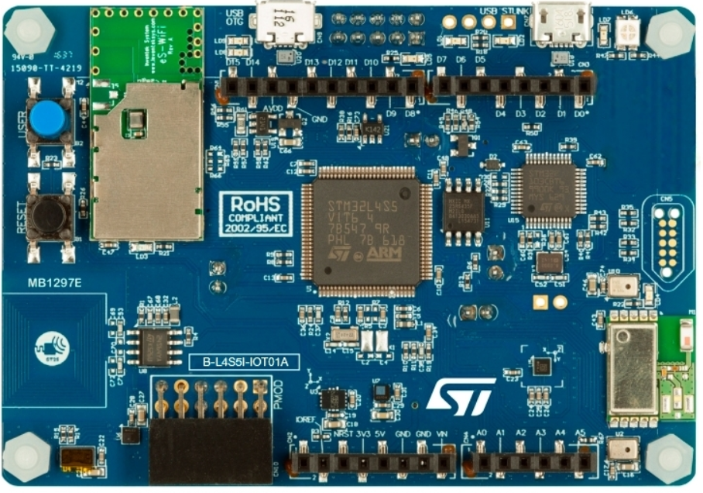

***Figure 1: STM32L4S5I Discovery kit for IoT Node***

**1.1 Configure Azure IoT hub for the demo**

**Step 1**: Create an IoT hub and Device using the Azure portal.

The Azure IoT hub user guide can be found at:

<https://docs.microsoft.com/azure/iot-hub/iot-hub-create-through-portal>

Save the **IoT Hub Connection String** for later use.

***IoT Hub -> Setting -> Shared access policies -> iothubowner -> Connection string***

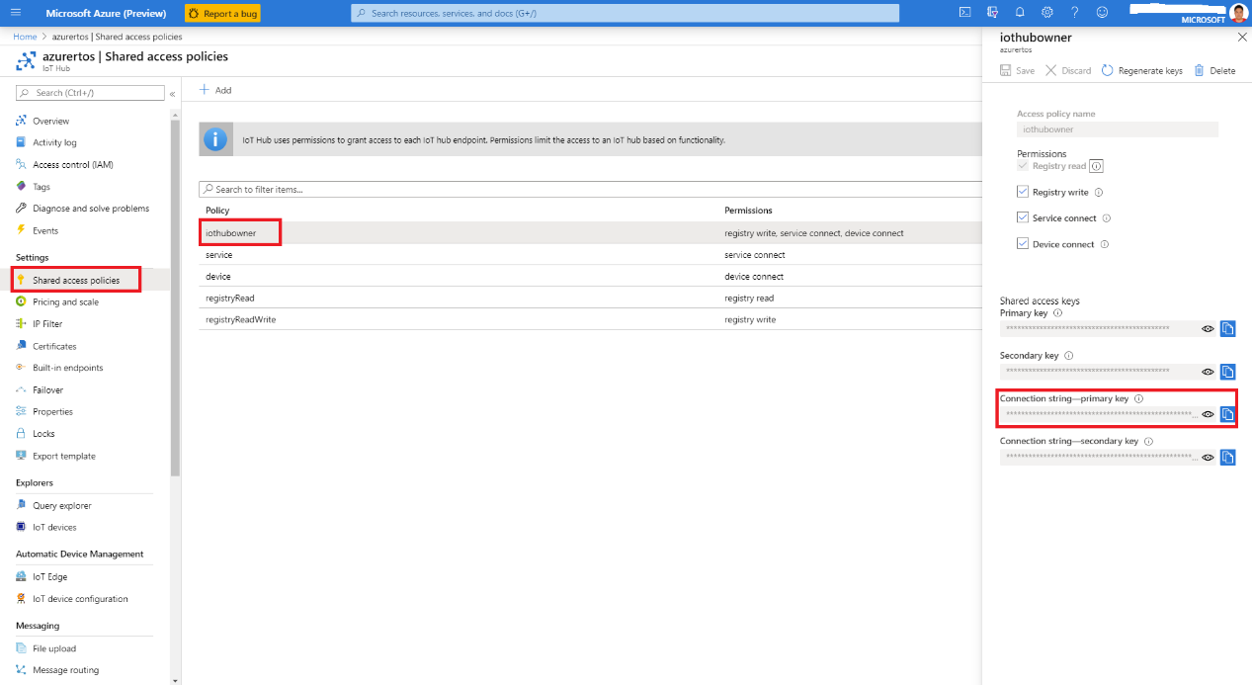

**Figure 2 IoT Hub Configuration**

**Step 2**: Install Azure IoT Explorer

The installer can be found at:

<https://github.com/Azure/azure-iot-explorer/releases>

**Step 3**: Get device credentials

1. Launch Azure IoT Explorer, paste the IoT Hub connection string you just got and select ***Connect***.  
   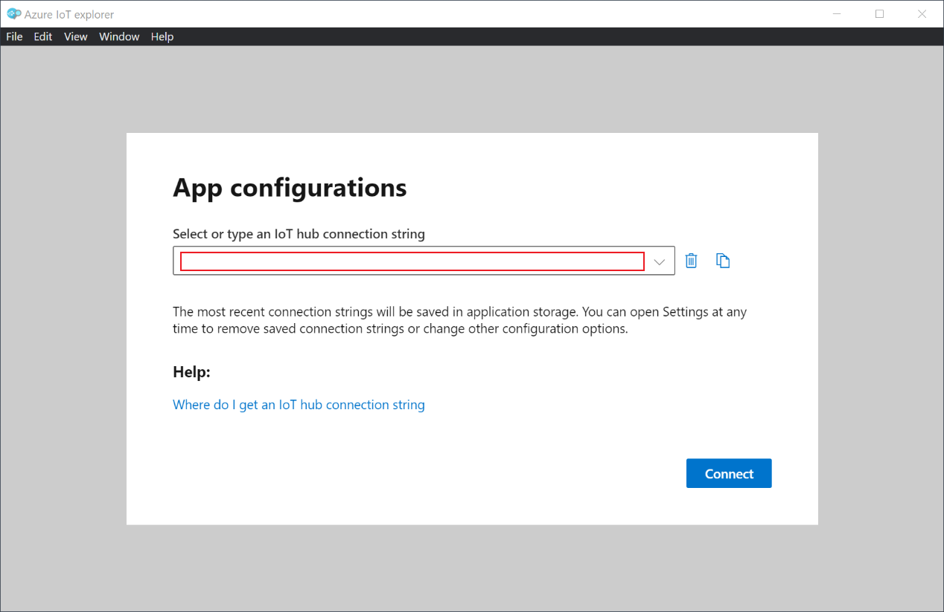
2. Select ***New*** to create a new IoT device. Enter a device ID for your device and keep the rest options as default. Then select ***Create***.  
   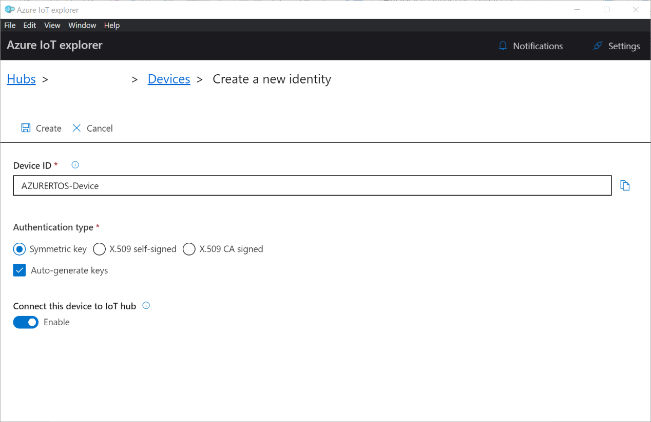
3. Select from the list for the device you just created. In the ***Device identity*** tab, copy ***Device ID*** to Notepad for later use. Then scroll down to find the ***Connection string with SAS token*** section, select ***Primary key*** from the dropdown list, and set the ***Expiration (minutes)*** a big longer than 5 minutes by default (e.g. 120). Then select ***Generate*** and copy ***SAS token connection string*** to Notepad.  
     
   For the ***SAS token connection string***, please be aware that we only need the portion of the string starts from ***SharedAccessSignature sr=***. You can see the below code configuration for the required string format.

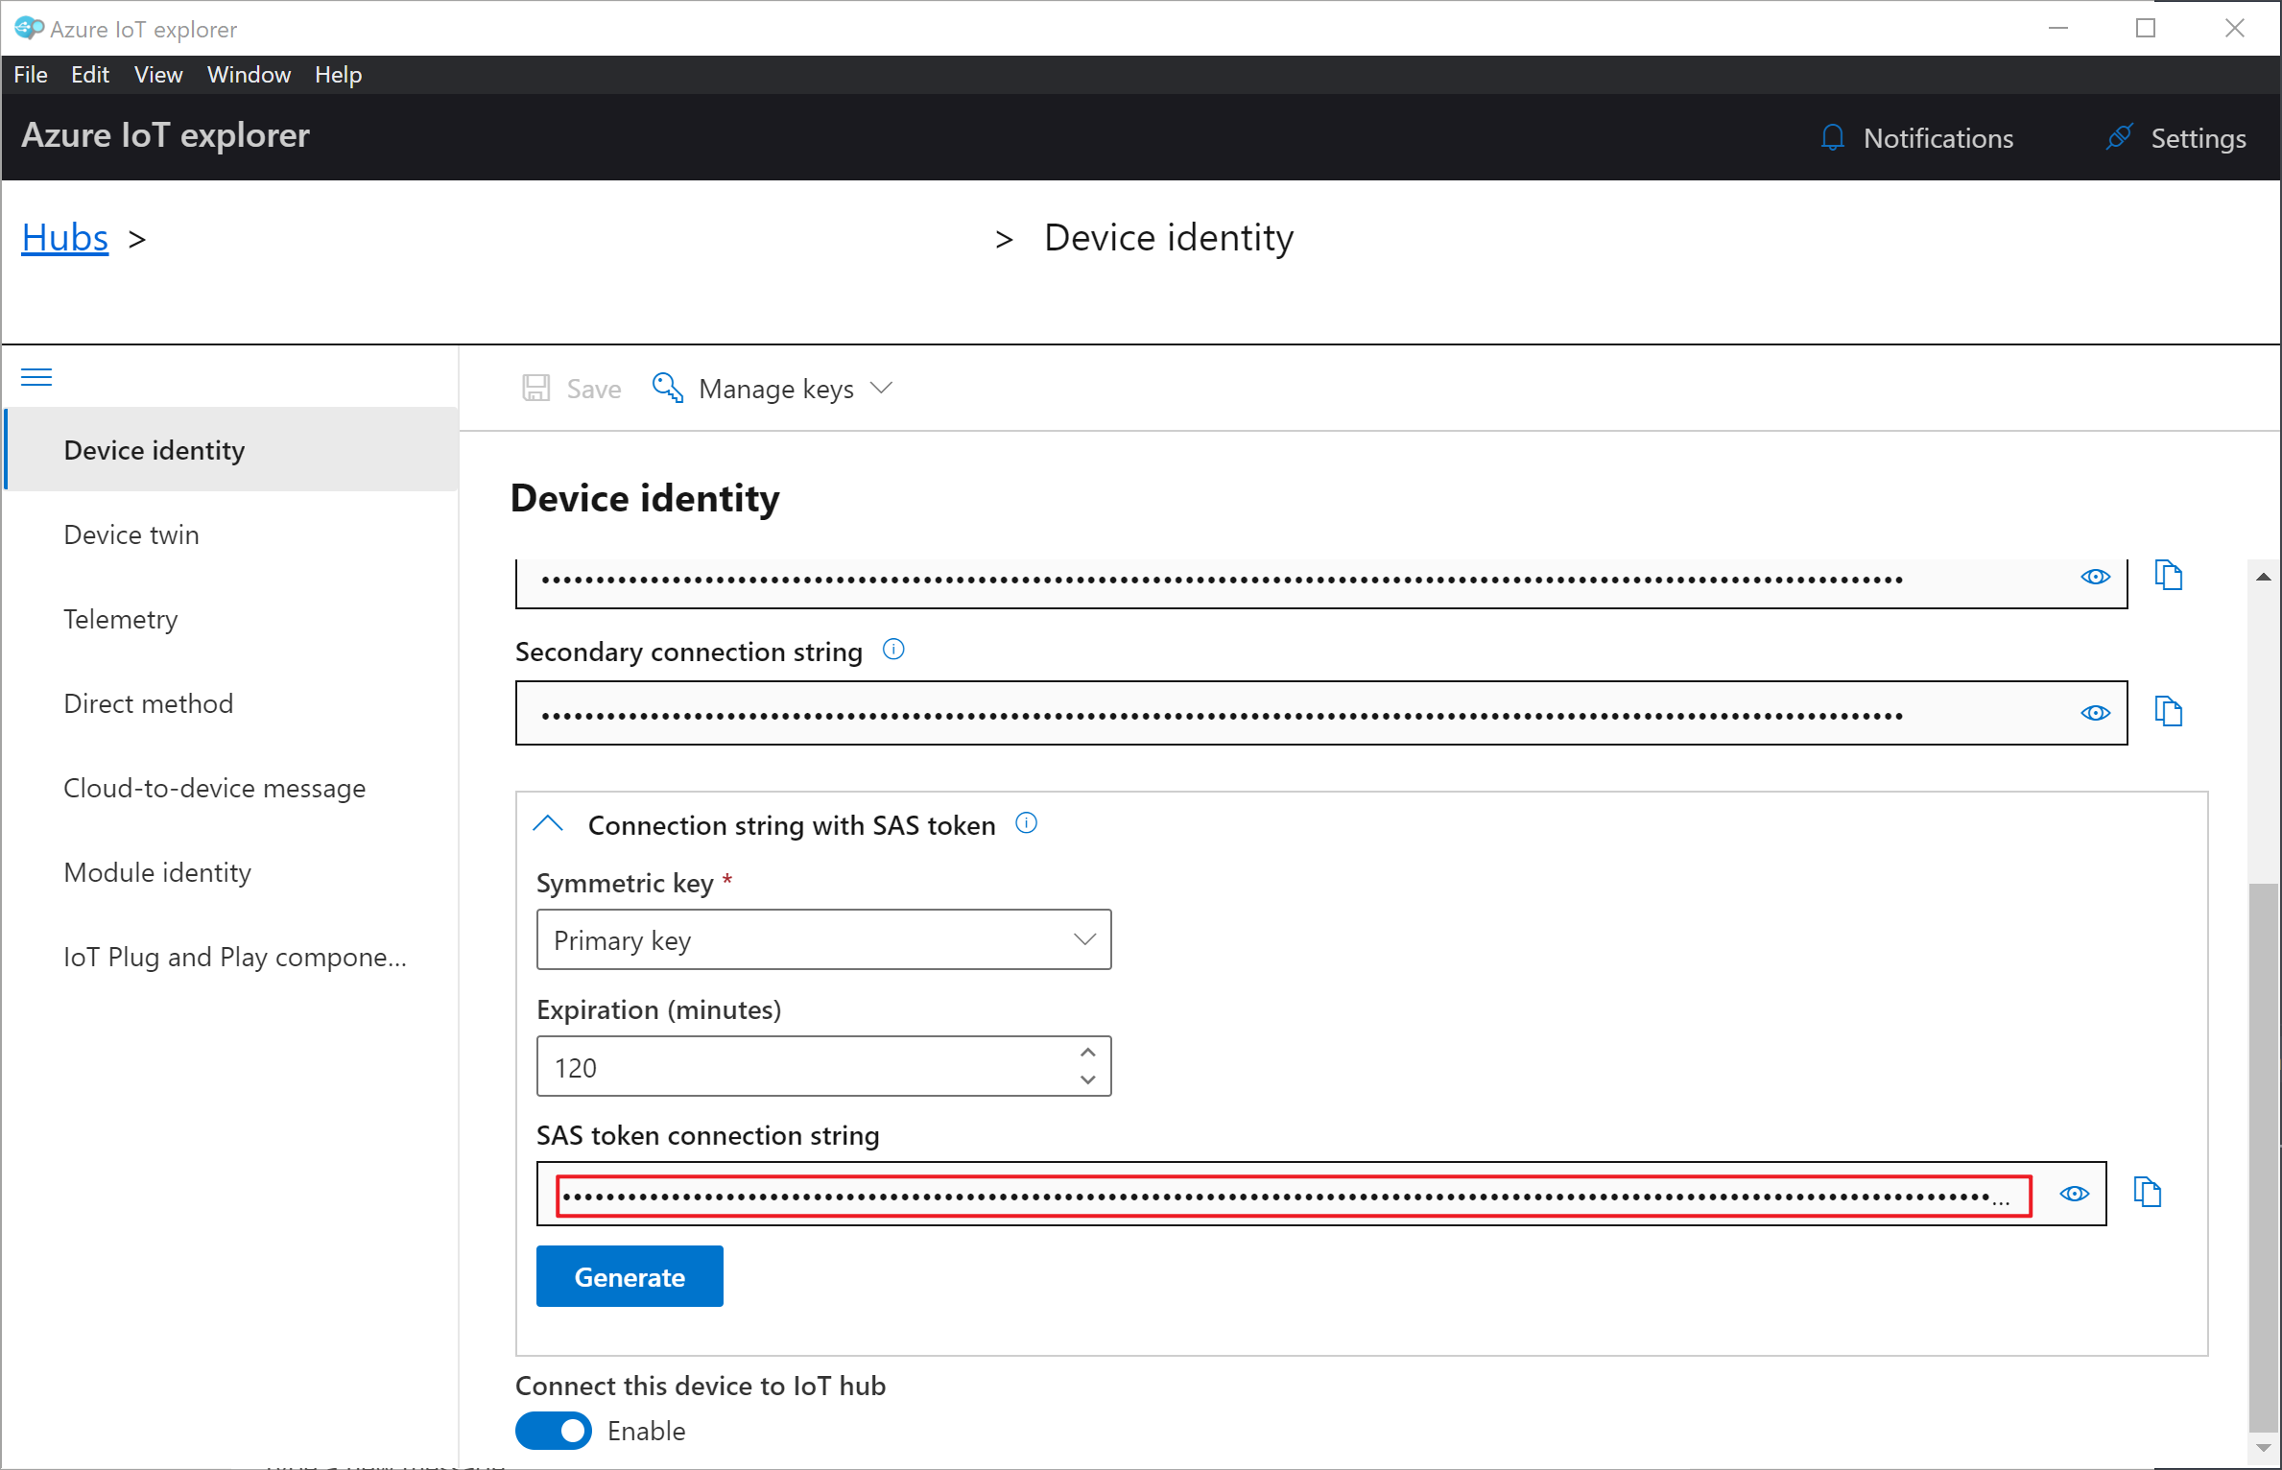

1. Also copy the ***IoT Hub host name prefix*** from the highlighted area to the Notepad. You need all above three device credentials for the sample code to connect to the IoT Hub.

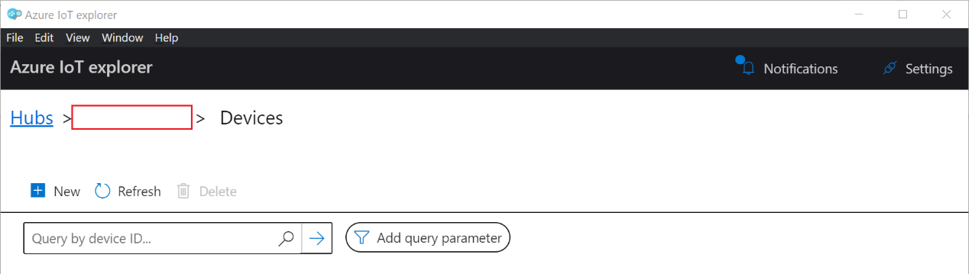

**1.2 Configure and execute the example**

**Step 1**: Once the code is downloaded. Unzip to ***C:/azure_rtos***, and open the project with IAR EW for ARM by selecting ***File > Open Workspace*** from:

***C:\azure_rtos\b-l4s5i-iot01a\iar\azure_rtos.eww***

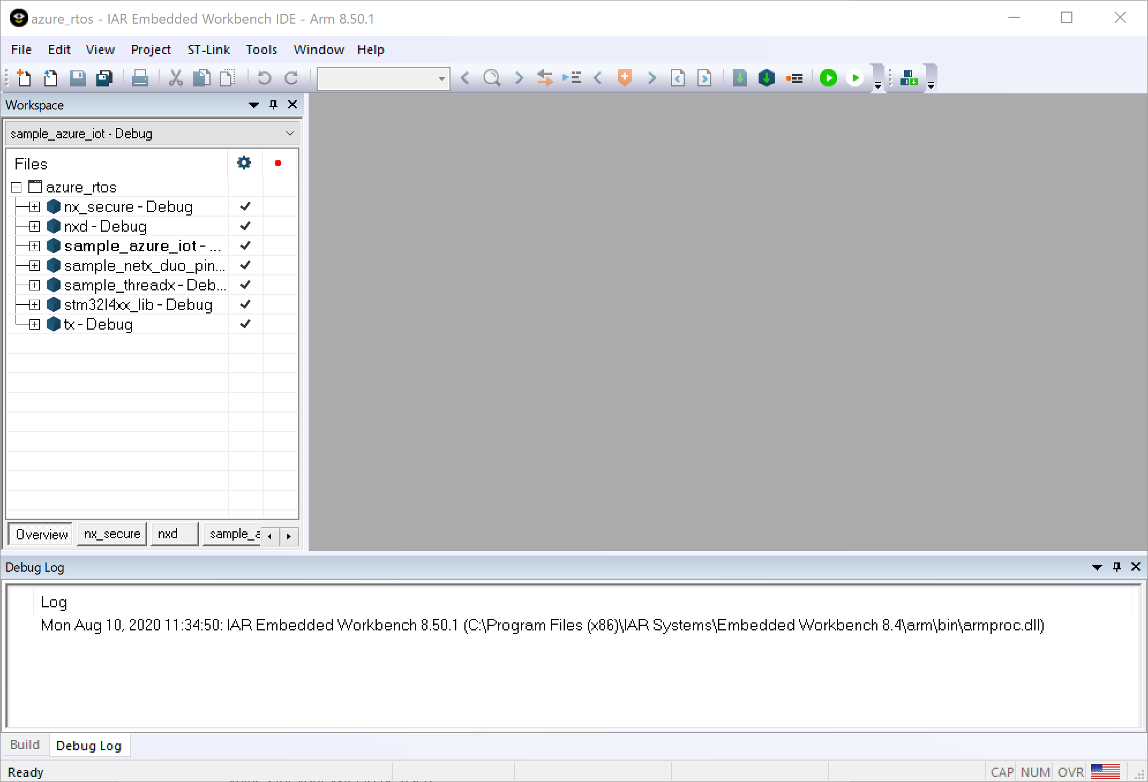

NOTE: If you unzip the IAR project in a very long path, it might not open properly.

Configure the ***WIFI_SSID*** and ***WIFI_PASSWORD*** by right click on active project, select ***Options > C/C++ Compiler > Preprocessor***. Replace the values for your WiFi to be used.

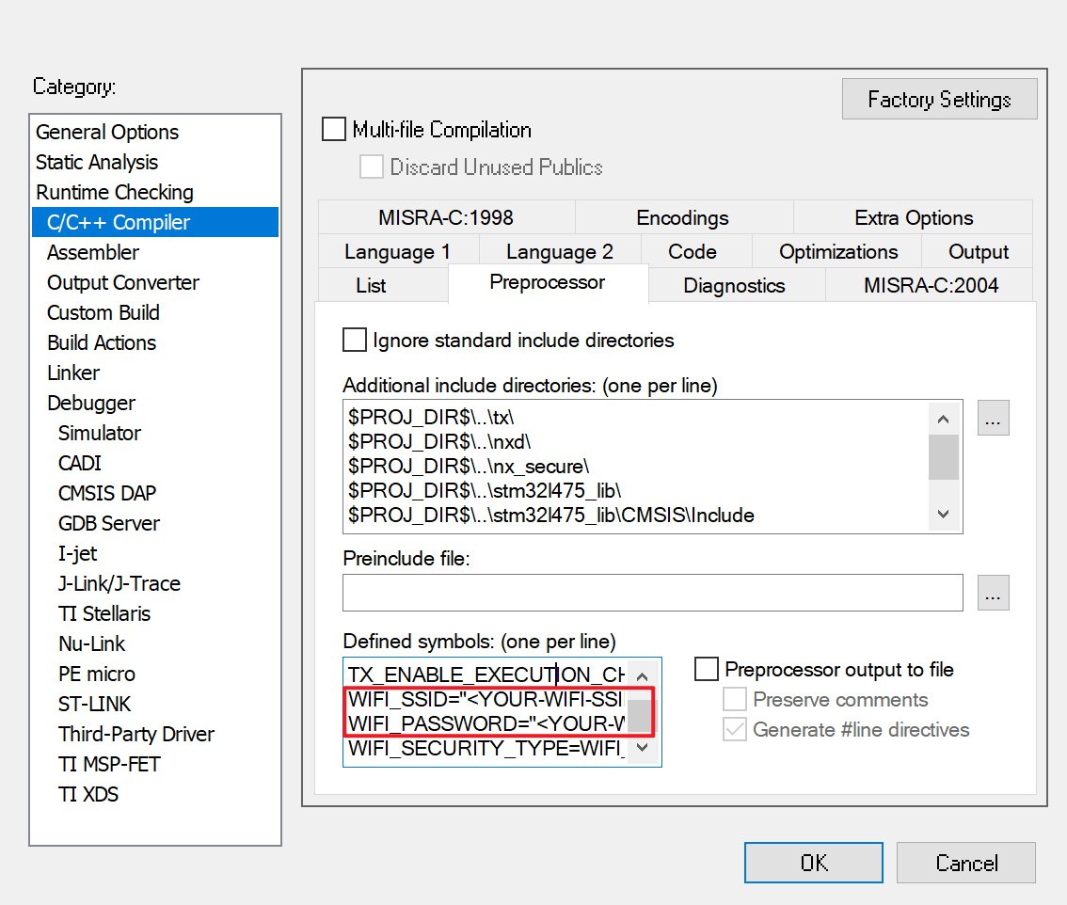

**Step 2**: Update the ***Host Name***, ***Device ID*** and ***Device SAS*** noted in previous step in ***C:\azure_rtos\b-l4s5i-iot01a\iar\sample_azure_iot\sample_azure_iot.c***

//

// TODO`s: Configure core settings of application for your IoTHub, replace the // [IoT Hub Name] and [Device ID] as yours. Use Device Explorer to generate

// [SAS].

//

#ifndef HOST_NAME

#define HOST_NAME "{Your IoT Hub Name}.azure-devices.net"

#endif /* HOST_NAME */

#ifndef DEVICE_ID

#define DEVICE_ID "{Your Device ID}"

#endif /* DEVICE_ID */

#ifndef DEVICE_SAS

#define DEVICE_SAS "{Your Device SAS Token}"

#endif /* DEVICE_SAS */

//

// END TODO section

//

The following shows example values:

HOST_NAME "azurertos.azure-devices.net"

DEVICE_ID "AZURERTOS-DEVICE"

DEVICE_SAS "SharedAccessSignature sr=azurertos.azure-

devices.net%2Fdevices%2FAZURERTOS-DEVICE&sig=......%2Fc%3D&se=1587436430"

**Step 3**: Build the project

From IAR, select ***Project > Batch Build*** and choose ***build_all*** and select ***Make*** to build all projects. You will observe compilation and linking of all sample projects.

**Step 4**: Download and run the project

From the IAR workspace explorer, right click the ***sample_azure_iot*** project and click ***Set as Active***. Press the green ***Download and Debug*** button in the toolbar to download the program and run it. Then press ***Go***. As the project runs, the demo prints out status information to the terminal IO window. The demo also publishes the message to IoT Hub every five seconds. Check the Terminal I/O to verify that messages have been successfully sent to the Azure IoT hub.

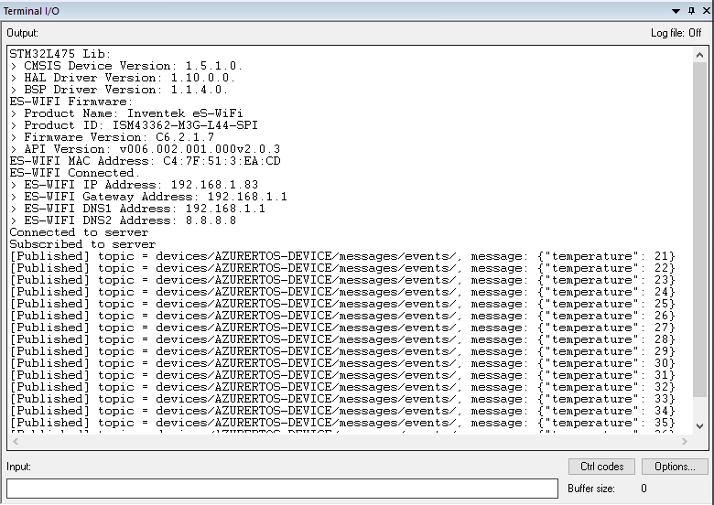

**Step 5**: Monitor telemetry data

In the Azure IoT Explorer, select the device you just created and select the ***Telemetry*** tab. Then select ***Start*** to view the messages published by the IoT Device.

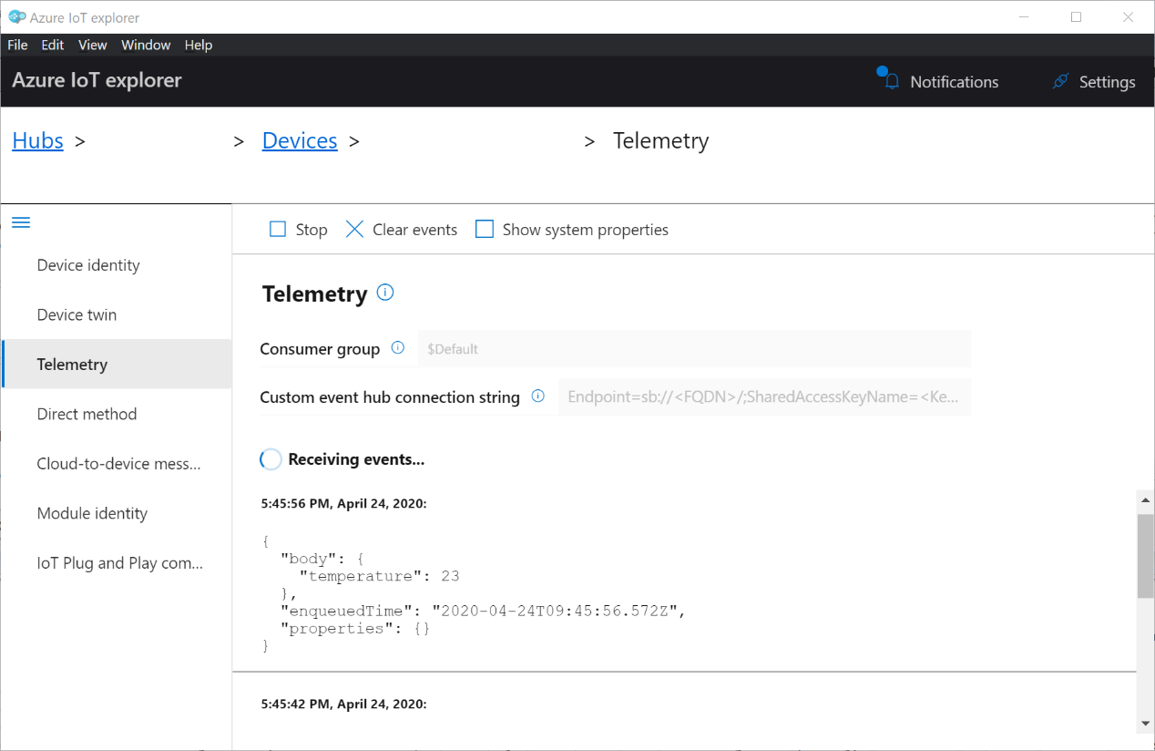

**Step 6**: Manually send messages to the device.

In the Azure IoT Explorer, switch to the ***Cloud-to-device message*** tab, and user can send commands to the IoT device.

In this demo, the following messages are defined:

{"fan": "on"}

{"fan": "off"}

Enter the message in the ***Message body*** and select ***Send message to device***.

User can send TurnFanOn message to Device to turn fan on. Device receives this message (to turn on fan), and in response decreases the temperature by 1 till the temperature reaches the minimum value of 0.

User can send TurnFanOff message to Device to turn fan off. Device receives this message (to turn off fan), and in response increases the temperature by 1 till the temperature reaches the maximum value of 40.

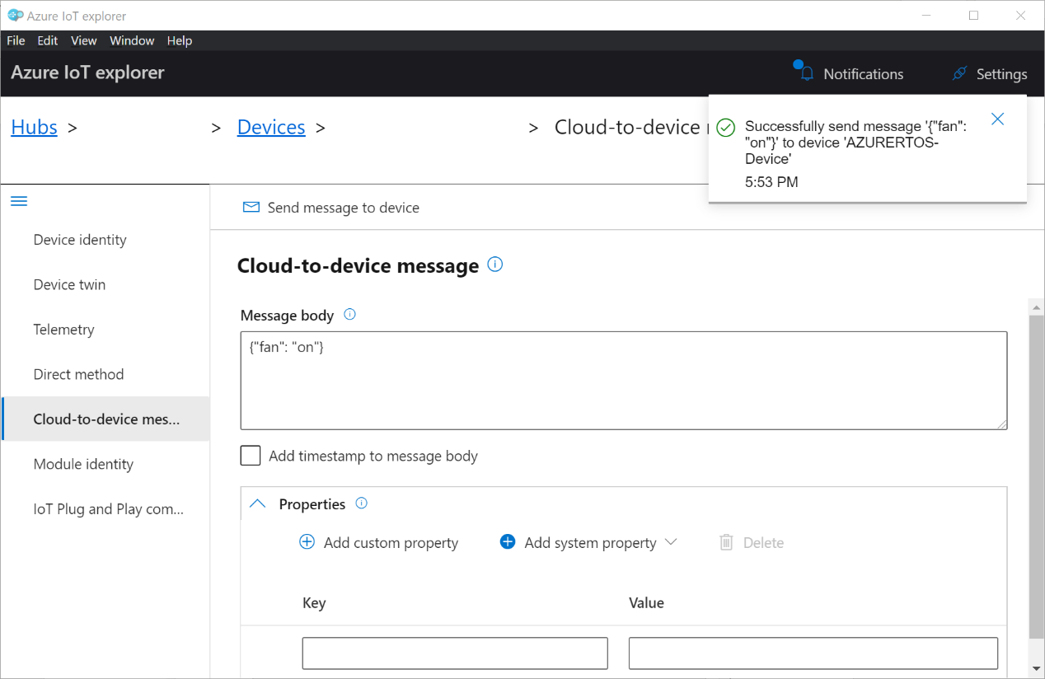

**Next steps:**

To learn more about Azure RTOS and how it works with Azure IoT, view <https://azure.com/rtos>.