AWS Open Data and Amazon Bedrock Workshop
Comprehensive Report

Executive Summary

This report provides an in-depth overview of the AWS Open Data and Amazon Bedrock
Workshop hosted by the XPRIZE Alumni Network in collaboration with Amazon Web
Services (AWS). The workshop focused on the growing intersection between open data
accessibility, cloud infrastructure, and generative artificial intelligence (AI). The primary
objective was to introduce participants to AWS’s Open Data ecosystem and demonstrate
practical implementations using AWS Glue, Athena, Redshift, and Bedrock. Through a
combination of technical lectures and guided demonstrations, participants explored how
AWS services streamline the process of discovering, cleaning, querying, and utilizing open
datasets. Furthermore, the integration of Amazon Bedrock showcased the potential of
generative AI models to process structured data and generate contextual insights using
Retrieval-Augmented Generation (RAG). This initiative aligns with AWS’s broader mission
to democratize access to cloud-based data analytics and AI innovation.

Session Overview

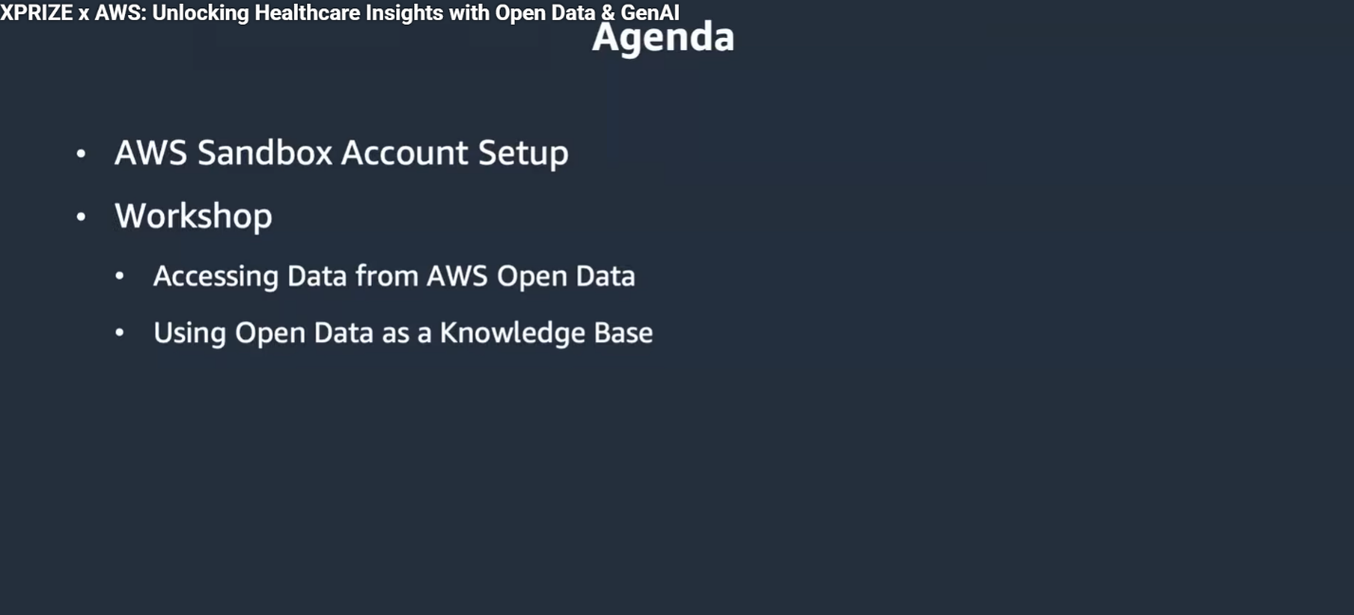

The workshop featured expert-led presentations by Barl Rob, Life Sciences Lead for AWS
Open Data, and Christian Chicas, AWS Solutions Architect. Participants included
members of the XPRIZE Alumni Network and professionals in data science,
bioinformatics, and AI. The event was structured into two main modules:
1. Exploring Open Data on AWS – Understanding the AWS Open Data Program, data registry tools,
and methods for querying public datasets hosted on Amazon S3.
2. Building a Generative AI Knowledge Base – Using AWS Glue, Redshift, and Bedrock to integrate
structured open data with generative AI models capable of responding to natural language
queries.

AWS Open Data Program

The AWS Open Data Program is a foundational component of Amazon’s commitment to
supporting research and innovation through freely available, cloud-hosted data. It enables
organizations to share high-value datasets with the global community without
infrastructure overhead. The program hosts more than 800 datasets across multiple
disciplines spanning genomics, healthcare, climate science, transportation, and space
exploration totaling approximately 300 petabytes of data. A notable feature is the Open
Data Sponsorship Program, which covers storage and egress costs for qualified projects
that promote data accessibility and reuse. Beyond hosting, AWS provides ecosystem tools
such as the Registry of Open Data (RODA) and Amazon S3 public dataset,
allowing users to explore data directly within their cloud environments or connect via
analytical services such as Athena or Redshift Spectrum. This removes barriers to entry
for data-driven research and encourages reproducibility across scientific communities.

Overview of Key AWS Services

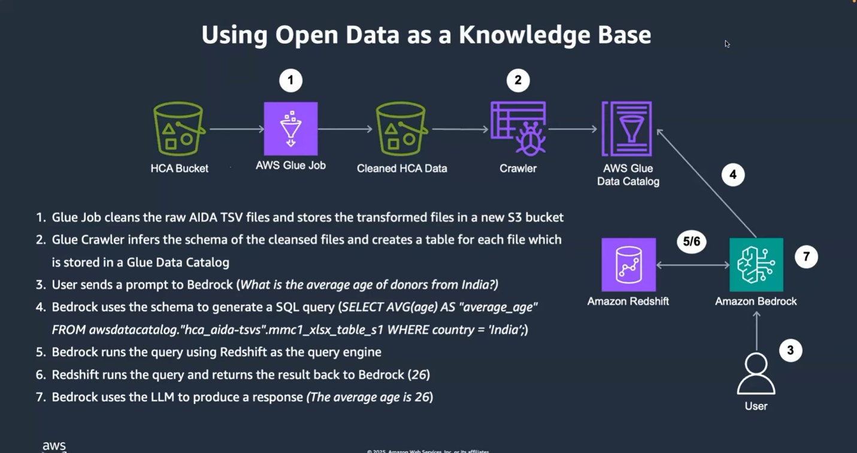

The workshop emphasized the interoperability of several AWS tools central to data
analysis and AI-driven insight generation:
AWS Glue – A fully managed extract, transform, and load (ETL) service used to clean and organize raw data.
Amazon Athena - A serverless, pay-per-query engine for analyzing structured data stored in
Amazon S3.
Amazon Redshift – A data warehouse optimized for high-performance
queries and integration with machine learning workloads.
Amazon Bedrock – A managed service enabling users to build generative AI applications using foundation models (FMs) from providers such as Anthropic, Cohere, and Amazon Titan. Together, these services form a cohesive data workflow from ingestion and transformation to
AI-driven analysis within a secure, scalable, and cost-efficient cloud environment.

Workshop Hands-On Components

Participants engaged in two practical modules demonstrating how to handle open datasets
using AWS tools.
Module 1: Accessing and Exploring Open Data, Attendees explored
the Registry of Open Data (RODA), identifying relevant biological datasets such as the
Seattle Alzheimer’s Disease Brain Spatial Atlas and the Asian Immune Diversity Atlas
(AIDA). The hands-on session included inspecting S3 file structures, using the AWS
Command Line Interface (CLI) to explore data buckets, and previewing data directly in the
AWS Management Console.
Module 2: Building a Generative AI Knowledge Base – This session demonstrated how to clean and transform structured data using AWS Glue and
Athena, then import the processed data into Redshift. Subsequently, participants
integrated the data with Amazon Bedrock, enabling large language models to query the
dataset using natural language prompts.

Technical Workflow and Implementation

The technical implementation process covered the complete lifecycle of data preparation
and AI integration:
1. Data Cleaning – Using AWS Glue jobs to remove unwanted lines,
standardize schemas, and prepare data for analysis. The cleaned data was stored in a
dedicated S3 bucket.
2. Schema Inference – Glue Crawlers automatically detected and
categorized data fields, generating table metadata in the Glue Data Catalog.
3. Data Querying – Amazon Athena was used to execute serverless SQL queries for data
validation.
4. Integration with Redshift – Datasets were imported into Amazon Redshift
for scalable analytical querying.
5.Bedrock Knowledge Base Setup – Bedrock connected to Redshift and the Glue catalog, establishing a knowledge base that could be
accessed through natural language prompts.
6.Retrieval-Augmented Generation (RAG) – Bedrock generated SQL queries automatically, retrieving precise data-driven answers grounded in the structured dataset. This workflow exemplified a seamless end-to-end pipeline for combining traditional data warehousing with modern generative AI
technologies.

Industry and Research Relevance

The integration of open data with generative AI represents a major advancement in
research and innovation strategies across industries. By combining publicly accessible
datasets with intelligent querying mechanisms, organizations can derive insights faster
and with greater transparency. In the life sciences, this approach accelerates genomic and
epidemiological research by simplifying access to large-scale biological data. In other
sectors, such as environmental monitoring, transportation analytics, and financial
modeling, similar methods are improving decision-making accuracy and reproducibility.
AWS’s infrastructure plays a pivotal role in ensuring data integrity, governance, and
scalability while enabling researchers to collaborate globally without managing physical
infrastructure.

Application in Public Health Data Science

Public health data scientists can apply the lessons from this workshop to enhance the
quality, scale, and speed of their research. The AWS Open Data ecosystem provides
access to datasets related to epidemiology, health demographics, genomics,
environmental health, and healthcare systems. These datasets can be analyzed and
modeled to uncover trends in disease outbreaks, healthcare disparities, and population
health. By leveraging AWS Glue for data cleaning and transformation, public health
researchers can prepare large and heterogeneous datasets collected from multiple
sources such as surveillance systems, hospital records, and genomic repositories.
Amazon Athena and Redshift can then be used to query and integrate these datasets,
allowing for seamless exploration of patterns in infection rates, vaccination coverage, or
environmental exposures. Using Amazon Bedrock, generative AI models can be built on
top of structured datasets to provide natural language interfaces for research queries. For
example, a model could interpret questions such as “What is the correlation between air
pollution and respiratory illness rates across regions?” and generate SQL-based queries
that retrieve factual insights from Redshift tables. This bridges the gap between data
science and policy-level interpretation of results. Furthermore, the architecture
demonstrated in the workshop can guide the direction of public health research by
enabling scalable model development. Predictive models for outbreak forecasting, social
determinants of health, or resource allocation can be trained using open datasets hosted
on AWS. This alignment of cloud-based data processing with AI-driven analytics fosters
reproducibility, transparency, and collaboration among global public health professionals.

Key Takeaways

The AWS Open Data ecosystem empowers researchers, developers, and enterprises to
access and analyze high-quality datasets with minimal setup. The combination of Glue,
Athena, and Redshift enables an efficient ETL-to-analytics pipeline. Bedrock’s generative
AI layer enhances accessibility by allowing users to query structured data using natural
language. Retrieval-Augmented Generation (RAG) ensures that generative AI outputs
remain grounded in factual data. Cloud-based open data access reduces redundancy,
lowers costs, and enhances collaborative innovation.

Neutral Reflection

This workshop exemplified the convergence of data accessibility, scalable cloud
infrastructure, and artificial intelligence. The demonstrations highlighted how AWS’s
ecosystem of open data tools and AI services can collectively advance global research
collaboration, foster transparency, and enable new forms of digital innovation without
compromising data reliability or governance.

Resources

Registry of Open Data: https://registry.opendata.aws - Amazon Bedrock Overview:
https://aws.amazon.com/bedrock - AWS Open Data Contact: opendata@amazon.com -
XPRIZE Alumni Network: alumni@xprise.org

