Task 2: Compute the summer rainfall over East China for different phases of the PDO
Using the information from the PDO phases obtained in Task 1, compute the composite summer rainfall pattern over East China (15°N–45°N, 100°E-130°E), for MIROC6 model and “observations” (precip.mon.total.v501.nc).
Perform the following steps:
- Apply a nine-year running mean to the PDO index (PC time series). Then, obtain the dates for the PDO positive phase and the PDO negative phase. Plot the figure with PDO time series.
Should be similar to this one for observation (ERSSTv4):
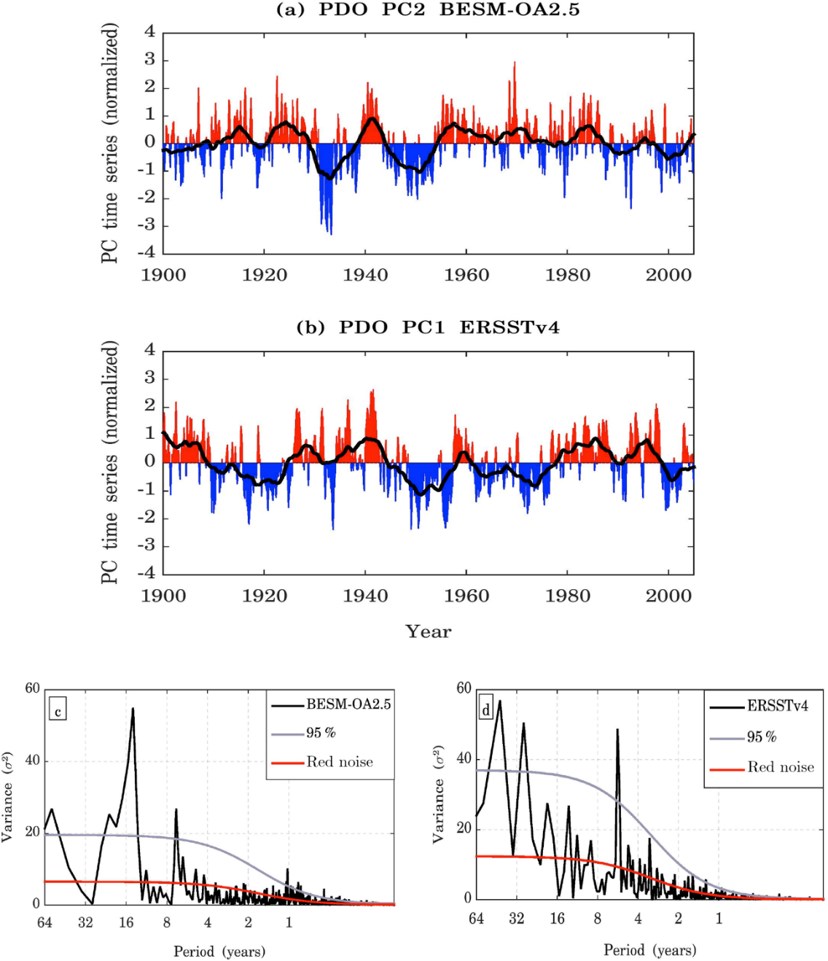

- For precipitation, select the region over East China (15°N–45°N, 100°E-130°E). Select the summer months (June, July and August) and compute the seasonal values (sum these three months for each year). Then calculate the seasonal average for the whole time series. Finally, compute the seasonal anomalies by subtracting the seasonal summer average of the whole period from the individual summer seasons.
- Using the PDO phases from the smoothed PDO time series (from the running mean), compute the composite summer rainfall based on the differences between the positive and negative PDO phases. Use the average summer season (summer months) to obtain the PDO phase. Composite analysis means that you should separate two groups of data for rainfall summers, one for the positive PDO phase and the other for the negative PDO phase. Then, average the rainfall values at each grid point for each group (positive and negative PDO). Then, calculate the spatial difference between them. You should find a map similar to Figure 2d of the article Yu 2013: Potential Correlation between the Decadal East Asian Summer Monsoon Variability and the Pacific Decadal Oscillation.

