### Sapi-Portuguese Ivory Bowl

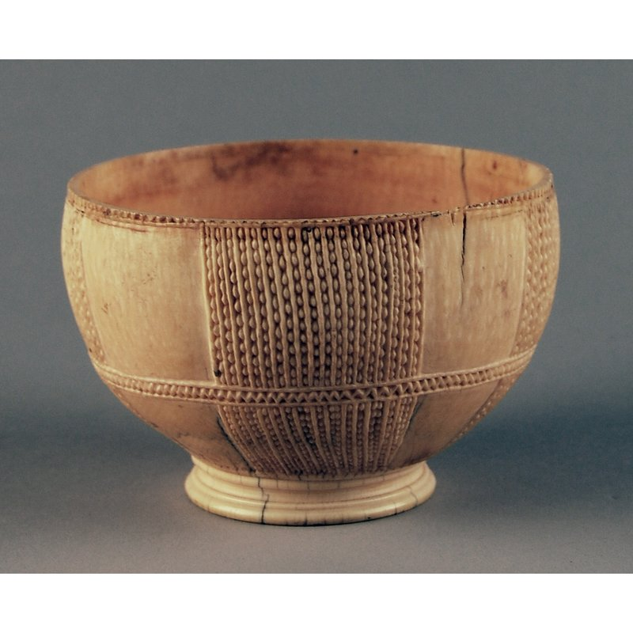

This is a 16th century carved ivory bowl, on a shallow pedestal. It has geometric incised carving running in panels from the rim, to the base. The British Museum records refer to this as Afro-Portuguese, a term used to indicate items from Sierra Leone and Nigeria, made for a Portuguese market in the 15th and 16th centuries. Such items display a mixture of African and European elements and motifs in their overall form and ornamentation, and were considered prestige items across Europe. A more specific term for items patronised in Sierra Leone, is Sapi-Portuguese.

**Further Information**

* **Object:**Sapi-Portuguese Ivory Bowl
* **Materials:**Bone, ivory, tooth
* **Culture Group:**Bullom; Temne
* **Dimensions:**
* **Production Date:**1490-1530
* **Associated Places:**Unknown
* **Associated People:**Augustus Wollaston Franks
* **Museum:**British Museum
* **Accession Number:**BM:Af.7398.a