**Wooden Lidded Bowl**

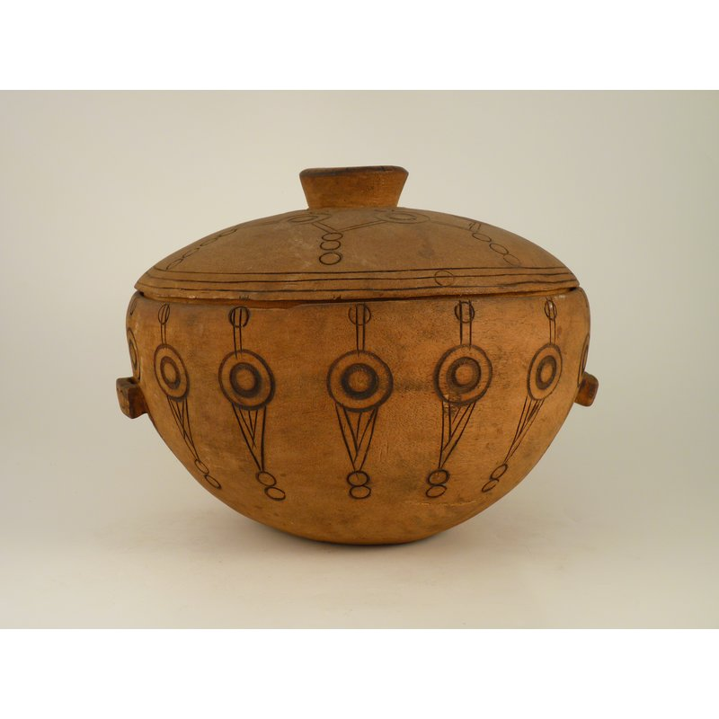

A carved bowl, made from light wood. It is globular in shape and has two small handles on either side, along with a lid. It is decorated with incised and burnt circular and geometric designs.

### Further Information

* **Object:**Wooden Lidded Bowl
* **Materials:**Wood
* **Culture Group:**Mandingo [Malinke; Mandinka]
* **Dimensions:**Unknown
* **Production Date:**Pre 1966
* **Associated Places:**Wara Klara, Yagala Chiefdom, Kabala (Place collected)
* **Associated People:**Paramount Chief Gbawara II
* **Museum:**Sierra Leone National Museum
* **Accession Number:**SLNM.1966.01.02