**Wooden Lidded Bowl**

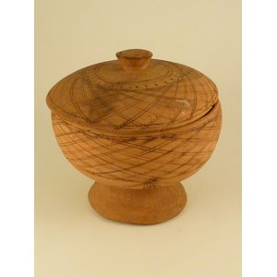

A carved bowl, made from light wood. It is globular in shape and has a lid. Both the bowl and the lid are decorated with burnt geometric designs.

**Further Information**

* **Object:**Wooden Lidded Bowl
* **Materials:**Wood
* **Culture Group:**Unknown
* **Dimensions:**Unknown
* **Production Date:**Pre 1968
* **Associated Places:**Lunsar
* **Associated People:**Mr. Amadu Kamara, Lunsar (Trader)
* **Museum:**Sierra Leone National Museum
* **Accession Number:**SLNM.1968.12.02B