Prompt :
Hello! I am Ahmed Raza, a first-semester Software Engineering undergraduate student at FAST-NUCES Islamabad (Roll No: 26I-3079, Section SE-1B).

My website theme is a cozy café menu and it uses #222f25 , #f5f0e4 , e55929 and use the font National Park "<link rel="preconnect" href="https://fonts.googleapis.com">
<link rel="preconnect" href="https://fonts.gstatic.com" crossorigin>
<link href="https://fonts.googleapis.com/css2?family=National+Park:wght@200..800&display=swap" rel="stylesheet">".

Since I need at least three pages total (with index.html as the home page) and need to make sure a JavaScript interactive element (such as window.alert() or console.log()) is properly working, please:
Review my current code and styling so we can keep the exact same visual identity and theme across all future pages
2. Suggest a clean 3-page structure that fits my theme
3. Help me refine my home page index.html to ensure it includes the required JavaScript interaction smoothly.
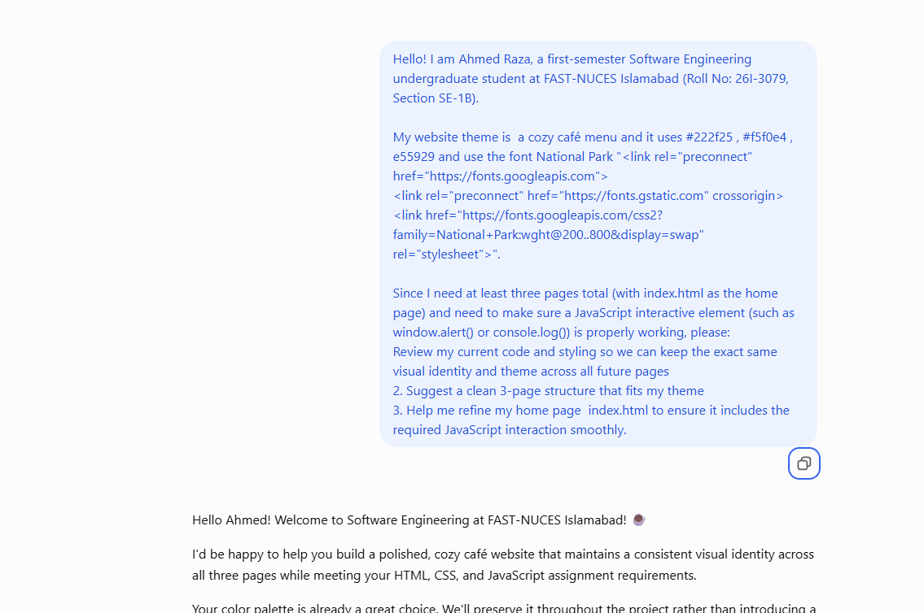
Ss2


