How to Download Files from Class Accounts

Two of the ways to save files from class accounts:
SquirrelMail (downloads one files at a time)
WinSCP (downloads multiple files at a time)

SquirrelMail

1) You can get there one of two ways:
* Go directly to http://gaia.ecs.csus.edu/mail
* Or go to http://www.ecs.csus.edu and click on the E-mail icon
Then login using your ECS UNIX account.
Note: If you see a warning about security and a certificate. Click OK or Yes.

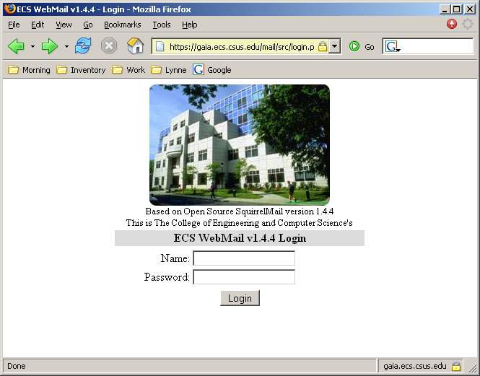

2) On the left hand column, go to File Folders and select the class folder.

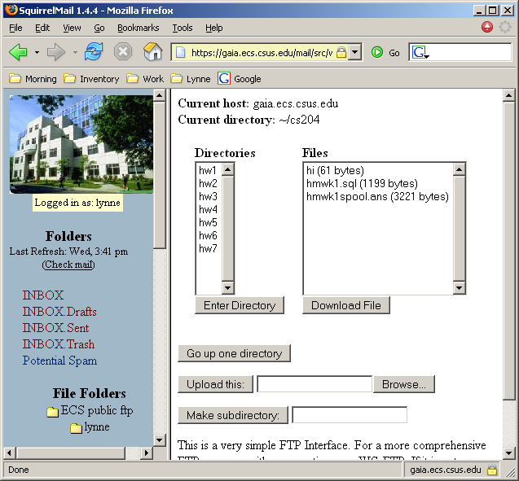

3) Select the directory which contains the files to be downloaded
Click on Enter Directory

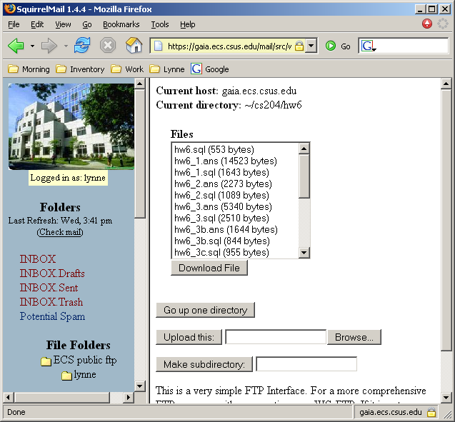
- Select the file to download.
Click on Download File

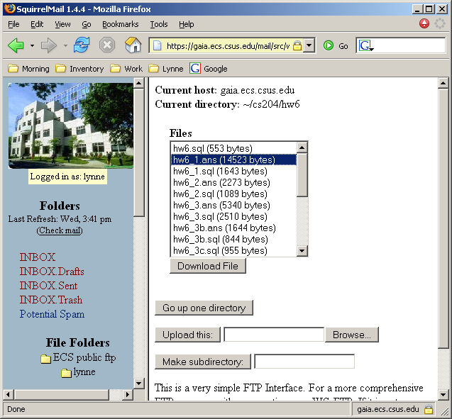

- Select Save to Disk
Click OK

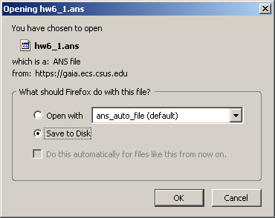

6) Browse to the location where the file is to be saved
Click Save

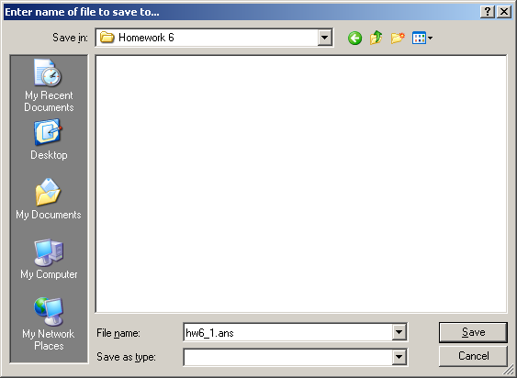
WinSCP

- Go to Start → All Programs → WinSCP
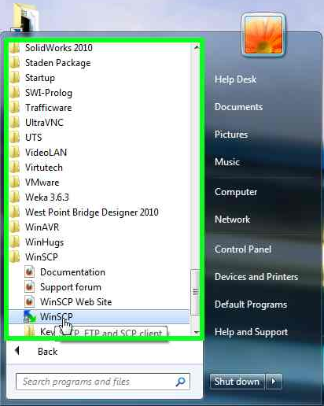

- Under Host Name Type: gaia.ecs.csus.edu
- Then Enter User name and Password
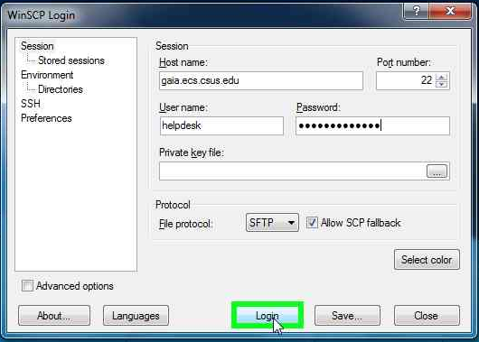
Note: Make sure that SFTP is selected for File Protocol*
- The window on the left is the computer.
The window on the right is the account you logged into through ftp.
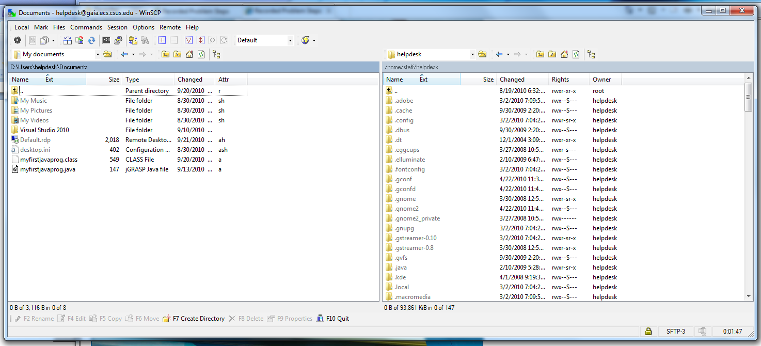

- On the right window, click on the folder directory (ie desktop)
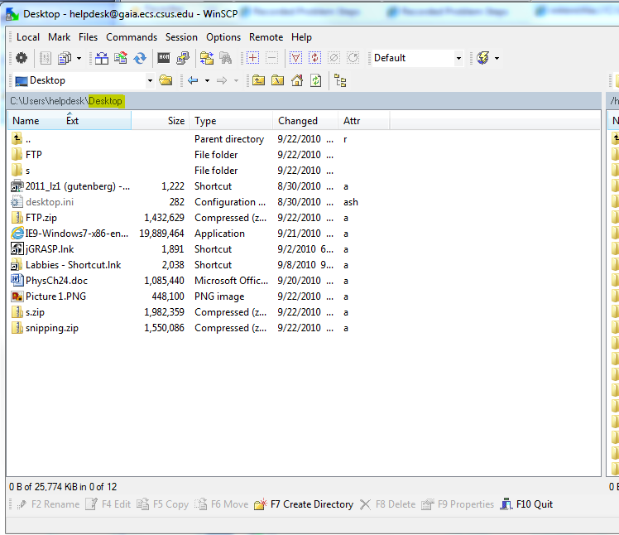

- The Directory that you want to put the files are your desktop.
(ie: C:\\Users\<account>\Desktop)
Then click OK
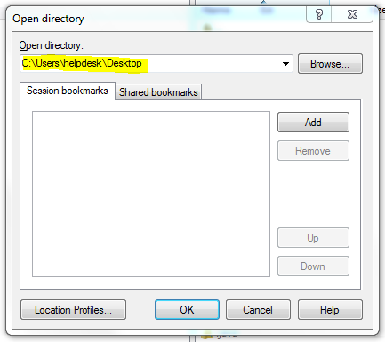

- Then Drag Files from right to left to transfer files to computer

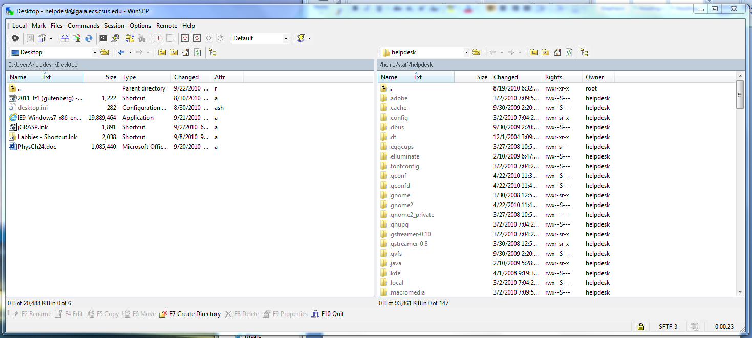.

- Now that the selection is on the computer, save the files to your personal media (floppy disks, CDs, USB memory sticks, etc)

How to Copy Documents from “My Home Space on Gaia” to Your Host Machine or Flash Drive

Follow the steps below:

Step 1: Log into an ECS lab system.

Step 2: Select the folder My Home Space on Gaia as shown in Fig. 1.

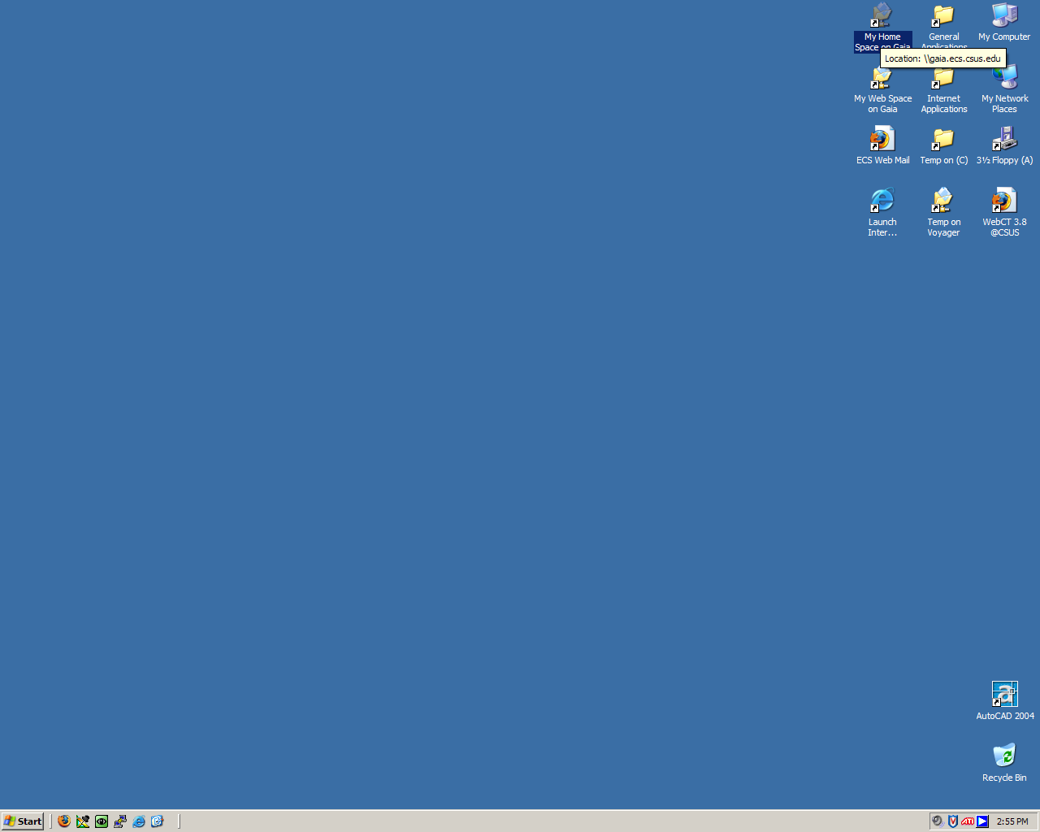 Figure 1
Step 3: Double click on the folder to open it. Refer Figure 2.

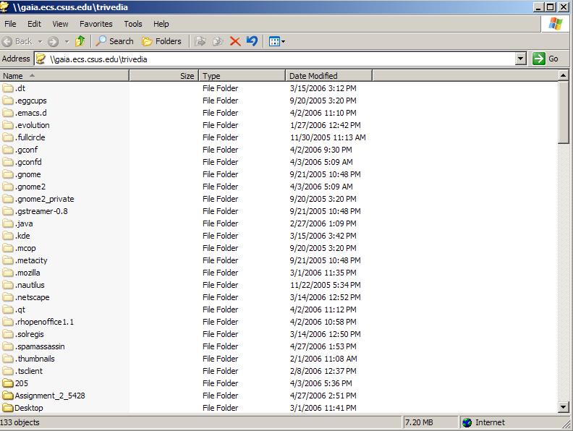
Figure 2

Step 4: Select the Temp on C folder, as shown in Figure 3.

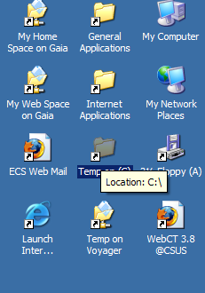
Figure 3

Step 5: Double click on the folder to open it (Figure 4)

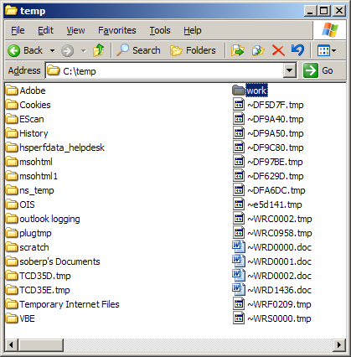
Figure 4

Step 6: Select the file you want to copy from My Home Space on Gaia and drag and drop to the Temp on C folder. The file which is dragged is shown in Figure 5 below marked by an arrow (Or you can use copy and paste commands).

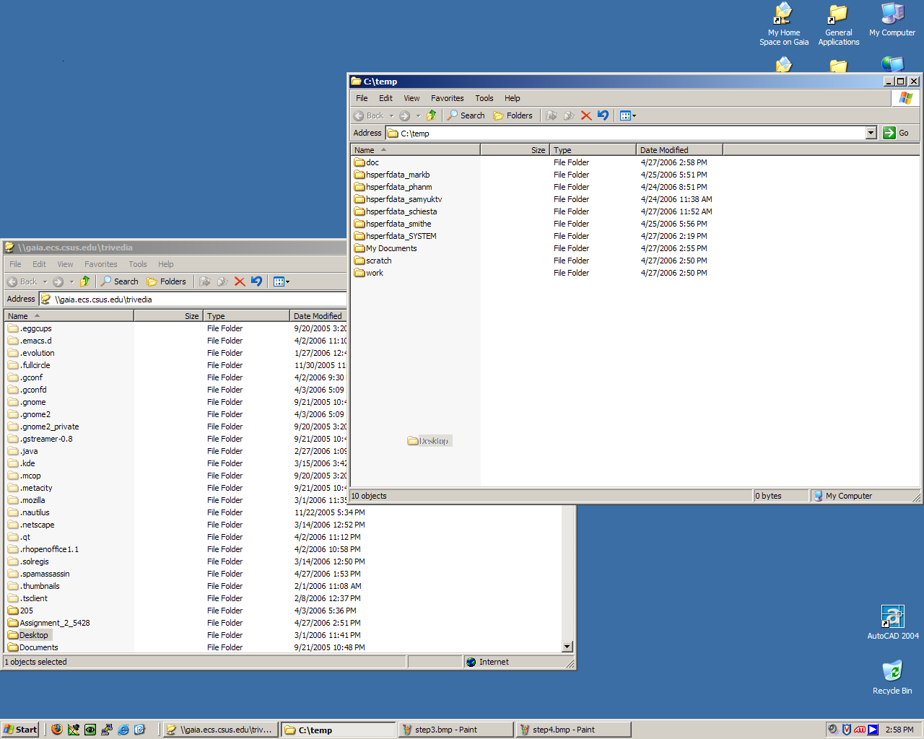
Figure 5

Step 7: The file gets copied into the C:\temp folder as shown highlighted in the figure below (Figure 6)

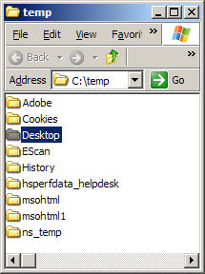
Figure 6

Step 8: You can then copy the file to your flash drive as shown in Figure 7 below, or simply copy from the C:\temp folder and paste to your Flash drive folder.
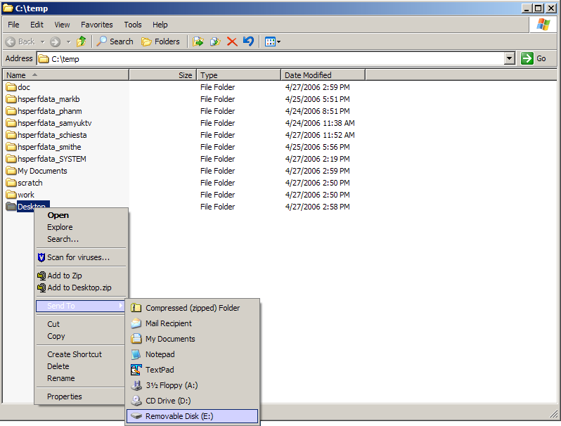
Figure 7

