<http://d.wanfangdata.com.cn/Periodical_xtgcydzjs201206030.aspx>

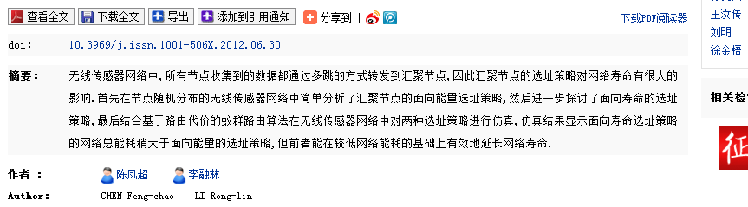

无线传感器网络中,所有节点收集到的数据都通过多跳的方式转发到汇聚节点,因此汇聚节点的选址策略对网络寿命有很大的影响.首先在节点随机分布的无线传感器网络中简单分析了汇聚节点的面向能量选址策略,然后进一步探讨了面向寿命的选址策略,最后结合基于路由代价的蚁群路由算法在无线传感器网络中对两种选址策略进行仿真,仿真结果显示面向寿命选址策略的网络总能耗稍大于面向能量的选址策略,但前者能在较低网络能耗的基础上有效地延长网络寿命.

低复杂度 low-complexity

最大化 网络是生命周期 maximize the network lifetime

A typical WSN architecture involves large numbers of

sensor nodes that report their measurements to locally

deployed data collection centers

such as topology management, energy efficient MAC design, power-aware routing, and energy-favored flow control and error control schemes.

