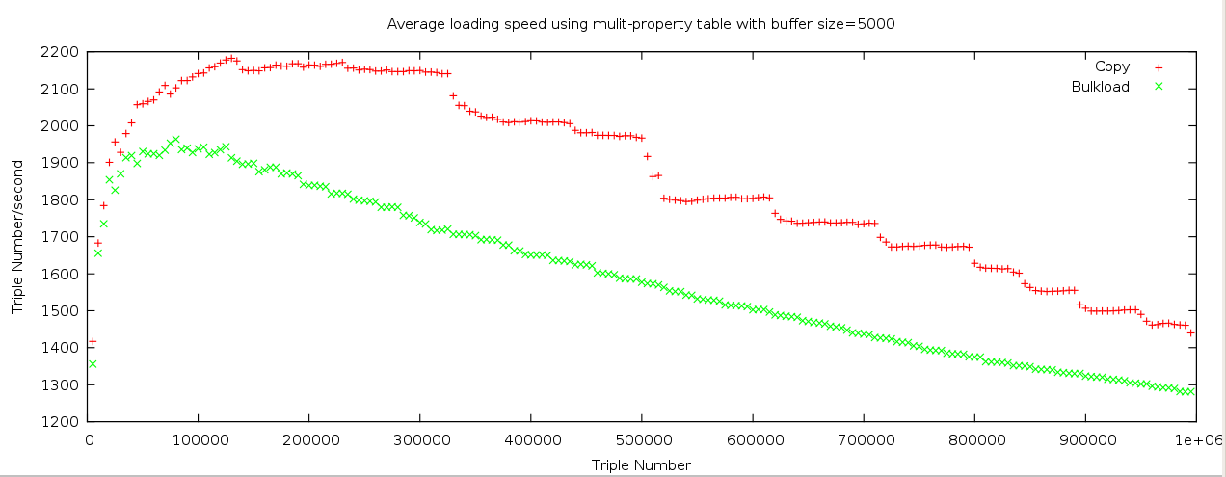

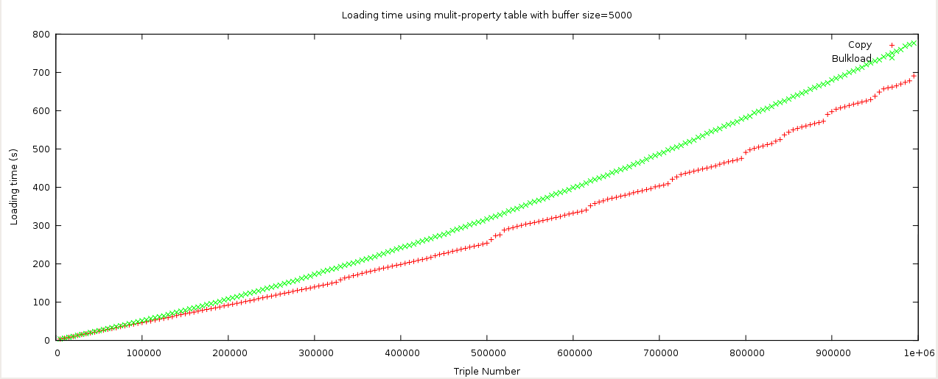

Some bugs by using bulkload:

BUG 1:
Cannot use hash index, otherwise the database server will crash.
e.g, in MAP table, we have index:
CREATE INDEX idx_map_uri ON map USING btree (decode(md5(uri::text), 'hex'::text));

Workaround:
a) Drop index idx_map_uri before bulkload;
b) Bulkload data into MAP table
c) Recreate index

But recreating index will cause performance lost.

BUG2:
Using bulkload sometimes causes database abnormal. Need to restart the database server.
For example: Use bulkload to load data into database. After the loading completion, in the second times' loading, the database server will become abnormal.

select a.id from map a, test b where a.id=b.id
---------------
1
select id from map where id = 1

-------------

The result is empty.

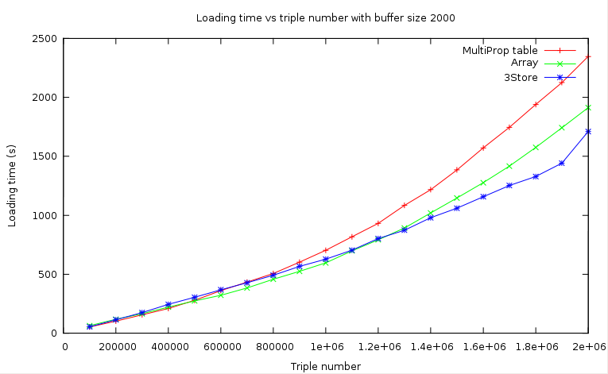

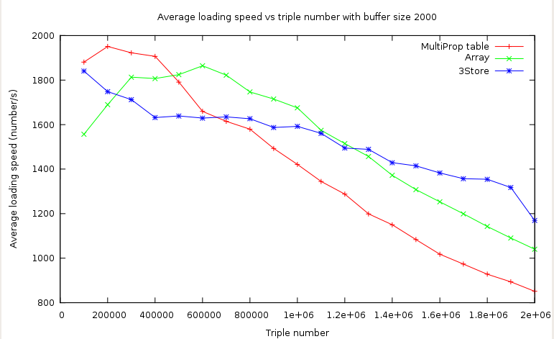

2. Triple Query
2.1 Query(*,*,*)
Query | Multi-Prop table | Array | 3Store
(*,*,*) | 40.98522407875 | 35.8288913535 | 70.698

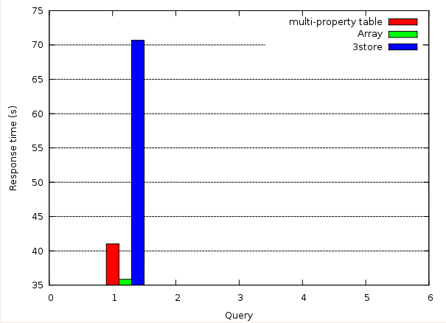
2.1
Query |  | Multi-Prop table | Array | 3Store
1. (s,*,*) | (www.eiao.net.2.0.RelaxedWAM.EIAO.TECH.1.2-M440251230,*,*) | 0.0082 | 0.0051 | 0.0366
2. (*,p,*) | (*,http://www.eiao.net/rdf/2.0#headercache_control,*) | 0.0117 | 0.0087 | 0.0268
3. (s,p,*) | (http://www.eiao.net/rdf/2.0#PageSurvey_http://www.eiao.net/rdf/2.0/PageSurvey_78,http://www.w3.org/WAI/ER/EARL/nmg-strawman#asserts,*) | 0.0610 | 0.0473 | 0.0637
4. (s,*,o) | (http://www.eiao.net/rdf/2.0#PageSurvey_http://www.eiao.net/rdf/2.0/PageSurvey_78,*,www.eiao.net.2.0.RelaxedWAM.UWEM.B.10.11.2.3.HTML.DEF.2.1-A264644335) | 0.0429 | 0.0257 | 0.0269
5. (*,p,o) | (*,http://www.w3.org/WAI/ER/EARL/nmg-strawman#asserts,www.eiao.net.2.0.RelaxedWAM.UWEM.B.10.11.2.3.HTML.DEF.2.1-A264644335) | 0.00524 | 0.0177 | 0.0199
6. (s,p,o) | (http://www.eiao.net/rdf/2.0#PageSurvey_http://www.eiao.net/rdf/2.0/PageSurvey_78,http://www.w3.org/WAI/ER/EARL/nmg-strawman#asserts,www.eiao.net.2.0.RelaxedWAM.UWEM.B.10.11.2.3.HTML.DEF.2.1-A264644335) | 0.0309 | 0.0193 | 0.0199

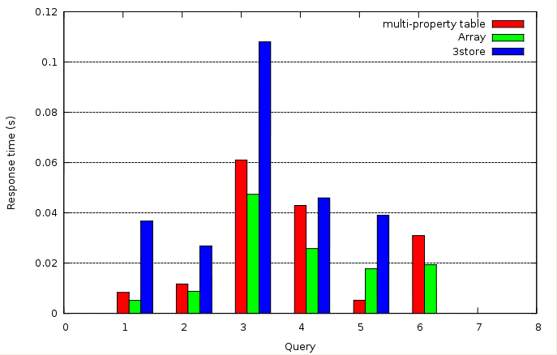

(S,P,*)

Query |  | Multi-Prop table | Array | 3Store
1. (s,p,*) | (http://www.eiao.net/rdf/2.0#PageSurvey_http://www.eiao.net/rdf/2.0/PageSurvey_78,http://www.w3.org/WAI/ER/EARL/nmg-strawman#asserts,*)
2. (s,p,*) | (http://www.eiao.net/rdf/2.0#Scenario_4043797403141018785974705900715313071_range-156,http://www.eiao.net/rdf/2.0#rangelocation_pagesurvey,*)
3. (s,p,*) | (http://www.eiao.net/rdf/2.0#Scenario_4043797403141018785974705900715313071_range-156,http://www.eiao.net/rdf/2.0#page,*)
4. (s,p,*) | (www.eiao.net.2.0.RelaxedWAM.UWEM.B.10.11.2.3.HTML.DEF.2.1-V264594838,http://www.eiao.net/rdf/2.0#result_barrierIndicator,*)
5. (s,p,*) | (http://www.eiao.net/rdf/2.0#PageSurvey_http://www.eiao.net/rdf/2.0/PageSurvey_167,http://www.eiao.net/rdf/2.0#webcacheurl,*)
6. (s,p,*) | (http://www.eiao.net/rdf/2.0#PageSurvey_http://www.eiao.net/rdf/2.0/PageSurvey_167,http://www.w3.org/WAI/ER/EARL/nmg-strawman#testsubject,*)

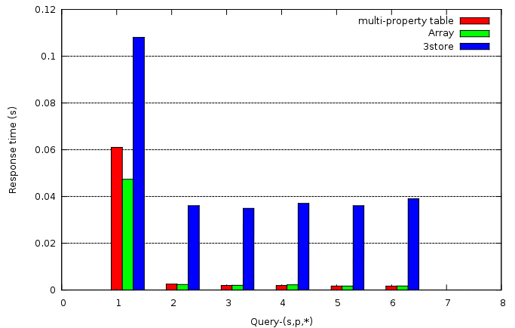

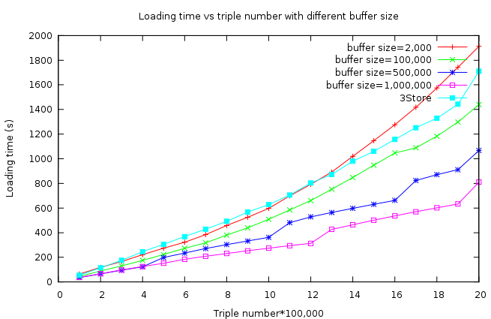

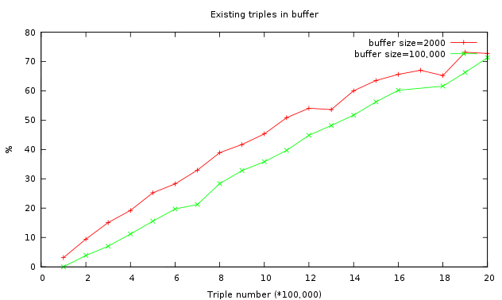

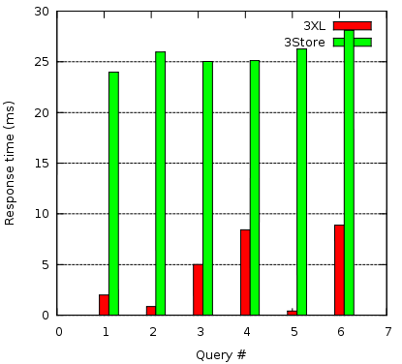

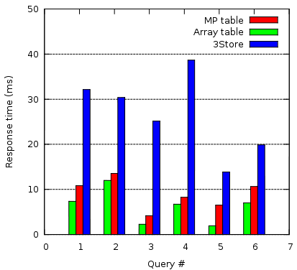

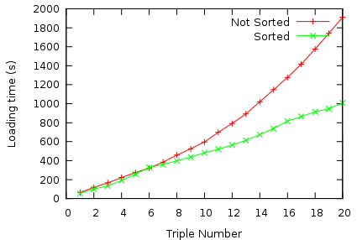  Loading time vs. Triple number with buffer size =2000 | 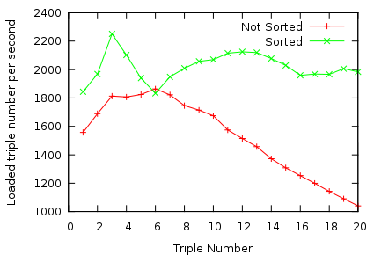  Loading speed vs. Triple number with buffer size=2000

Loading sorted and unsorted RDF data into 3Store
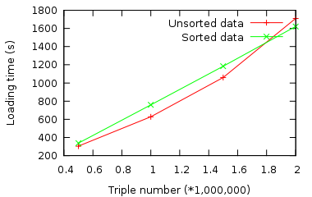 | 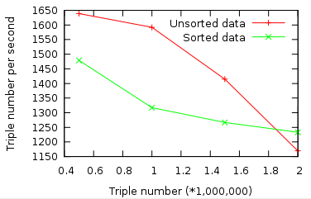

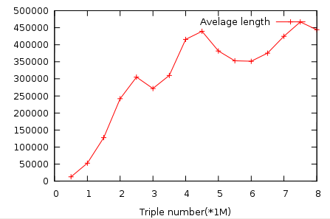

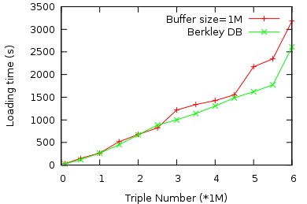
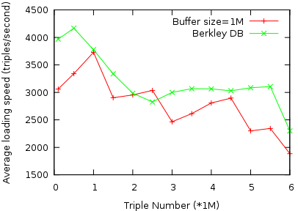

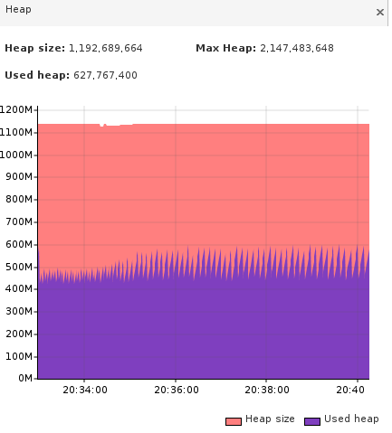

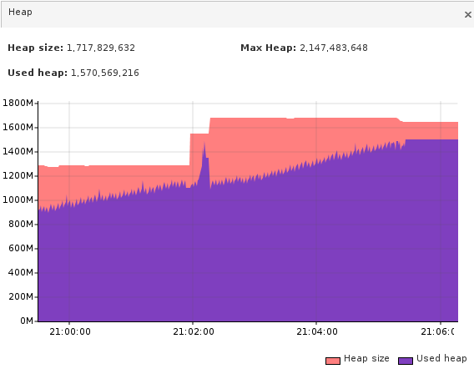

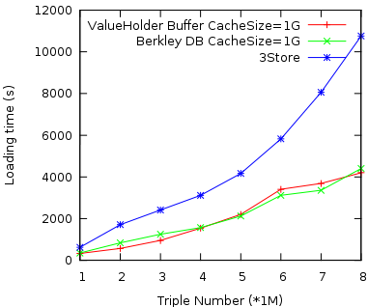 | 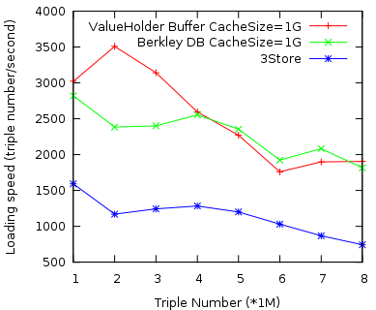

2009-02-16
1. Database schema
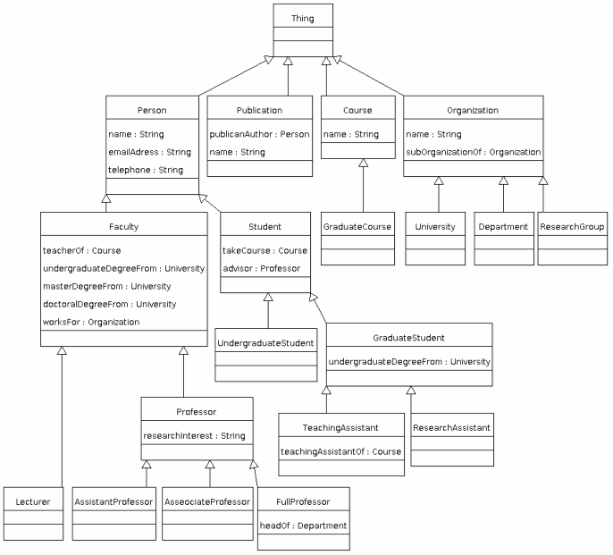

2. Data loading

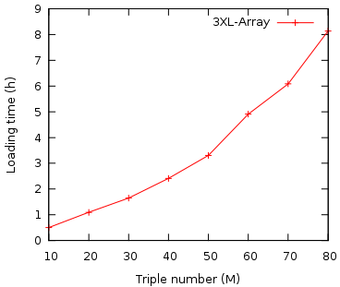 | 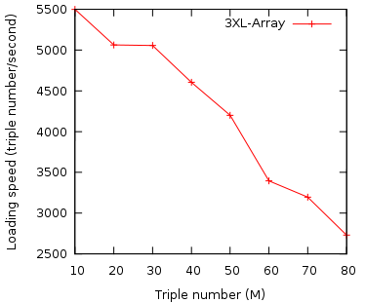

- Query
(s,p, o) =
("http://www.Department6.University0.edu/GraduateStudent95",
"http://www.eiao.net/rdf/2.0#emailaddress",
"GraduateStudent95@Department6.University0.edu")

triple number = 70 m in database;
Query | Time (ms)
(s, p, o) | 0.00261205
(s, p, *) | 0.0021965
(s, *, o) | 18.36579785
(s, *, *) | 12.0868469
(*, p, o) | 0.0335308
(*, p, *) | 0.0189584
(*, *, o) | 44922.01234725
(*, *, *)

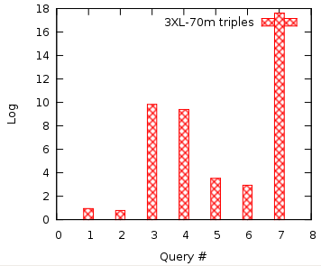

================ Meeting February 27, 2008 =======================

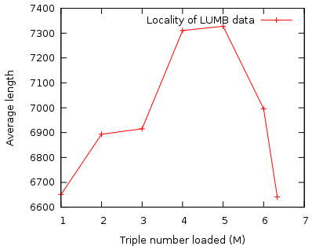

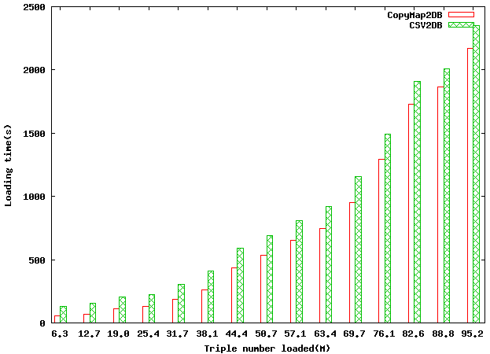

2009 – 05 ／15

