Document title
  - Document subtitle

Heading 2

Heading 3

Heading 4

Heading 5

Heading 6
“A block quote.”
- John Smith
Paragraph with a hyperlink.
Footnote
Endnote
Bookmark
A cross-reference to a Bookmark.
A cross-reference to a footnote1.
A second cross-reference to a footnote1.
A cross-reference to a label (Figure 1).
A cross-reference to a heading: Heading 2.

Full citation (Kilpatrick, 2011).
Citation with author and title suppressed (2011).
Point citation (Kilpatrick, 2011, p. 325).

Commented text Highlights, Italics, Bold, Underlined, Strikethrough

An unordered list:
- Item 1 unordered
- Item 2 unordered

A ordered list:
- First ordered
- Second ordered

An unordered, nested list:
- Item 1 unordered, nested
  - Item 2 unordered, nested

An ordered, nested list:
- First ordered, nested
  - Second ordered, nested

A mixed, nested list:
- First
  - Blue
    - A
    - B

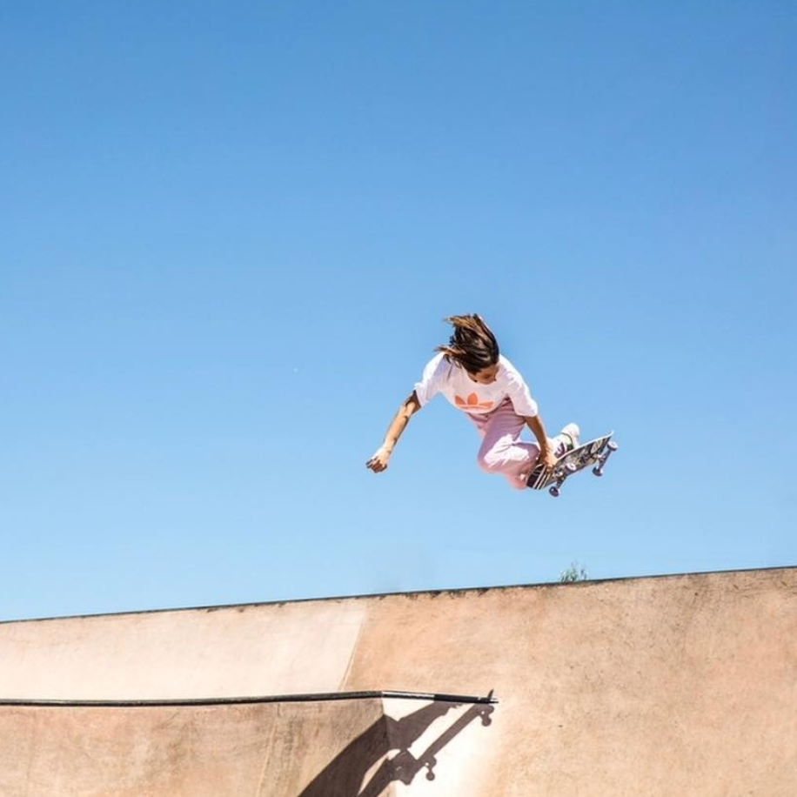


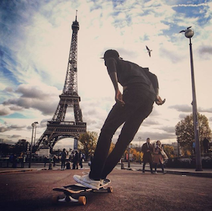
Figure 1 A captioned image.

Figure 2 A multipart figure with caption.

Table 1 A table with images and footnotes.
 | Header 2 | Header 3 | Total
A | Inline image 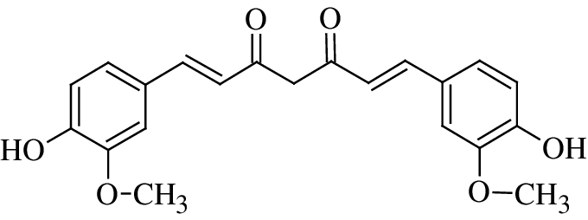 | 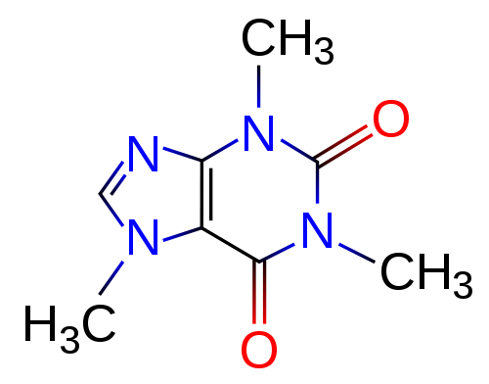 | Total A
B | $$a^{2}+b^{2}=c^{2}$$ | Data | Total B
C | Data | Data$A=πr^{2}$ | Total C
Total Row | Total 2 | Total 3 | Total

Text Box 1 A text box caption.

Text Box Heading
A text box with only text and a heading.

Text Box 2 A textbox with uncaptioned images.
Inline image 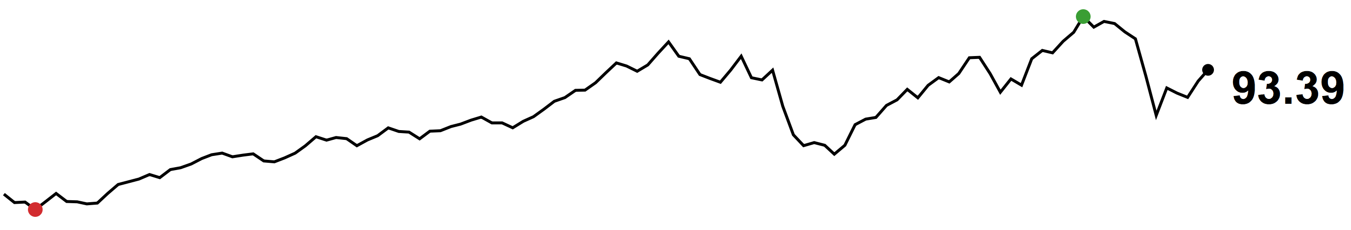

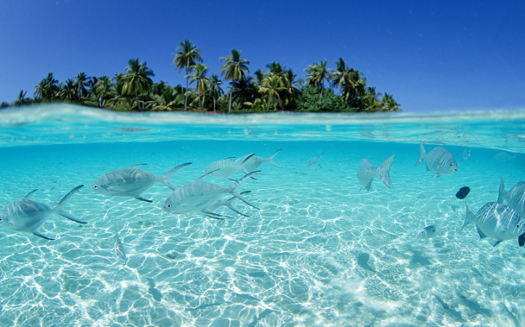

Inline code str.length

# standard tests
x <- runif(100, 0, 10) # 100 draws from U(0,10)
y <- 2 + 3*x + rnorm(100) # beta = [2, 3] and sigma is 1
d <- lm(y ~ x)
summary(d)
Code 1 Code block sample. Programming Language: R.

An inline equation $x=\frac{-b±\sqrt{b^{2}-4ac}}{2a}$
Equation 1 Binomial theorem.
$${\left(x+a\right)}^{n}=\sum_{k=0}^{n}{\left({n \atop k}\right)x^{k}a^{n-k}}$$

https://www.ncbi.nlm.nih.gov/nuccore/NC_012532.1
Supporting Dataset 1 Genbank.

References
Kilpatrick, A. M., 2011. Globalization, Land Use, and the Invasion of West Nile Virus. Science, 21 October, 334(6054), pp. 323-327.

A footnote
Table footnote
An endnote

