Textbox test

Introduction
Text Box 1 A textbox with uncaptioned images.
Inline image 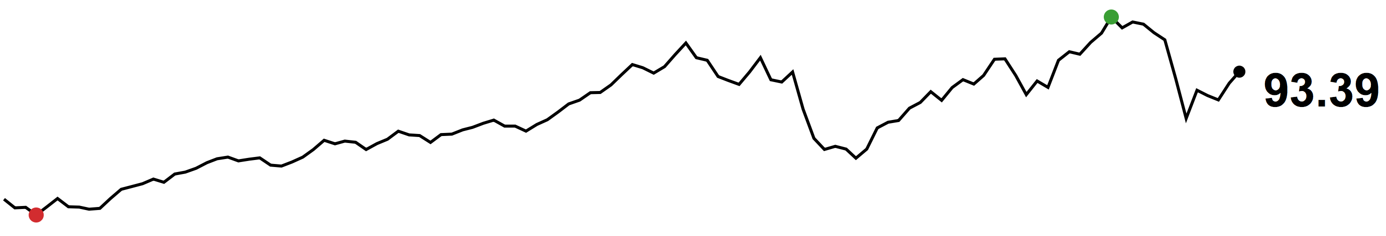



Text Box 1 A textbox with only text
Hello world.

