Uncaptioned image test

Introduction
Inline image 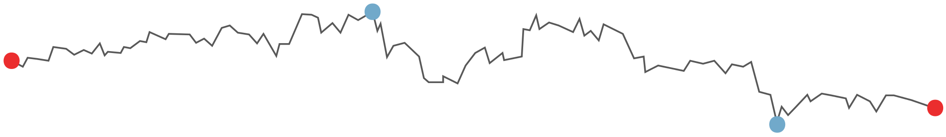



Text Box 1 A textbox with uncaptioned images.
Inline image 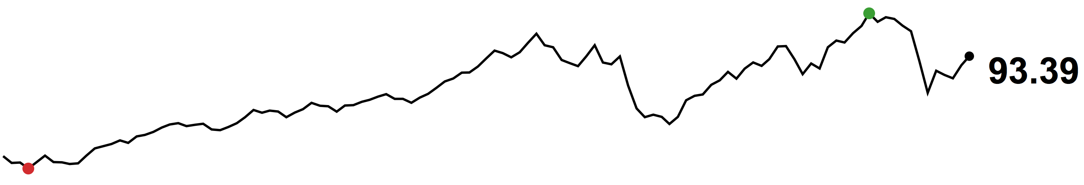



Table 1 A table with uncaptioned images.
Table header 1 | Table header 2
Inline image 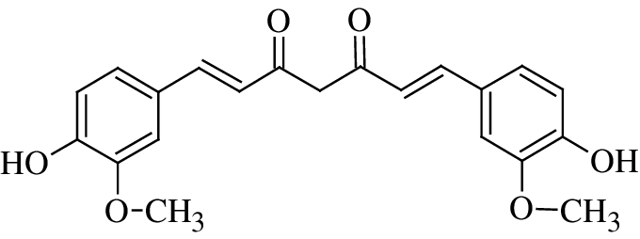 | 