LCLE: a web portal for comprehensive gene distance analysis for correlation networks in liver cancer

Xiuquan Wang¹, Xiaoqian Zhu², Keli Xu³, Junqing Wang*^{,4}, Yunyun Zhou*^{,2}
¹ Department of Mathematics and Computer Science, Natural Science Division, Tougaloo College, 500 W. County Line Rd, Jackson, MS, 39174, United States
² Department of Data Science, John D. Bower School of Population Health, University of Mississippi Medical Center, 2500 North State Street, Jackson, MS, 39216, United States
³ Department of Neurobiology and Anatomical Sciences, University of Mississippi Medical Center, Jackson, Mississippi, 39216,
⁴ Department of Surgery, Ruijin Hospital, Shanghai Jiao Tong University School of Medicine, Shanghai, 20025, China,

* Corresponding to: yzhou@umc.edu; wangjunqingmd@163.com

Abstract
Most of the currently available co-expression network analysis method only can capture linear correlation among genes; however, ignore the non-linear dependent correlations. Accurately and easily getting the distance values among genes are of significant importance in clustering genes which are shared in the same biological functions. We developed an online tool, LCLE, which is able to systematically analyze gene expression data to identify more comprehensive relationships among lncRNAs and protein-coding genes (PCGs) from five different distances metrics. Our simulation results demonstrated that the selection of an appropriate distance method could help to identify novel important genes from networks. Users can download and visualize figures, and distance tables analyzed from publically available RNAseq data such as TCGA and GTEx or upload their own data for analysis. Overall, our web portal will benefit for biologists or clinicians without programming background in identifying novel co-regulation relations for lncRNAs and PCGs.

Keywords: adjacency matrix, co-expression network, correlation, non-coding RNA, liver cancer

Introduction

Correlation networks are widely used in system biology applications such as estimating the co-expression patterns among genes, clustering genes shared in the same pathway, and selecting genes related to certain phenotypic conditions. In order to obtain optimal results, the key step is to fine-tune the distance parameters among genes. While many previous studies have developed methodologies for correlation network, no comprehensive studies comparatively investigated the outcome performance if choosing different distance metrics. Also, there are no user-friendly and reliable tools available so that users can have more options in choosing a distance metric based on their data distribution.

In the network analysis, determining which distance to use is probably one of the most difficult decisions [1]. Providing more options to calculate the adjacency matrix of a network is increasingly important in detecting novel gene-gene and gene-traits associations. Especially the expression of long non-coding genes (lncRNA) is generally lower than protein-coding genes (PCG), their dependent correlations are highly likely to be ignored using traditional linear correlation method such as Pearson correlation.
Also, another gap is currently available weighted co-expression network methods such as WGCNA [2] only has the power to detect linear correlation among genes due to the limited distance calculation options for the adjacency matrix. Our online liver cancer lncRNA explorer (LCLE) is a comprehensive collection of distance functions for performing various weighted or un-weighted correlation network analysis. In a weighted network, connections between genes using the similarity score between 0 and 1 as the weight to indicate the strength of correlations among genes. In an un-weighted network, users can set a distance cutoff value to determine if the genes are connected or unconnected based on if the genes with a correlation above the cutoff threshold.

Here, we provided the following five distance measurement including Pearson’s correlation coefficient [3] [4] Spearman’s correlation coefficient [5], Kendall’s correlation coefficient [6], distance correlation [7], and maximal information coefficient [8] in our LCLE web portal. This work seeks to identify a dependency between protein-coding and non-coding genes (i.e. lncRNAs, pseudogenes) from liver cancer RNAseq data. We discussed sample size, local dependence and linear/non-linear and also non-functional relationships.

Materials and Methods
Project design and data resource
The framework of the project design can be found in Figure 1. To show the analysis capacity of a various data matrix, we applied our data on RNAseq data downloaded from GTEx (n=110) normal liver samples and TCGA (n=369) tumor and (n =50) normal samples as well as clinical data. All these coding and non-coding gene expression data are processed by the same Toil pipeline[9] developed by UCSC. Given that the non-coding transcript expression of RNAseq data contains many types of ncRNAs, we mainly group them into three big categories: protein-coding genes (PCGs), lncRNAs and pseudogenes. Specifically, “lincRNA", "antisense", "sense intronic", "sense overlapping", "processed transcript" are grouped into lncRNAs; "pseudogene", "processed pseudogene", "transcribed processed pseudogene", "unitary pseudogene", "polymorphic pseudogene" are grouped into pseudogenes. To show HCC specific non-coding genes, we also performed differential expression analysis by R package limma [10].
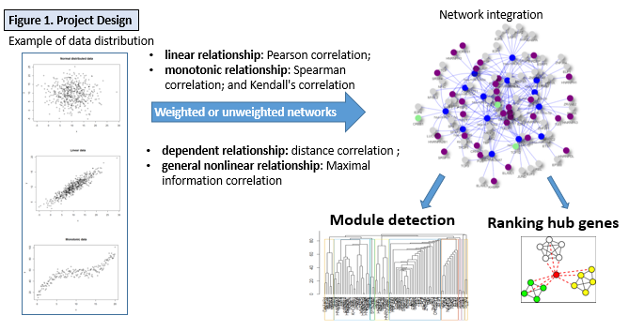
Distance method description
Let us consider the fundamental concept of Covariance. For two discrete random variables $X$ and $Y$ with probability mass functions (pmf) $p\left(x\right), p(y)$ and joint pmf $p\left(x, y\right)$, Covariance can be written as
$$Cov\left(X,Y\right)=E[(X-E(X))(Y-E(Y))] \\ =E\left(XY\right)-E\left(X\right)E\left(Y\right) \\ =\sum_{x,y}{p\left(x,y\right)}xy-\left( \sum_{x}{p\left(x\right)x}\right)\left( \sum_{y}{p\left(y\right)y}\right) \\ =\sum_{x,y}{[p\left(x,y\right)-p(x)p(y)]xy}$$
$Cov\left(X,Y\right)$ creates a weighted sum of the product of the two random variables $X$ and $Y$. $p\left(x,y\right)-p(x)p(y)$ is a measure of the distance of the two random variable $X$ and $Y$ from independence. So with $Cov\left(X,Y\right)$, what non-independence does to their product can be found. But the value of the covariance is not easy to interpret, it depends on the weighted variables product (magnitudes of inner product).
Pearson’s correlation coefficient is defined as
$$ρ_{X,Y}=\frac{Cov\left(X,Y\right)}{σ_{X}σ_{Y}}$$
It can be interpreted as standardized covariance which adopted by scientist to measure the strength of linear correlation between a pair of variables. The correlation coefficient ranges from −1 to 1. A value of 1 implies that a linear equation describes the relationship between X and Y perfectly, with all data points lying on a line for which Y increases as X increases. A value of −1 implies that all data points lie on a line for which Y decreases as X increases. A value of 0 implies that there is no linear correlation between the variables.
Pearson’s correlation coefficient is wildly used in the sciences. However, for nonlinear distributed data, $ρ_{X,Y}$ usefulness is greatly reduced. We needed are those with the ability to capture nonlinear association, but reduced to Pearson correlation for linear case [11]
Spearman's rank correlation coefficient and Kendall's $τ$ rank correlation coefficient measure how well the relationship between two variables can be described using a monotonic function, the assumption of linearity does not required in the relationship between variables.
Let $\{\left(x_{i}, y_{i}\right), i=1, 2,…n\}$ be a set of observations of the two joint random variables $X$ and $Y$ respectively. First, $\{x_{i}\}$ and $\{y_{i}\}$ are converted to ranks $\{rg X_{i}\}$, $\{rg Y_{i}\}$ and $r_{s}$ is defined as
$$r_{s}=ρ_{rg_{X},rg_{Y}}=\frac{Cov\left(rg_{X}, rg_{Y}\right)}{σ_{rg_{X}}σ_{rg_{Y}}}$$
The Spearman correlation between two variables is equal to the Pearson correlation between the rank values of those two variables. Pearson's correlation assesses linear relationships, Spearman's correlation assesses monotonic relationships (whether linear or not). If there are no repeated data values, a perfect Spearman correlation of +1 or −1 occurs when each of the variables is a perfect monotone function of the other.
Kendall $τ$ rank correlation coefficient is used to measure the ordinal association between two measured quantities. The explicit expression for Kendall $τ$ rank correlation coefficient is defined as:
$$τ\left(X, Y\right)=\frac{2}{n(n-1)}\sum_{i<j}{sgn(x_{i}-x_{j})sgn(y_{i}-y_{j})}$$
Where $sgn(x)$ is defined as
$$sgn(x)=\left\{\begin{aligned}-1, if x<0, \\ 0, if x=0, \\ 1, if x>0 \end{aligned}\right.$$
Any pair of observations $(x_{i}, y_{i})$ and $(x_{j}, y_{j})$ where $i<j$, are said to be concordant, otherwise discordant. If both $x_{i}>x_{j}$ and $y_{i}>y_{j}$ or if both $x_{i}<x_{j}$ and $y_{i}<y_{j}$, $sgn\left(x_{i}-x_{j}\right)sgn\left(y_{i}-y_{j}\right)=1$, The summation over $i<j$ is the number of concordant pairs while If both $x_{i}>x_{j}$ and $y_{i}<y_{j}$ or if both $x_{i}<x_{j}$ and $y_{i}>y_{j}$, $sgn\left(x_{i}-x_{j}\right)sgn\left(y_{i}-y_{j}\right)=-1$, the summation over $i<j$ is the number of discordant. If $x_{i}=x_{j}$ and $y_{i}=y_{j}$, the pair is neither concordant nor discordant. The Kendall correlation between two variables will be high when observations have a similar rank (or identical for a correlation of 1) between the two variables, and low when observations have a dissimilar rank (or fully different for a correlation of -1) between the two variables.
It is common to regard these two rank correlation coefficients as alternatives to Pearson's coefficient, used either to reduce the amount of calculation or to make the coefficient less sensitive to non-normality in distributions. However, this view has little mathematical basis, as rank correlation coefficients measure a different type of relationship than the Pearson product-moment correlation coefficient, and are best seen as measures of a different type of association, rather than as alternative measure of the population correlation coefficient [12] [13]
Distance Correlation: The Pearson correlation coefficient [14] is mainly sensitive to a linear relationship between two variables. Distance correlation was introduced in 2005 by Gábor J. Székely [7] to address this deficiency of Pearson’s correlation, namely that it can easily be zero for dependent variables.
Let $\{\left(x_{i}, y_{i}\right), i=1, 2,…n\}$ be a set of observations of the two joint random variables X and Y respectively. First, compute the n by n distance matrices $(a_{i, j})$ for variable X and $(b_{i, j})$ for variable Y, each containing all pairwise distances.
$$a_{i,j}=\left|\left|X_{i}-X_{j}\right|\right|, i, j=1, 2,…n \\ b_{i,j}=\left|\left|Y_{i}-Y_{j}\right|\right|, i, j=1, 2,…n$$where $||⋅||$ denotes Euclidean norm. Then take all doubly centered distances
$A_{i,j}≔ a_{i,j}- {\overline{a}}_{i, .}-{\overline{a}}_{.,j}+{\overline{a}}_{.,.}$ $B_{i,j}≔ b_{i,j}- {\overline{b}}_{i, .}-{\overline{b}}_{.,j}+{\overline{b}}_{.,.}$ where ${\overline{a}}_{i, .}$is the $i$-th row mean, ${\overline{a}}_{., j}$is the $j$-th column mean, and ${\overline{a}}_{., .}$is the grand mean of the distance matrix of the X sample. The notation is similar for the b value. Then the distance covariance is defined by
$$dCov\left(X,Y\right)=\sqrt{\frac{1}{n^{2}}\sum_{i=1}^{n}{\sum_{j=1}^{n}{A_{i,j}B_{i,j}}} }$$
And $dVar\left(X\right)=dCov\left(X,X\right)$, $dVar\left(Y\right)=dCov\left(Y,Y\right)$. Distance covarianc is not the covariance between the distances themselves. It is the covariance between the special inner products which the "double centered" matrices are comprised of. $dCov\left(X,Y\right)=0$ if and only if X and Y are independent.
Distance correlation is obtained from the numbers analogously how Pearson correlation is obtained from usual covariance and the pair of variances: divide the covariance by the square root of the product of two variances. That is
$$dCor\left(X,Y\right)=\frac{dCov\left(X,Y\right)}{\sqrt{dVar\left(X\right)dVar\left(Y\right)}}$$
Distance correlation satisfies$0≤dCor\left(X,Y\right)≤1$. And $dCor\left(X,Y\right)=0$ if and only if X and Y are independent. Thus, distance correlation measures both linear and nonlinear association between two random variables. This is in contrast to Pearson's correlation, which can only detect linear association between two random variables.
The maximal information correlation (MIC) was introduced by Reshef et al as a statistics. Method is based on naïve Mutual information computed using a data dependent binning scheme.
$$MIC\left(X,Y\right)=\max_{a*b<B}{\frac{I\left(X,Y\right)}{\log_{2}{min⁡(a,b)}}}$$
Where the maximum is taken over all $a by b$ grids, B is the search-grid size which is a function of sample size, usually set $B=n^{0.6}$. $I\left(X,Y\right) =-\sum_{x∈X}{\sum_{y∈Y}{p\left(x,y\right)\log\left(\frac{p\left(x\right)p\left(y\right)}{p\left(x,y\right)}\right)}}$ is the maximum mutual information over all grids $X$ by $Y$, of the distribution induced by $(x, y)$ on a grid having $X$ and $Y$bins (where the probability mass on a cell of the grid is the fraction of points of $(x, y)$ falling in that cell). By applying Jensen Inequality on convex negative logarithm function, we get$I\left(X,Y\right)≥0$. $I(X,Y)=0$ if and only if $p\left(x,y\right)=p(x)p(y)$, which means $X$ and $Y$ are independent random variables. $I\left(X,Y\right)>0$ when X and Y are dependent and the stronger the mutual dependence is, the larger the MI value. The limit is zero if Y is a non-constant function of X [8].
The main idea is to discretize the data onto many different two-dimensional grids and calculate normalized scores that represents the mutual information of the two variables on each grid. The scores are normalized to ensure a fair comparison between different grids and vary between 0 (uncorrelated) and 1 (high correlations). MIC captures a wide range of associations both functional and not, and for functional relationships provides a score that roughly equals the Pearson’s coefficient of determination ($R^{2}$) of the data relative to the regression function.
The choice of which method to use depends on which behavior seems most reasonable for your purposes. If you are okay with discarding unrelated, dependent variables, then the Pearson’s coefficient is fine. But if you truly want unrelated, dependent variable to be considered, then the nonlinear method are probably best. The following table list several measurement to the performance of methods. Generality means that with sufficient sample size the statistic should capture a wide range of interesting associations, not limited to specific function types (such as linear, exponential, or periodic), or even to all functional relationships. Equitability means that the statistic should give similar scores to equally noisy relationships of different types.
Development of the correlation network for liver cancer RNAseq data
Detecting patterns across different distance conditions is becoming an important task. For example, it is interested in identifying gene modules and what’s the difference among these networks. Data on gene networks can be acquired for multiple distance measurement in our LCLE web browser. In a weighted correlation network, each node represents a gene (feature), and links represent correlations between the genes. In an unsigned co-expression network, modules correspond to clusters of genes with high absolute correlations. Specifically, we used a_{ij} = |cor(x_{i} , x_{j})| to represent the adjacency of a weighted network. Optionally, in an unweighted network, users can set a correlation cutoff to determine if the genes should be connected or not connected. The connectivity score is used to measure the connection strengths for each gene with the other network genes. Then we performed gene modules analysis to cluster genes of highly interconnected using Hierarchical cluster method.

Results
Analysis of simulations for distance measurement
As shown in Table 1, we evaluated the strengths and limitations of each distance method to help users determining which method to choose so that it marries well with their gene expression data. The choice of which method to use depends on which behavior seems most reasonable for your purposes. If you are okay with discarding unrelated, dependent variables, then the Pearson’s coefficient is fine. But if you truly want an unrelated, dependent variable to be considered, then the nonlinear method is probably best. However, generally, a large sample size should capture a wide range of interesting associations, no matter a linear or non-linear relationship.
Table 1. Comparative summary for five standard distance method
Methods | Application | Normalization | Generality | Equitability | symmetry
Pearson | Linear Data | Yes | low | Non-equitable[20] | Yes
Spearman | Linear, Monotonic nonlinear | Yes | low | Weakly-equitable[12] | Yes
Kendall | Linear, Monotonic nonlinear | Yes | low | Non-equitable[20] | Yes
Distance Correlation | Linear, Nonlinear | Yes | high | Non-equitable[20] | Yes
MIC | Linear, Nonlinear | Yes | high | Non-equitable[20] | Yes

Performance evaluation for various distance on simulation data.
To show the performance of each distance metrics, we simulated different types of gene relationship and evaluated statistic score to compare each method. As shown in Figure. 2 and Table 2, for six types of relationships such as linear, monotonic, and cross relationships, the performance of statistic correlation values for different distance are different.

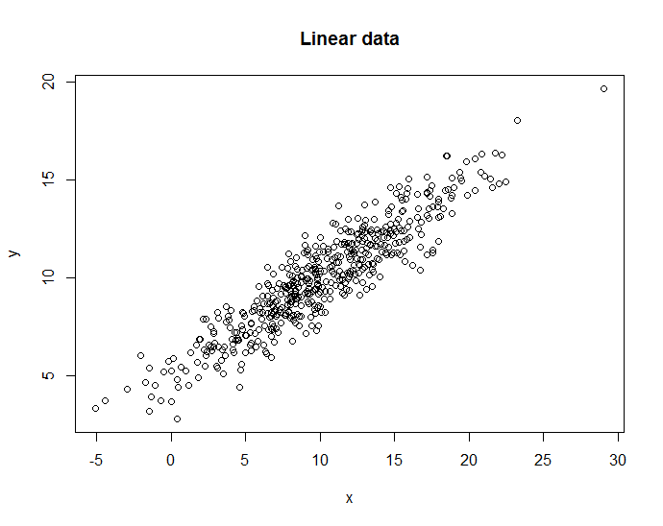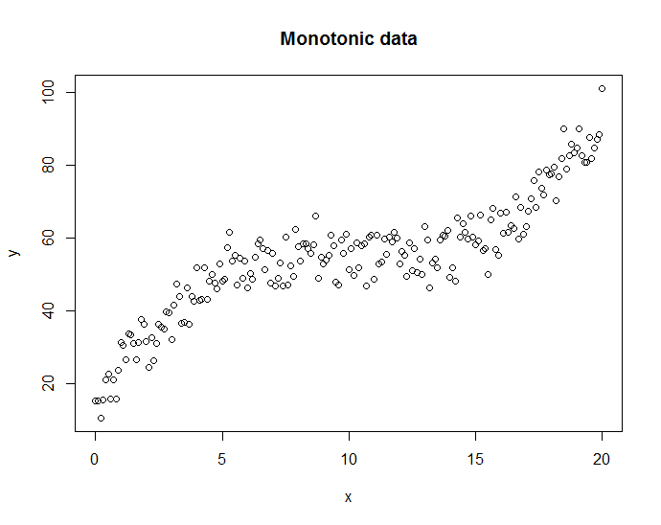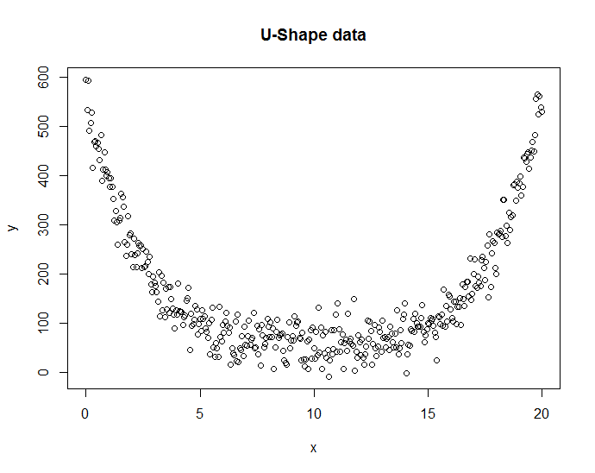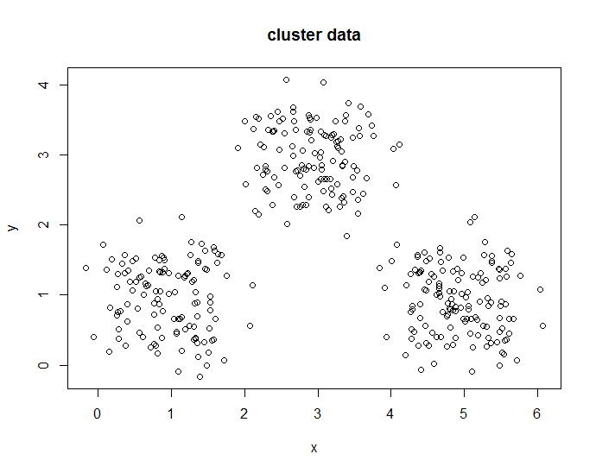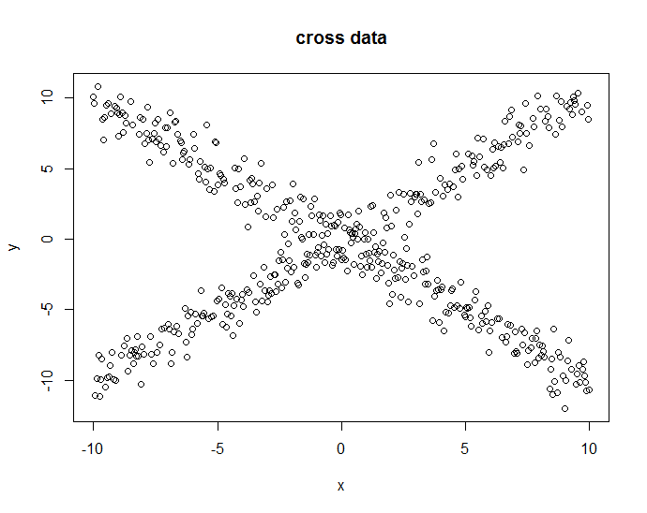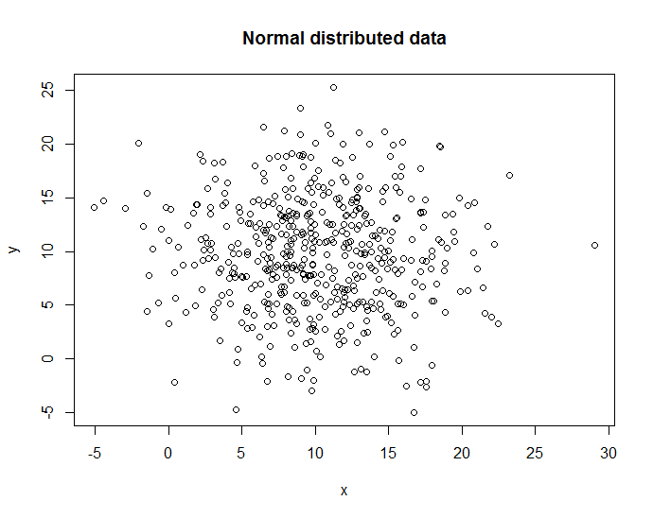
Figure 2: Illustration of simulated dataset with dependent relations. N=500 data points generated for six relationship types with additive noise.
Relationship type | Pearson  -1 ≤ r ≤ 1 | Spearman  -1 ≤ ρ ≤ 1 | Kendall  -1 ≤ t ≤ 1 | Distance  0 ≤ d ≤ 1 | MIC  0 ≤ r ≤ 1
Normal Distributed | -0.04122944 | -0.03337165 | -0.02284569 | 0.064276 | 0.159698
Linear | 0.9203632 | 0.9092514 | 0.7396393 | 0.890504 | 0.7444594
monotonic | 0.8799572 | 0.8762066 | 0.7233831 | 0.85228 | 0.7045513
U-shaped | -0.009896153 | -0.01134514 | -0.008029925 | 0.4387108 | 0.7888479
cross | -0.0580843 | -0.05691431 | -0.04578758 | 0.2425225 | 0.4705612
Clustering | 0.2962691 | 0.3826086 | 0.3806709 | 0.34575 | 0.9535275

Table 2: The correlation values of listed dependence measures on six example distributions. For Pearson, linear or close linear distribution (monotonic type) have a higher correlation, but on others dependent relation, it shows very low correlation. Spearman and Kendall show a little better performance than Pearson, but still lower than what we expected on the nonlinear case. Distance correlation performs a little poorer than Pearson on linear example, but simulation on nonlinear dependence examples are much better. MIC correlation shows a strong dependence on linear and nonlinear example except cross one.

Application of lncRNAs and PCGs co-expression network for Liver cancer
To illustrate the applications of the five distance methods in retrieving relevant coding and non-coding genes regulatory relationships, we applied them to an RNA-seq data from liver cancer. Figure 3 illustrated the visualization example of network cluster analysis based on Pearson correlation distance. Figure 3A and 3B showed the clusters by the hierarchical tree structure and network modularity analysis respectively. Figure 3C showed an example of a linear relationship between two genes, which is easily detected by Pearson correlation method.
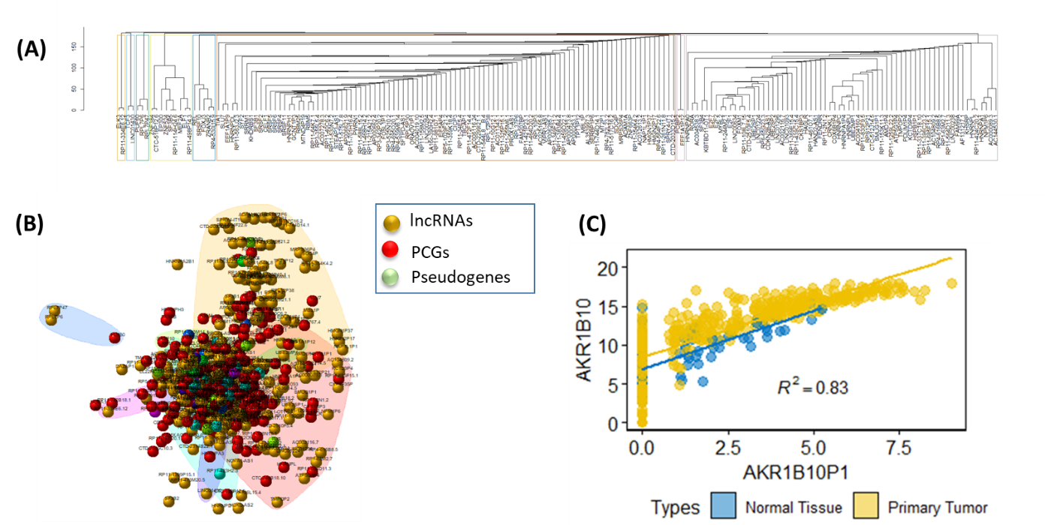
Figure 3. Illustration of gene clustering based on Pearson correlation method.

Web portal Visualization
We now deployed all these functions in the LCLE (https://datasciences123.shinyapps.io/LCLE ), we have provided network visualization for different distance metrics for Liver cancer RNAseq data we also allow the users to perform a network analysis for their own data with a restricted 2000 genes due to the hardware limitations. Users can download the figures and statistic summary tables analyzed by our tool.

Discussion
One major task in computational system biology is to understand the dependency among genes to model gene correlation networks. Correlation networks facilitate network-based gene screening methods that can be used to identify candidate biomarkers or therapeutic targets. However, the currently available network tools focus on a variety of fancy and comprehensive algorithms while ignored a basic fundamental step for the correlation distance calculation. Here, we provided users an interactively web portal so that users can have more options in genes distance measurement based on their data distribution.

Pearson’s correlation is the most common method used to measure the distance between gene expressions, but if the gene pairs are linearly associated, the results will be optimal. For other types of association, such as non-linear or non-functional relationships, methods based on the rank correlation and information theory are more adequate than the Pearson’s correlation but are less used in applications, most probably because of a lack of clear guidelines for their use. Moreover, given the same dataset, significant differences in conclusions may arise from the selection of distinct distance measures. Therefore, providing more options for distance selection is an appropriate method so that users can identify novel meaningful genes.
However, if the data contain a lot of technical artifacts or noise, the results will be very sensitive. Because of the unsupervised clustering in network analysis, it is important to detect f unwanted variations. While the methods development was motivated by gene expression data, the underlying data mining approach can be applied to a variety of different types of data. More importantly, not limited to network analysis, any clustering or classification problems of samples or genes involved with choosing an appropriate distance, because some distance metric will be sensible than others, depending on the properties of the given dataset.

Acknowledgement
This study was kindly supported by grants from the University of Mississippi Medical Center Intramural Research Support Program for Clinical Population Science fund (No. 51002630519 (YZ)) and partially supported by grants from the following: National Natural Science Foundation of China (No. 81602544).

Reference
1. de Siqueira Santos S, Takahashi DY, Nakata A, Fujita A: A comparative study of statistical methods used to identify dependencies between gene expression signals. Briefings in bioinformatics 2013, 15(6):906-918.
2. Langfelder P, Horvath S: WGCNA: an R package for weighted correlation network analysis. BMC bioinformatics 2008, 9(1):559.
3. Galton F: I. Co-relations and their measurement, chiefly from anthropometric data. Proceedings of the Royal Society of London 1889, 45(273-279):135-145.
4. Pearson K: Notes on the history of correlation. Biometrika 1920, 13(1):25-45.
5. Spearman C: " General Intelligence," objectively determined and measured. The American Journal of Psychology 1904, 15(2):201-292.
6. Kendall MG: A new measure of rank correlation. Biometrika 1938, 30(1/2):81-93.
7. Székely GJ, Rizzo ML, Bakirov NK: Measuring and testing dependence by correlation of distances. The annals of statistics 2007, 35(6):2769-2794.
8. Reshef DN, Reshef YA, Finucane HK, Grossman SR, McVean G, Turnbaugh PJ, Lander ES, Mitzenmacher M, Sabeti PC: Detecting novel associations in large data sets. science 2011, 334(6062):1518-1524.
9. Vivian J, Rao AA, Nothaft FA, Ketchum C, Armstrong J, Novak A, Pfeil J, Narkizian J, Deran AD, Musselman-Brown A: Toil enables reproducible, open source, big biomedical data analyses. Nature biotechnology 2017, 35(4):314.
10. Ritchie ME, Phipson B, Wu D, Hu Y, Law CW, Shi W, Smyth GK: limma powers differential expression analyses for RNA-sequencing and microarray studies. Nucleic acids research 2015, 43(7):e47-e47.
11. Speed T: A correlation for the 21st century. Science 2011, 334(6062):1502-1503.
12. Ding AA, Li Y: Copula correlation: An equitable dependence measure and extension of pearson's correlation. arXiv preprint arXiv:13127214 2013.
13. Kendall MG: Rank correlation methods. 1948.
14. Pearson K: Contributions to the mathematical theory of evolution. Philosophical Transactions of the Royal Society of London A 1894, 185:71-110.

