
Department of Mathematics and Computer Science
Natural Science Division
Tougaloo College
Tougaloo, MS 39174

September 3, 2020
Dear Prof. Streeter
Please accept this letter for consideration for my promotion to the rank of Associate Professor in the Department of Mathematics and Computer Science at Tougaloo College. In the documents provided in my dossier and the collection of artifacts on my webpage (https://xiuquan0418.github.io/), you will find all of the required materials in support of my request for promotion and tenure. I hope the committee finds my promotion and tenure materials demonstrate my commitment and merit tenure status and promotion to associate professor. I thank you in advance for the consideration of my letter, dossier, and supporting materials. I am happy to provide further evidence or answer any questions, if necessary.

Sincerely,
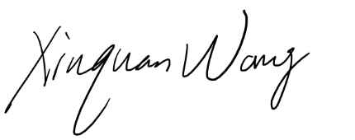
Xiuquan Wang
Department of Mathematics and Computer Science
Natural Science Division
Tougaloo College
Tougaloo, MS 39174

