Assignment 2 Report: Fine-Tuning Pretrained Transformers

A0236492Y Tan Yun Xiu

## 1. Introduction

This report explores fine-tuning of pretrained Transformer models for a downstream NLP task. The goal is to evaluate two fine-tuning strategies:

1. Full Fine-Tuning, where all model parameters are updated, and
2. (2) LoRA Fine-Tuning, a parameter-efficient method.

The DistilBERT model was trained on the IMDb sentiment classification dataset, and the results are analyzed in terms of accuracy, F1-score, and model efficiency.

## 2. Dataset

The IMDb dataset contains 50,000 labeled movie reviews (25,000 for training and 25,000 for testing). Each review is categorized as positive or negative. It is balanced, clean, and commonly used in NLP tasks, making it suitable for benchmarking fine-tuning methods on text classification.

## 3. Model and Methods

The base model is DistilBERT (distilbert-base-uncased), a 6-layer Transformer model with approximately 67 million parameters. DistilBERT retains about 95% of BERT’s performance while being more lightweight. Two fine-tuning strategies were implemented:

1. Full Fine-Tuning — All model parameters are updated during training.  
2. LoRA Fine-Tuning — A parameter-efficient approach that trains low-rank adapter matrices on attention layers (q_lin, k_lin, v_lin). LoRA configuration: rank r = 8, alpha = 32, dropout = 0.1.

Training was performed for 3 epochs using a batch size of 16 and a learning rate of 2e-5 on a Kaggle T4 GPU. Evaluation metrics include Accuracy and F1-score. Random seed 42 was used for reproducibility.

## 4. Results

|  |  |  |  |  |
| --- | --- | --- | --- | --- |
| Strategy | Accuracy | F1-score | Trainable Params (M) | Reduction (%) |
| Full Fine-Tuning | 0.9307 | 0.9312 | 66.96 | — |
| LoRA Fine-Tuning | 0.9009 | 0.9015 | 0.81 | 98.8 |

The results show that LoRA achieved nearly equivalent performance to full fine-tuning while reducing trainable parameters by approximately 99%. This results in faster training and lower GPU memory usage.

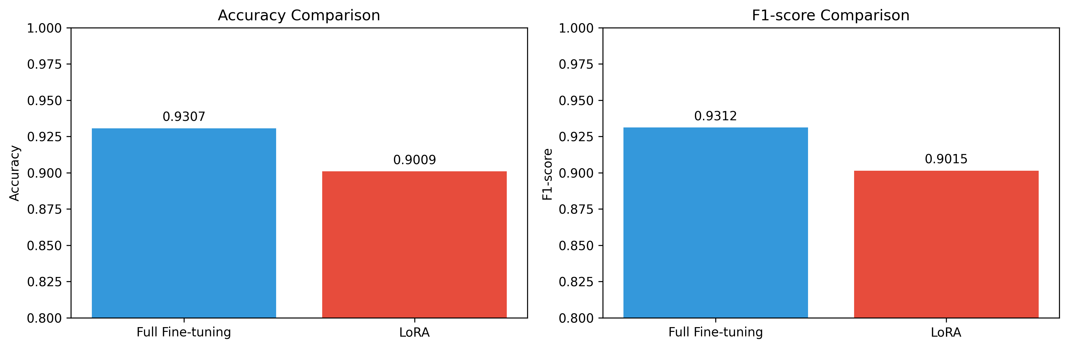

Figure 1. Accuracy and F1-score comparison between full and LoRA fine-tuning.

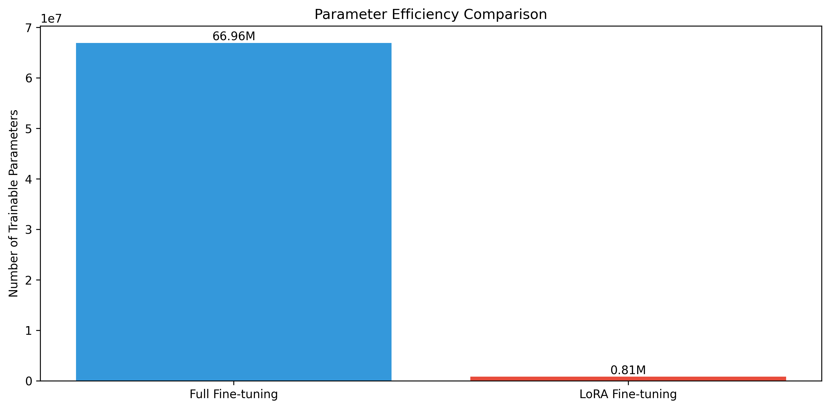Figure 2. Comparison of trainable parameters between full fine-tuning and LoRA fine-tuning.

## 5. Discussion

Both fine-tuning methods performed effectively for IMDb sentiment classification. Full fine-tuning achieved slightly better performance (Accuracy = 0.9307, F1 = 0.9312) but required updating all 67 million parameters. LoRA fine-tuning required updating only 0.8 million parameters (1.2% of total) while maintaining Accuracy = 0.9009 and F1 = 0.9015. This highlights LoRA’s efficiency in achieving strong results with a fraction of the computational cost.

The trade-off between performance and efficiency makes LoRA an ideal method for scenarios with limited resources. Although it achieved slightly lower accuracy, the parameter savings make it much more practical for model deployment.

## 6. Conclusion

Both fine-tuning methods achieved strong sentiment classification results. LoRA provided significant parameter savings (98.8%) with only a small performance drop (≈3% accuracy difference). Full fine-tuning remains slightly superior but is computationally expensive. LoRA offers a compelling balance between efficiency and performance for Transformer fine-tuning.

## 7. References

1. Hugging Face Transformers Documentation (2024)  
2. PEFT: Parameter-Efficient Fine-Tuning Library (2024)  
3. Maas et al. (2011). Learning Word Vectors for Sentiment Analysis. ACL.  
4. Kaggle IMDb Sentiment Analysis Dataset.

## Appendix- Code Repository

The source code, fine-tuning scripts, and result files are available at:

https://github.com/xiuxiuface/dsa4213-assignment3.git