Layer name | Output size | convnext_tiny | convnext_small | convnext_base | convnext_large | Convnext_xlarge
stem | 56×56 | 4×4,96  stride 4
res2 | 56×56 | 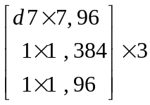
res3 | 28×28 | 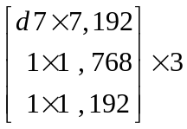
res4 | 14×14 | 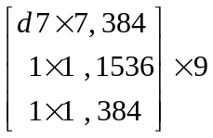
res5 | 7×7 | 