Semester Project:
Smart Parking Platform
Version 3.0

Table of Contents
Contents
1 Existing Parking Applications 3
1.1 Current Parking Applications 3
1.2 Comparison of Existing Parking Applications 4
1.3 How Our Application Will Be Different 5
2 Vision and Scope 6
2.1 Project background 6
2.2 Company overview 6
2.3 Project overview 6
3 Software Requirements Specification (SRS) 7
3.1 Use Cases 7
4 Work Breakdown Structure (WBS) 12
5 Project Timeline 13
6 Agile Project Planning 14
6.1 Product Backlog 14
6.2 Sprint 1 Backlog 16

Existing Parking Applications

Current Parking Applications
Before developing our Smart Parking Parking Platform, I looked at some of the parking applications that are already available and the features they provide. There are several applications that already help drivers find and pay for parking, including SpotHero, ParkMobile, ParkWhiz, and ParkHouston. Looking at these applications gives us a better idea of what already works and what we could do differently with our platform.
Spothero allows users to search for parking near their destination and compare different parking locations and prices. Users can reserve and pay for their parking ahead of time and access their parking information through the app.
ParkMobile allows users to find and pay for parking using their phone. One of its main features is the ability to enter a parking zone number and pay for a parking session without having to use a physical parking meter. In supported areas, users can also extend their parking time through the app. It also offers the option to reserve parking ahead of time.
ParkWhiz is another application that allows drivers to search for parking near a specific destination or event. Users can compare nearby parking options, prices, and reserve and pay for their parking before they arrive.
ParkHouston is a parking application powered by ParkMobile that allows users to pay for on-street and off-street parking from their phones. Users can enter a parking zone number, choose how long they want to park, and pay directly through the app. The app also allows users to extend their parking time when available, receive notifications when their parking session is about to expire, and reserve parking ahead of time. Although the app is designed around parking in Houston, it can also be used in hundreds of other cities across the country.
Application | Main Features | Strengths | Limitations/Opportunity
SpotHero | Search and compare parking, advance reservations, digital passes, event/airport/monthly parking, filters | Strong reservation system, upfront pricing, many parking types, easy comparison between locations | Primarily reservation-focused features depend on participating parking facilities
ParkMobile | Zone-based payments, time extensions, expiration alerts, reservations, multiple payment options | Useful for both on-demand and advanced parking, convenient remote payments and extensions | Availability of features such as extensions and reservations varies by location
ParkWhiz | Reservations, on-demand parking, digital passes, event/monthly parking, Express Pay, EV charging | Wide range of parking and payment options, includes integrations and tools for parking operators | Some advanced features are only available at participating or compatible facilities
ParkHouston | Zone-based payments, time extensions, alerts, advance reservations, pay-by-plate | Convenient for Houston parking, powered by ParkMobile and usable across its broader network | Many features rely on ParkMobile infrastructure and local parking rules still determine session limits

Comparison of Existing Parking Applications
The four applications have a lot of similar features, but there are also some differences between them. SpotHero and ParkWhiz are both focused heavily on helping users find and reserve parking ahead of time. They allow drivers to compare different parking options and prices before deciding where they want to park.
ParkMobile is a little different because it also focuses on parking that does not require a reservation ahead of time. For example, users can park in a supported area, enter the zone number into the app, and pay for parking from their phone. This can be useful for someone who is already at their destination and just needs a quick way of paying for parking and the option to extend said parking if needed through the app.
ParkHouston has many similarities to ParkMobile because it is powered by ParkMobile. It offers features such as paying through the app using a parking zone, extending parking sessions when available, receiving notifications, and making parking reservations. What makes ParkHouston useful to look at for this project is that it shows how an existing parking platform can also be adapted around the needs of a specific city while still being connected to a larger parking network.
Overall, all four applications make parking more convenient by allowing users to search for parking, make reservations, or pay through their phones. SpotHero and ParkWhix have a stronger focus on finding and reserving parking ahead of time, while ParkMobile and ParkHouston also provide tools for drivers who have already arrived at a parking location and need to pay for their parking session.

How Our Application Will Be Different
After looking at these existing applications, I noticed that many of the features we plan to include in our Smart Parking Platform already exist in some form. Applications like SpotHero and ParkWhiz already make it easy to search for and reserve parking ahead of time, while ParkMobile and ParkHouston make it convenient to pay for parking and manage an active parking session from a phone
Because of this, the goal of our Smart Parking Platform would not be to simply recreate these features, but to bring them together into one system while putting some focus on real-time parking availability. Drivers would be able to see how much parking is actually available before arriving, search for a location, reserve a space, make a payment, receive notifications, and get navigation assistance through the same platform.
The platform would also provide tools for parking facility operators. Operators would be able to monitor occupancy, manage parking availability and pricing, and access reports and analytics about how their facilities are being used. While some existing platforms already provide similar tools, our goal would be to make the driver and operator sides of the system work together more closely.
Overall, our Smart Parking Platform would take ideas that are already being used successfully and combine them into a more connected parking experience. The main focus would be giving drivers better information about parking availability while also giving parking operators the information they need to manage their facilities.

Vision and Scope

Project background
WE ARE $oftware corp. was approached by a group of parking facility operators who were looking for a better way to manage their parking facilities and improve the overall parking experience for drivers. One of the main problems they noticed was how much time drivers can spend searching for parking that is available, especially in or near busy areas. Parking operators also need a better way to keep track of available spaces, reservations, pricing, and overall occupancy.
Based on these problems, the idea of the Smart Parking Platform was created. The goal is to develop one system which makes it easier for drivers to find and reserve parking while also giving parking operators the tools they need to manage their facilities.

Company overview
WE ARE $oftware corp. is a fictional software development company that creates software solutions based on the needs of its clients. For this project, the company has unlimited resources and budget, which gives the team the flexibility to focus on creating the best solution possible without having to worry about any financial limitations.
For the Smart Parking Platform, the company will be responsible for planning and managing the project from beginning to end. This includes figuring out what the system needs, working with different stakeholders involved, planning the development process, managing possible risks, and making sure the project stays organized throughout the semester.

Project overview
The Smart Parking Platform will be a web and mobile application designed to make parking easier for drivers and easier to manage for parking facility operators. Drivers will be able to search for parking near their destination, see available parking spaces in real-time, reserve a space, make payments, and get directions to the parking location.
Users will also be able to view their previous reservations and receipts and receive notifications about their parking. On the other side of the platform, parking operators will have tools that allow them to monitor occupancy and better manage their parking facilities.
Overall, the idea behind this platform is to bring the main parts of the parking process into one place. Instead of drivers having to search for parking without knowing what is actually available, the platform would give them the necessary information ahead of time and allow them to plan their parking before arriving. At the same time, parking operators would have a better way to keep track of how their facilities are being used.

Software Requirements Specification (SRS)

Use Cases
- Create User Account
Actor: Driver
Precondition: User does not already have an account
Steps:
  - User selects “Create Account”
  - User enters required personal information
  - User enters an email address and password
  - User submits registration form
  - System validates the information and creates the account
Postcondition: user account is created and available for login

- Log In
Actor: Registered user
Precondition: User has an existing account
Steps:
- User selects “Log in”
- Enter email address and password
- Submit login information
- System verifies credentials
- System shows the user’s account dashboard
Postcondition: the user is authenticated and logged into the system

- Search for Parking
Actor: Driver
Precondition: User has access to the application
Steps:
- User selects the parking search option
- Enter a destination or location
- System searched for parking locations nearby
- System displays available parking options
Postcondition: user can view parking locations near the selected destination

- View Available Parking Spots
Actor: Driver
Precondition: user has selected a parking location
Steps:
- User opens the selected parking location
- System retrieves current parking availability
- The system displays available parking spaces
- User reviews the available parking options
Postcondition: user can see the current availability at the parking location they chose

- View Parking Locations on Map
Actor: Driver
Precondition: user entered or selected a destination
Steps:
- User selects map view
- System retrieves parking locations near the destination
- System displays the locations on an interactive map
- User selects a parking location from the map
Postcondition: user can view and select parking locations geographically

- View Parking Details
Actor: Driver
Precondition: user has selected a parking location
Steps:
- User selects a parking location
- System retrieves information about this location
- System displays the availability, pricing, address and other parking information
- User reviews the parking details
Postcondition: user has the information needed to make a choice whether to use the parking location.

- Reserve Parking Space
Actor: Registered Driver
Precondition: user is logged in and an available parking space exists
Steps:
- User selects an available parking location or space
- Select the desired reservation date and time
- System displays the reservation details
- User confirms the reservation
- System saves reservation
Postcondition: parking space is reserved for the user.

- Modify Reservation
Actor: Registered Driver
Precondition: user is logged in and has an active reservation
Steps:
- User opens reservation history
- Selects an active reservation
- Selects “Modify Reservation”
- User changes the available reservation details
- User confirms the changes
- The system updates reservation
Postcondition: reservation has updated information of the user

- Cancel Reservation
Actor: Registered Driver
Precondition: user has active reservation
Steps:
- User opens reservation history
- Selects active reservation
- User selects “Cancel Reservation”
- System asks if the user wants to confirm the cancellation
- User selects confirm
- System cancels the reservation
Postcondition: Reservation is cancelled and the parking space is available again

- Make a Payment
Actor: Registered Driver
Precondition: user selected a parking reservation requiring payment
Steps:
- User proceeds to payment
- System displays amount due
- User selects a payment method
- User enters required payment information
- User confirms payment
- System processes the payment and displays confirmation
Postcondition: Payment is recorded for the parking reservation

- View Reservation History
Actor: Registered Driver
Precondition: User is logged into the system
Steps:
- User opens their account
- User selects “Reservation History”
- System retrieves the user’s previous and current reservations
- System displays the reservation history
- User selects a reservation to view its details
Postcondition: user can review previous and current parking reservations

- View/Download Receipt
Actor: Registered Driver
Precondition: User has completed a parking payment
Steps:
- User opens a completed reservation
- User selects “View Receipt”
- System displays the payment receipt
- User selects the download option if desired
- System provides the receipt for download
Postcondition: user can view or save a copy of the payment receipt

- Receive Parking Notifications
Actor: Registered Driver
Precondition: user has an active reservation and notifications are enabled
Steps:
- System monitors user’s active reservation
- System identifies an event requiring a notification
- System generates an appropriate alert
- System sends the notification to the user
- User receives the parking notification
Postcondition: user is informed of relevant information concerning the parking reservation

- Navigate to Parking Location
Actor: Driver
Precondition: user has selected a parking location
Steps:
- User selects “Navigate”
- System retrieves the selected parking location
- System connects to the external mapping/navigation service
- System provides the parking destination to the navigation service
- User receives directions to the parking location
Postcondition: user can navigate to the selected parking location

- View Parking Occupancy
Actor: Parking Facility Operator
Precondition: Operator is logged into the admin dashboard
Steps:
- Operator opens the admin dashboard
- Operator selects a parking facility
- System retrieves current occupancy information
- System displays occupied and available parking info
- Operator reviews current occupancy information
Postcondition: parking facility operator can view the current occupancy of a selected facility

Work Breakdown Structure (WBS)
The Work Breakdown Structure (WBS) below breaks down the Smart Parking Platform into its main components and smaller deliverables. This helps organize the different parts of the project and provides a clearer picture of what will need to be completed throughout the development process.
Figure 1. Smart Parking Platform Work Breakdown Structure (WBS)

Project Timeline
The project timeline below outlines the planned schedule for developing the Smart Parking Platform. The tasks are organized based on the Work Breakdown Structure (WBS) and include the major development activities needed throughout the project. Some tasks overlap because different areas of the system can be worked on at the same time, while other tasks depend on the completion of previous activities. The Gantt chart provides a visual view of the project schedule, including task durations, dependencies, and overall progression from planning through final delivery
Figure 2. Smart Parking Platform Gantt Chart
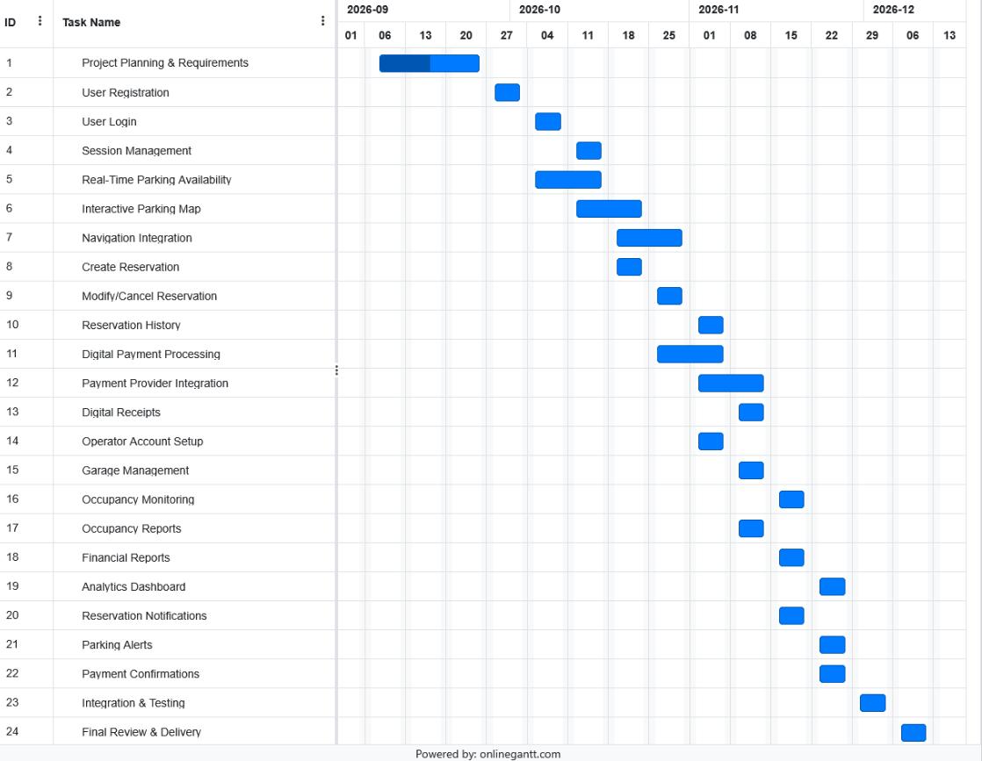

Agile Project Planning
For this part of the project, I used Jira to organize the work that would need to be completed for the Smart Parking Platform. I created a product backlog that breaks the project down into smaller tasks related to login, the user and operator interfaces, backend processes, and reporting. I also planned the first sprint by choosing a group of related tasks that would make sense to work on together.

Product Backlog
The product backlog includes 45 work items covering the main areas of the Smart Parking Platform. Breaking the project down this way made it easier to see the individual tasks that would need to be completed instead of looking at each feature as one large piece of work.
Figure 3. Smart Parking Platform Product Backlog
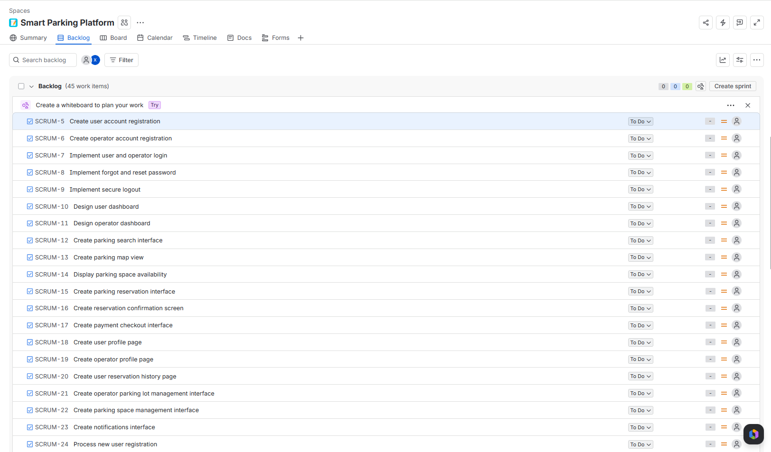
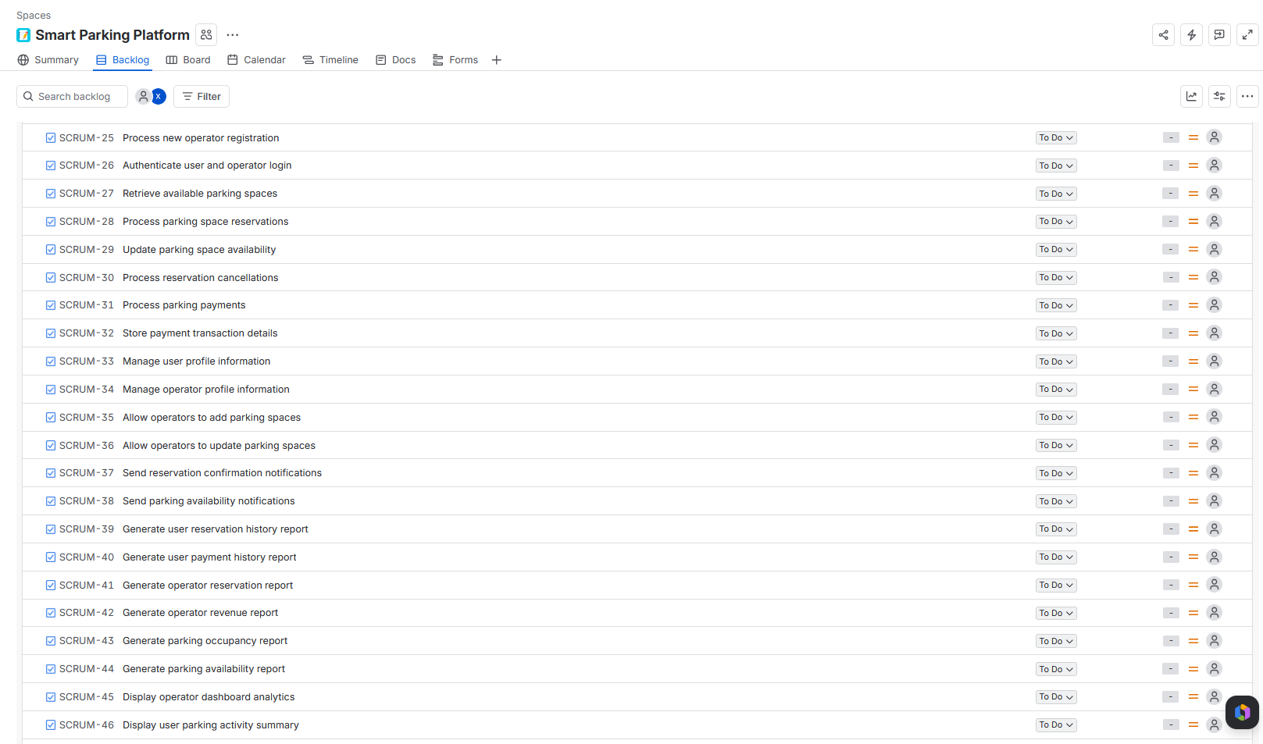

Sprint 1 Backlog
For Sprint 1, I decided to focus on account registration and authentication since these features would be needed before users and operators can access the rest of the platform. I selected eight related items from the product backlog, including user and operator registration, login, password reset, logout, and the backend processes needed to support registration and authentication.
Figure 4. Smart Parking Platform Sprint 1 Backlog
