Salesforce

Sales Cloud 使用全球首屈一指的 CRM，更快、更智能地销售。

Service Cloud为每位客户提供支持。 不限时间。 不限地点。

Marketing Cloud 市场营销的未来就是一对一的客户体验。

Community Cloud 重新构想客户、合作伙伴和员工互动。

App Cloud 快速构建应用程序。以更快的速度开展业务。

客户成功故事

https://www.salesforce.com/cn/customers/ 丰田 樟宜机场

https://www.salesforce.com/cn/?ir=1

Camel Salesforce 的使用

salesforce可以快速建立一个进销存的系统。

生成salesforce的类
可以使用插件：
<plugin>
<groupId>org.apache.camel.maven</groupId>
<artifactId>camel-salesforce-maven-plugin</artifactId>
<version>2.15.1.redhat-621117</version>
</plugin>

mvn camel-salesforce:generate -DcamelSalesforce.clientId=3MVG9ZL0ppGP5UrBeyeG7Hoqgl4A.BzKD1b3xoX6eqc2AE5smmPwFzebj6_NX_AM0TvWtYzgwQID_9qvtSnOK -DcamelSalesforce.clientSecret=1851731235796242942 -DcamelSalesforce.userName=xiaohui_wu@163.com -DcamelSalesforce.password=XXXXXX

JBoss Fuse Integration External ID
注册完之后，oauth选择：
http://localhost:8888/RestTest/oauth/_callback

curl https://ap2.salesforce.com/a02/o
curl https://ap2.salesforce.com/services/data/

JSON is the default. You can use the HTTP ACCEPT header to select either JSON or XML, or append . json or . xml to the URI
(for example, /Account/001D000000INjVe.json ).

比如：
https://ap2.salesforce.com/services/data/v36.0/sobjects/Account/0012800000mm2eoAAA.json
/services/data/v27.0/sobjects/Account/0012800000mm2eoAAA.json

使用SOAPUI来测试：

建立Authority
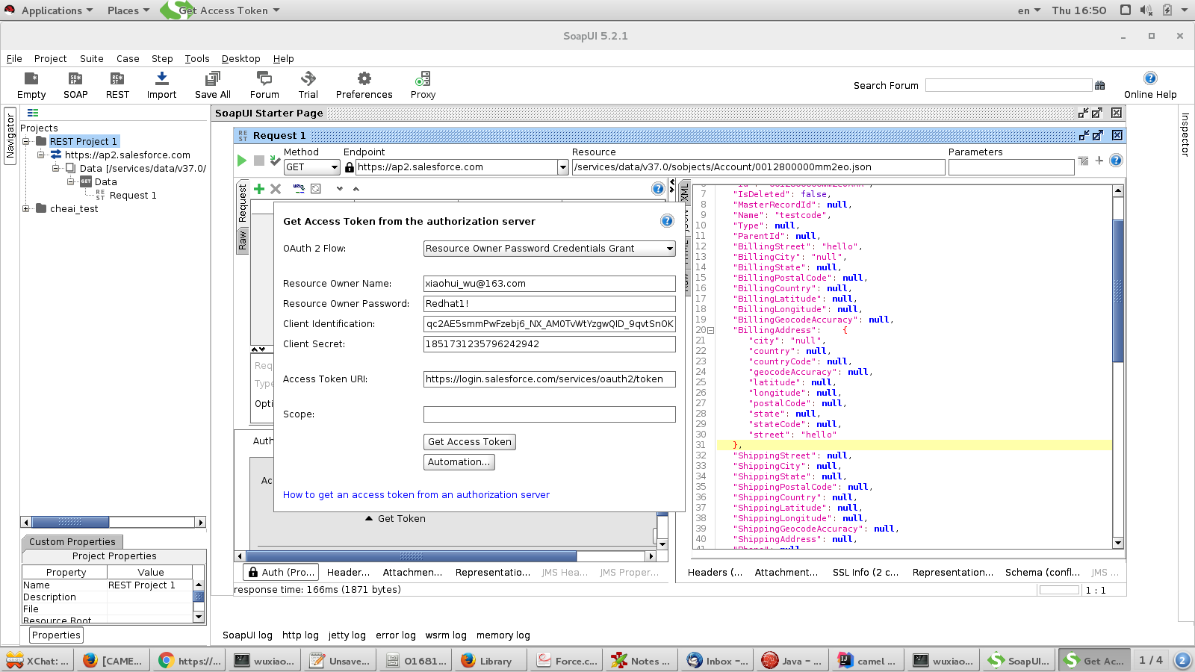
更新测试：
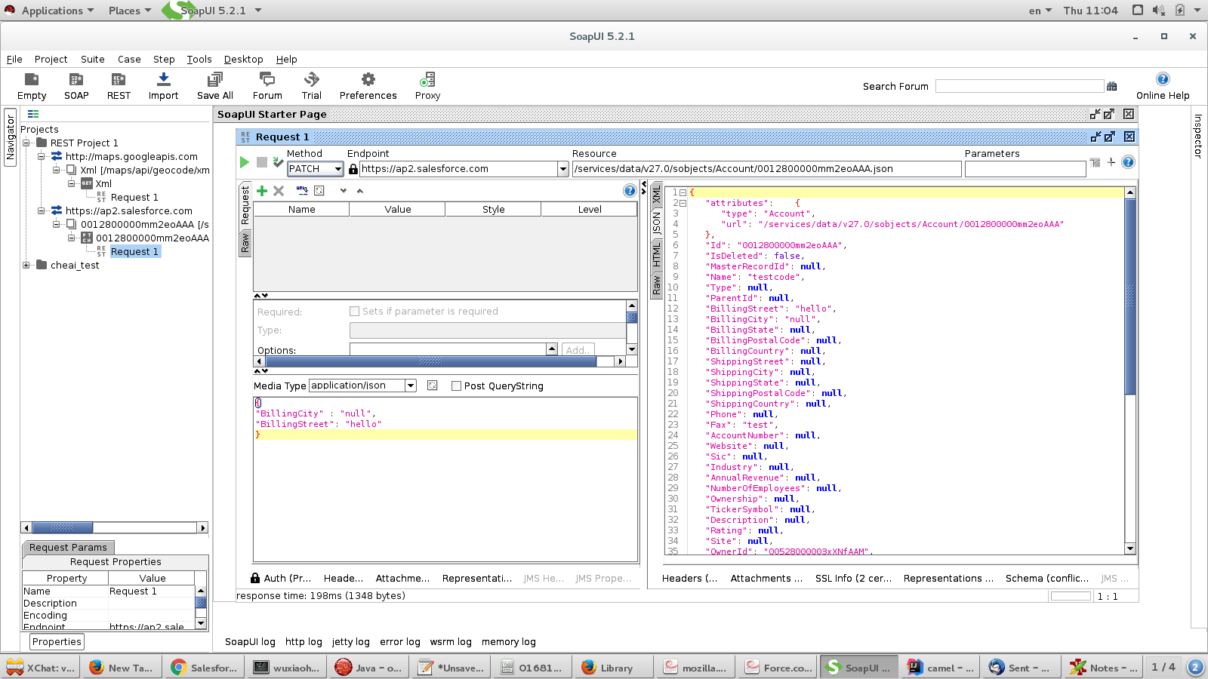

使用camel-salesforce的步骤：

#get a developer account number
developer.salesforce.com/signup

#setup oauth
new connected app
A "Connected App" is an application that can connect to salesforce.com over Identity and Data APIs. Connected Apps use the standard OAuth 2.0 protocol to authenticate, provide Single Sign-On, and acquire access tokens for use with Salesforce APIs. In addition to the standard OAuth capabilities supported by the existing Remote Apps feature (which Connected Apps is designed to replace), Connected Apps add additional levels of control, allowing administrators explicit control over who can use the application, and various security policies to be enforced by the application.
然后，在Oauth中选择：
https://localhost:8443/RestTest/oauth/_callback

#生成相应的salesforce 服务器端类
[INFO] Salesforce login...
[INFO] Logging clientId: 3MVG9ZL0ppGP5UrBeyeG7Hoqgl4A.BzKD1b3xoX6eqc2AE5smmPwFzebj6_NX_AM0TvWtYzgwQID_9qvtSnOK into Salesforce url: https://login.salesforce.com/services/oauth2/token
[INFO] Login successful
[INFO] Salesforce login successful
[INFO] Getting Salesforce Objects...
[INFO] Logout successful

#可以访问自己的服务：
https://yourInstance.salesforce.com/services/data

https://ap2.salesforce.com/services/data/v27.0/sobjects/Account/0012800000mm2eoAAA.json

返回结果如下：
{
"attributes": {
"type": "Account",
"url": "/services/data/v27.0/sobjects/Account/0012800000mm2eoAAA"
},
"Id": "0012800000mm2eoAAA",
"IsDeleted": false,
"MasterRecordId": null,
"Name": "www",
"Type": null,
"ParentId": null,
"BillingStreet": null,
"BillingCity": null,
"BillingState": null,
"BillingPostalCode": null,
"BillingCountry": null,
"ShippingStreet": null,
"ShippingCity": null,
"ShippingState": null,
"ShippingPostalCode": null,
"ShippingCountry": null,
"Phone": null,
"Fax": null,
"AccountNumber": null,
"Website": null,
"Sic": null,
"Industry": null,
"AnnualRevenue": null,
"NumberOfEmployees": null,
"Ownership": null,
"TickerSymbol": null,
"Description": null,
"Rating": null,
"Site": null,
"OwnerId": "00528000003xXNfAAM",
"CreatedDate": "2016-08-10T06:00:02.000+0000",
"CreatedById": "00528000003xXNfAAM",
"LastModifiedDate": "2016-08-10T06:00:02.000+0000",
"LastModifiedById": "00528000003xXNfAAM",
"SystemModstamp": "2016-08-10T06:00:02.000+0000",
"LastActivityDate": null,
"Jigsaw": null,
"JigsawCompanyId": null,
"CleanStatus": "Pending",
"AccountSource": null,
"DunsNumber": null,
"Tradestyle": null,
"NaicsCode": null,
"NaicsDesc": null,
"YearStarted": null,
"SicDesc": null,
"DandbCompanyId": null,
"CustomerPriority__c": null,
"SLA__c": null,
"Active__c": null,
"NumberofLocations__c": null,
"UpsellOpportunity__c": null,
"SLASerialNumber__c": null,
"SLAExpirationDate__c": null,
"JBoss_Fuse_Integration_External_ID__c": 33333
}

如果要更新的话，那么就可以使用json的格式如下：
{
"BillingCity" : null,
"BillingStreet": "hello"
}
各个版本的salesforce的元数据定义是不一样的，比如在新版37.0中，新增了属性 BillingLatitude。
[ HttpClient-25] TimerConsumer WARN Error processing exchange. Exchange[Message: [Body is null]]. Caused by: [org.apache.camel.component.salesforce.api.SalesforceException - Error parsing JSON response: Unrecognized field "BillingLatitude" (Class org.apache.camel.salesforce.dto.Account), not marked as ignorable
at [Source: java.io.ByteArrayInputStream@564f4653; line: 1, column: 345] (through reference chain: org.apache.camel.salesforce.dto.Account["BillingLatitude"])]
{message:'Error parsing JSON response: Unrecognized field "BillingLatitude" (Class org.apache.camel.salesforce.dto.Account), not marked as ignorable
at [Source: java.io.ByteArrayInputStream@564f4653; line: 1, column: 345] (through reference chain: org.apache.camel.salesforce.dto.Account["BillingLatitude"])',statusCode:0}

从camel中调用返回的话，可以看到如下的结果。

[ HttpClient-24] sfRoute INFO Query result back from Salesforce: {"attributes":{"type":"Account","url":"/services/data/v27.0/sobjects/Account/0012800000mm2eoAAA"},"CleanStatus":"Pending","JBoss_Fuse_Integration_External_ID__c":33333.0,"CreatedById":"00528000003xXNfAAM","LastModifiedDate":1470808802000,"LastModifiedById":"00528000003xXNfAAM","OwnerId":"00528000003xXNfAAM","IsDeleted":false,"CreatedDate":1470808802000,"SystemModstamp":1470808802000,"Id":"0012800000mm2eoAAA","Name":"www"}

参考文档：
https://developer.salesforce.com/docs/atlas.en-us.api_rest.meta/api_rest/quickstart_oauth.htm

