Walmart Retail Sales Performance Analysis
STA 9750: Software Tools for Data Analysis
Baruch College, Zicklin School of Business
Spring 2026
Xixi Lin Group 11
1. Introduction

This project analyzes weekly retail sales data from 45 Walmart stores across the United States to identify which economic and seasonal factors most significantly influence sales performance. Understanding what drives retail sales is critical for business planning, inventory management, and resource allocation.

The dataset used in this analysis is the Walmart Store Sales Dataset, sourced from Kaggle, covering the period from February 2010 to October 2012. The dataset contains 6,435 weekly observations across 45 stores and includes the following variables:

- Weekly_Sales: Weekly revenue per store in USD (response variable)
- Holiday_Flag: Binary indicator for holiday weeks (0 = non-holiday, 1 = holiday)
- Temperature: Regional average temperature in degrees Fahrenheit
- Fuel_Price: Regional fuel price in USD per gallon
- CPI: Consumer Price Index, a measure of regional inflation
- Unemployment: Regional unemployment rate (%)
- Store: Store identifier (1–45)
- Date: Week of sales record

The core research question addressed in this project is: Which economic and seasonal factors most significantly drive weekly retail sales across Walmart stores? To answer this, we conduct association analysis to explore relationships between each predictor and weekly sales, build and compare multiple regression models, and apply additional techniques including Lasso and Ridge regularization and ARIMA time series forecasting.

2. Data Cleaning

Before conducting any analysis, the dataset was carefully examined and cleaned using R to ensure data quality and reliability.

2.1 Initial Inspection
The raw dataset contained 6,435 rows and 8 columns. Initial checks confirmed no missing values across any column. A summary of the data revealed one row with a temperature value of -2.06°F, which is physically implausible for any US store location.

2.2 Cleaning Steps
- Removed 1 row with a negative temperature value (-2.06°F).
- Converted Holiday_Flag from integer to factor (categorical binary variable).
- Converted Store from integer to factor (store IDs are identifiers, not quantities).
- Verified no zero or negative values in Weekly_Sales.

2.3 Distribution of Weekly Sales
After cleaning, the final dataset contains 6,434 complete observations. The histogram and QQ plot below show that Weekly_Sales is right-skewed, with most stores generating between $500,000 and $2,000,000 per week.
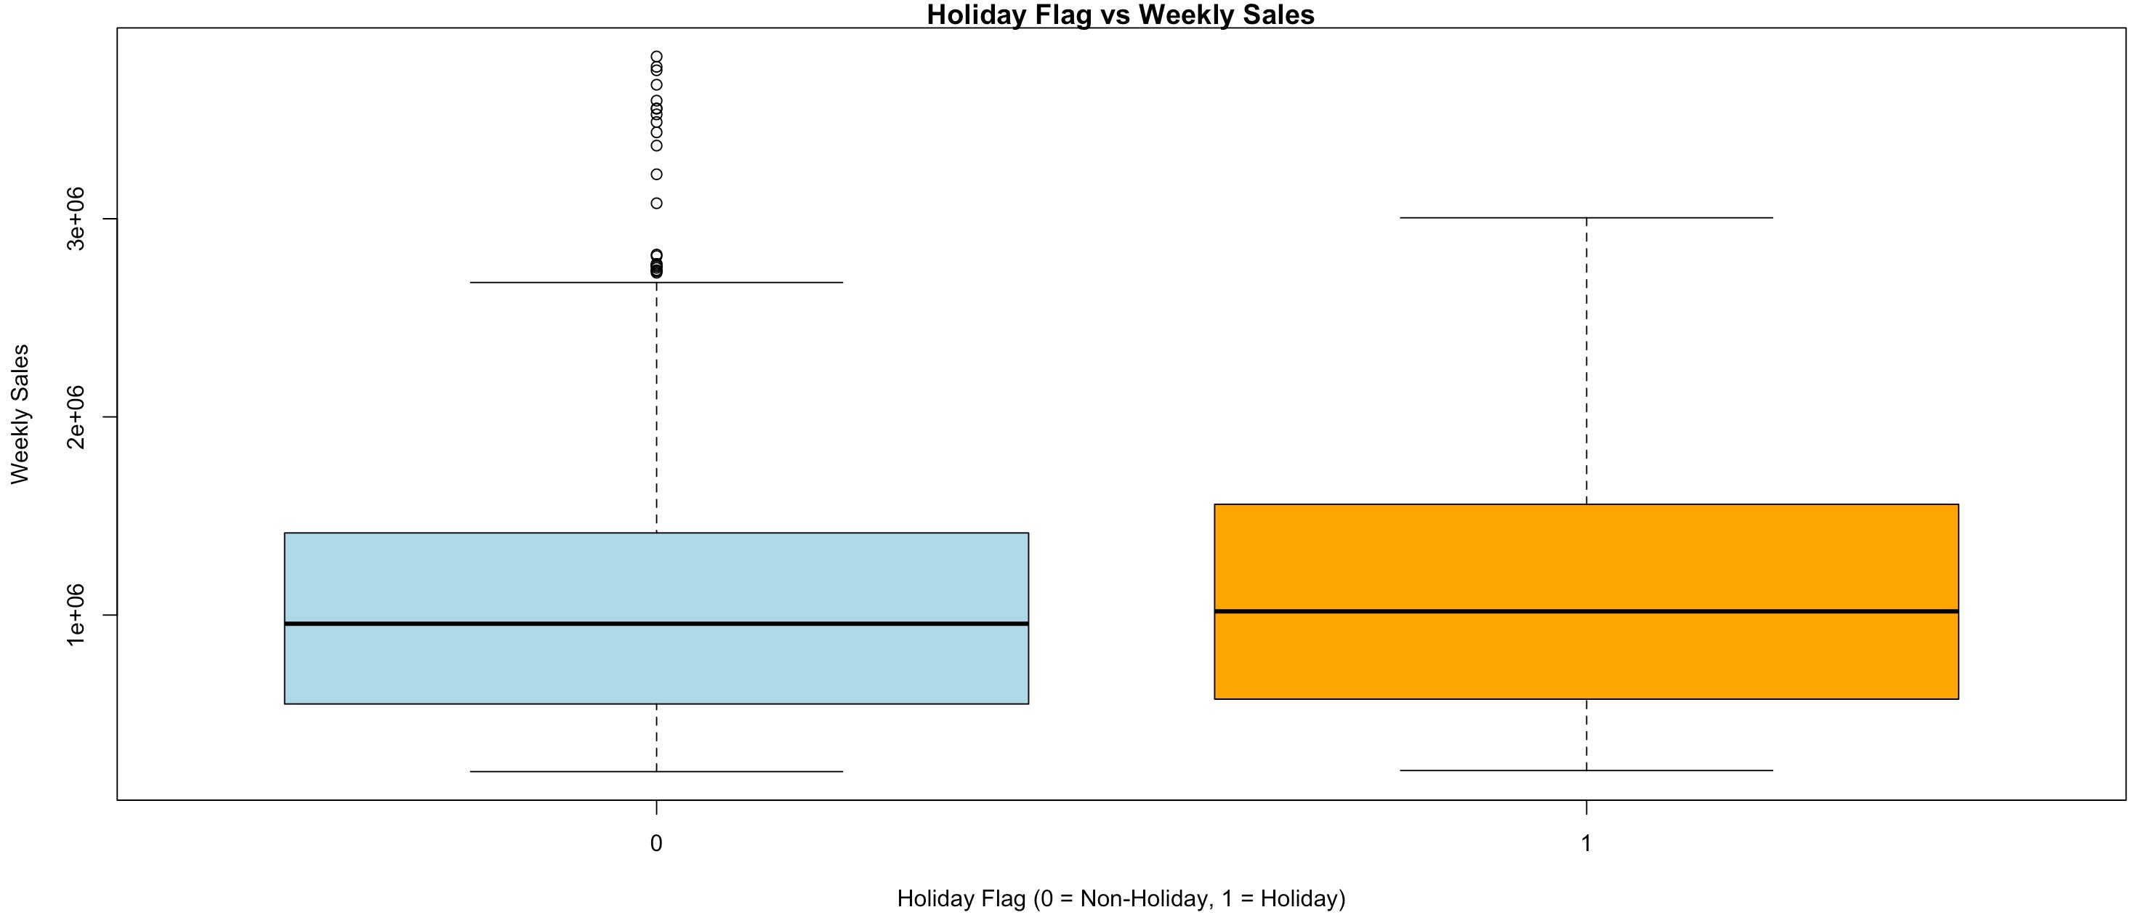
Figure 1: Distribution of Weekly Sales by Holiday Flag (Boxplot)

3. Association Analysis
Association analysis was conducted to explore the relationships between each of the five predictor variables and the response variable Weekly_Sales. Both visualizations and formal statistical tests were applied.

3.1 Temperature vs. Weekly Sales
The scatterplot shows no clear directional trend. Sales are distributed across all temperature ranges without a consistent pattern. The Pearson correlation is r = -0.064 (p < 0.001), indicating a statistically significant but practically weak negative association.
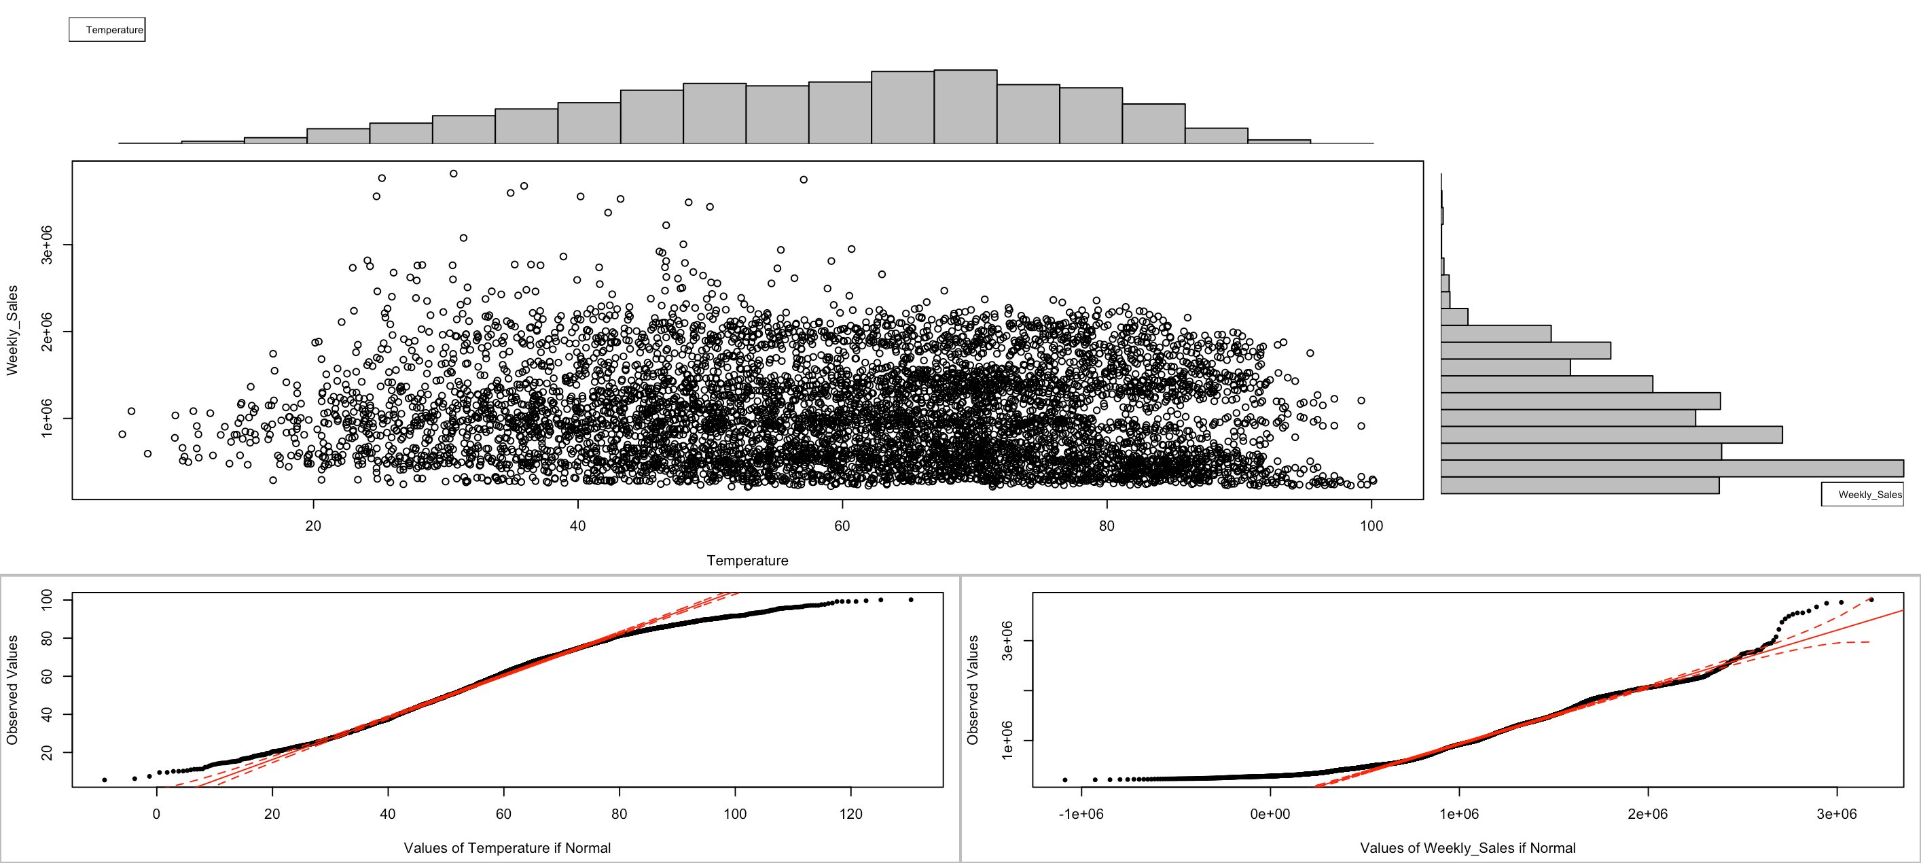
Figure 2: Temperature vs. Weekly Sales — Scatterplot with marginal histograms and QQ plots

3.2 Fuel Price vs. Weekly Sales
The scatterplot of Fuel_Price versus Weekly_Sales shows no discernible pattern. The permutation-based test yields a Pearson correlation of r = 0.009 (p = 0.462), confirming no significant association. Fuel Price is the least useful predictor in this analysis.

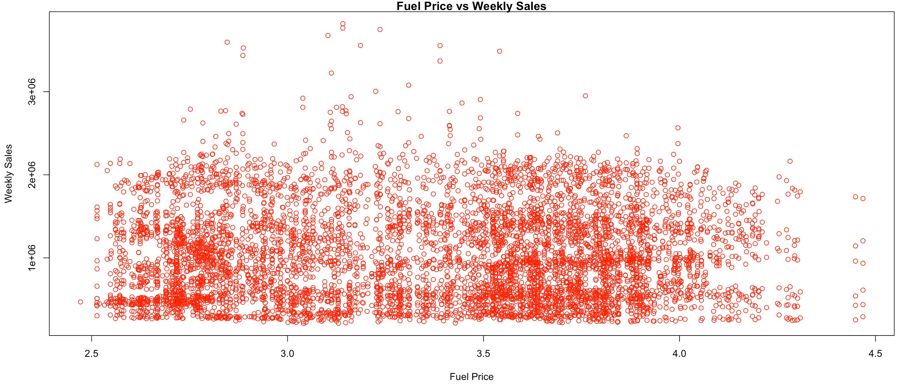
Figure 3: Fuel Price vs. Weekly Sales — Scatterplot

3.3 CPI vs. Weekly Sales
The CPI scatterplot reveals three distinct clusters corresponding to stores in different regional markets. While statistically significant (Pearson r = -0.073, p ≈ 0), the overall relationship with Weekly_Sales is weak. Higher-CPI regions tend to have slightly lower weekly sales.

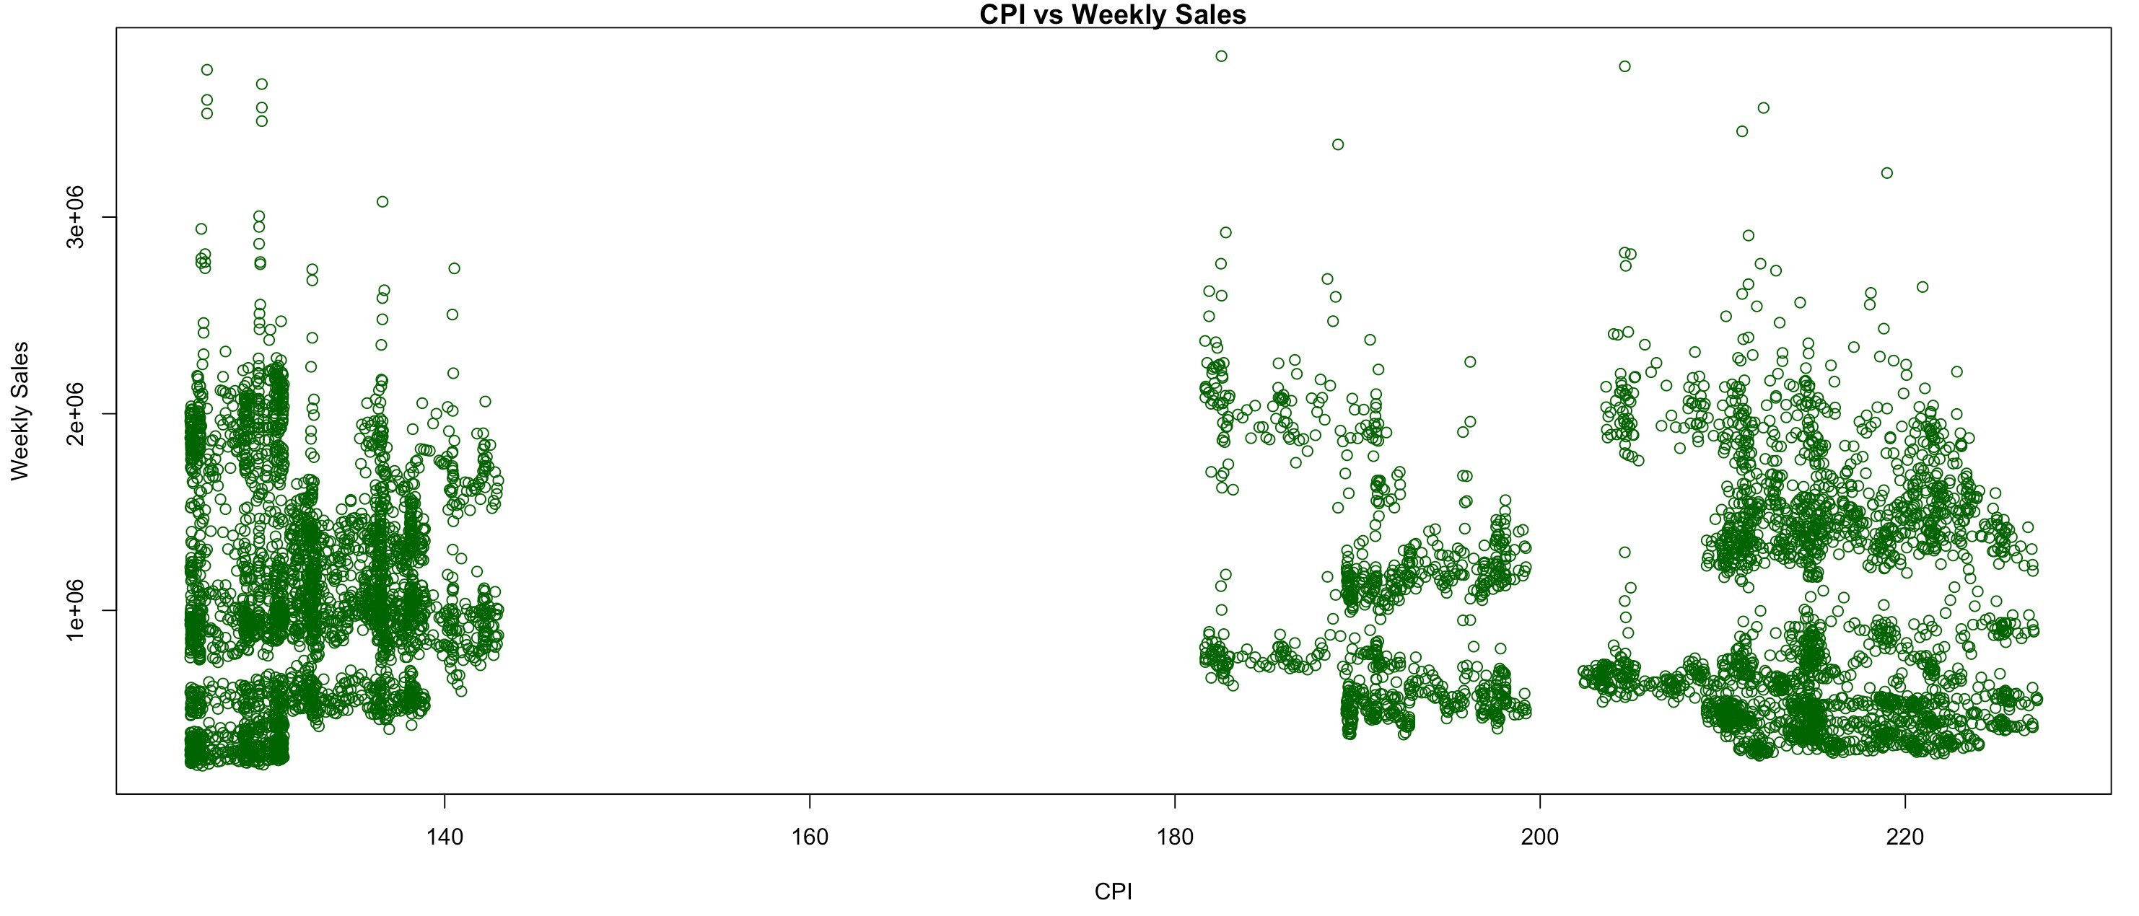
Figure 4: CPI vs. Weekly Sales — Scatterplot showing three regional clusters

3.4 Unemployment vs. Weekly Sales
Unemployment shows the strongest association with Weekly_Sales. The scatterplot displays a clear negative trend confirmed by a Pearson correlation of r = -0.106 (p ≈ 0). Stores in higher unemployment regions generate lower weekly sales.

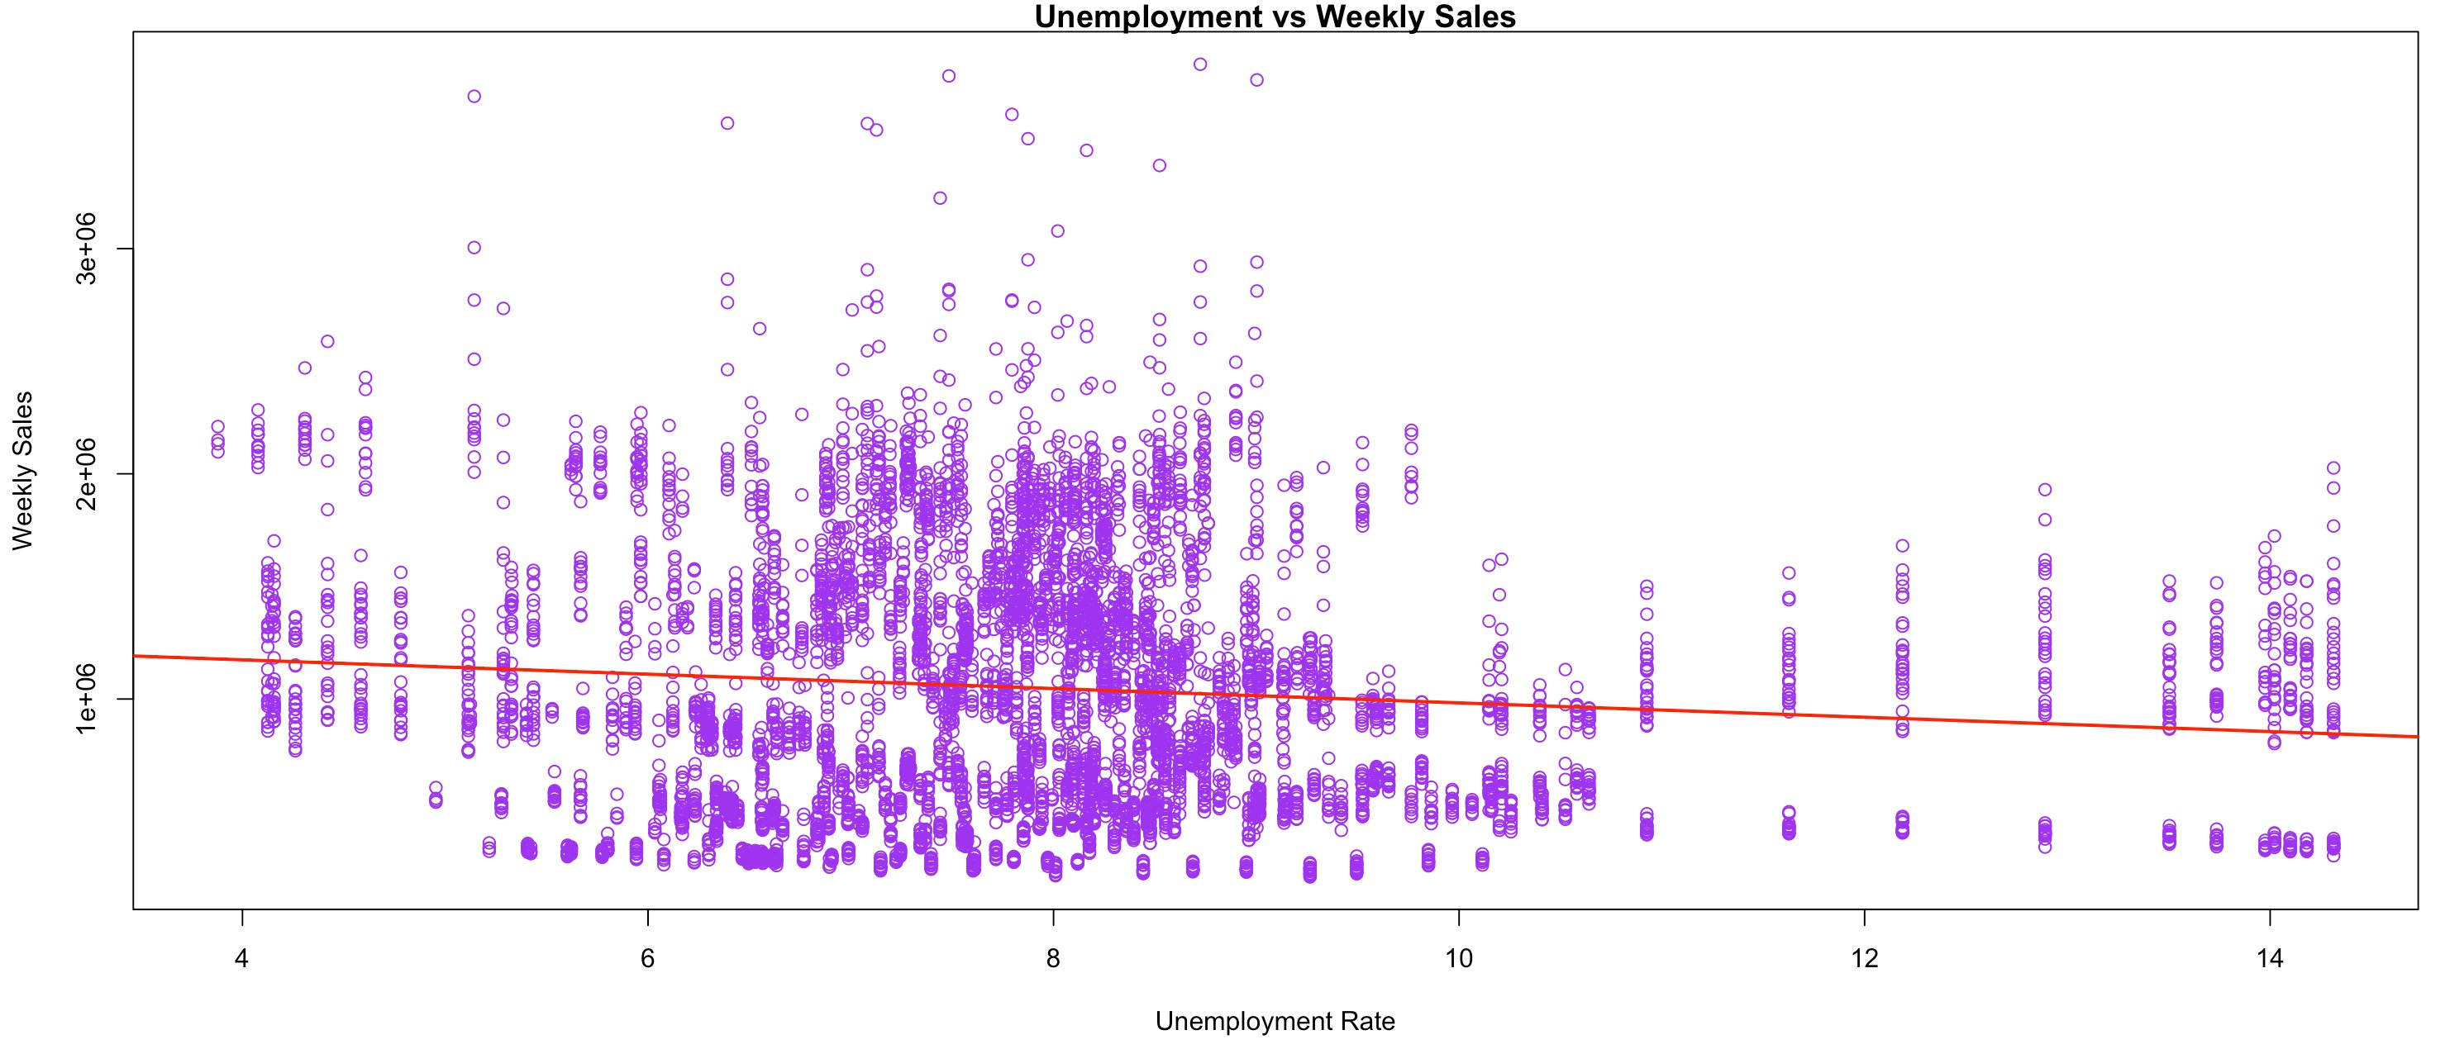
Figure 5: Unemployment Rate vs. Weekly Sales — Scatterplot with regression line

3.5 Holiday Flag vs. Weekly Sales
The boxplot reveals a clear difference in median sales between holiday and non-holiday weeks. Holiday weeks generate a median of approximately $1,018,538 compared to $956,220 for non-holiday weeks — a difference of about $62,318. The ANOVA permutation test yields p = 0.004, confirming statistical significance.


Figure 6: Holiday Flag vs. Weekly Sales — Boxplot

3.6 Summary of Association Tests
Variable | Test Used | Statistic | p-value | Conclusion
Temperature | Pearson r | r = -0.064 | < 0.001 | Significant, weak
Fuel Price | Permutation | r = 0.009 | 0.462 | Not significant
CPI | Permutation | r = -0.073 | ≈ 0 | Significant, weak
Unemployment | Permutation | r = -0.106 | ≈ 0 | Significant, moderate
Holiday Flag | ANOVA/Permutation | F = 8.749 | 0.004 | Significant

4. Regression Model
Three regression models were fitted to predict Weekly_Sales, progressing from a simple single-predictor model to a multiple regression model and a reduced best model.

4.1 Model 1: Simple Linear Regression (Unemployment Only)
Model equation: Weekly_Sales = 1,302,423 − 31,927 × Unemployment
Unemployment is highly significant (p < 2e-16). R² = 1.1%, RMSE = $561,147.

4.2 Model 2: Multiple Regression (All 5 Variables)
CPI (p < 2e-16), Unemployment (p < 2e-16), and Holiday_Flag (p = 0.007) are statistically significant. Temperature is marginally significant (p = 0.065). Fuel_Price is not significant (p = 0.519). R² = 2.54%, RMSE = $557,110.

4.3 Model 3: Reduced Model (Best Model)
Model equation: Weekly_Sales = 1,664,629 − 1,652 × CPI − 42,520 × Unemployment + 84,439 × Holiday_Flag

- CPI: A 1-unit increase in CPI → $1,652 decrease in weekly sales (p < 2e-16)
- Unemployment: A 1% rise → $42,520 decrease in weekly sales (p < 2e-16) — largest effect
- Holiday_Flag: Holiday weeks generate $84,439 more in sales (p = 0.002)
- All three variables are statistically significant (p < 0.05)
- R² = 2.48%, RMSE = $557,302, AIC = 188,524

4.4 Model Comparison
Model | Variables | R² | RMSE | AIC
Model 1 | Unemployment only | 1.13% | $561,147 | 188,608
Model 2 | All 5 variables | 2.54% | $557,110 | 188,523
Model 3 ✓ | CPI + Unemployment + Holiday | 2.48% | $557,302 | 188,524
Model 2 and Model 3 achieve nearly identical R², RMSE, and AIC. Removing Temperature and Fuel_Price did not reduce performance, confirming they are not significant predictors. Model 3 is the best model — simpler with equivalent accuracy.

4.5 95% Confidence Intervals (Model 3)

Variable | Estimate | 2.5% | 97.5%
(Intercept) | 1,664,629 | 1,564,206 | 1,765,053
CPI | -1,652 | -2,015 | -1,288
Unemployment | -42,520 | -50,139 | -34,900
Holiday_Flag | 84,439 | 31,017 | 137,861

5. Other Techniques
Three additional techniques were applied beyond standard regression analysis.

5.1 Feature Engineering: Sales_Level Variable
A new categorical variable Sales_Level was created by splitting Weekly_Sales into High and Low categories based on the median value ($960,185). This enabled categorical analysis of sales performance patterns.

5.2 Mosaic Plot and Chi-Square Test
A mosaic plot was constructed to visualize the relationship between Holiday_Flag and Sales_Level. The plot shows that holiday weeks have a higher proportion of above-median (High) sales.

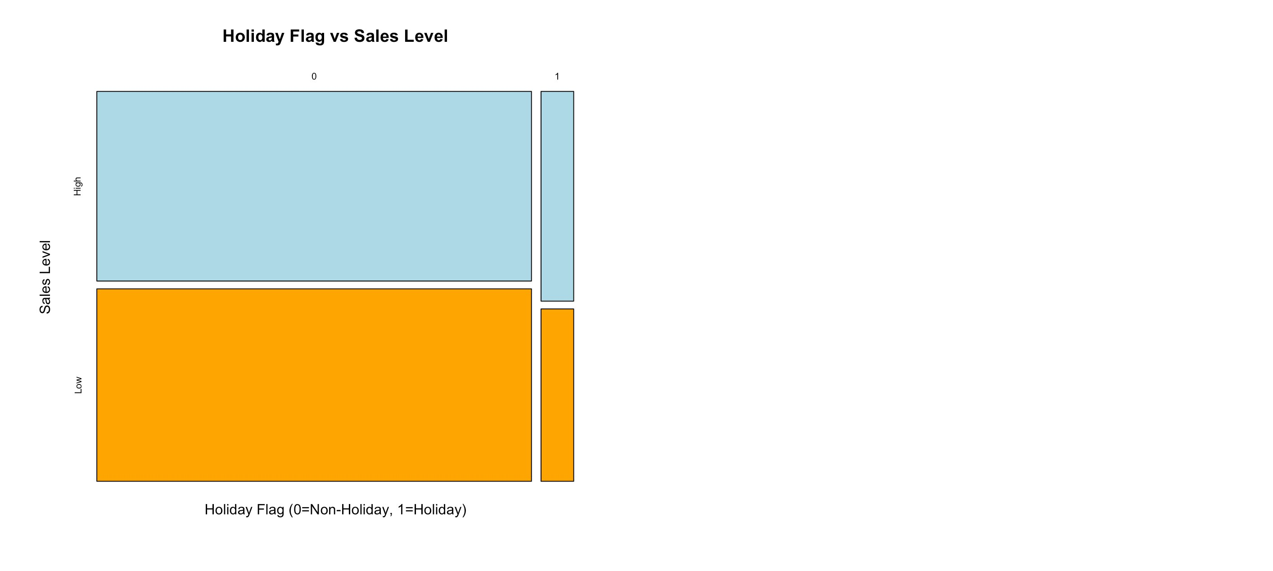
Figure 7: Mosaic Plot — Holiday Flag vs. Sales Level
- Chi-Square Test: X² = 4.4179, df = 1, p-value = 0.036
- Conclusion: The association between holiday periods and above-median sales is statistically significant (p < 0.05).

5.3 Lasso and Ridge Regression
Lasso (alpha = 1) and Ridge (alpha = 0) regression were applied using the glmnet package with cross-validation to select the optimal lambda parameter.

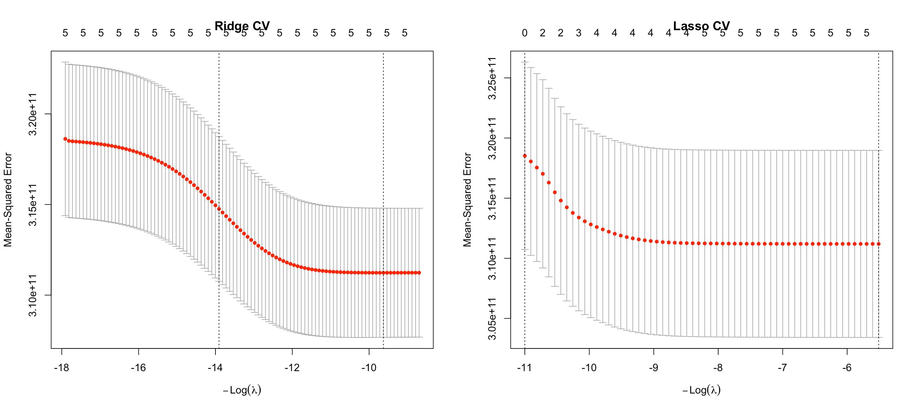
Figure 8: Cross-Validation Curves for Ridge (left) and Lasso (right) Regression

- Ridge Regression: R² = 2.54%, RMSE = $557,117
- Lasso Regression: R² = 2.54%, RMSE = $557,111

Both methods produced results nearly identical to Model 2, confirming that the predictor variables are not highly correlated with each other. Model 3 remains the best choice.

5.4 ARIMA Time Series Forecasting
Weekly sales were aggregated by date and an ARIMA model was fitted using auto.arima(), which automatically selected ARIMA(1,1,1)(0,1,0)[52] based on AIC minimization.

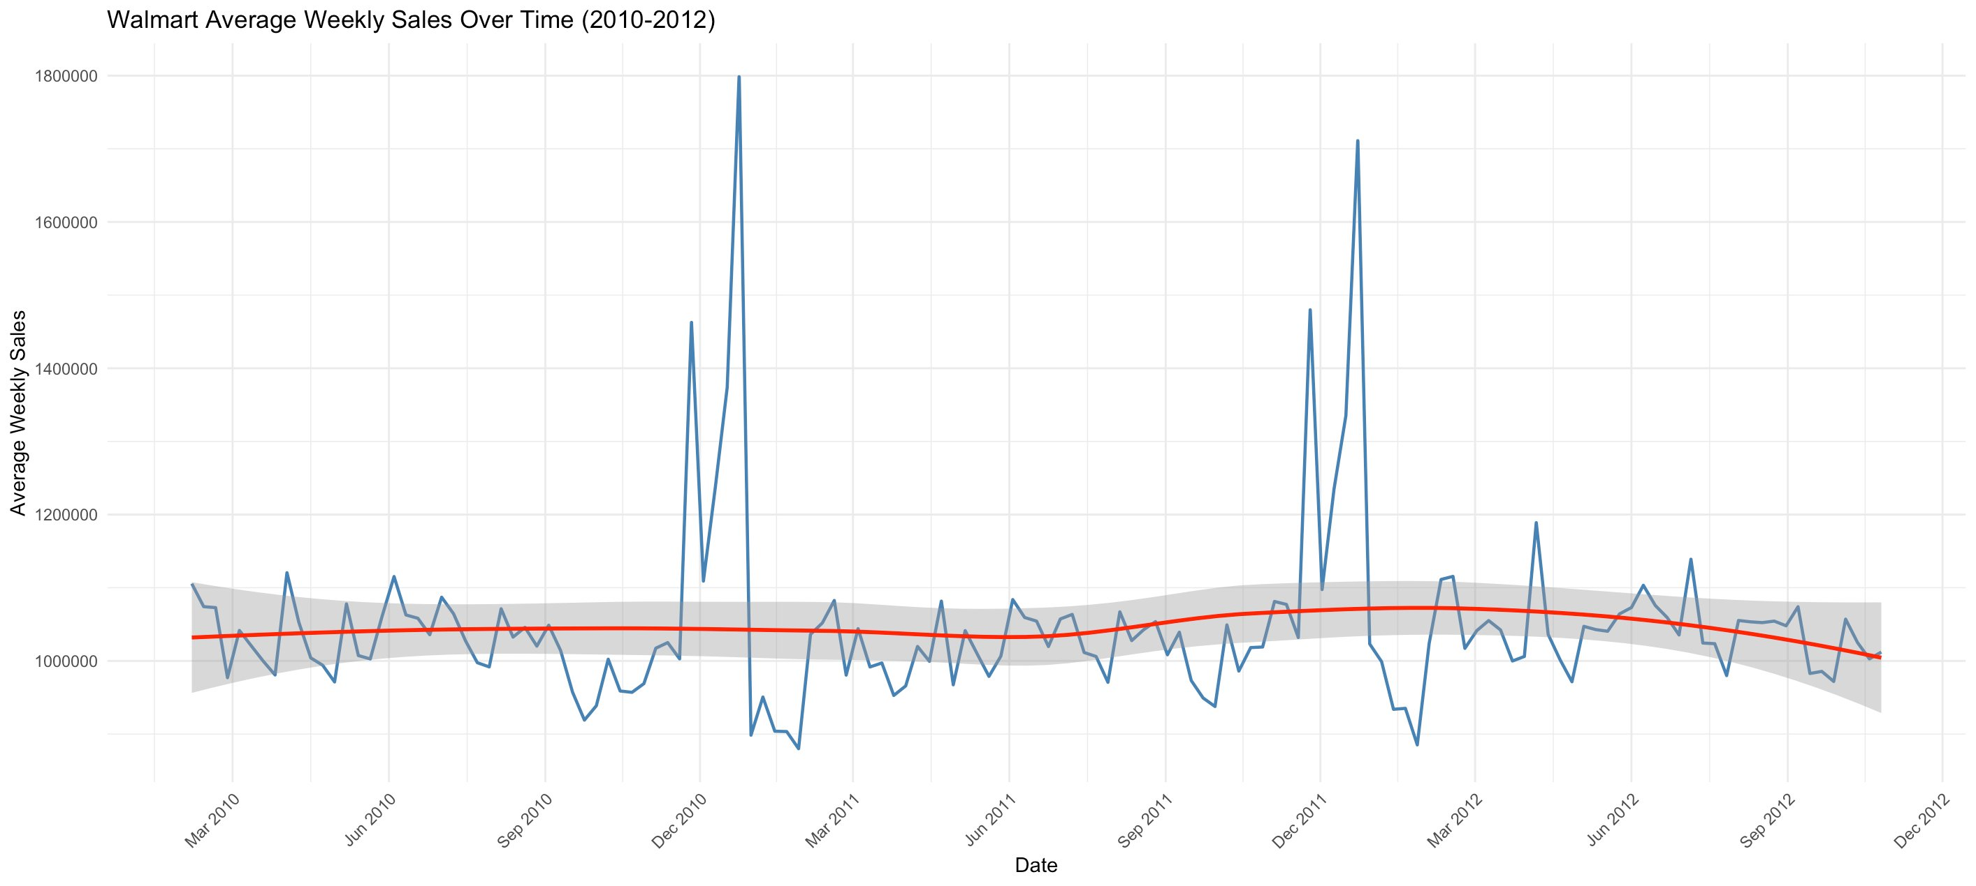
Figure 9: Walmart Average Weekly Sales Over Time (2010–2012) with Trend Line

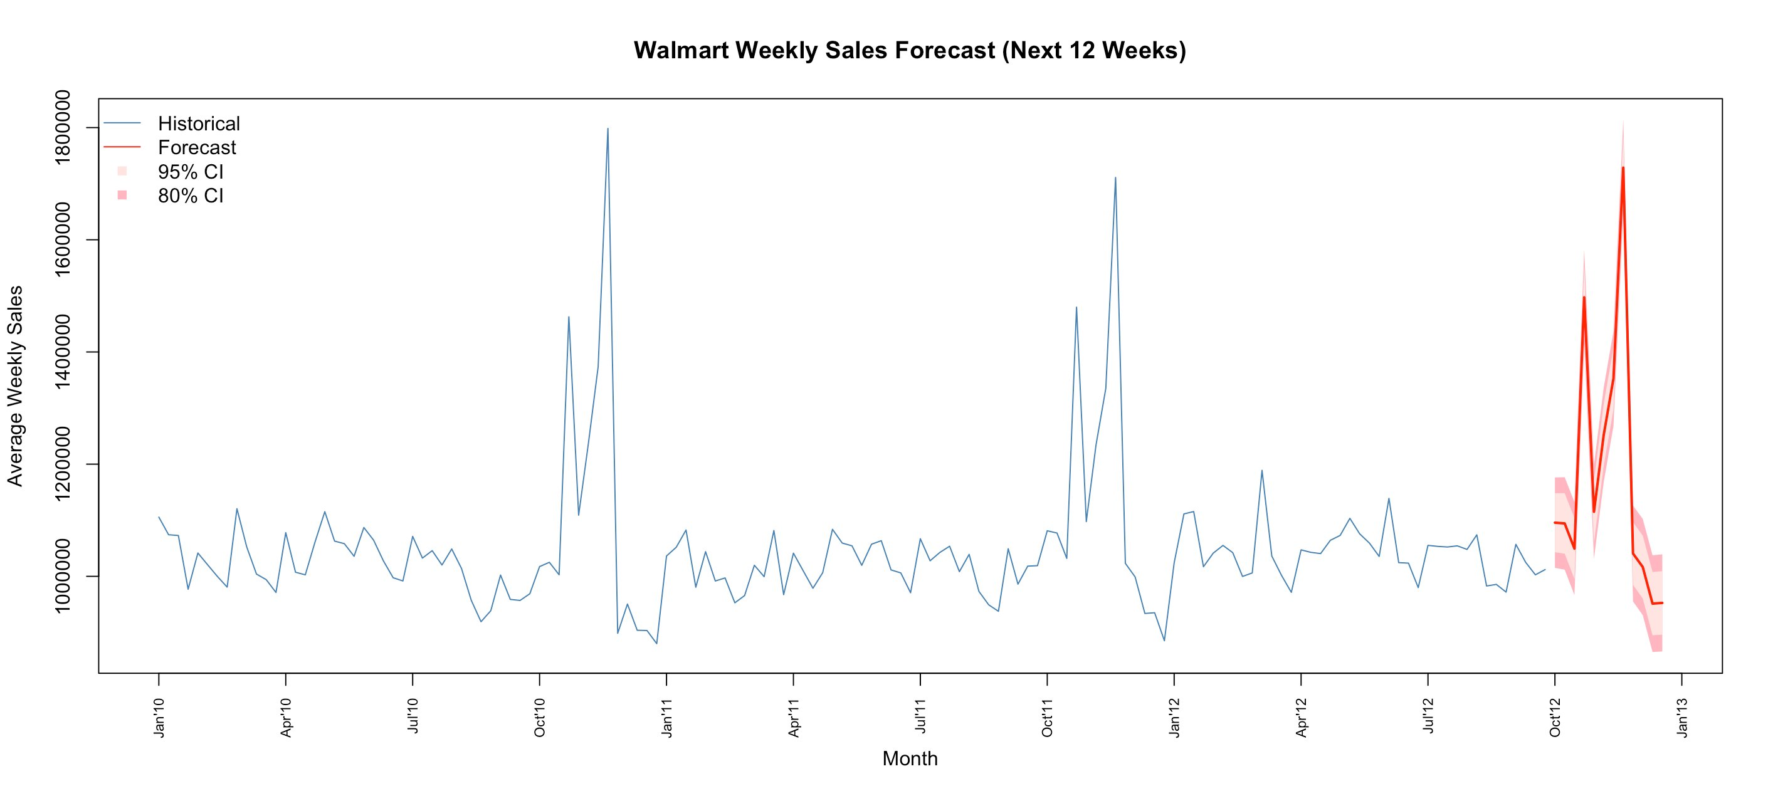
Figure 10: ARIMA Forecast — Walmart Weekly Sales (Next 12 Weeks)

- Model: ARIMA(1,1,1)(0,1,0)[52] — weekly seasonal frequency
- RMSE = 32,249, MAE = 18,212
- Forecast: Sales will remain stable around $1,000,000 in early 2013
- Post-holiday decline consistent with patterns from 2010 and 2011

6. Conclusion

This project analyzed 6,434 weekly sales observations from 45 Walmart stores between 2010 and 2012 to identify the key drivers of retail sales performance.

- Unemployment is the strongest economic predictor. A 1% rise is associated with a $42,520 decrease in weekly sales — the largest single effect observed.
- Holiday weeks significantly boost sales. Holiday weeks generate approximately $84,439 more in sales on average (p = 0.002), confirmed by both regression and Chi-Square test (p = 0.036).
- Fuel Price and Temperature are not meaningful predictors. Removing them from Model 3 did not reduce accuracy.
- Macroeconomic variables have limited predictive power. R² = 2.5% — other factors like promotions, inventory, and store-specific effects likely explain most of the variation.
- ARIMA forecasting confirms seasonal stability. Sales are forecast to remain around $1,000,000 in early 2013, consistent with historical patterns.

Best Model: Model 3 (CPI + Unemployment + Holiday_Flag) — R² = 2.48%, RMSE = $557,302, AIC = 188,524.

Appendix I: Team Member Contributions

Team Member | Role & Contributions
Xixi Lin | Sole contributor. Responsible for all aspects: dataset selection, data cleaning, association analysis, regression modeling, other techniques (Lasso, Ridge, ARIMA), presentation slides, and written report.

Appendix II: Submitted Materials

- Real Data: Walmart.csv — Walmart Store Sales Dataset (Kaggle, 2010–2012)
- R Code: Group11_walmart_final_project.R — Complete R script
- Presentation Slides: Group11_STA9750_Walmart_Presentation.pptx
- Final Report: Group11_walmart_final_report

