# Hyperparameters

# RC network model description

## Network schema

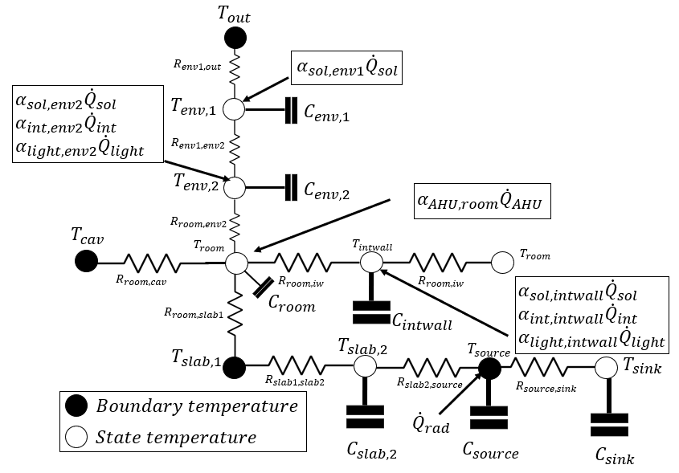

The above figure depicts electrical analog for radiant slab systems RC network, in which denote temperature, capacitances, resistances, heat flux due to radiation and corresponding coefficients. And the subscripts, , represent outdoor air, façade cavity, slab concrete, hot water or chilled water within tubes, insulation below tubes, envelope, room air, internal wall, solar radiation, internal heat, lighting, air handling unit, thermal heat flux load requirements.

## Heat balance equations

|  |  |
| --- | --- |
|  | (1) |
|  | (2) |
|  | (3) |
|  | (4) |
|  | (5) |
|  | (6) |
|  | (7) |

## Variables and parameters

The above thermal network can be represented with a state-space model with the following definition for state, input, and output variables:

|  |  |
| --- | --- |
|  | () |
|  | () |
|  | () |

And the non-zero elements for the state-space coefficient matrices and vectors are:

|  |  |  |
| --- | --- | --- |
|  |  |  |
|  |  |  |
|  |  |  |
|  |  |  |
|  |  |  |
|  |  |  |

|  |  |  |
| --- | --- | --- |
|  |  |  |
|  |  |  |
|  |  |  |
|  |  |  |
|  |  |  |
|  |  |  |

|  |  |
| --- | --- |
|  |  |
|  |  |

## Initial estimation and final converged values for learning parameters

**Table 1** Estimated values of resistances (K/W), capacitances (J/K) and heat flux coefficients for Model 3.

|  |  |  |  |
| --- | --- | --- | --- |
|  |  |  |  |
|  |  |  |  |
| 3.6E-3 |  |  |  |
|  |  |  |  |
|  |  |  |  |
|  |  |  |  |

**Table** **2** Final converged values of resistances (K/W), capacitances (J/K) and heat flux coefficients for Model 3.

|  |  |  |  |
| --- | --- | --- | --- |
| *= 3.11E-1* | *5.45E-1* | *9.94E-1* | *=-1.46E-2* |
| *7.21E-1* | *4.69E-1* | *5.64E-4* | *6.44E-4* |
| *9.07E-4* |  |  |  |
|  |  |  |  |
|  | *1.87E-1* |  |  |
| *1.41* | *4.66E-1* |  |  |