## Reference Buildings

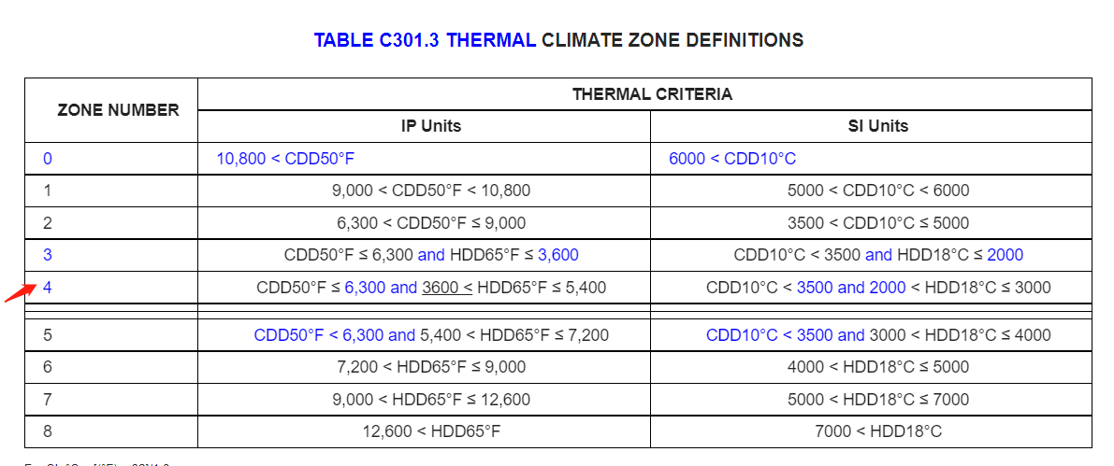

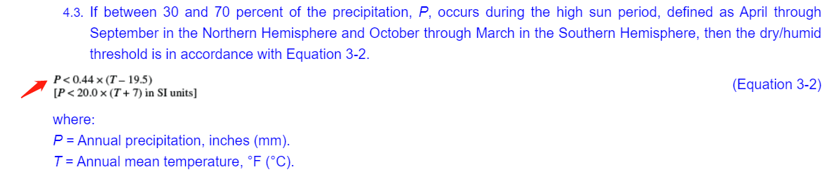

IECC Climate Zone Number: 4

IECC Moisture Regime: Dry(B)

Selected reference buildings: RefBldgMediumOfficePost1980_v1.4_7.2_4B_USA_NM_ALBUQUERQUE.idf

## Raw EPW

|  |  |
| --- | --- |
| **Location** | **Elevation (above sea level)** |
| Monoprix Building | 488 ft = 146 m |
| FRA Montpellier | 6 m |
| FRA Bordeaux✅ | 61 m |

## Only-EP

(idf, EPW)

|  |  |  |  |
| --- | --- | --- | --- |
|  | MidRiseApart | SmallOffice_Residential | MediumOffice |
| Wall/Solar |  |  | Perimeter_bot_ZN_1_Wall_South  Perimeter_mid_ZN_1_Wall_South  Perimeter_top_ZN_1_Wall_South  Perimeter_bot_ZN_3_Wall_North  Perimeter_mid_ZN_3_Wall_North  Perimeter_top_ZN_3_Wall_North |
| Roof |  |  | Building_Roof |
| Floor |  |  | Perimeter_bot_ZN_1_Floor  Perimeter_bot_ZN_2_Floor  Perimeter_bot_ZN_3_Floor  Perimeter_bot_ZN_4_Floor  Core_bot_ZN_5_Floor |
| Others (Heating/Cooling) |  |  | CORE_MID  sens_cool_demand_sensor_handle  sens_heat_demand_sensor_handle  cool_consumption_sensor_handle  heat_consumption_sensor_handle  zone_indor_temp_sensor_handle  zone_indor_spe_hum_sensor_handle |

Only-VCWG

(idf, EPW, + uwg)