## Which Rural Weather

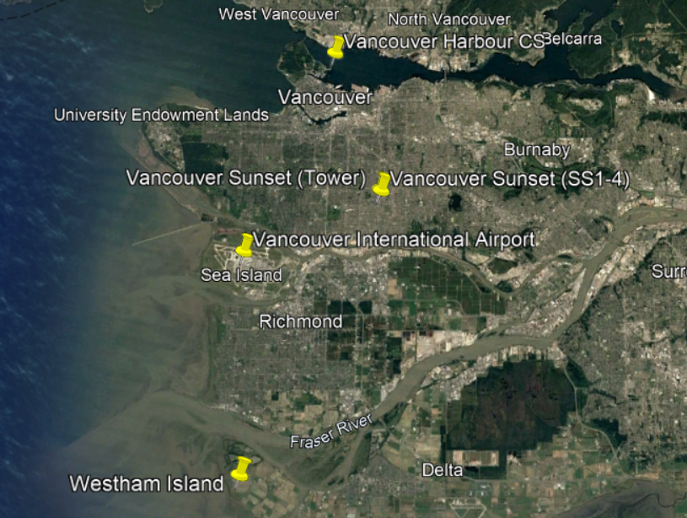

|  |  |  |  |
| --- | --- | --- | --- |
| **Location** | **Elevation relative mean sea level (m)** | **Format** | **Variables** |
| Sunset neighborhood | 90 | csv, gif | 1.2m agl air temperature, 26m agl air temperature  Relative humidty  Short Wave Radiation  Albedo  Long-Wave Radiation  Net All-Wave Radiation  Sensible Heat Flux Density  Latent Heat Flux Density  Energy Balance  Precipitation  Barometric- Pressure  Wind Velocity  Wind Direction  Friction Velocity  Turbulent Kinetic Energy  Wind components Std Dev  Carbon Dioxide Mixing Ratio  Methane Flux  Li-7700 Signal Strength  System Voltages  System Temperatures  Ceilometer |
| HARBOUR CS | 3 | csv | TMP, DEW, SLP |
| Int’l Airport | 4.26 | csv | WND, TMP, DEW, SLP |
| Westham Island | 1.5m | gif | 0.5m agl air temperature  2m agl air temperature, 1.76 agl acoustic temperature  Relative humidty  Short Wave Radiation  Albedo  Long-Wave Radiation  Net All-Wave Radiation  Sensible Heat Flux Density  Latent Heat Flux Density  Energy Balance  Precipitation  Barometric- Pressure  Soil Temperature  Soil Volumetric Water Content  Soil Heat Flux Density  Wind Velocity  Wind Direction  Friction Velocity  Turbulent Kinetic Energy  Wind components Std Dev  Carbon Dioxide Mixing Ratio  Carbon Dioxide Flux  LiCor AGC  System Voltages  System Temperatures. |

## EPiCC Vancouver

[EPiCC Vancouver (ubc.ca)](https://ibis.geog.ubc.ca/~epicc/)

[EPiCC Vancouver Data Archive (ubc.ca)](https://ibis.geog.ubc.ca/~epicc/webdata/index.html)

## Urban

SSDTA4, Vancouver Sunset (SS4, very close to Tower), Air temperature, 1.2m, May 10, 2008 -Sep 10, 2008, CSV+gif

STDTA1, Vancouver Sunset (Tower), Air temperature, 26 m, May 10, 2008 -Sep 10, 2008, CSV + gif

STATA2, Vancouver Sunset (Tower), Acoustic temperature, 28.8m, May 10, 2008 -Sep 10, 2008, CSV +gif

## Rural

WIDTA1, Westham Island, Air temperature, 0.5m, 2007-2010, Data Archive in picture format (gif)

WIDTA2, Westham Island, Air temperature, 2m, 2007-2010, Data Archive in picture format (gif)

[WI_DT_2008_360.gif (720×256) (ubc.ca)](https://ibis.geog.ubc.ca/~epicc/webdata/resources/images/WI_DT_2008_360.gif)

## Other air temperature measurement sites

