Contents
Contents 1
Routing 2
4.1 TYPES OF ROUTING ALGORITHMS 2
4.2 DEADLOCK AVOIDANCE 4
4.4 OBLIVIOUS ROUTING 5
4.5 ADAPTIVE ROUTING 7
4.5.1 ADAPTIVE TURN MODEL ROUTING 8
4.6 IMPLEMENTATION 10
4.6.1 SOURCE ROUTING 11
4.6.2 NODETABLE-BASED ROUTING 12
4.6.3 COMBINATIONAL CIRCUITS 13
4.6.4 ADAPTIVE ROUTING 14
4.7 ROUTING ON IRREGULAR TOPOLOGIES 14

Routing
After determining the network topology, the routing algorithm is used to decide what path a message will take through the network to reach its destination. The goal of the routing algorithm is to distribute traffic evenly among the paths supplied by the network topology, so as to avoid hot spots and minimize contention, thus improving network latency and throughput. All of these performance goals must be achieved while adhering to tight constraints on implementation complexity: routing circuitry can stretch critical path delay and add to a router’s area footprint. While energy overhead of routing circuitry is typically low, the specific route chosen affects hop count directly, and thus substantially affects energy consumption.
4.1 TYPES OF ROUTING ALGORITHMS
In this section, we briefly discuss various classes of routing algorithms. Routing algorithms are generally divided into three classes: deterministic, oblivious and adaptive.
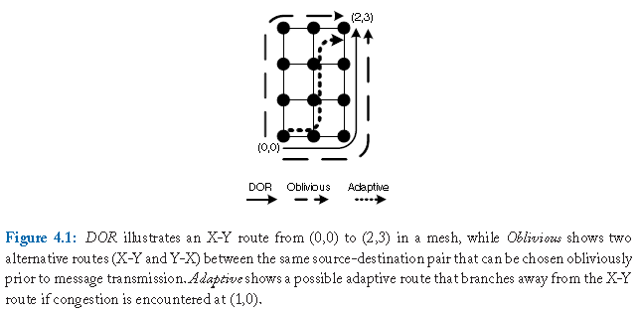
Figure 4.1: DOR illustrates an X-Y route from (0,0) to (2,3) in a mesh, while Oblivious shows two alternative routes (X-Y and Y-X) between the same source-destination pair that can be chosen obliviously prior to message transmission. Adaptive shows a possible adaptive route that branches away from the X-Y route if congestion is encountered at (1,0).

While numerous routing algorithms have been proposed, the most commonly used routing algorithm in on-chip networks is dimension-ordered routing (DOR) due to its simplicity. Dimension-ordered routing is an example of a deterministic routing algorithm, in which all messages from node A to B will always traverse the same path. With DOR, a message traverses the network dimension-by-dimension, reaching the ordinate matching its destination before switching to the next dimension.In a 2-dimensional topology such as the mesh in Figure 4.1, X-Y dimension-ordered routing sends packets along the X-dimension first, followed by the Y-dimension. A packet traveling from (0,0) to (2,3) will first traverse 2 hops along the X-dimension, arriving at (2,0), before traversing 3 hops along the Y-dimension to its destination.
Another class of routing algorithms are oblivious ones, where messages traverse different paths from A to B, but the path is selected without regard to network congestion. For instance, a router could randomly choose among alternative paths prior to sending a message. Figure 4.1 shows an example where messages from (0,0) to (2,3) can be randomly sent along either the Y-X route or the X-Y route. Deterministic routing is a subset of oblivious routing.
A more sophisticated routing algorithm can be adaptive, in which the path a message takes from A to B depends on network traffic situation. For instance, a message can be initially following the X-Y route and see congestion at (1,0)’s east outgoing link. Due to this congestion, the message will instead choose to take the north outgoing link towards the destination (see Figure 4.1).
Routing algorithms can also be classified as minimal and non-minimal. Minimal routing algorithms select only paths that require the smallest number of hops between the source and the destination. Non-minimal routing algorithms allow paths to be selected that may increase the number of hops between the source and destination. In the absence of congestion, non-minimal routing increases latency and also power consumption as additional routers and links are traversed by a message. With congestion, the selection of a non-minimal route that avoids congested links, may result in lower latency for packets.
Before we get into details on specific deterministic, oblivious and adaptive routing algorithms, we will discuss the potential for deadlock that can occur with a routing algorithm.
4.2 DEADLOCK AVOIDANCE
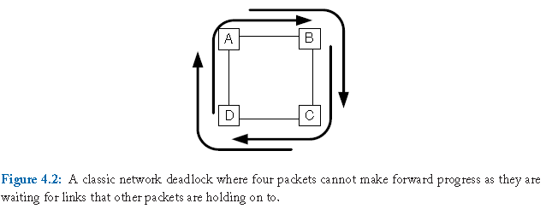
Figure 4.2: A classic network deadlock where four packets cannot make forward progress as they are waiting for links that other packets are holding on to.

In selecting or designing a routing algorithm, not only must its effect on delay, energy, throughput and reliability be taken into account, most applications also require the network to guarantee deadlock freedom. A deadlock occurs when a cycle exists among the paths of multiple messages. Figure 4.2 routing deadlock shows four gridlocked (deadlocked) messages waiting for links that are currently held by other messages, preventing any message from making forward progress. The packet entering router A from the South input port is waiting to leave through the East output port, but another packet is holding onto that exact link while waiting at router B to leave via the South output port, which is again held by another packet that is waiting at router C to leave via the West output port and so on.
Deadlock freedom can be ensured in the routing algorithm by preventing cycles among the routes generated by the algorithm, or in the flow control protocol by preventing router buffers from being acquired and held in a cyclic manner [63, 178].A network that uses a deadlock-prone routing algorithm requires a flow control protocol that ensures deadlock freedom, as discussed in Section 5.6.

4.3 DETERMINISTIC DIMENSION-ORDERED ROUTING

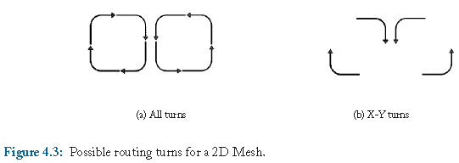
Figure 4.3: Possible routing turns for a 2D Mesh.

A routing algorithm can be described by which turns are permitted. Figure 4.3a illustrates all possible turns in a 2D mesh network while Figure 4.3b illustrates the more limited set of permissible turns allowed by DOR X-Y routing. Allowing all turns results in cyclic resource dependencies, which can lead to network deadlock. To prevent these cyclic dependencies, turns may be disallowed. As you can see, no cycle is present in Figure 4.3b. Specifically, a message traveling east or west is allowed to turn north or south; however, messages traveling north and south are permitted no turns. Two of the four turns in Figure 4.2 will not be permitted, so a cycle is not possible.
Alternatively, Y-X routing can be used where messages traveling north or south are allowed to turn east or west but once a message is traveling East or West, no further turns are permitted. Depending on the network dimensions, i.e. whether there are more nodes along X or Y, one of these routing algorithms will balance load better with uniform random traffic since channel load is higher along the dimension with fewer nodes.
Dimension order routing is both simple and deadlock-free; however, it eliminates path diversity in a mesh network and thus lowers throughput. With dimension order routing, exactly one path exists between every source and destination pair. Without path diversity, the routing algorithm is unable to route around faults in the network or avoid areas of congestion. As a result of routing restrictions, dimension order routing does a poor job of load balancing the network.
4.4 OBLIVIOUS ROUTING
Using an oblivious routing algorithm, routing paths are chosen without regard to the state of the network. By not using information about the state of the network, these routing algorithms can be kept simple.
Valiant’ s randomized routing algorithm [205] is one example of an oblivious routing algorithm. To route a packet from source s to destination d using Valiant’ s algorithm, an intermediate destination d’ is randomly selected. The packet is first routed from s to d’ and then from d’ to d. By routing first to a randomly selected intermediate destination before routing to the final destination, Valiant’ s algorithm is able to load balance traffic across the network; the randomization causes any traffic pattern to appear to be uniform random. Load balancing with Valiant’ s algorithm comes at the expense of locality; for example, by routing to an intermediate destination, the locality of near neighbor traffic on a mesh is destroyed. Hop count is increased, which in turn increases the average packet latency and the average energy consumed by the packet in the network.
Valiant’ s routing algorithm can be restricted to support only minimal routes [158], by restricting routing choices to only the shortest paths in order to preserve locality. In a k-ary n-cube topology, the intermediate node d’ must lie within the minimal quadrant; the smallest n-dimensional sub-network with s and d as corner nodes bounding this quadrant.

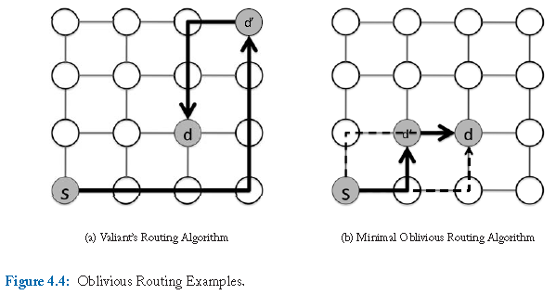
Figure 4.4: Oblivious Routing Examples.

With both Valiant’ s randomized routing and minimal adaptive routing, dimension order routing can be used to route from s to d’ and from d’ to d. If DOR is used, not all paths will be exploited but better load balancing is achieved than deterministic routing from s directly to d. Figure 4.4 illustrates a routing path selected using Valiant’ s algorithm and minimal oblivious routing. In Figure 4.4a, Valiant’ s algorithm randomly selects an intermediate destination d’. The random selection can destroy locality and significantly increase hop count; here, the hop count is increased from three hops to nine hops. To preserve locality, minimal oblivious routing can be employed as in Figure 4.4b. Now, d’ can only be selected to lie within the minimal quadrant formed by s and d, preserving the minimum hop count of three. One possible selection is highlighted (two other paths are possible for this source-destination pair as shown with dashed lines).
Valiant’ s routing algorithm and minimal oblivious routing are deadlock free when used in conjunction with X-Y routing. An example of an oblivious routing algorithm that is not deadlock free is one that randomly chooses between X-Y or Y-X routes. The oblivious algorithm that randomly chooses between X-Y or Y-X routes is not deadlock-free because all four turns from Figure 4.2 are possible leading to potential cycles in the link acquisition graph.
4.5 ADAPTIVE ROUTING
A more sophisticated routing algorithm can be adaptive, i.e. the path a message takes from A to B depends on the network traffic situation. For instance, a message can be going along the X-Y route, see congestion at (1,0)’s east outgoing link and instead choose to take the north outgoing link towards the destination (see Figure 4.1).
Local or global information can be leveraged to make adaptive routing decisions. Adaptive routing algorithms often rely on local router information such as queue occupancy and queuing delay to gauge congestion and select links [50]. The back pressure mechanisms used by flow control (discussed in the next chapter) allow congestion information to propagate from the congestion site back through the network.

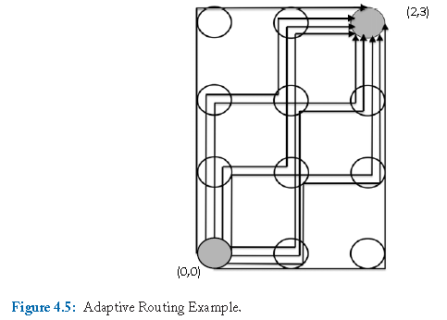
Figure 4.5: Adaptive Routing Example.

Figure 4.5 shows all possible (minimal) routes that a message can take from Node (0,0) to Node (2,3).There are nine possible paths. An adaptive routing algorithm that leverages only minimal paths could exploit a large degree of path diversity to provide load balancing and fault tolerance.
Adaptive routing can be restricted to taking minimal routes between the source and the destination. An alternative option is to employ misrouting, which allows a packet to be routed in a non-productive direction resulting in non-minimal paths. When misrouting is permitted, livelock becomes a concern. Without mechanisms to guarantee forward progress, livelock can occur as a packet is continuously misrouted so as to never reach its destination. We can combat this problem by allowing a maximum number of misroutes per packet and giving higher priority to packets than have been misrouted a large number of times. Misrouting increases the hop count but may reduce end-to-end packet latency by avoiding congestion (queuing delay).
With a fully-adaptive routing algorithm, deadlock can become a problem. For example, the adaptive route shown in Figure 4.1 is a superset of oblivious routing and is subject to potential deadlock. Planar-adaptive routing [38] limits the resources needed to handle deadlock by restricting adaptivity to only two dimensions at a time. Duato has proposed flow control techniques that allow full routing adaptivity while ensuring freedom from deadlock [62]. Deadlock-free flow control will be discussed in Chapter 5.
Another challenge with adaptive routing is preserving inter-message ordering as may be needed by the coherence protocol. If messages must arrive at the destination in the same order that the source issued them, adaptive routing can be problematic. Mechanisms to re-order messages at the destination can be employed or messages of a given class can be restricted in their routing to prevent re-ordering.
4.5.1 ADAPTIVE TURN MODEL ROUTING
While we introduced turn model routing earlier in Section 4.3, discussing how dimension order X-Y routing eliminates two out of four turns (Figure 4.3), here, we explain how turn model can be more turn model routing broadly applied to derive deadlock-free adaptive routing algorithms. Adaptive turn model routing eliminates the minimum set of turns needed to achieve deadlock freedom while retaining some path diversity and potential for adaptivity.
With dimension order routing only four possible turns are permitted of the eight turns available in a two dimensional mesh. Turn model routing [75] increases the flexibility of the algorithm by allowing six out of eight turns. Only one turn from each cycle is eliminated.

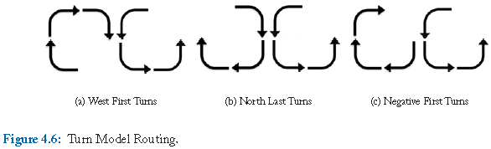
Figure 4.6: Turn Model Routing.
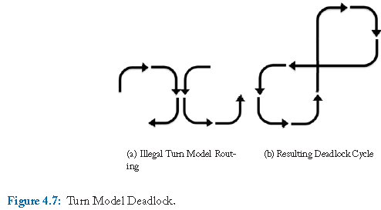
Figure 4.7: Turn Model Deadlock.

In Figure 4.6, three possible routing algorithms are illustrated. Starting with all possible turns (shown in Figure 4.6a), the north to west turn is eliminated; after this elimination is made, the three routing algorithms shown in Figure 4.6 can be derived. In Figure 4.6a, the west-first algorithm is shown; in addition to eliminating the North to West turn, the South to West turn is eliminated. In other words, a message must first travel in the West direction before traveling in any other direction. The North-Last algorithm (Figure 4.6b) eliminates both the North to West and the North to East turns. Once a message has turned North, no further turns are permitted; hence, the North turn must be made last. Finally, Figure 4.6c removes turns from North to West and East to South to create the Negative-First algorithm. A message travels in the negative directions (west and south) first before it is permitted to travel in positive directions (east and north). All three of these turn model routing algorithms are deadlock-free. Figure 4.7 illustrates a possible turn elimination that is invalid; the elimination of North to West combined with the elimination of West to North can lead to deadlock. A deadlock cycle is depicted in Figure 4.7b that can result from a set of messages using the turns specified in Figure 4.7a.
Odd-even turn model routing [39] proposes eliminating a set of two turns depending on whether the current node is in an odd or even column. For example, when a packet is traversing a node in an even column1, turns from East to North and from North to West are prohibited. For packets traversing an odd column node, turns from East to South and from South to West are prohibited. With this set of restrictions, the odd-even turn model is deadlock free provided 180◦ turns are disallowed. The odd-even turn model provides better adaptivity than other turn model algorithms such as West-First. With West-First, destinations to the West of the source, have no flexibility; with odd-even routing, there is flexibility depending on the allowable turns for a given column.
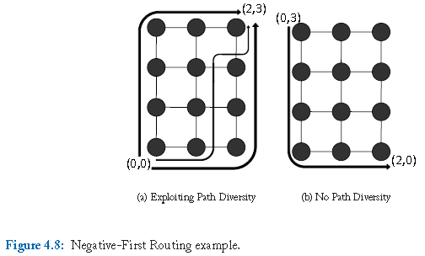
Figure 4.8: Negative-First Routing example.

In Figure 4.8, we apply the Negative-First turn model routing to two different source destination pairs. In Figure 4.8a, three possible routes are shown between (0,0) and (2,3) (more are possible); turns from North to East and from East to North are permitted allowing for significant flexibility. However, in Figure 4.8b, there is only one path allowed by the algorithm to route from (0,3) to (2,0).The routing algorithm does not allow the message to turn from East to South. Negative routes must be completed first, resulting in no path diversity for this source-destination pair. As illustrated by this example, turn model routing provide more flexibility and adaptivity than dimension-order routing but it is still somewhat restrictive.

- A column is even if the dimension-0 coordinate of the column is even.

4.6 IMPLEMENTATION
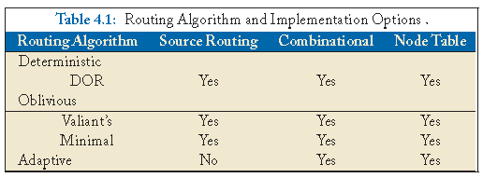

In this section, we discuss various implementation options for routing algorithms. Routing algorithms can be implemented using look-up tables at either the source nodes or within each router. Combinational circuitry can be used as an alternative to table-based routing. Implementations have various trade-offs, and not all routing algorithms can be achieved with each implementation. Table 4.1 shows examples for how routing algorithms in each of the three different classes can be implemented.
4.6.1 SOURCE ROUTING
Routing algorithms can be implemented in several ways. First, the route can be embedded in the packet header at the source, known as source routing. For instance, the X-Y route in Figure 4.1 can be encoded as < E,E,N,N,N,Eject >, while the Y-X route can be encoded as < N,N,N,E,E,Eject >. At each hop, the router will read the leftmost direction off the route header, send the packet towards the specified outgoing link, and strip off the portion of the header corresponding to the current hop.

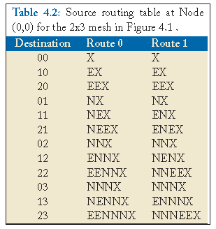

There are a few benefits to source routing. First, by selecting the entire route at the source, latency is saved at each hop in the network since the route does not need to be computed or looked up. The per-router routing hardware is also saved; no combinational routing logic or routing tables are needed once the packet has received its route from the source node. Second, source routing tables can be reconfigured to deal with faults and can support irregular topologies. Multiple routes per source-destination pair can be stored in the table (as shown in Table 4.2) and selected randomly for each packet to improve load balancing.
The disadvantages of source routing include the bit overheads required to store the routing table at the network interface of each source and to store the entire routing path in each packet; these paths are of arbitrary length and can grow large depending on network size. For a 5-port switch, each routing step is encoded by a 3-bit binary number. Just as the packet must be able to handle arbitrary length routing paths, the source table must also be designed to efficiently store different length paths. Additionally, by choosing the entire route at the source node, source based routing is unable to take advantage of dynamic network conditions to avoid congestion. However, as mentioned, multiple routes can be stored in the table and selected either randomly or with a given probability to improve the load distribution in the network.
4.6.2 NODETABLE-BASED ROUTING
More sophisticated algorithms are realized using routing tables at each hop which store the outgoing link a packet should take to reach a particular destination. By accessing routing information at each hop (rather than all at the source), adaptive algorithms can be implemented and per-hop network congestion information can be leveraged in making decisions.

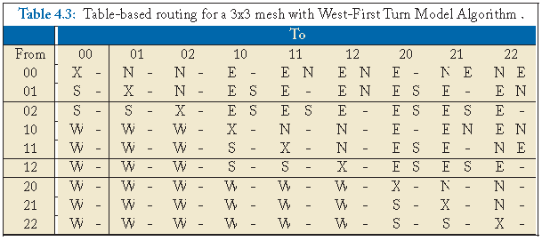

Table 4.3 shows the routing table for the west-first turn model routing algorithm on a 3-ary 2-mesh. Each node’s table would consist of the row corresponding to its node identifier, with up to two possible outgoing links for each destination. Ejection is indicated by an X. By implementing a turn model routing algorithm in the per-node tables, some adaptivity can be achieved.
Compared to source routing, node-based routing requires smaller routing tables at each node. Each routing table needs to store only the routing information to select the next hop for each destination rather than the entire path. When multiple outputs are included per destination, node based routing supports some adaptivity. Local information about congestion or faults can be used to bias the route selection to the non-congested link or to a non-faulty path. Node-based routing tables can also be programmable. By allowing the routing tables to be changed, the routing algorithm is better able to tolerate faults in the network.
The most significant downside to node routing tables is the increase in packet delay. Source routing requires a single look-up to acquire the entire routing path for a packet. With node-based routing, the latency of a look-up must be expended at each hop in the network.
4.6.3 COMBINATIONAL CIRCUITS
Alternatively, the message can encode the ordinates of the destination and use comparators at each router to determine whether to accept (eject) or forward the message. Simple routing algorithms are typically implemented as combinational circuits within the router due to the low overhead.

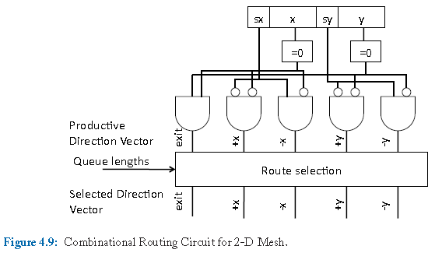
Figure 4.9: Combinational Routing Circuit for 2-D Mesh.

With source routing, the packet must contain space to carry all the bits needed to specify the entire path. Routing using combinational circuits requires only that the packet carry the destination identifier. The circuits required to implement the routing algorithm can be quite simple and executed with very low latency. An example circuit to compute the next hop based on current buffer occupancies in a 2-D mesh is shown in Figure 4.9. Alternatively, the route selection could implement dimension order routing rather than make a selection based on queue lengths.
By implementing the routing decision in combinational circuits, the algorithm is specific to one topology and one routing algorithm.The generality and configurability of table-based strategies are sacrificed. Despite the speed and simplicity of using a circuit to compute the next hop in the routing path, this computation adds latency to the packet traversal when compared to source-based routing. As with node-routing, the next output must be determined at each hop in the network. As will be discussed in Chapter 6, this routing computation can add a pipeline stage to the router traversal.
4.6.4 ADAPTIVE ROUTING
Adaptive routing algorithms need mechanisms to track network congestion levels, and update the route. Route adjustments can be implemented by modifying the header, by employing combinational circuitry that accepts as input these congestion signals, or by updating entries in a routing table. Many congestion sensitive mechanisms have been proposed, with the simplest being tapping into information that is already captured and used by the flow control protocol, such as buffer occupancy or credits [193, 50].
The primary benefit of increasing the information available to the routing circuitry is adaptivity. By improving the routing decision based on network conditions, the network can achieve higher bandwidth and reduce the congestion latency experienced by packets.
The disadvantage of such an approach is complexity. Additional circuitry is required for congestion-based routing decisions; this circuitry can increase the latency of a routing decision and the area of the router. Although the leveraging of information already available at the router is often done to make routing decisions, increasing the sophistication of the routing decision may require that additional information be communicated from adjacent routers.This additional communication could increase the network area and energy.
4.7 ROUTING ON IRREGULAR TOPOLOGIES
The discussion of routing algorithms in this chapter has assumed a regular topology such as a torus or a mesh. In the previous chapter, the potential for power and performance benefits of using irregular topologies for MPSoCs composed of heterogeneous nodes was explored. Irregular topologies can require special considerations in the development of a routing algorithm. Common routing implementations for irregular networks rely on source table routing or node-table routing [104, 34, 69]. Care must be taken when specifying routes so that deadlock is not induced. Turn model routing may not be feasible if certain connectivity is removed by the presence of oversized cores in a mesh network, for example.

