% Course: Nonlinear Optimization. %

% FALL.2018. Dr. Cheng. %

% Assignment: (10) %

% Date:(2018.11.14) %

% By: 卢博 %

% ID NUMBER: 11849159 %

% LAB:(10) %

%

1. Design of Experiments -Auxiliary Functions

2D 1

3<=D 2

clear;clc  
l1 = 0;u1 = 1;  
l2 = 0;u2 = 1;  
N = 50;

## 2D

n = 2;  
dots = rand(N,n);  
plot(dots(:,1),dots(:,2),'o')  
title(['Uniformity= ',num2str(Auxiliary_functions(dots))])

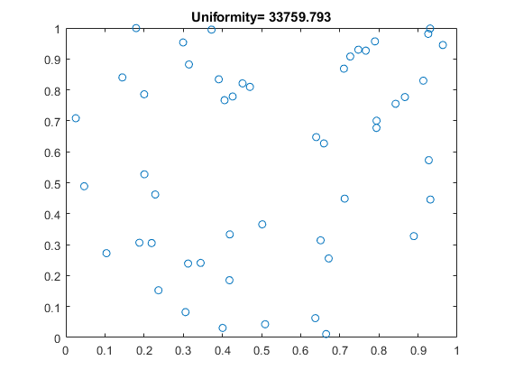

## 3<=D

n = 3;  
dots = rand(N,n);  
% figure  
% plot3(dots(:,1),dots(:,2),dots(:,3),'o')  
% grid  
% Auxiliary_functions(dots)  
or = nchoosek(1:n,2);  
k = size(or,1);  
figure  
hold on  
for i = 1:k  
 subplot(1,k,i);  
 plot(dots(:,or(i,1)),dots(:,or(i,2)),'o')  
  
 xlabel(['x=',num2str(or(i,1)),' y=',num2str(or(i,2))])  
 title([' Uniformity= ',num2str(Auxiliary_functions(dots(:,or(i,:))))])  
end

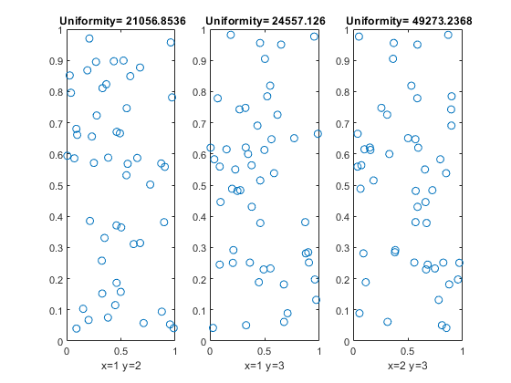

function E = Auxiliary_functions(dots)  
N = size(dots);  
E = 0;  
for i = 1:N  
 for j = i+1:N  
 E = E + 1/(norm(dots(i,:)-dots(j,:)))^2;  
 end  
end  
  
end

[*Published with MATLAB® R2018b*](https://www.mathworks.com/products/matlab)

1. Random Sampling

Random Sampling 1

Stratified Random Sampling 2

## Random Sampling

clear;clc  
N = 100;  
n = 2;  
dots = rand(N,n);  
subplot(121)  
plot(dots(:,1),dots(:,2),'o')  
title(['Uniformity= ',num2str(Auxiliary_functions(dots))])  
xlabel('Unoptimized')  
grid on

## Stratified Random Sampling

subplot(122)  
L = sqrt(N);  
dots = rand(N,n)/L;  
moved = zeros(N,n);  
k = 1;  
for i = 1:L  
 for j = 1:L  
 moved(k,:) = [(i-1)/L,(j-1)/L];  
 k = k + 1;  
 end  
end  
dots = dots + moved;  
plot(dots(:,1),dots(:,2),'o')  
title(['Uniformity= ',num2str(Auxiliary_functions(dots))])  
xlabel('Optimized')  
grid on

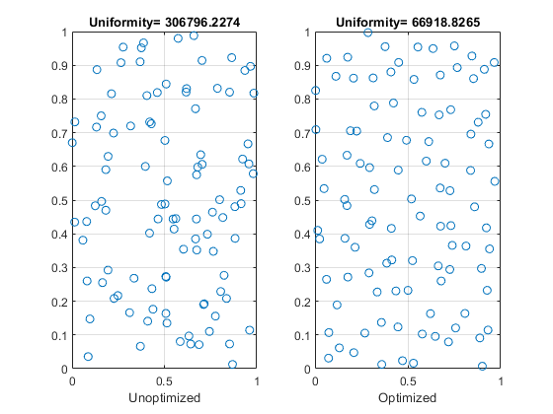

[*Published with MATLAB® R2018b*](https://www.mathworks.com/products/matlab)

1. Latin Hypercube Sampling

2D 1

3D 2

## 2D

clear;clc  
N = 100;  
n = 2;  
dots = rand(N,n);  
subplot(121)  
plot(dots(:,1),dots(:,2),'o')  
title(['Uniformity= ',num2str(Auxiliary_functions(dots))])  
xlabel('Unoptimized')  
grid on  
forbid = [];dots = [];  
subplot(122)  
for i = 1:N  
 dotx = (i-1)/N + rand()/N; % 限制x在一段范围内  
 doty = rand(); % y可以随意取值  
 while ismember(ceil(doty*N),forbid) % 如果y所在的行已经被其他点占据，则重新取值，直到这个y值单独占据一行  
 doty = rand();  
 end  
 forbid = [forbid ceil(doty*N)]; % 将新的y值所在的行记为已使用  
 dots = [dots;[dotx,doty]];  
 plot(dotx,doty,'bo')  
 hold on  
end  
title(['Uniformity= ',num2str(Auxiliary_functions(dots))])  
xlabel('Optimized')  
grid on

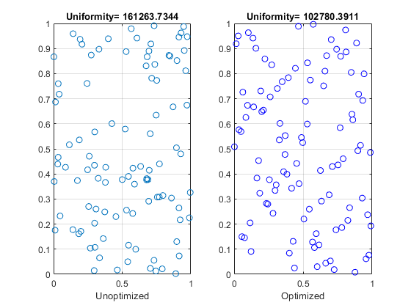

## 3D

n = 3;  
dots = rand(N,n);  
figure  
subplot(121)  
plot3(dots(:,1),dots(:,2),dots(:,3),'o')  
title(['Uniformity= ',num2str(Auxiliary_functions(dots))])  
xlabel('Unoptimized')  
grid on  
forbidx = [];forbidy = [];dots = [];  
subplot(122)  
for z = 1:N  
 dotz = (z-1)/N + rand()/N;  
 dotx = rand();  
 doty = rand();  
 while ismember(ceil(dotx*N),forbidx)  
 dotx = rand();  
 end  
 forbidx = [forbidx ceil(dotx*N)];  
 while ismember(ceil(doty*N),forbidy)  
 doty = rand();  
 end  
 forbidy = [forbidy ceil(doty*N)];  
 dots = [dots;[dotx,doty,dotz]];  
 plot3(dotx,doty,dotz,'bo')  
 hold on  
end  
title(['Uniformity= ',num2str(Auxiliary_functions(dots))])  
xlabel('Optimized')  
grid on

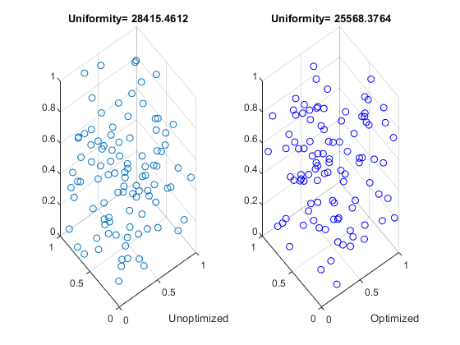

[*Published with MATLAB® R2018b*](https://www.mathworks.com/products/matlab)

1. Optimization-Based Sampling Algorithm

Optimization-Based Sampling Algorithm 1

2D 1

3D 3

## Optimization-Based Sampling Algorithm

clear;clc  
f = @ Auxiliary_functions;  
N = 100;

## 2D

n = 2;  
  
forbid = [];dots = [];  
subplot(121)  
for i = 1:N  
 dotx = (i-1)/N + rand()/N;  
 doty = rand();  
 while ismember(ceil(doty*N),forbid)  
 doty = rand();  
 end  
 forbid = [forbid ceil(doty*N)];  
 dots = [dots;[dotx,doty]];  
 plot(dotx,doty,'bo')  
 hold on  
end  
title(['Uniformity= ',num2str(Auxiliary_functions(dots))])  
xlabel('Unoptimized')  
  
subplot(122)  
dots = rand(N,n);  
dots = fmincon(f,dots,[],[],[],[],zeros(size(dots)),ones(size(dots)));  
plot(dots(:,1),dots(:,2),'o')  
title(['Uniformity= ',num2str(Auxiliary_functions(dots))])  
xlabel('Optimized')

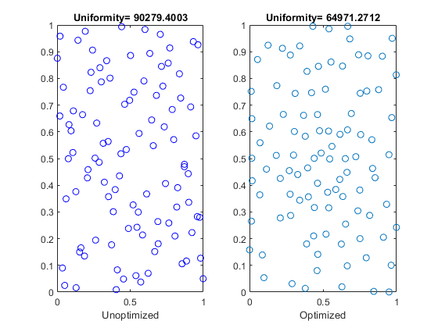

## 3D

figure  
n = 3;  
  
forbidx = [];forbidy = [];dots = [];  
subplot(121)  
for z = 1:N  
 dotz = (z-1)/N + rand()/N;  
 dotx = rand();  
 doty = rand();  
 while ismember(ceil(dotx*N),forbidx)  
 dotx = rand();  
 end  
 forbidx = [forbidx ceil(dotx*N)];  
 while ismember(ceil(doty*N),forbidy)  
 doty = rand();  
 end  
 forbidy = [forbidy ceil(doty*N)];  
 dots = [dots;[dotx,doty,dotz]];  
 plot3(dotx,doty,dotz,'bo')  
 hold on  
end  
title(['Uniformity= ',num2str(Auxiliary_functions(dots))])  
xlabel('Unoptimized')  
  
subplot(122)  
dots = rand(N,n);  
dots = fmincon(f,dots,[],[],[],[],zeros(size(dots)),ones(size(dots)));  
plot3(dots(:,1),dots(:,2),dots(:,3),'o')  
title(['Uniformity= ',num2str(Auxiliary_functions(dots))])  
xlabel('Optimized')

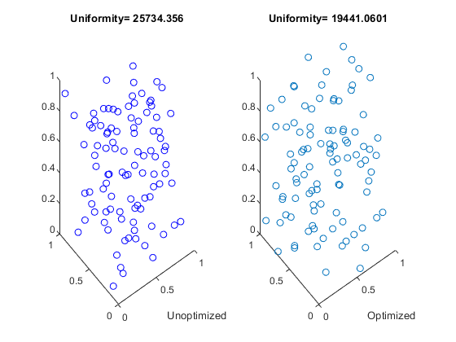

[*Published with MATLAB® R2018b*](https://www.mathworks.com/products/matlab)