% Course: Nonlinear Optimization. %

% FALL.2018. Dr. Cheng. %

% Assignment: (9) %

% Date:(2018.11.7) %

% By: 卢博 %

% ID NUMBER: 11849159 %

% LAB:(9) %

%

1. Multiobjective Using Genetic Algorithm

clear;clc  
fitness = @simpleMultiObjective;  
nvar = 1;  
[x, fval] = gamultiobj(fitness, nvar);

Optimization terminated: maximum number of generations exceeded.

x0 = -10:0.5:10;  
f1 = (x0+2).^2 - 10;  
f2 = (x0-2).^2 + 20;  
figure;hold on  
plot(x0, f1, x0, f2)  
grid;  
xlabel('x')  
ylabel('f')   
plot(x, fval(:,1),'x')  
plot(x, fval(:,2),'o')  
  
figure  
plot(fval(:,1),fval(:,2),'o');  
xlabel('f1')  
ylabel('f2')  
grid

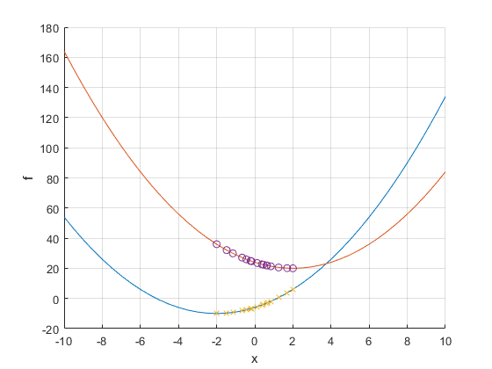

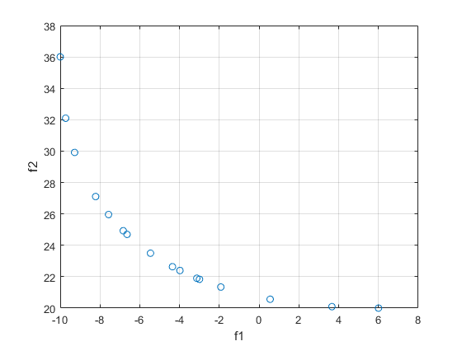

function y = simpleMultiObjective(x)  
y(1) = (x+2).^2 - 10;  
y(2) = (x-2).^2 + 20;  
end

[*Published with MATLAB® R2018b*](https://www.mathworks.com/products/matlab)

1. Random Search

Problem Definition 1

MOEA/D Settings 1

Initialization 2

Main Loop 3

Reults 5

clc;  
clear;

## Problem Definition

CostFunction=@ ft; % Cost Function  
nVar=3; % Number of Decision Variables  
VarSize=[nVar 1]; % Decision Variables Matrix Size  
VarMin = [0.5 -2 -2]'; % Decision Variables Lower Bound  
VarMax = [1 2 2]'; % Decision Variables Upper Bound  
nObj=numel(CostFunction(unifrnd(VarMin,VarMax,VarSize)));

## MOEA Settings

MaxIt=50; % Maximum Number of Iterations  
nPop=100; % Population Size (Number of Sub-Problems)  
nArchive=50;  
T=max(ceil(0.15*nPop),2); % Number of Neighbors  
T=min(max(T,2),15);  
crossover_params.gamma=0.7;  
crossover_params.VarMin=VarMin;  
crossover_params.VarMax=VarMax;

## Initialization

Create Sub-problems

sp=CreateSubProblems(nObj,nPop,T);  
% Empty Individual  
empty_individual.Position=[];  
empty_individual.Cost=[];  
empty_individual.g=[];  
empty_individual.IsDominated=[];  
% Initialize Goal Point  
z=zeros(nObj,1);  
% Create Initial Population  
pop=repmat(empty_individual,nPop,1);  
for i=1:nPop  
 pop(i).Position=unifrnd(VarMin,VarMax,VarSize);  
 pop(i).Cost=CostFunction(pop(i).Position);  
 z=min(z,pop(i).Cost);  
end  
for i=1:nPop  
 pop(i).g=DecomposedCost(pop(i),z,sp(i).lambda);  
end  
  
% Determine Population Domination Status  
pop=DetermineDomination(pop);  
  
% Initialize Estimated Pareto Front  
EP=pop(~[pop.IsDominated]);

## Main Loop

for it=1:MaxIt  
 for i=1:nPop  
  
 % Reproduction (Crossover)  
 K=randsample(T,2);  
  
 j1=sp(i).Neighbors(K(1));  
 p1=pop(j1);  
  
 j2=sp(i).Neighbors(K(2));  
 p2=pop(j2);  
  
 y=empty_individual;  
 y.Position=Crossover(p1.Position,p2.Position,crossover_params);  
  
 y.Cost=CostFunction(y.Position);  
  
 z=min(z,y.Cost);  
  
 for j=sp(i).Neighbors  
 y.g=DecomposedCost(y,z,sp(j).lambda);  
 if y.g<=pop(j).g  
 pop(j)=y;  
 end  
 end  
  
 end  
  
 % Determine Population Domination Status  
 pop=DetermineDomination(pop);  
  
 ndpop=pop(~[pop.IsDominated]);  
  
 EP=[EP  
 ndpop];  
  
 EP=DetermineDomination(EP);  
 EP=EP(~[EP.IsDominated]);  
  
 if numel(EP)>nArchive  
 Extra=numel(EP)-nArchive;  
 ToBeDeleted=randsample(numel(EP),Extra);  
 EP(ToBeDeleted)=[];  
 end  
  
  
end  
PlotCosts(EP);

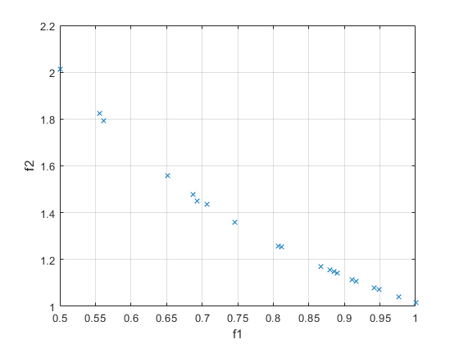

## Reults

EPC=[EP.Cost];  
for j=1:nObj  
  
 disp(['f #' num2str(j) ':']);  
 disp([' Min = ' num2str(min(EPC(j,:)))]);  
 disp([' Max = ' num2str(max(EPC(j,:)))]);  
 disp([' Range = ' num2str(max(EPC(j,:))-min(EPC(j,:)))]);  
 disp(' ');  
  
end

f #1:  
 Min = 0.5  
 Max = 1  
 Range = 0.5  
   
f #2:  
 Min = 1.0151  
 Max = 2.0117  
 Range = 0.99654

[*Published with MATLAB® R2018b*](https://www.mathworks.com/products/matlab)

Other code files of Q2 will show in the *.zip file.