clear;clc;
global R;R=10; %驱动点运动半径
global omega;omega=pi/3; %驱动点运动半径
global l;l=15;
global m;m=0.05;
global g;g=9.8;
t=linspace(0,100,1001);
j=0;
figure
title('The diagram of Lagging Pendulum');
axis([-30 30 -30 30 -10 10]);
grid on
hold on
plot3([0;0],[0;0],[10;-7],'k-.')
for k=0:0.5:10
R=10+k;
j=j+11;
x0=[0.1;0.1];
options = optimoptions('fsolve');
[x,fval] = fsolve(@myfun,x0,options);
r=x(1);
theta=x(2);
th=theta./(2*pi).*180;
x0=R.*sin(omega.*t);
y0=R.*cos(omega.*t);
z0=0.*t+8;
x1=r.*sin(omega.*t+pi);
y1=r.*cos(omega.*t+pi);
z1=z0-l*sin(theta)+0.*t;
h12=plot3([x0(1);x1(1)],[y0(1);y1(1)],[y0(1);y1(1)],'b-o','LineWidth',1.5);%画杆并取句柄
for i=j:j+10
set(h12,'XData',[x0(i);x1(i)],'YData',[y0(i);y1(i)],'Zdata',[z0(i);z1(i)]);
plot3([x0(i);x0(i+1)],[y0(i);y0(i+1)],[z0(i);z0(i+1)],'g')
plot3([x1(i);x1(i+1)],[y1(i);y1(i+1)],[z1(i);z1(i+1)],'r')
drawnow
end
end
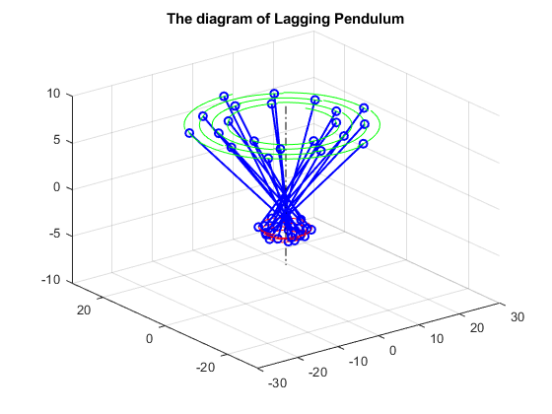
Published with MATLAB® R2017b

