Latin Hypercube Sampling
2D 1
3D 2

2D
clear;clc
N = 100;
n = 2;
dots = rand(N,n);
subplot(121)
plot(dots(:,1),dots(:,2),'o')
title(['Uniformity= ',num2str(Auxiliary_functions(dots))])
xlabel('Unoptimized')
grid on
forbid = [];dots = [];
subplot(122)
for i = 1:N
dotx = (i-1)/N + rand()/N; % 限制x在一段范围内
doty = rand(); % y可以随意取值
while ismember(ceil(doty*N),forbid) % 如果y所在的行已经被其他点占据，则重新取值，直到这个y值单独占据一行
doty = rand();
end
forbid = [forbid ceil(doty*N)]; % 将新的y值所在的行记为已使用
dots = [dots;[dotx,doty]];
plot(dotx,doty,'bo')
hold on
end
title(['Uniformity= ',num2str(Auxiliary_functions(dots))])
xlabel('Optimized')
grid on
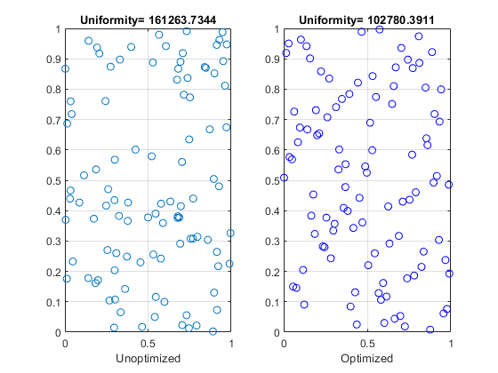

3D
n = 3;
dots = rand(N,n);
figure
subplot(121)
plot3(dots(:,1),dots(:,2),dots(:,3),'o')
title(['Uniformity= ',num2str(Auxiliary_functions(dots))])
xlabel('Unoptimized')
grid on
forbidx = [];forbidy = [];dots = [];
subplot(122)
for z = 1:N
dotz = (z-1)/N + rand()/N;
dotx = rand();
doty = rand();
while ismember(ceil(dotx*N),forbidx)
dotx = rand();
end
forbidx = [forbidx ceil(dotx*N)];
while ismember(ceil(doty*N),forbidy)
doty = rand();
end
forbidy = [forbidy ceil(doty*N)];
dots = [dots;[dotx,doty,dotz]];
plot3(dotx,doty,dotz,'bo')
hold on
end
title(['Uniformity= ',num2str(Auxiliary_functions(dots))])
xlabel('Optimized')
grid on
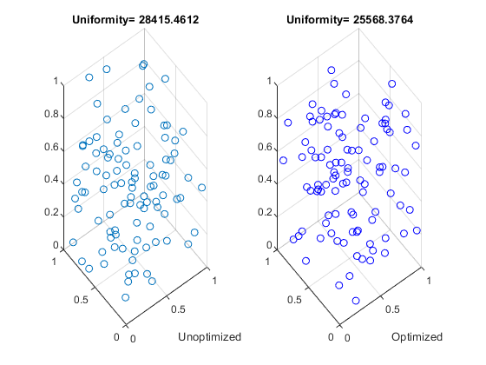
Published with MATLAB® R2018b

