Optimization-Based Sampling Algorithm 1
2D 1
3D 3

Optimization-Based Sampling Algorithm
clear;clc
f = @ Auxiliary_functions;
N = 100;

2D
n = 2;
forbid = [];dots = [];
subplot(121)
for i = 1:N
dotx = (i-1)/N + rand()/N;
doty = rand();
while ismember(ceil(doty*N),forbid)
doty = rand();
end
forbid = [forbid ceil(doty*N)];
dots = [dots;[dotx,doty]];
plot(dotx,doty,'bo')
hold on
end
title(['Uniformity= ',num2str(Auxiliary_functions(dots))])
xlabel('Unoptimized')
subplot(122)
dots = rand(N,n);
dots = fmincon(f,dots,[],[],[],[],zeros(size(dots)),ones(size(dots)));
plot(dots(:,1),dots(:,2),'o')
title(['Uniformity= ',num2str(Auxiliary_functions(dots))])
xlabel('Optimized')
Solver stopped prematurely.
fmincon stopped because it exceeded the function evaluation limit,
options.MaxFunctionEvaluations = 3000 (the default value).
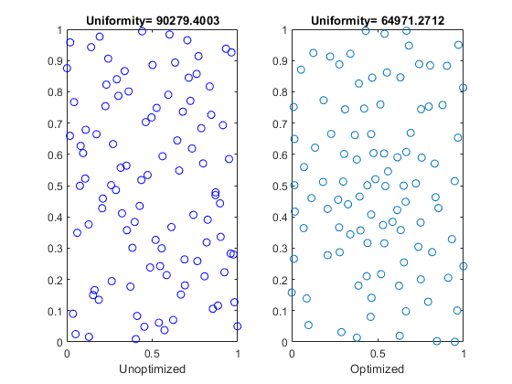

3D
figure
n = 3;
forbidx = [];forbidy = [];dots = [];
subplot(121)
for z = 1:N
dotz = (z-1)/N + rand()/N;
dotx = rand();
doty = rand();
while ismember(ceil(dotx*N),forbidx)
dotx = rand();
end
forbidx = [forbidx ceil(dotx*N)];
while ismember(ceil(doty*N),forbidy)
doty = rand();
end
forbidy = [forbidy ceil(doty*N)];
dots = [dots;[dotx,doty,dotz]];
plot3(dotx,doty,dotz,'bo')
hold on
end
title(['Uniformity= ',num2str(Auxiliary_functions(dots))])
xlabel('Unoptimized')
subplot(122)
dots = rand(N,n);
dots = fmincon(f,dots,[],[],[],[],zeros(size(dots)),ones(size(dots)));
plot3(dots(:,1),dots(:,2),dots(:,3),'o')
title(['Uniformity= ',num2str(Auxiliary_functions(dots))])
xlabel('Optimized')
Solver stopped prematurely.
fmincon stopped because it exceeded the function evaluation limit,
options.MaxFunctionEvaluations = 3000 (the default value).
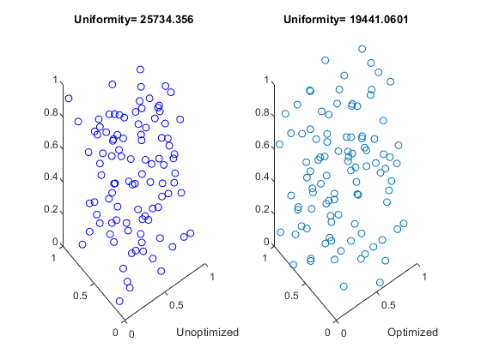
Published with MATLAB® R2018b

