clear;clc
dots = [randi([0 100], 40, 1), randi([0 100], 40, 1)];
min_path(dots)
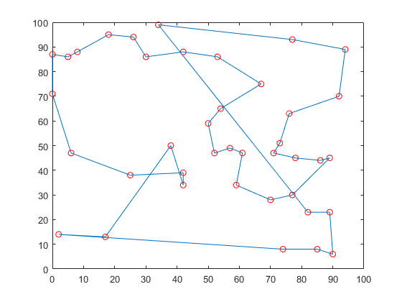
Published with MATLAB® R2018a

