clear;clc
dots = [randi([0 100], 40, 1), randi([0 100], 40, 1)];
subplot(1,2,1)
nor_path(dots) % 普通连接
subplot(1,2,2)
min_path(dots) % 优化连接
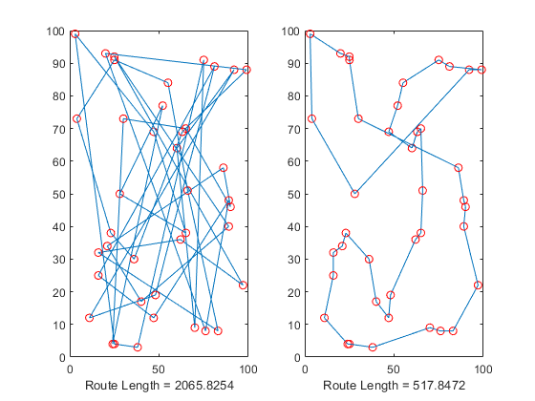
Published with MATLAB® R2018a

