clear;clc
fitness = @simpleMultiObjective;
nvar = 1;
[x, fval] = gamultiobj(fitness, nvar);
Optimization terminated: maximum number of generations exceeded.
x0 = -10:0.5:10;
f1 = (x0+2).^2 - 10;
f2 = (x0-2).^2 + 20;
figure;hold on
plot(x0, f1, x0, f2)
grid;
xlabel('x')
ylabel('f')
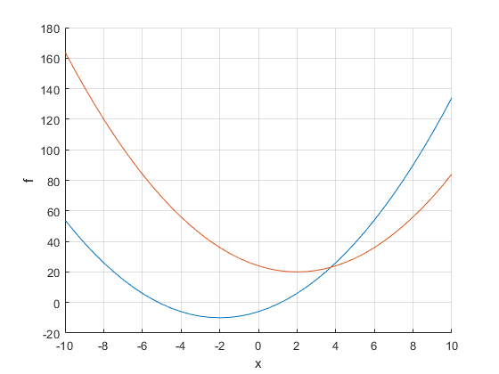
plot(x, fval(:,1),'x')
plot(x, fval(:,2),'o')
figure
plot(fval(:,1),fval(:,2),'o');
xlabel('f1')
ylabel('f2')
grid
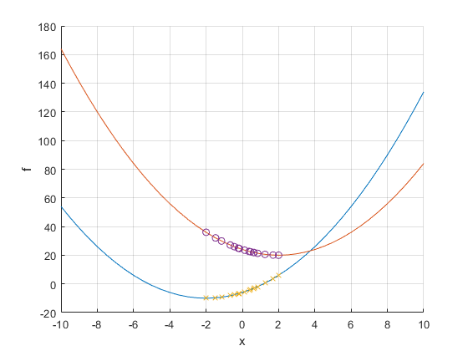
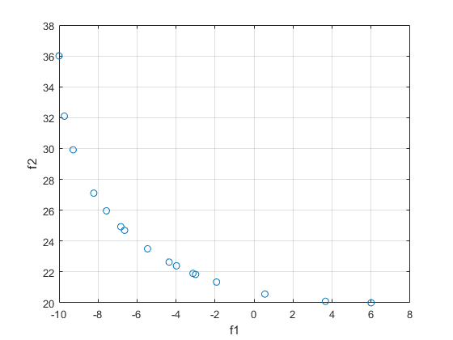
Published with MATLAB® R2018b

