Problem Definition 1
MOEA/D Settings 1
Initialization 2
Main Loop 3
Reults 5
clc;
clear;

Problem Definition
CostFunction=@ ft; % Cost Function
nVar=3; % Number of Decision Variables
VarSize=[nVar 1]; % Decision Variables Matrix Size
VarMin = [0.5 -2 -2]'; % Decision Variables Lower Bound
VarMax = [1 2 2]'; % Decision Variables Upper Bound
nObj=numel(CostFunction(unifrnd(VarMin,VarMax,VarSize)));

MOEA/D Settings
MaxIt=50; % Maximum Number of Iterations
nPop=100; % Population Size (Number of Sub-Problems)
nArchive=50;
T=max(ceil(0.15*nPop),2); % Number of Neighbors
T=min(max(T,2),15);
crossover_params.gamma=0.7;
crossover_params.VarMin=VarMin;
crossover_params.VarMax=VarMax;

Initialization
Create Sub-problems
sp=CreateSubProblems(nObj,nPop,T);
% Empty Individual
empty_individual.Position=[];
empty_individual.Cost=[];
empty_individual.g=[];
empty_individual.IsDominated=[];
% Initialize Goal Point
z=zeros(nObj,1);
% Create Initial Population
pop=repmat(empty_individual,nPop,1);
for i=1:nPop
pop(i).Position=unifrnd(VarMin,VarMax,VarSize);
pop(i).Cost=CostFunction(pop(i).Position);
z=min(z,pop(i).Cost);
end
for i=1:nPop
pop(i).g=DecomposedCost(pop(i),z,sp(i).lambda);
end
% Determine Population Domination Status
pop=DetermineDomination(pop);
% Initialize Estimated Pareto Front
EP=pop(~[pop.IsDominated]);

Main Loop
for it=1:MaxIt
for i=1:nPop
% Reproduction (Crossover)
K=randsample(T,2);
j1=sp(i).Neighbors(K(1));
p1=pop(j1);
j2=sp(i).Neighbors(K(2));
p2=pop(j2);
y=empty_individual;
y.Position=Crossover(p1.Position,p2.Position,crossover_params);
y.Cost=CostFunction(y.Position);
z=min(z,y.Cost);
for j=sp(i).Neighbors
y.g=DecomposedCost(y,z,sp(j).lambda);
if y.g<=pop(j).g
pop(j)=y;
end
end
end
% Determine Population Domination Status
pop=DetermineDomination(pop);
ndpop=pop(~[pop.IsDominated]);
EP=[EP
ndpop];
EP=DetermineDomination(EP);
EP=EP(~[EP.IsDominated]);
if numel(EP)>nArchive
Extra=numel(EP)-nArchive;
ToBeDeleted=randsample(numel(EP),Extra);
EP(ToBeDeleted)=[];
end
end
PlotCosts(EP);
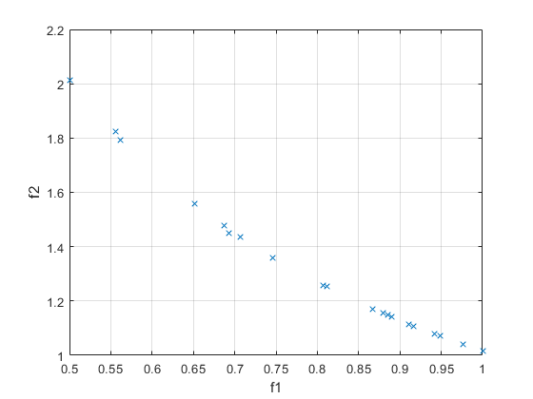

Reults
EPC=[EP.Cost];
for j=1:nObj
disp(['f #' num2str(j) ':']);
disp([' Min = ' num2str(min(EPC(j,:)))]);
disp([' Max = ' num2str(max(EPC(j,:)))]);
disp([' Range = ' num2str(max(EPC(j,:))-min(EPC(j,:)))]);
disp(' ');
end
f #1:
Min = 0.5
Max = 1
Range = 0.5
f #2:
Min = 1.0151
Max = 2.0117
Range = 0.99654
Published with MATLAB® R2018b

