Interactive RNA-Seq Classifier and DEG Explorer for Heart Disease Using the Magnetique Dataset

Xiya Song

Abstract
Heart diseases are one of the major complex health conditions that remain to be solved. This project developed an interactive web application for classifying heart disease from control samples, mainly for DCM (Dilated Cardiomyopathy) and HCM (hypertrophic cardiomyopathy), using RNA-Seq gene expression data from the Magnetique dataset. The web app included the pipeline involved data preprocessing, normalization, feature selection using the top 1000 most variable genes, and training of various machine learning models (Logistic Regression, Random Forest, Decision Tree, SVM, MLPClassifier) for both binary (Control vs. Dilated Cardiomyopathy) and multi-class (Control vs. DCM vs. HCM ) classification. The model interpretability was enhanced using SHAP values. In addition, differential Expression Analysis (DEG) was performed to provide a easy-access for the significantly differentially expressed genes. The web application, built with Streamlit, provides an accessible interface for data exploration, model evaluation, and interpretation. The web server is accessible on: https://xiyasong-ddls-project-app-k830az.streamlit.app/
Introduction

Heart failure represents a significant global health burden. Dilated cardiomyopathy (DCM) is characterized by dilation and impaired contraction of the ventricles, leading to reduced systolic function and heart failure, often with diverse genetic and non-genetic causes. In contrast, hypertrophic cardiomyopathy (HCM) involves abnormal thickening of the ventricular myocardium, typically due to sarcomeric gene mutations, which can impede diastolic filling and outflow.
Understanding the molecular signatures distinguishing diseased from healthy tissue can reveal candidate genes and pathways for therapeutic intervention. RNA-Seq technology provides a powerful means to profile gene expression, but extracting meaningful insights requires robust computational analysis. Since RNA-Seq data are formed as a tabular 2D matrix, they are a good resource for constructing ML models and regression analysis (as represented by DEG analysis).
The motivation for this project was to develop a lightweight, interpretable RNA-Seq-based classifier that allows for fast explorations of key genes that lead the variance between heart tissue suffering from diseases and normal tissue, without requiring access to raw sequencing reads.
The Magnetique dataset, focusing on left-ventricular tissue, offered a suitable public resource for this task, aligning with the course's emphasis on interpretable AI in biomedical research.

Materials and Methods
The project utilized the Magnetique dataset (Zenodo:https://zenodo.org/record/7148045), described in Sci Data 2023. This dataset comprises RNA-Seq data from left-ventricular tissue of patients with dilated cardiomyopathy (DCM), hypertrophic cardiomyopathy (HCM), and non-failing donor (NFD) hearts.
Typical bulk transcriptomic analysis involves data preprocessing, normalization, exploratory analysis, and downstream modeling. After quality control and alignment to a reference genome, raw read counts are summarized at the gene level and normalized to correct for library size and sequencing bias, commonly using methods implemented in DESeq2 or edgeR. Variance-stabilizing or log transformations enable subsequent exploratory data analysis, such as principal component analysis (PCA) and clustering, to assess sample quality and overall structure.
Several statistical methods were chosen and applied to this project.
First, differential expression analysis (DGE) employs statistical models, usually based on negative binomial distributions, to identify genes with significant expression differences between experimental conditions. Second, machine learning (ML) models such as logistic regression, random forests, support vector machines, and decision trees are increasingly used to classify samples and uncover predictive gene signatures. Model performance is typically evaluated using receiver operating characteristic (ROC) curves and the area under the curve (AUC) metric. Lastly, deep neural networks (DNNs) have been applied to capture nonlinear transcriptomic patterns. When combined with explainability tools such as SHAP values, these models offer both predictive accuracy and biological interpretability.
To achieve the construction of these models, we first applied the data pre-processing.

The initial input was a gene raw count matrix (gene_count_matrix.csv).
Sample metadata (MAGE_metadata.txt) was integrated to link samples to their respective disease etiologies. The raw
counts were normalized using the Variance Stabilizing Transformation (VST) from the DESeq2 R package (01_normalize.R). This step accounts for library size differences and stabilizes variance across expression levels.
Ensembl gene IDs were converted to human-readable gene symbols using the mygene Python library for improved interpretability in plots and reports.
When constructing the ML models, the dataset was consistently split into 70% for training and 30% for testing, ensuring stratified sampling to maintain class proportions in both binary and multi-class scenarios.

For model training, the top 1000 most variable genes across all samples were selected. This approach reduces dimensionality while retaining genes with significant biological activity, balancing computational efficiency with biological relevance.
A range of supervised machine learning models was implemented to classify samples based on normalized gene expression profiles. Logistic regression was employed as a linear baseline model to provide an interpretable reference for classification performance. In addition, non-linear models including decision trees and random forests were used to capture potential higher-order feature interactions. A support vector machine with a linear kernel was applied to assess margin-based separation in high-dimensional expression space. To incorporate non-linear representation learning, a multi-layer perceptron neural network was implemented using the MLPClassifier from the scikit-learn library. Furthermore, a deeper neural network architecture was implemented separately using TensorFlow and Keras on Google Colab to explore the potential benefits of increased model complexity and hierarchical feature learning.

Due to local environment compatibility issues, a Deep Neural Network (DNN) model using TensorFlow/Keras was developed and executed on Google Colab, leveraging GPU acceleration (Figure 1). The DNN was configured for binary classification (Control vs. DCM) with the following architecture:
Input Layer: Dense(512, activation='relu', input_shape=(num_features,))
Hidden Layer 1: Dropout(0.3)
Hidden Layer 2: Dense(128, activation='relu')
Hidden Layer 3: Dropout(0.2)
Output Layer: Dense(1, activation='sigmoid')
Compilation: optimizer='adam', loss='binary_crossentropy', metrics=['accuracy', tf.keras.metrics.AUC(name='auc')]
Training: epochs=100, batch_size=32, validation_split=0.2, EarlyStopping callback.
TensorBoard was used to monitor the training process and visualize model metrics.

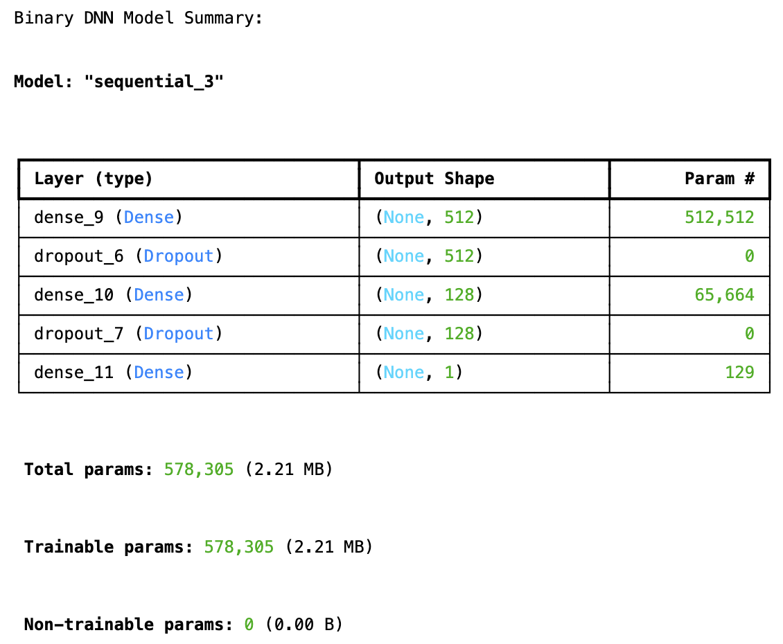
Figure 1. General features of the binary DNN models
Model performance was evaluated using multiple complementary metrics. Classification reports were generated to summarize precision, recall, F1-score, and class support, enabling assessment of per-class predictive performance. Overall discriminative ability was quantified using the area under the receiver operating characteristic curve, with macro-averaged ROC AUC applied for multi-class classification scenarios. Confusion matrices were used to visualize the correspondence between true and predicted class labels and to identify systematic misclassification patterns. To enhance model interpretability, SHAP values were computed to quantify the contribution of individual genes to model predictions, allowing for biological interpretation of feature importance across different classifiers.

To improve the accessibility and reproducibility of the analytical workflow, the complete transcriptomics analysis and machine learning pipeline were wrapped into an interactive web application developed using the Streamlit framework. Streamlit was selected due to its lightweight architecture and native support for rapid prototyping of data science applications in Python.

Results

PCA for data distributions
Initial exploratory data analysis included checking for missing values and basic descriptive statistics. Principal Component Analysis (PCA) was extensively used to visualize data distributions and assess sample quality.
Initial PCA plot (Figure 2) consistently showed clear separation of samples based on disease condition (DCM, HCM, NFD). To ensure that this separation was due to biological signal rather than technical artifacts or confounding factors, further PCA plots were generated, colored by metadata attributes such as sex and race.

These investigations confirmed that samples did not cluster significantly by sex or race, indicating that these factors were not major drivers of variance in the dataset and suggesting the absence of strong batch effects related to these demographic variables. This validated that the observed separation in PCA was primarily driven by the biological differences between the disease states.

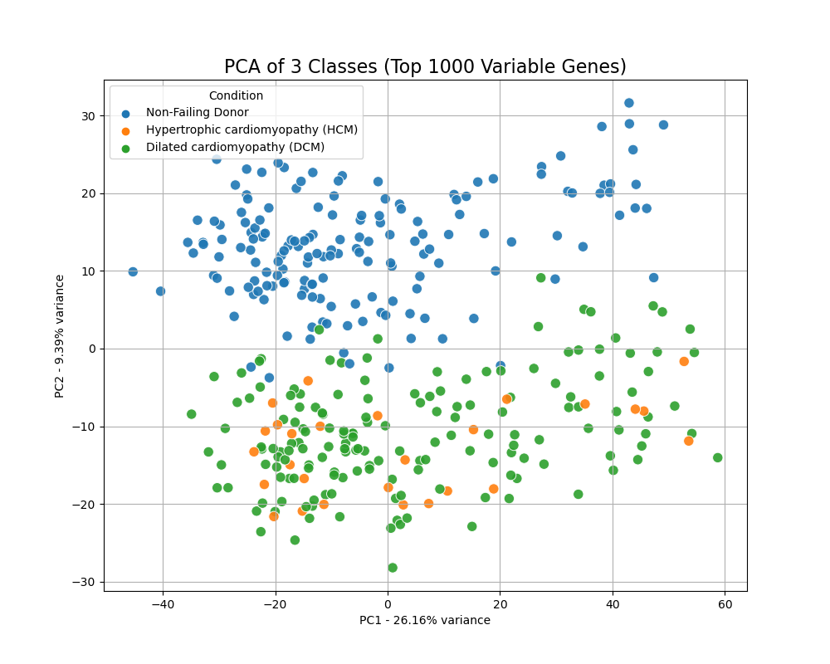
Figure 2. PCA for the general distribution of the data included in the study.

Differential Expression Analysis (Binary: Control vs. DCM)
Differential Expression Analysis (DEG) was performed using DESeq2 (R package), comparing Non-Failing Donors (Control) against Dilated Cardiomyopathy (DCM). The analysis identified genes significantly up- or down-regulated between these two groups. The results were saved in DEG_results.csv, and a volcano plot (volcano_plot.png) was generated, with the top 10 most significant genes labeled with their gene symbols.
We analyzed the differential gene expression between DCM patients and Non-Failing Donors to identify key molecular alterations. As Figure 2 shows, Genes on the right side of the plot showed significantly increased expression in DCM tissues. SMOC2 emerged as the most significantly upregulated gene. Other top candidates included FNDC1, FRZB, FREM1, TRIL, and SEZ6L, suggesting their potential involvement in disease progression. Genes on the left side demonstrated significantly reduced expression in DCM. The most prominent downregulated genes were IL1RL1 (ST2) and SERPINA3. Additionally, members of the Lipocalin family, specifically LCN6 and LCN10, showed a significant decrease in expression levels.

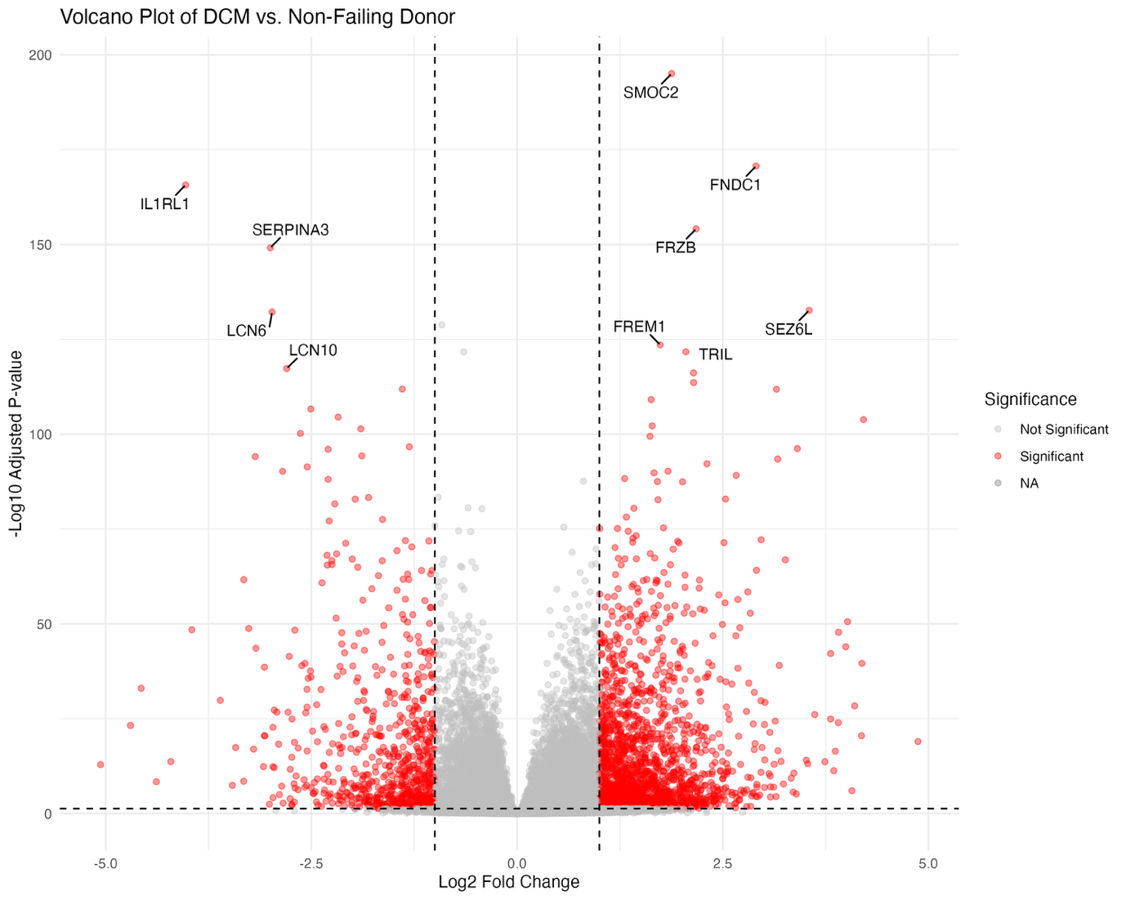
Figure 3. Volcano plot of differentially expressed genes in DCM vs. Non-Failing Donors.

Machine Learning Model Performance

Initially, models were trained on a binary classification task (Non-Failing Donor vs. Dilated Cardiomyopathy). Several models, particularly Logistic Regression and SVM, achieved extremely high accuracy (ROC AUC scores near 1.00). This suggested that the two groups are highly separable based on gene expression, potentially indicating a relatively simple classification problem or a strong signal in the data.

To introduce a more challenging and realistic scenario, the analysis was extended to a 3-class problem (Control vs. DCM vs. HCM), which significantly increased the complexity, especially given the smaller sample size for the HCM group. The models were trained using the top 1000 most variable genes.
We visually compare the macro-averaged ROC curves for all five models on handeling 2-class problem (left) and the 3-class problem (right). As Figure 3 shows, most of the classifiers show nearly perfect prediction for the 2-class problem, indicating a big difference between control and DCM. For the 3-class problem, while Logistic Regression and SVM still performed very well (macro AUC ~0.98), RF, DNN, and decision tree have a significant drop for predicting HCM against control and DCM, highlighting the challenge posed by its limited sample representation. We assume that the DNN model is too complex for solving such a problem compared to general ML models.
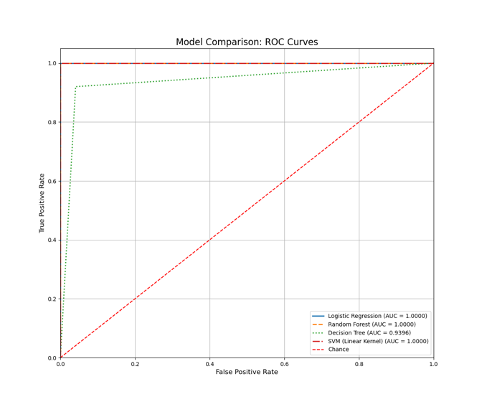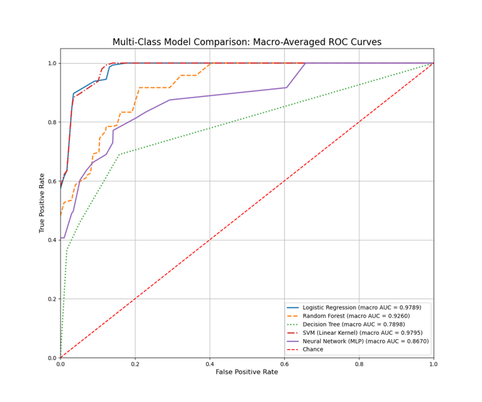
Figure 4. Binary and Multiclass ROC Curves for different models

In addition, confusion matrices were generated for all models for visualizing their performance in the 3-class problem (Figure 5). We can see that the major problem is the prediction for HCM, due to the limited sample size.
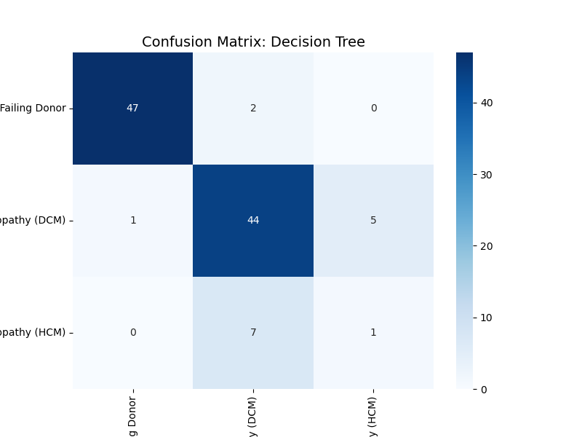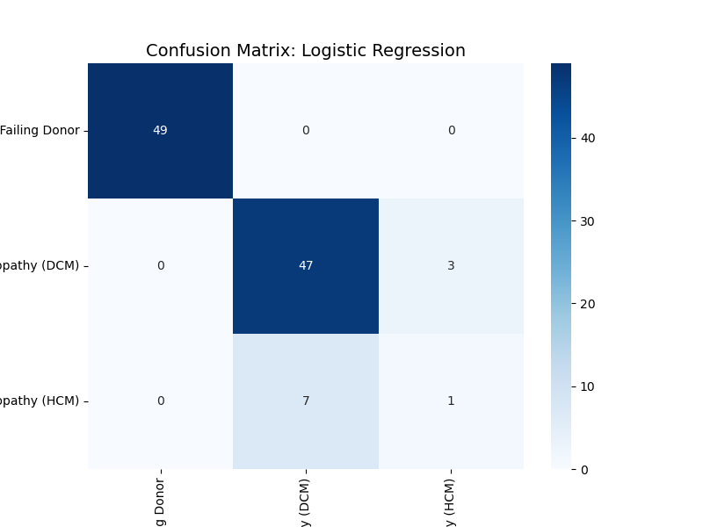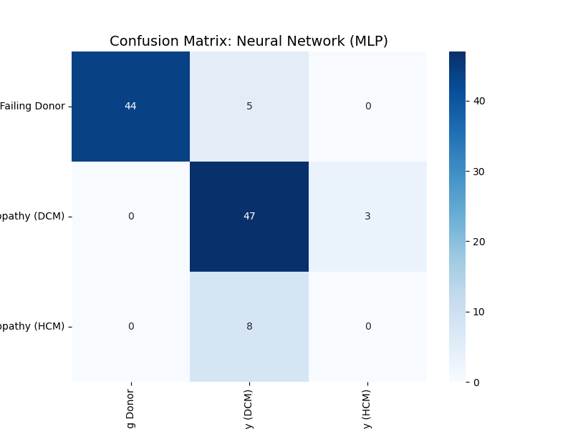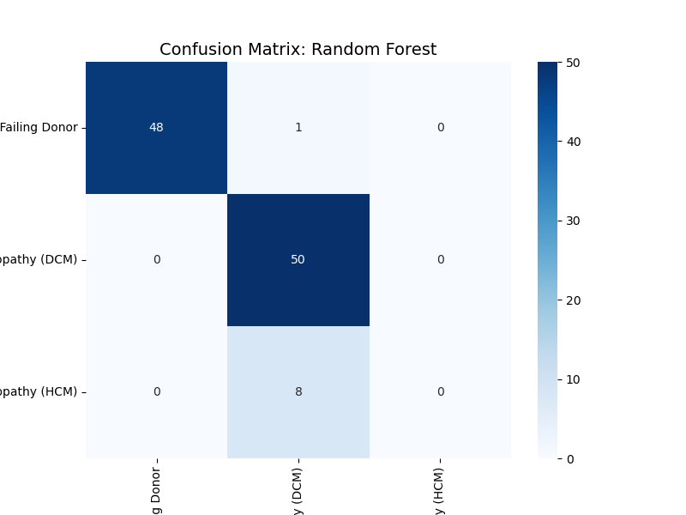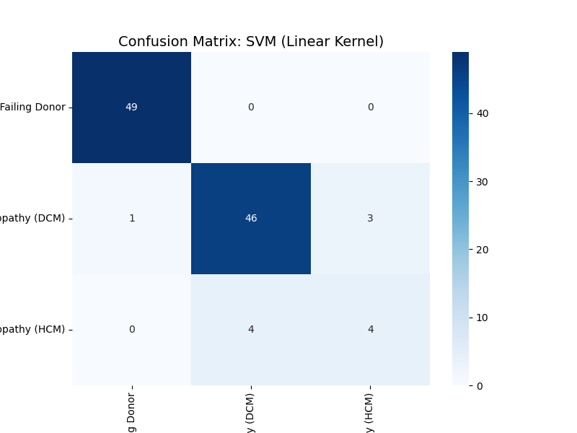
Figure 5. Confusion matrices for all models in the multi-classifier

Model Interpretation with SHAP Values
SHAP (SHapley Additive exPlanations) values were used to interpret the model predictions, identifying the contribution of each gene to the classification outcome. We performed SHAP analysis on both the binary classifier and the multi-classifier to compare the differences.
For binary classification (Control vs. DCM), the SHAP summary plot (Figure 6) was generated from the TensorFlow DNN model run on Google Colab. This plot illustrates key genes like HBA2 and HBA1 (high expression associated with DCM) and SERPINA3, IL1RL1, and SFRP4 (high expression associated with Control) as drivers of the model's predictions.
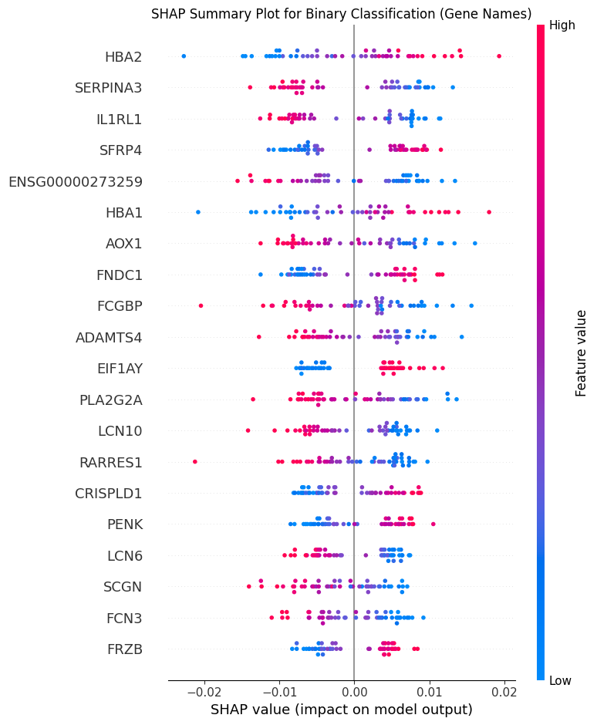
Figure 6. The SHAP summary plot for the binary DNN model
For the 3-class problem, we selected the SVM model as representations and calculated the SHAP values. The KernelExplainer was used, returning SHAP values as a 3D array (samples, features, classes). To visualize, three separate summary plots were generated(Figure 7). We used SHAP to quantify the contribution of each gene to the prediction of specific subtypes (DCM, HCM, and Non-Failing Donor). Unlike binary classification, where a single output probability is generated, our multi-class model produces a probability vector for each sample. Consequently, SHAP values were computed separately for each class output. In this context, the SHAP value represents how a gene’s expression pushes the model’s prediction towards (positive SHAP value) or away from (negative SHAP value) a specific class, relative to the other classes. This "One-vs-Rest" interpretability approach allows us to identify unique genomic signatures that drive the classification of each specific cardiomyopathy subtype.

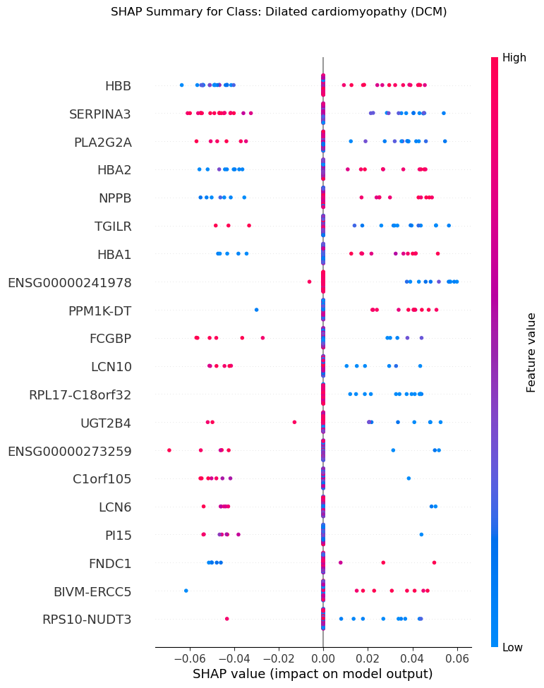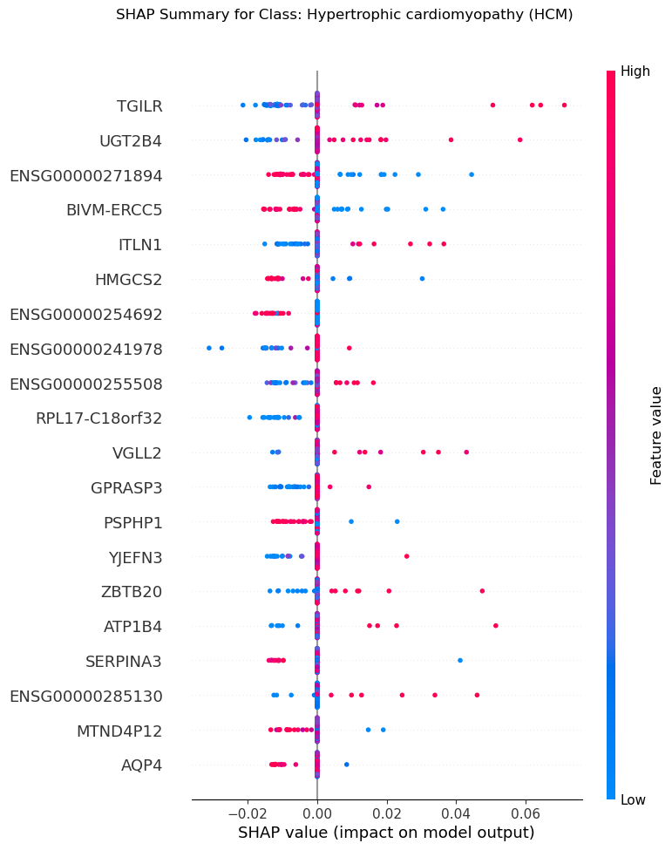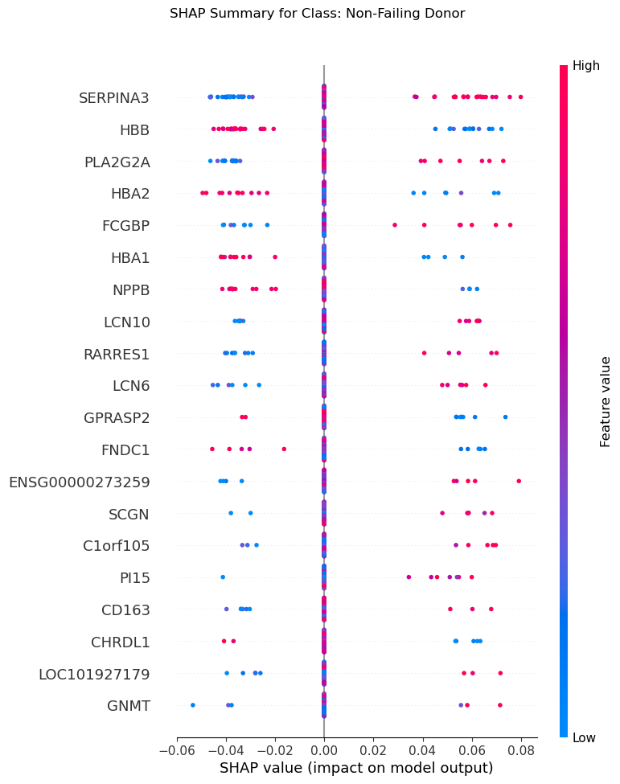
Figure 7. The SHAP summary plot for the multi-class DNN model
In Figure 7, we first revealed that high expression of HBB and NPPB (indicated by red dots) corresponds to positive SHAP values, acting as strong predictors for the DCM class. Notably, NPPB is a well-established marker for heart failure, validating the model's biological relevance. Conversely, high expression of SERPINA3 and PLA2G2A yields negative SHAP values, suggesting that elevated levels of these genes reduce the likelihood of a DCM classification. The profile for Non-Failing Donors largely mirrors the DCM signature but with opposite polarity. Here, high expression of SERPINA3, PLA2G2A, and HBB (low expression) are the primary drivers pushing the model towards a "Non-Failing" prediction. Specifically, the model uses high SERPINA3 as a strong indicator of a healthy (non-failing) state, whereas it associates low SERPINA3 with disease. Lastly, hypertrophic cardiomyopathy (HCM) displays a unique feature set distinct from the DCM/Donor axis. Genes such as TGILR, UGT2B4, and VGLL2 emerge as top predictors. High expression of these genes contributes positively to the probability of identifying a sample as HCM. This suggests that HCM is characterized by a specific transcriptional program that differs significantly from the stress-response markers observed in DCM.

Web Application Development
We implemented the complete analysis pipeline as an interactive web application (app.py) via Streamlit to enable dynamic data exploration. The application was designed to allow users to customize the analysis by selecting between binary and multi-class classification modes and choosing various scikit-learn model architectures. Beyond model configuration, the tool provides immediate visual feedback through dynamic PCA plots and comprehensive evaluation metrics, including confusion matrices and ROC curves. Furthermore, the application incorporates on-demand SHAP analysis, enabling users to visualize the top contributing genes and interpret model decisions in real-time, thus bridging the gap between complex algorithmic outputs and biological interpretation.

Conclusion & Discussion
This project successfully developed a comprehensive pipeline for heart disease classification from RNA-Seq data. The binary classification proved highly accurate, while the multi-class problem, particularly the HCM class, presented a more challenging scenario due to sample imbalance. Feature selection using the top 1000 most variable genes effectively balanced performance and computational efficiency. SHAP values provided crucial insights into the biological drivers of model predictions.
Limitations: The primary limitation is the small sample size for the HCM group, impacting multi-class performance. The reliance on CPU for KernelExplainer and TensorFlow's incompatibility with the local environment also posed challenges. The current web app uses pre-loaded data; user data upload would be a valuable future enhancement.
Future Directions: Future work could involve collecting more data for underrepresented classes, exploring more advanced feature selection techniques, implementing more sophisticated multi-class deep learning models (e.g., on cloud GPUs), and integrating additional biological pathway analysis.

Data and Code Availability
- Dataset: Magnetique dataset available on Zenodo: https://zenodo.org/record/7148045
- Code Repository: The project code is available on GitHub: https://github.com/xiyasong/DDLS_Project.git

Acknowledgments
This project was developed with significant assistance from the Gemini-CLI AI agent, which facilitated code generation, debugging, and project management. Its contributions are detailed in the AI deep research log.

References

Britto-Borges, T., Ludt, A., Boileau, E. et al. Magnetique: an interactive web application to explore transcriptome signatures of heart failure. J Transl Med 20, 513 (2022). https://doi.org/10.1186/s12967-022-03694-z

Appendices
- AI Deep Research Log: final_history.json

