**(5 Points) The various states that an app can enter on your platform of choice**

Android.

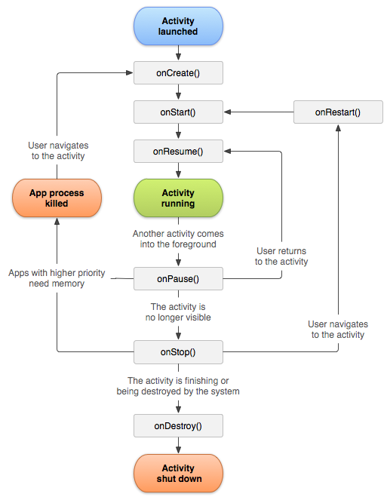

Six common call back functions: [onCreate()](https://developer.android.com/reference/android/app/Activity?hl=zh-cn#onCreate(android.os.Bundle)), [onStart()](https://developer.android.com/reference/android/app/Activity?hl=zh-cn#onStart()), [onResume()](https://developer.android.com/reference/android/app/Activity?hl=zh-cn#onResume()), [onPause()](https://developer.android.com/reference/android/app/Activity?hl=zh-cn#onPause()), [onStop()](https://developer.android.com/reference/android/app/Activity?hl=zh-cn#onStop()) and [onDestroy()](https://developer.android.com/reference/android/app/Activity?hl=zh-cn" \l "onDestroy()). 4 States: Activity Launched, Activity Running, App process killed, Activity shut down. Or you can divide into 6 states according to these 6 call back functions.

**(5 Points) The various states that you must consider for your app, why you must consider it, and what must happen in each state.**

Activity launched: onCreate, when my app is created, the app must initialize the main page, and need to load user settings such as account and selected language.

Activity running: onPause, when user leave the app to background, my app must keep alive and remember the settings. And in this state, the main activity needs to translate the image send by service, and return the translated result. onResume, when user back to the main page, the main page need to remember and show the correct settings.

Before app process killed and activity shut down: onStop, save all user settings locally. onDestory, shut down the floating button service when the activity is destroyed.